kdrcc User Guide
  - Kernel Based Doubly Robust Case Crossover Regression
Version 0.1.0 | R 3.6.3 and later
Peizheng Li
pzli25@m.fudan.edu.cn
GPL-3
A practical manual from installation to complete analysis and customized outputs, with accompanying data, runnable examples and plotting scripts.

Reading route
First use: Sections 1–5 for installation, the case and data.
Routine analysis: Sections 6–17 for configuration, fitting and outputs.
Advanced use: Sections 18–23 for tuning, graphics, saving and troubleshooting.
Reference: Sections 24–25 for complete arguments and reporting.

Contents
1 Getting started
2 Distribution files and installation
3 Running the complete example
4 Preparing matched data
5 Allocating learning selection and estimation samples
6 Method and effect scale
7 Configuring the kernel and solver
8 Specifying the auxiliary models
9 Fitting and inspecting a model
10 Checking numerical estimation
11 Predicting observed exposure combinations
12 Joint exposure curves
13 Single-exposure curves
14 Reporting quantitative odds ratios and intervals
15 Testing variable participation
16 Testing and interpreting interactions
17 Variable importance and contribution shares
18 Selecting configurations with independent data
19 Creating custom result tables
20 Customizing graphics with ggplot2
21 Saving reloading and reusing a kernel
22 Linux execution and parallel configuration
23 Troubleshooting
24 Complete function reference
25 Reporting and citation

1 Getting started
This guide takes a first-time kdrcc user from installation to a complete analysis, interpretation and customized outputs. Runnable files in package/examples accompany the examples. The final reference section documents every exported function and its arguments.
kdrcc implements Kernel-Based Doubly Robust Case-Crossover Regression, abbreviated KDR-CC. It accepts individually matched event and reference dates and returns joint exposure effects, background-specific single-exposure curves, odds ratios for specified contrasts, variable participation tests, interaction tests and contribution shares.
Start with the complete example, then replace its data with your own. Enter R code in the R console or an R script; enter bash commands in a Linux terminal. Use forward slashes in paths and quotation marks around strings. R function names are case-sensitive.
library(kdrcc)
packageVersion("kdrcc")
help(package = "kdrcc")
?kdrcc
args(kdrcc_control)
The object fit stores a fitted model; fit$reference extracts its reference combination. Result objects commonly contain a data frame such as single$data. Use names() to list fields, str() to inspect structure and head() to inspect the first rows.

2 Distribution files and installation
Path | Purpose
package/kdrcc | Package source and help files
package/installers | kdrcc and CompQuadForm installation archives
package/INSTALL_AND_TEST.R | Cross-platform installation and workflow checks
package/examples/RUN_EXAMPLE.R | Complete worked analysis
package/examples/RUN_TUNING.R | Configuration-selection example
package/examples/CUSTOM_PLOTS.R | Customized ggplot2 graphics
package/kdrcc_user_guide_zh.docx | Chinese user guide
package/kdrcc_user_guide_en.docx | English user guide

Install 64-bit R version 3.6.3 or newer and copy the complete distribution to the computer. The example below places it at D:/KDRCC_R_package_release_0.1.0; change root to your location. Install once for each R library, then use library(kdrcc) in each new session.
root <- "D:/KDRCC_R_package_release_0.1.0"
source(file.path(root, "package", "INSTALL_AND_TEST.R"), encoding = "UTF-8")
library(kdrcc)
The installation settings are library, archive, install_dependencies, repository and output. library=NULL uses the user R library; archive="auto" chooses the platform archive; repository supplies the dependency repository; output names the installation-record directory. Successful completion prints Installation and workflow tests completed.
Windows R 4.4 uses the bundled Windows binaries. Linux, macOS and other supported R versions use source archives. kdrcc is pure R; building the CompQuadForm dependency from source requires platform C/C++ development tools. Use the configured compiler and R development environment on Linux, matching Rtools on Windows, or Command Line Tools on macOS. An installed CompQuadForm version 1.4.4 or newer is reused.
# Manual source installation from the distribution
install.packages(file.path(root, "package/installers", "CompQuadForm_1.4.4.tar.gz"), repos = NULL, type = "source")
install.packages(file.path(root, "package/installers", "kdrcc_0.1.0.tar.gz"), repos = NULL, type = "source")
Inspect library locations with .libPaths(). Reinstall in the target R environment when changing computer or major R version. ggplot2 is optional for customized graphics; the core analysis and built-in plots use base R graphics.

3 Running the complete example
The worked data contain 800 matched sets of four dates, giving 3,200 rows. X1 has a positive main effect, X2 a protective main effect, X3 participates through an X1-by-X3 interaction, X4 is null, and W is a time-varying covariate. The case illustrates inputs, outputs and the operational workflow.
source(file.path(root, "package/examples/RUN_EXAMPLE.R"), encoding = "UTF-8")
fit <- example_analysis$fit
results <- example_analysis$results
example_analysis$output
Outputs are written to package/examples/output. CSV files support tables and plots; PNG files display the results; fitted_model.rds saves the fitted model; analysis_objects.rds saves interpretation results; session_info.txt records the environment. Run CUSTOM_PLOTS.R separately to produce ggplot2 graphics.
d <- read.csv(file.path(root, "package/examples", "example_matched_data.csv"))
head(d)
table(table(d$set_id))
table(tapply(d$case, d$set_id, sum))
Regenerate the same example with kdrcc_example(n=800L, seed=702L). n counts matched sets. Set discrete=TRUE to generate W as -1, 0 and 1 for a discrete auxiliary-model example.

4 Preparing matched data
Each row is an event or reference date. set_id uniquely identifies the complete matched set for one event. case is numeric zero or one, with exactly one event and at least one reference per set. Exposures must be finite numeric values. Use distinct columns for exposures, adjustment covariates and matched identifiers.
Column | Example meaning | Preparation
set_id | Matched set for one event | Matched set for one event; unique across the analysis
case | Numeric or logical | Numeric or logical; one event in each set
X1 … X4 | Numeric | Numeric; preserve and record exposure units
W | Time-varying adjustment variable specified by adjust | Time-varying adjustment variable specified by adjust

Construct reference dates, lag summaries and covariates according to the study protocol before fitting. Each exposure column contains its final analysis value, such as a prespecified lag 0–1 average. Date matching and lag calculation precede package input. Distinguish every event-specific matched set when individuals or events share dates.
vars <- c("X1", "X2", "X3", "X4")
required <- c("set_id", "case", vars, "W")
stopifnot(all(required %in% names(d)))
stopifnot(all(vapply(d[vars], is.numeric, logical(1))))
stopifnot(all(is.finite(as.matrix(d[vars]))))
stopifnot(all(d$case %in% c(0, 1)))
stopifnot(all(table(d$set_id) >= 2L))
stopifnot(all(tapply(d$case, d$set_id, sum) == 1L))
Apply a prespecified missing-data strategy and recheck the matched structure. The following complete-set filter retains sets whose required columns are complete and records excluded sets. Include Inf and NaN checks in the row eligibility rule.
row_ok <- complete.cases(d[required]) & apply(is.finite(as.matrix(d[vars])), 1L, all)
set_ok <- tapply(row_ok, as.character(d$set_id), all)
excluded_sets <- names(set_ok)[!set_ok]
d_clean <- d[as.character(d$set_id) %in%
names(set_ok)[set_ok], , drop = FALSE]

5 Allocating learning selection and estimation samples
The learning sample determines standardization, centers, distances and auxiliary dictionaries. The final estimation sample estimates auxiliaries and effect coefficients. Add an independent selection sample for tuning. kdrcc_split allocates complete matched sets; learning and tuning accept proportions or integer matched-set counts.
parts <- kdrcc_split(d, strata = "set_id", learning = 250L, seed = 703L)
sapply(parts[c("learning", "tuning", "estimation")], function(x) length(unique(x$set_id)))
head(parts$assignment)
This example allocates 250 learning and 550 estimation sets. tuning=0 produces an empty selection sample. Allocate real study data according to total size and candidate complexity, and record matched-set counts in every role. The final-fit folds parameter controls auxiliary cross-fitting and has a distinct role from sample allocation and tuning validation folds.
Repeated events, shared exposure time series and regional clustering can create dependence across sets. Align sample allocation and interpretation with the study independence unit. Automatic allocation and cross-fitting operate on the matched sets specified by strata.

6 Method and effect scale
Gaussian kernel centers describe a smooth multiexposure response. Independent learning estimates variable-specific distance scales. Final estimation combines an ordered-pair doubly robust moment, auxiliary cross-fitting and a penalty on mixed-derivative complexity. Numerical optimization uses derivatives and local criterion curvature.
OR(a; b) = exp(h(a) - h(b))
log_OR(a; b) = h(a) - h(b)
The reference combination b defines the comparison. OR=1 indicates equal relative effect, OR>1 an increase in odds and OR<1 a decrease relative to b. The response supports harmful, protective, nonlinear and interacting relationships. A curve describes how increasing its exposure changes the effect at the specified background.
The base moment has the double-robust identity when either auxiliary function is correct. The finite kernel representation and positive penalty define the regularized fitted response. Covariance propagates local coefficient and finite-dimensional auxiliary estimation variability, conditional on independent learning and selection. Intervals and significance calculations follow this target and local inference definition.

7 Configuring the kernel and solver
kdrcc_control returns a configuration object. centers is the number M of centers, kappa controls learning-stage regularization, and lambda controls final interaction complexity. Larger M increases representation size and cost; kappa changes learning stability; lambda changes smoothing in mixed-coordinate directions. The reference section lists every default and argument.
cc <- kdrcc_control(
centers = 10L, kappa = 1e-3, lambda = 1, folds = 3L,
coverage = .25, seed = 27182818L, workers = 1L,
kernel_tolerance = 1e-4, verbose = TRUE
)
str(cc)
coverage specifies the coverage-oriented fraction of centers; remaining centers follow weighted center selection. initial_scale and rho_bounds control the initial distance coefficient and relative search range in standardized exposure space. penalty_rows controls sampled date rows for the mixed-derivative penalty matrix. Retain the seed to reproduce these randomized steps.
workers controls independent kernel-profile tasks in kdrcc_tune. A single kdrcc fit uses one process. A grid varying only lambda with fixed M and kappa has one profile, which limits parallel gains. Budget physical cores, available memory and the feature-matrix size per model together.

8 Specifying the auxiliary models
The g auxiliary model fits the adjustment design together with an exposure dictionary by conditional logistic regression within matched sets. g_exposure chooses the dictionary: spline_kernel combines univariate splines with kernel features, spline uses univariate splines, and kernel uses kernel features. g_df controls spline construction and kernel_rank the number of auxiliary kernel features.
The f auxiliary estimates the conditional mean of kernel-feature differences when the event occupies the second ordered-pair position. basis uses weighted finite-basis least squares, with spline terms for ordered covariates by default. cells uses saturated indicators for discrete ordered covariate combinations. Each training fold needs information for its chosen cells.
nu <- kdrcc_nuisance(g_exposure = "spline_kernel", g_df = 2L, kernel_rank = 4L, f_method = "basis", f_df = 2L)
nu_formula <- kdrcc_nuisance(
g_exposure = ~ X1 + I(X1^2) + X2 + X3,
f_method = "basis",
f_formula = ~ plus.W + minus.W +
I(plus.W^2) + I(minus.W^2)
)
In f_formula, plus.W and minus.W name the two ordered-pair W values. A custom g_exposure function accepts a date-level data frame and returns a finite numeric matrix with one row per date. Use the same column definitions for learning and estimation data. Store fixed knots, centers or scaling values in the function closure.
make_dictionary <- function(center) {
force(center)
function(data) cbind(data$X1 - center, data$X2,
(data$X1 - center) * data$X3)
}
nu_callback <- kdrcc_nuisance(
g_exposure = make_dictionary(mean(parts$learning$X1)),
f_method = "basis", f_df = 2L
)

9 Fitting and inspecting a model
When both kernel and learning_data are NULL, kdrcc allocates 25% of input matched sets to independent learning and the remainder to estimation. For explicit L and N, call kdrcc_split and supply learning_data. fold_id can supply labels 1 through folds in first-appearance order of estimation sets; the control seed determines the default allocation.
vars <- c("X1", "X2", "X3", "X4")
ref <- vapply(parts$learning[vars], median, numeric(1))
fit <- kdrcc(
data = parts$estimation, case = "case", strata = "set_id",
exposures = vars, adjust = ~ W + I(W^2),
learning_data = parts$learning, nuisance = nu,
control = cc, reference = ref
)
summary(fit)
names(fit)
fit$reference
summary prints learning and estimation set counts, exposure names, M, kappa, lambda, the criterion, maximum gradient and covariance status. coef(fit) returns kernel-coordinate coefficients; vcov(fit) returns their full covariance. Exposure-level effects are obtained through prediction contrasts.
fit$kernel stores centers, scaling, distances, whitening and the penalty; fit$nuisance stores fold-specific auxiliaries; fit$diagnostics stores solver records; fit$reproducibility stores seeds and folds; fit$evaluation supplies the default evaluation distribution. keep_data=TRUE additionally retains the final estimation input.
The default evaluation distribution consists of the first evaluation_points learning rows. Supply representative combinations explicitly through fit$evaluation to define default quantile paths, participation tests and contribution summaries. Fitted coefficients and covariance retain their estimated values. The worked example uses the first 1,000 estimation rows explicitly.
fit$evaluation <- parts$estimation[seq_len(min(1000L, nrow(parts$estimation))), vars, drop = FALSE]
B <- coef(fit)
V <- vcov(fit)
dim(V)

10 Checking numerical estimation
dg <- kdrcc_diagnostics(fit)
fit$diagnostics$converged
fit$covariance$status
dg$estimation
dg$distance_parameters
dg$boundaries
dg$minimum_curvature
dg$curvature_condition
plot(fit)
The iteration table includes iteration, objective and gradient. Inspect the criterion trajectory, final gradient, convergence flag and covariance availability. distance_parameters lists variable-specific distance coefficients; boundaries counts coefficients near their search bounds. A large curvature condition number motivates checks of support, correlation and configuration stability.
Address numerical problems by checking inputs, simplifying candidate dictionaries, adjusting M, kappa or lambda, or increasing informative learning data. maxit increases allowed iterations; tolerance and step_tolerance set stopping thresholds. Recheck predictions and interpretation after changing a configuration.
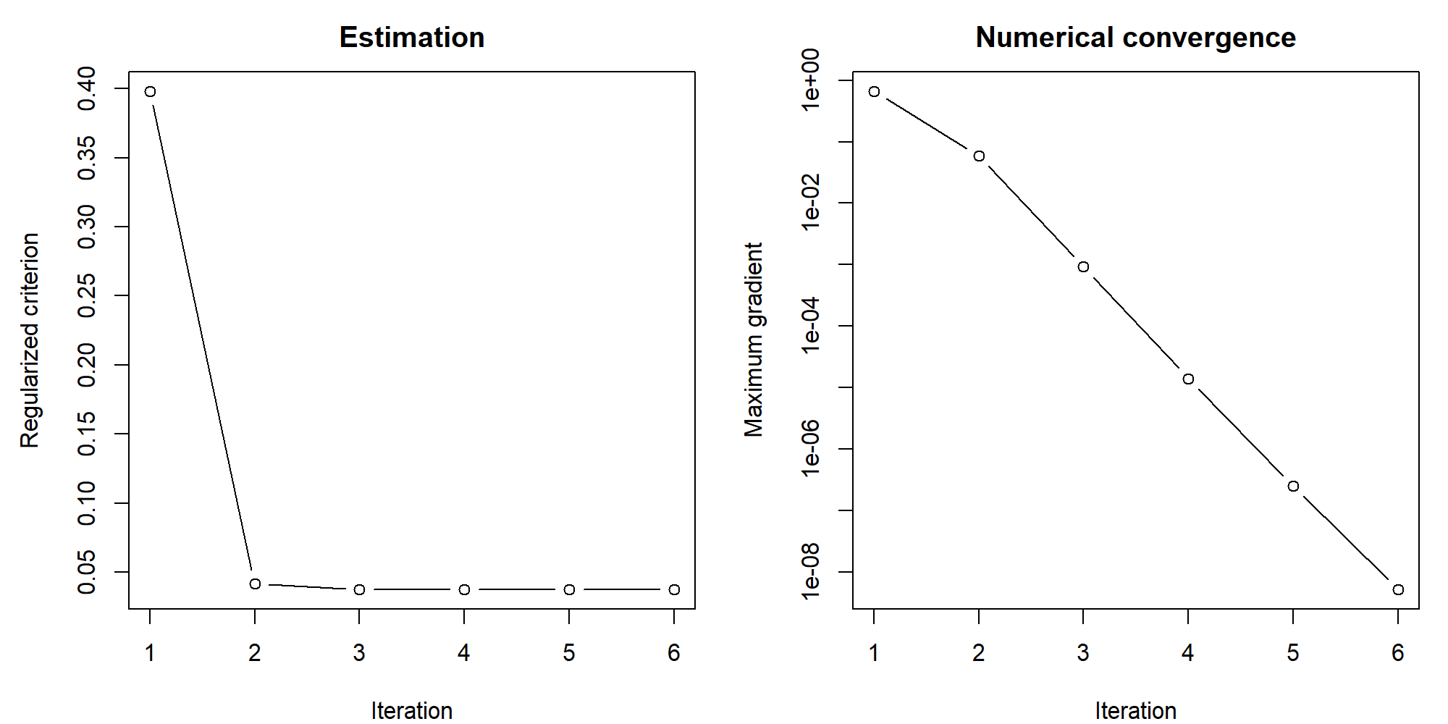
Figure 1 Criterion and gradient trajectories for the worked fit

11 Predicting observed exposure combinations
new <- parts$estimation[1:5, vars, drop = FALSE]
pred <- predict(fit, newdata = new, reference = ref, type = "or", interval = TRUE, level = .95)
pred
Prediction requires all fitted exposure columns. reference accepts a complete named vector, a one-row data frame, or one reference row for each newdata row. It defaults to fit$reference. type chooses the display scale of estimate, conf_low and conf_high, while complete log-OR and OR fields are returned together.
Field | Meaning
log_or | Difference h(a) minus h(b)
se | Model standard error on the log-OR scale
lower / upper | Pointwise log-OR confidence limits
or | exp(log_or)
or_lower / or_upper | Pointwise OR confidence limits
estimate / conf_low / conf_high | Convenience columns in the requested type scale

se is measured on the log-OR scale. Exponentiating log-OR confidence limits gives OR limits. interval=FALSE computes point estimates with missing interval fields and supports large prediction batches. Retain physical concentrations and reference combinations to document each contrast.

12 Joint exposure curves
joint <- kdrcc_joint(fit, quantiles = seq(.1, .9, .05), reference = ref, level = .95)
head(joint$data)
plot(joint, scale = "or")
The default path sets selected exposures to the same marginal quantile and compares that combination with the complete reference. position is the common quantile. variables selects the changing exposures; other exposures remain at reference. The curve describes effects along this specified multivariate path.
joint_two <- kdrcc_joint(fit, variables = c("X1", "X2"))
grid <- as.data.frame(lapply(parts$learning[vars], function(x) as.numeric(quantile(x, c(.25,.5,.75)))))
custom_joint <- kdrcc_joint(fit, grid = grid, reference = ref)
grid supplies arbitrary complete combinations; position then indexes rows. For physical concentration paths, policy targets or regional representative combinations, retain the full grid and customize axis labels.
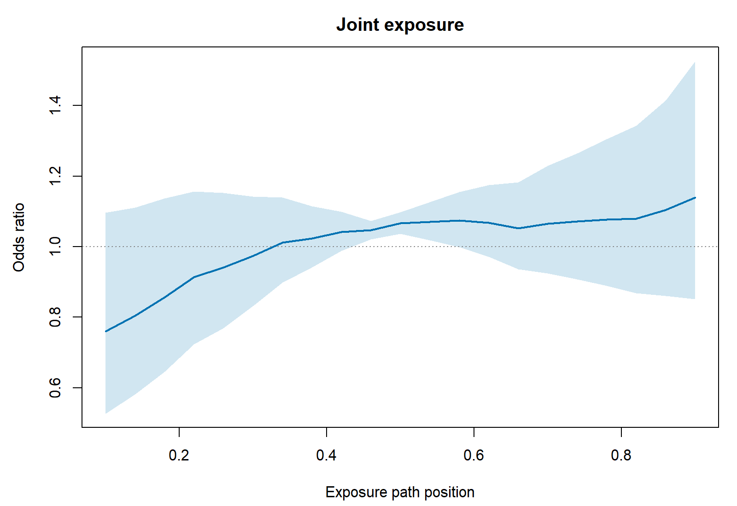
Figure 2 Joint quantile-path effects and pointwise intervals

13 Single-exposure curves
single <- kdrcc_single(fit, background = ref, points = 41L)
single_x2 <- kdrcc_single(fit, exposure = "X2", values = seq(-2, 2, length.out = 61L), background = ref)
plot(single_x2, scale = "or")
head(single$data)
One exposure change while all others remain at background; the resulting combination is compared with background itself. concentration uses analysis units. values accepts a common numeric vector or a list named by exposure. The default range spans the 10th to 90th percentiles of the evaluation distribution.
Protective exposures can produce decreasing curves. For example, falling OR as X2 increases indicates a lower relative effect at higher X2 under that background. Whether OR falls below one also depends on the concentration relative to its reference. Interactions allow these curves to change with background.
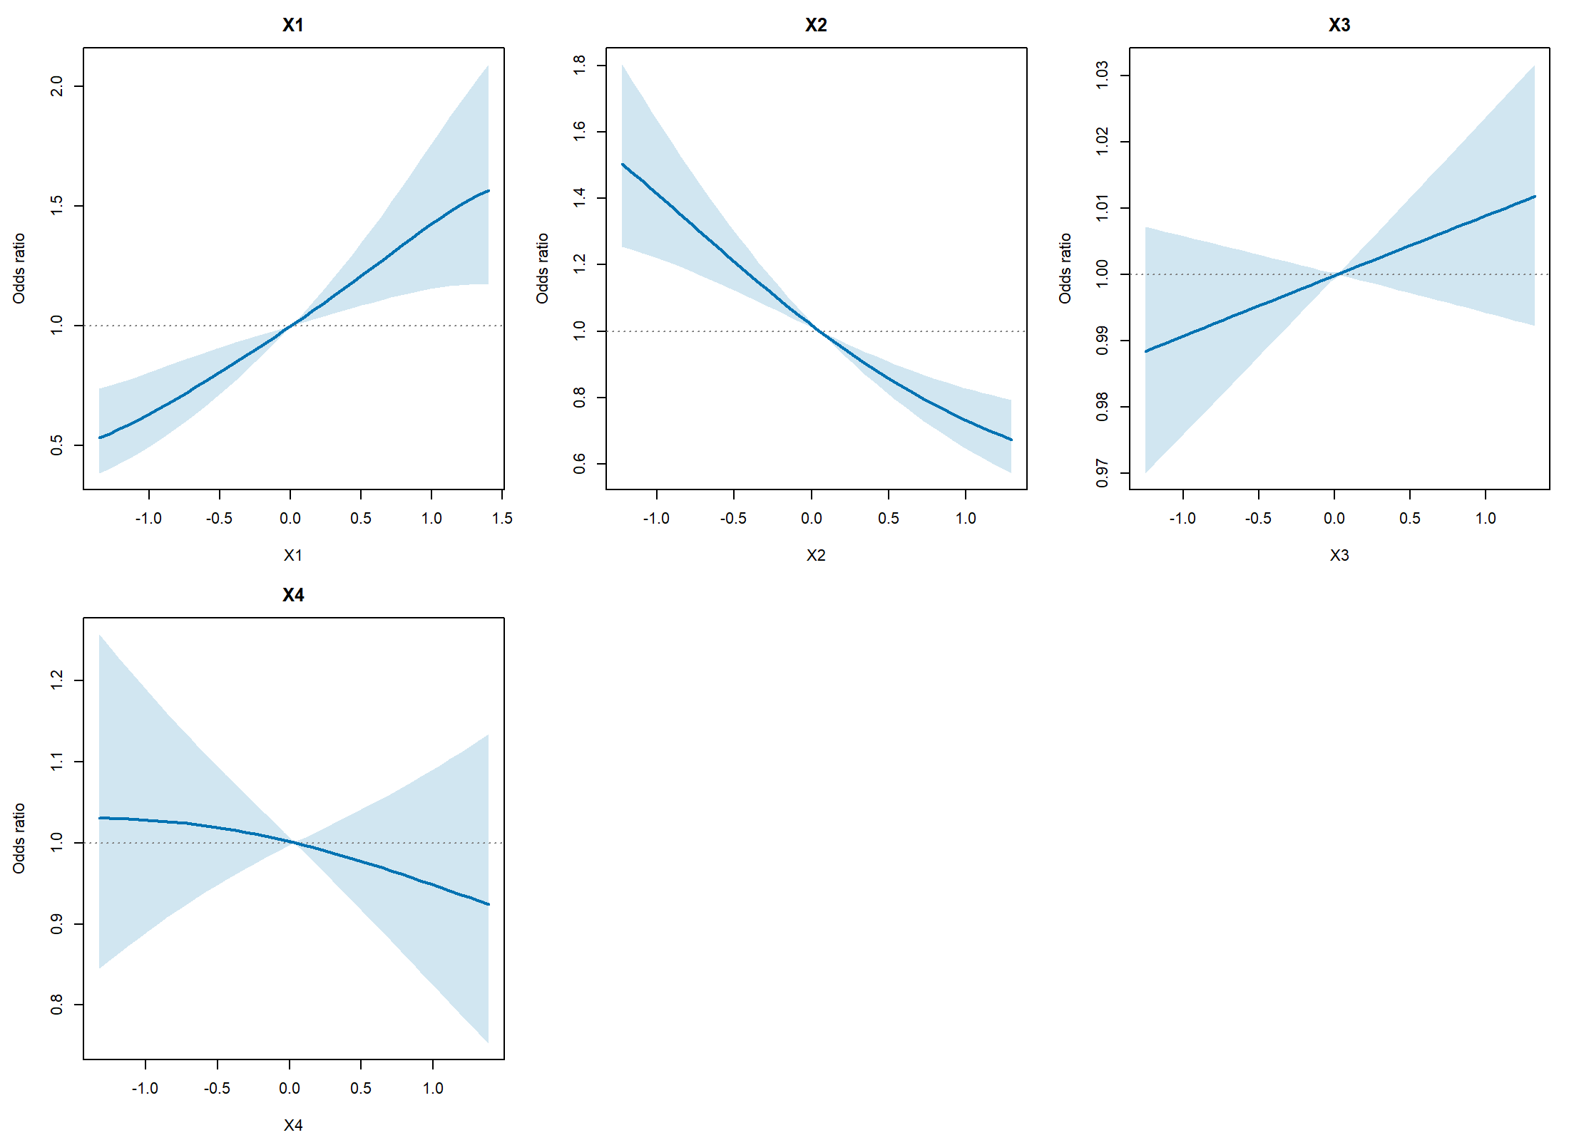
Figure 3 Background-specific curves for the four exposures

14 Reporting quantitative odds ratios and intervals
Quantify nonlinear effects using two prespecified concentrations, such as the 75th versus the 25th percentile. Quantify a joint effect by comparing two complete combinations. kdrcc_contrast returns exposure coordinates together with predictions for direct tabulation.
a <- as.data.frame(as.list(ref)); b <- a
a$X1 <- unname(quantile(parts$learning$X1, .75))
b$X1 <- unname(quantile(parts$learning$X1, .25))
or_x1 <- kdrcc_contrast(fit, a, reference = b)
or_x1$data[c("or", "or_lower", "or_upper")]

a_all <- as.data.frame(lapply(parts$learning[vars],
function(x) unname(quantile(x,.75))))
b_all <- as.data.frame(lapply(parts$learning[vars],
function(x) unname(quantile(x,.25))))
or_joint <- kdrcc_contrast(fit, a_all, reference = b_all)
The supplied example gives an X1 interquartile contrast OR of approximately 1.773, with a 95% interval of 1.367 to 2.300. This specifies the initial and final X1 concentrations and the background of the remaining exposures. Record the full concentration columns to link the OR to its curve segment.

15 Testing variable participation
participation <- kdrcc_variables(fit, alpha = .05, adjust = "holm")
participation$data
selected <- participation$data$variable[!is.na(participation$data$selected) & participation$data$selected]
The test uses the evaluation-average squared coordinate derivative: whether changing an exposure changes the fitted response beyond local estimation variability. statistic is a nonnegative quadratic statistic. A weighted chi-square reference yields p_value, followed by multiplicity adjustment specified by adjust, with Holm as the default.
p_adjusted is the adjusted p value and selected indicates significance at alpha. algorithm records the tail method, such as Davies, scaled chi-square or Monte Carlo; accuracy describes numerical error; draws records fallback sampling; numerically_stable checks whether the decision is stable to numerical error. Numerically unresolved decisions are returned as NA.
In the supplied example, X1 and X2 reach Holm-adjusted significance, with adjusted p values approximately 0.000263 and 0.00000320. X3 and X4 have adjusted p values approximately 0.458 and 0.570. Interpret participation alongside curves and specified contrasts. The test targets coordinate derivatives of the fitted regularized response over the stated evaluation distribution.

16 Testing and interpreting interactions
pairs <- matrix(c("X1", "X3"), ncol = 2L, byrow = TRUE)
inter <- kdrcc_interaction(fit, pairs = pairs, background = ref, points = 9L, alpha = .05, adjust = "holm")
inter$overall
head(inter$data)
plot(inter)
I(a,b) = h(a,b,z0) - h(a,b0,z0) - h(a0,b,z0) + h(a0,b0,z0)
The four-point contrast measures departure from additivity on the log-OR scale. background supplies a0, b0 and z0. A positive value indicates a higher log OR than the sum of the two separate changes at that background; a negative value indicates a lower value. Anchor rows and columns equal zero by construction.
overall returns a grid-wide quadratic statistic and overall p value for each pair, with Holm adjustment across the supplied pairs. data returns concentrations, log_or, SE, intervals, p values, adjusted p values and direction at each point. Pointwise adjustment covers all eligible interaction-grid points in the call. Read overall significance and local direction separately.
Supply named concentration sequences through values to align grids with the study range. direction values positive, negative and zero describe the sign of the estimated contrast; significant or p_adjusted describes whether the point meets the testing criterion.

17 Variable importance and contribution shares
contrib <- kdrcc_contribution(fit, variables = c("X1", "X2", "X3"), reference = ref, chunk = 128L)
contrib$data
head(contrib$allocations)
contrib$identity_error
plot(contrib)
Baseline Shapley allocation assigns the log OR of a specified combination relative to reference among the selected variables. Each row of allocations contains signed contributions for one combination; its sum equals the corresponding log_or. mean_absolute_contribution averages absolute allocations, and share_percent normalizes these means to 100% within the selected set.
variables defines the contribution set; other exposures are held at reference. The scientific target or participation decisions can help specify that set. mean_signed_contribution preserves average direction and can reflect cancellation across combinations; overall importance is commonly summarized by mean_absolute_contribution or share_percent.
The example shares are approximately 56.90% for X1, 41.84% for X2 and 1.26% for X3. Protective X2 can therefore have substantial importance. Shares summarize participation in the effect within the selected set, reference and evaluation distribution; interpret harmful or protective direction using curves and specified OR contrasts.
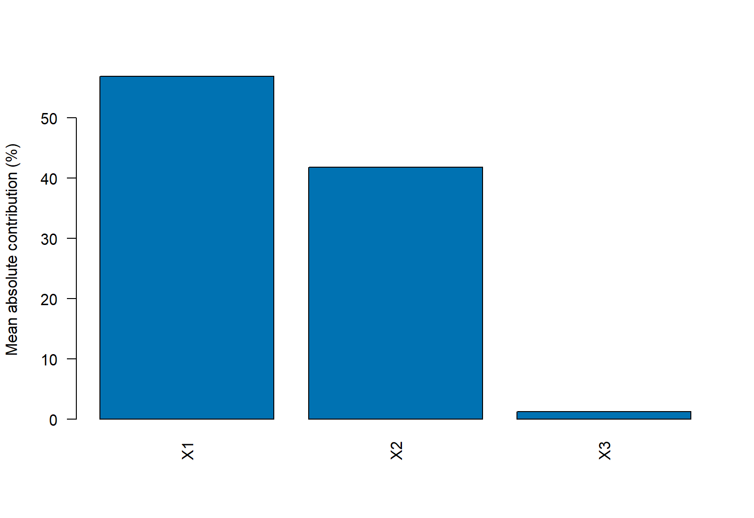
Figure 4 Mean absolute contribution shares within the selected variables

18 Selecting configurations with independent data
kdrcc_tune minimizes held-out conditional negative log likelihood on a selection sample. Independent learning data determine candidate kernels. Selection data are split by complete matched sets; auxiliaries are cross-fitted inside training folds and loss is evaluated in held-out folds. Fit and report the chosen model on independent final estimation data.
source(file.path(root, "package/examples/RUN_TUNING.R"), encoding = "UTF-8")
selection$selected
selection$grid
selection$scores
selection$fallback
summary(fit_tuned)
Each grid row specifies M, kappa and lambda. Candidates with the same M and kappa share kernel learning. mean_loss is weighted by validation matched-set counts; eligible requires valid scores in every fold. selected gives the chosen configuration. If all candidates fail, fallback=TRUE uses the baseline control configuration; fallback=FALSE stops for candidate review.
Start with a compact justified grid, review scores, computation time and failures, then expand the range. Larger M generally increases computation and memory per kernel profile. L and N are determined by data allocation; grid compares M, kappa and lambda under that allocation.

19 Creating custom result tables
table_or <- or_x1$data[c("or", "or_lower", "or_upper")]
table_or$contrast <- "X1: Q75 versus Q25"
table_or$OR_CI <- sprintf("%.3f (%.3f, %.3f)",
table_or$or, table_or$or_lower,
table_or$or_upper)
write.csv(table_or, "specified_OR_table.csv", row.names = FALSE)
write.csv(participation$data, "variable_tests.csv", row.names = FALSE)
write.csv(contrib$data, "contribution_shares.csv", row.names = FALSE)
Retain full numerical precision in CSV and generate rounded display columns separately. Table titles and notes should identify exposures, contrast concentrations, reference background, interval level and adjustment method. Contribution tables identify the evaluation distribution and variable set; interaction tables distinguish overall tests and local directions.

20 Customizing graphics with ggplot2
Principal outputs are ordinary data frames that can be passed directly to ggplot2. Install a ggplot2 version compatible with your R version, then run the supplied file. The same CSV outputs also support Excel, other R table tools and journal templates.
install.packages("ggplot2")
source(file.path(root, "package/examples/CUSTOM_PLOTS.R"),
encoding = "UTF-8")
library(ggplot2)
ggplot(single$data, aes(concentration, or)) +
geom_ribbon(aes(ymin = or_lower, ymax = or_upper),
fill = "#0072B2", alpha = .2) +
geom_line(colour = "#0072B2") +
geom_hline(yintercept = 1, linetype = 3) +
facet_wrap(~ exposure, scales = "free") +
labs(x = "Exposure concentration", y = "Odds ratio") +
theme_classic(base_size = 14)
The ribbon shows pointwise confidence limits from one fit. Check displayed interval ranges when changing coordinate scales. Use ggsave to export ggplot2 figures. Base graphics use png(), a plotting function and dev.off().
png("joint_curve.png", width = 2400, height = 1600, res = 300)
plot(joint, scale = "or")
dev.off()

p_custom <- ggplot(joint$data, aes(position, or)) +
geom_line() + theme_classic()
ggsave("custom_joint.png", p_custom, width = 8, height = 6, dpi = 300)

21 Saving reloading and reusing a kernel
saveRDS(fit, "fitted_kdrcc.rds", version = 2)
saveRDS(list(joint = joint, single = single,
participation = participation, contribution = contrib),
"interpretation_objects.rds", version = 2)
fit_loaded <- readRDS("fitted_kdrcc.rds")
predict(fit_loaded, new, type = "or")
writeLines(capture.output(sessionInfo()), "session_info.txt")
After reloading, use the model for prediction, contrasts and figures directly. Kernel reuse requires the same exposure names and order, adjustment specification and auxiliary design. control$lambda can change the final penalty; the learned kernel determines centers and kappa.
cc_reuse <- fit$specification$control
fit_reuse <- kdrcc(parts$estimation, exposures = vars,
adjust = ~ W + I(W^2), kernel = fit$kernel,
control = cc_reuse, reference = ref)
Retain data versions, cleaning rules, sample allocation, seeds, configuration, reference combinations, evaluation ranges, model objects and sessionInfo. For large prediction sets, process row batches using the same reference and saved model, then combine returned data frames.

22 Linux execution and parallel configuration
# bash commands from the distribution root
Rscript --vanilla package/INSTALL_AND_TEST.R
nohup Rscript --vanilla package/examples/RUN_EXAMPLE.R \
> example_run.log 2>&1 &
tail -f example_run.log
Parallel tuning uses kdrcc_control(workers=...). Each distinct M and kappa combination defines a kernel-profile task. Choose processes according to task count and resources, and coordinate R processes with numerical-library threads. On Linux the following environment variables can be set before R starts.
export OMP_NUM_THREADS=1
export OPENBLAS_NUM_THREADS=1
export MKL_NUM_THREADS=1
Rscript --vanilla package/examples/RUN_TUNING.R

23 Troubleshooting
Message or observation | Action
there is no package called kdrcc | Install in the active R library and inspect .libPaths()
Analysis columns contain missing values | Apply the prespecified missing-data strategy to complete sets
Every matched set must contain one event | Check event coding, set identifiers and duplicate event rows
Exposure columns must be numeric | Inspect imported types and numeric concentration columns
auxiliary columns are aliased | Inspect aliased transformations and simplify the auxiliary dictionary
A covariate-pair cell was absent | Check learning-cell coverage; consider basis or more learning information
Covariance is unavailable | Inspect the error, convergence, curvature, information and configuration
Numerically unresolved decisions | Increase tail precision or computation budget and review the test
Every tuning candidate fails | Inspect selection$scores$error and simplify candidate complexity
Graphics-device error | Close stale devices and reopen a PNG file device
Zero interval at the reference | A combination compared with itself has zero contrast and SE
High memory use | Reduce centers, auxiliary dimension or workers and batch predictions

24 Complete function reference
This reference lists all 13 exported functions and common S3 methods. Defaults are extracted from the actual version 0.1.0 definitions. Required arguments are marked required. object denotes a fitted model, while x denotes the object received by print or plot.

kdrcc
Returns a kdrcc model with coefficients, kernel, auxiliaries, full covariance, evaluation data and diagnostics.
kdrcc(data, case="case", strata="set_id", exposures, adjust=~1,
learning_data=NULL, nuisance=kdrcc_nuisance(), control=kdrcc_control(),
reference=NULL, kernel=NULL, fold_id=NULL)

Argument | Meaning
data | Analysis data frame: matched date rows for fitting or combinations for interpretation.
case | Name of the numeric zero/one event indicator.
strata | Name of the complete matched-set identifier.
exposures | Unique numeric exposure names in a fixed order.
adjust | One-sided adjustment formula; in test functions, the multiplicity method.
learning_data | Independent complete matched learning data.
nuisance | Auxiliary specification from kdrcc_nuisance.
control | Configuration from kdrcc_control.
reference | Complete reference vector; prediction also accepts row-specific references.
kernel | Learned kernel for reusing a fixed learning result.
fold_id | Cross-fitting fold labels in first-appearance order of estimation sets.

kdrcc_control
Returns a kdrcc_control configuration list.
kdrcc_control(centers=144L, kappa=1e-04, lambda=1, folds=3L, coverage=0.25,
seed=27182818L, workers=1L, verbose=FALSE, maxit=70L, tolerance=1e-07,
step_tolerance=1e-06, rho_bounds=c(0.01, 100), initial_scale=0.0625,
kernel_maxit=80L, kernel_continuations=1L, kernel_tolerance=1e-05,
penalty_rows=256L, evaluation_points=1000L, confidence=0.95,
tail_accuracy=1e-08, tail_terms=100000L, tail_retry_terms=1000000L,
tail_draws=199999L, keep_data=FALSE)
Argument | Meaning
centers | Number M of kernel centers, integer at least two.
kappa | Positive regularization coefficient for kernel learning.
lambda | Nonnegative final mixed-derivative complexity penalty.
folds | Auxiliary cross-fitting folds, integer at least two.
coverage | Coverage-oriented fraction of centers between zero and one.
seed | Positive integer seed below 2147483000.
workers | PSOCK processes for independent tuning kernel profiles.
verbose | Whether to print fitting progress.
maxit | Maximum final-estimation iterations.
tolerance | Final gradient stopping threshold.
step_tolerance | Final step-size stopping threshold.
rho_bounds | Positive distance-coefficient search bounds relative to their baseline.
initial_scale | Initial distance-coefficient multiplier within rho_bounds.
kernel_maxit | Maximum optimization iterations per kernel-learning round.
kernel_continuations | Additional kernel optimization continuation rounds.
kernel_tolerance | Kernel-learning projected-gradient threshold.
penalty_rows | Maximum sampled date rows for the mixed-derivative penalty.
evaluation_points | Maximum default evaluation rows retained from learning data.
confidence | Default pointwise confidence level for predict.
tail_accuracy | Numerical accuracy target for weighted chi-square tails.
tail_terms | Initial Davies integration limit.
tail_retry_terms | Retry Davies integration limit.
tail_draws | Minimum Monte Carlo fallback draws.
keep_data | Whether to retain final estimation inputs in the model.

kdrcc_nuisance
Returns a kdrcc_nuisance specification list.
kdrcc_nuisance(g_exposure="spline_kernel", f_method=c("basis", "cells"),
g_df=4L, kernel_rank=24L, f_df=3L, f_formula=NULL)
Argument | Meaning
g_exposure | g dictionary type, one-sided formula or numeric-matrix callback.
f_method | basis finite-basis regression or cells saturated discrete cells.
g_df | Basis-size setting for g univariate splines.
kernel_rank | Maximum kernel features in g; zero is allowed.
f_df | Basis-size setting for the default f spline terms.
f_formula | One-sided formula using ordered covariates such as plus.W and minus.W.

kdrcc_split
Returns learning, tuning and estimation frames, assignment and seed.
kdrcc_split(data, strata, learning=0.25, tuning=0, seed=27182818L)
Argument | Meaning
data | Analysis data frame: matched date rows for fitting or combinations for interpretation.
strata | Name of the complete matched-set identifier.
learning | Fraction or integer number of learning matched sets.
tuning | Fraction or integer number of selection matched sets.
seed | Positive integer seed below 2147483000.

kdrcc_tune
Returns kernel, control, grid, scores, selected, fallback and record.
kdrcc_tune(data, learning_data, case="case", strata="set_id", exposures,
adjust=~1, nuisance=kdrcc_nuisance(), grid=expand.grid(M = c(96L, 144L),
kappa = c(3e-05, 1e-04), lambda = c(0.3, 1, 3)), control=kdrcc_control(),
validation_folds=3L, fallback=TRUE)
Argument | Meaning
data | Analysis data frame: matched date rows for fitting or combinations for interpretation.
learning_data | Independent complete matched learning data.
case | Name of the numeric zero/one event indicator.
strata | Name of the complete matched-set identifier.
exposures | Unique numeric exposure names in a fixed order.
adjust | One-sided adjustment formula; in test functions, the multiplicity method.
nuisance | Auxiliary specification from kdrcc_nuisance.
grid | M/kappa/lambda candidates for tuning; full combinations for joint curves.
control | Configuration from kdrcc_control.
validation_folds | Outer matched-set validation folds, at least two.
fallback | Use the control baseline if every candidate fails scoring.

kdrcc_example
Returns a data frame containing set_id, case, X1 to X4 and W.
kdrcc_example(n=800L, seed=13579L, discrete=FALSE)
Argument | Meaning
n | Number of generated matched sets, at least twenty.
seed | Positive integer seed below 2147483000.
discrete | Whether example W has three discrete levels.

predict.kdrcc
Returns a data frame of log_or, se, confidence limits, OR and convenience fields.
predict.kdrcc(object, newdata, reference=NULL, type=c("log_or", "or"),
interval=TRUE, level=object$specification$control$confidence, ...)
Argument | Meaning
object | A fitted kdrcc object.
newdata | Combinations containing all fitted exposure columns.
reference | Complete reference vector; prediction also accepts row-specific references.
type | Scale of estimate convenience columns: log_or or or.
interval | Whether to compute SEs and intervals.
level | Pointwise confidence level for this evaluation.
... | Additional arguments to R generic methods or graphics.

kdrcc_contrast
Returns kdrcc_effect; data contains specified concentrations and effect fields.
kdrcc_contrast(object, newdata, reference=NULL, level=0.95)
Argument | Meaning
object | A fitted kdrcc object.
newdata | Combinations containing all fitted exposure columns.
reference | Complete reference vector; prediction also accepts row-specific references.
level | Pointwise confidence level for this evaluation.

kdrcc_joint
Returns kdrcc_effect; data contains position, concentrations and effect fields.
kdrcc_joint(object, quantiles=seq(0.1, 0.9, length.out = 21L),
variables=object$specification$exposures, grid=NULL, reference=NULL,
level=0.95)
Argument | Meaning
object | A fitted kdrcc object.
quantiles | Common marginal quantiles for selected exposures, between zero and one.
variables | Variables changing on the joint path or included in contribution allocation.
grid | M/kappa/lambda candidates for tuning; full combinations for joint curves.
reference | Complete reference vector; prediction also accepts row-specific references.
level | Pointwise confidence level for this evaluation.

kdrcc_single
Returns kdrcc_effect; data contains exposure, concentration and effect fields.
kdrcc_single(object, exposure=object$specification$exposures, values=NULL,
background=NULL, points=41L, level=0.95)
Argument | Meaning
object | A fitted kdrcc object.
exposure | One or more exposure names for single-exposure curves.
values | Explicit concentration vector or named list of sequences.
background | Complete reference background for single or interaction effects.
points | Default concentration-grid size, at least three.
level | Pointwise confidence level for this evaluation.

kdrcc_variables
Returns kdrcc_test; data contains statistics, p values, adjustment, accuracy and decisions.
kdrcc_variables(object, data=object$evaluation, alpha=0.05, adjust="holm")
Argument | Meaning
object | A fitted kdrcc object.
data | Analysis data frame: matched date rows for fitting or combinations for interpretation.
alpha | Significance level strictly between zero and one.
adjust | One-sided adjustment formula; in test functions, the multiplicity method.

kdrcc_interaction
Returns overall pair tests, pointwise data, reference and test settings.
kdrcc_interaction(object, pairs, values=NULL, background=NULL, points=9L,
alpha=0.05, adjust="holm", level=0.95)
Argument | Meaning
object | A fitted kdrcc object.
pairs | Two-column matrix, one pair of distinct fitted exposures per row.
values | Explicit concentration vector or named list of sequences.
background | Complete reference background for single or interaction effects.
points | Default concentration-grid size, at least three.
alpha | Significance level strictly between zero and one.
adjust | One-sided adjustment formula; in test functions, the multiplicity method.
level | Pointwise confidence level for this evaluation.

kdrcc_contribution
Returns summary data, per-combination allocations, log_or, reference and identity_error.
kdrcc_contribution(object, data=object$evaluation,
variables=object$specification$exposures, reference=NULL, chunk=128L)
Argument | Meaning
object | A fitted kdrcc object.
data | Analysis data frame: matched date rows for fitting or combinations for interpretation.
variables | Variables changing on the joint path or included in contribution allocation.
reference | Complete reference vector; prediction also accepts row-specific references.
chunk | Combination rows per contribution-computation chunk.

kdrcc_diagnostics
Returns data, estimation, kernel_learning, distance_parameters, boundaries, curvature and auxiliary diagnostics.
kdrcc_diagnostics(object)
Argument | Meaning
object | A fitted kdrcc object.

coef.kdrcc
Returns the kernel-coordinate coefficient vector.
coef.kdrcc(object, ...)
Argument | Meaning
object | A fitted kdrcc object.
... | Additional arguments to R generic methods or graphics.

vcov.kdrcc
Returns the full coefficient covariance matrix.
vcov.kdrcc(object, ...)
Argument | Meaning
object | A fitted kdrcc object.
... | Additional arguments to R generic methods or graphics.

summary.kdrcc
Returns summary.kdrcc with model and numerical summaries.
summary.kdrcc(object, ...)
Argument | Meaning
object | A fitted kdrcc object.
... | Additional arguments to R generic methods or graphics.

print.kdrcc
Use the print or plot generic on the corresponding object. Plots use the active graphics device and return the object invisibly.
print.kdrcc(x, ...)
Argument | Meaning
x | Model or result object to print or plot.
... | Additional arguments to R generic methods or graphics.

print.summary.kdrcc
Use the print or plot generic on the corresponding object. Plots use the active graphics device and return the object invisibly.
print.summary.kdrcc(x, ...)
Argument | Meaning
x | Model or result object to print or plot.
... | Additional arguments to R generic methods or graphics.

print.kdrcc_effect
Use the print or plot generic on the corresponding object. Plots use the active graphics device and return the object invisibly.
print.kdrcc_effect(x, ...)
Argument | Meaning
x | Model or result object to print or plot.
... | Additional arguments to R generic methods or graphics.

print.kdrcc_test
Use the print or plot generic on the corresponding object. Plots use the active graphics device and return the object invisibly.
print.kdrcc_test(x, ...)
Argument | Meaning
x | Model or result object to print or plot.
... | Additional arguments to R generic methods or graphics.

print.kdrcc_interaction
Use the print or plot generic on the corresponding object. Plots use the active graphics device and return the object invisibly.
print.kdrcc_interaction(x, ...)
Argument | Meaning
x | Model or result object to print or plot.
... | Additional arguments to R generic methods or graphics.

print.kdrcc_contribution
Use the print or plot generic on the corresponding object. Plots use the active graphics device and return the object invisibly.
print.kdrcc_contribution(x, ...)
Argument | Meaning
x | Model or result object to print or plot.
... | Additional arguments to R generic methods or graphics.

print.kdrcc_tuning
Use the print or plot generic on the corresponding object. Plots use the active graphics device and return the object invisibly.
print.kdrcc_tuning(x, ...)
Argument | Meaning
x | Model or result object to print or plot.
... | Additional arguments to R generic methods or graphics.

plot.kdrcc
Use the print or plot generic on the corresponding object. Plots use the active graphics device and return the object invisibly.
plot.kdrcc(x, ...)
Argument | Meaning
x | Model or result object to print or plot.
... | Additional arguments to R generic methods or graphics.

plot.kdrcc_effect
Use the print or plot generic on the corresponding object. Plots use the active graphics device and return the object invisibly.
plot.kdrcc_effect(x, scale=c("or", "log_or"), ...)
Argument | Meaning
x | Model or result object to print or plot.
scale | Built-in effect-plot scale: or or log_or.
... | Additional arguments to R generic methods or graphics.

plot.kdrcc_interaction
Use the print or plot generic on the corresponding object. Plots use the active graphics device and return the object invisibly.
plot.kdrcc_interaction(x, ...)
Argument | Meaning
x | Model or result object to print or plot.
... | Additional arguments to R generic methods or graphics.

plot.kdrcc_contribution
Use the print or plot generic on the corresponding object. Plots use the active graphics device and return the object invisibly.
plot.kdrcc_contribution(x, ...)
Argument | Meaning
x | Model or result object to print or plot.
... | Additional arguments to R generic methods or graphics.

25 Reporting and citation
Report matching rules, exposures and units, lag definitions, covariates, sample allocation, auxiliary designs, kernel configuration, tuning criterion, reference combinations, evaluation distribution, confidence level, multiplicity families, contribution set and software versions. Support significance and direction statements with the corresponding tests and curves.
citation("kdrcc")
packageVersion("kdrcc")
sessionInfo()
Author and maintainer: Peizheng Li, pzli25@m.fudan.edu.cn. kdrcc 0.1.0 is distributed under GNU General Public License version 3. Citation: Peizheng Li (2026). kdrcc: Kernel-Based Doubly Robust Case-Crossover Regression. R package version 0.1.0.
For R fundamentals, consult An Introduction to R by the R Core Team. In ggplot2, geom_ribbon uses ymin and ymax for interval limits. Official resources are listed below.
https://www.r-project.org/
https://stat.ethz.ch/R-manual/R-devel/doc/manual/R-intro.html
https://ggplot2.tidyverse.org/reference/geom_ribbon.html
https://www.gnu.org/licenses/gpl-3.0.html

