Data And Sources Appendix
Plain-language background for the e-dispo-atRisk-v2 Excel model
Item | Detail
Active model | e-dispo-v4.0
Workbook | e-dispo-atRisk-v2.xlsx
Dataset basis | Derived pooled NHAMCS 2018-2022 artifacts
Raw data | Not included in this package

Important: This is an educational/statistical workbook for testing and learning. It is not clinical decision support, diagnosis, triage, treatment advice, discharge guidance, medical advice, or a medical device.

Model Snapshot
Item | Value
Model ID | e-dispo-v4.0
Model version | e_dispo_v4_0_pain_severe_20260501
Workbook version | e-dispo-atRisk-v2
Population | Adult men ages 18-64 already in the ED with non-traumatic abdominal pain.
Endpoint | Same-hospital admission versus routine ED discharge home after exclusions.
Simulation settings | Seed 20260428; planned 100,000 @RISK iterations.
Allowed use | Educational/statistical testing only.

Where The Evidence Comes From
Source | What it supports
docs/model-card.md | High-level model status, use boundary, performance summary, and limitations.
docs/validation/model-validation-handoff.md | Technical reviewer handoff that this friend guide simplifies.
docs/validation/performance-report.md | AUROC, Brier score, calibration, and active model performance.
docs/validation/predictive-power-usability-review.md | Plain-language interpretation of predictive power and usability limits.
src/data/eDispoV4Model.ts | Authoritative exported coefficients and model metadata.
outputs/nhamcs_pooled/*.csv | Derived pooled NHAMCS 2018-2022 artifacts, including coefficients, calibration, and cohort summaries.
output/e-dispo-atRisk-v2.xlsx | The Excel @RISK workbook being tested.

Raw data note: The friend package does not include raw NHAMCS data. It includes the workbook and plain-language documents built from already-derived repo artifacts.

Cohort Summary
The active model uses a pooled NHAMCS 2018-2022 educational export. These counts help explain the scale of the source data behind the model.
Quantity | Value
Complete-case unweighted N used for e-dispo-v4.0 fit | 2,674
Admission events in the complete-case fit | 307
Full strict binary pooled NHAMCS N before complete-case restriction | 3,805
Admission events before complete-case restriction | 459
Weighted admission prevalence in strict binary pooled artifact | 0.1244851498

Historical 2022 audit context
Step or count | Value
All NHAMCS ED records | 16,025
Male records | 8,465
Male age 18-64 | 5,066
Abdominal pain RFV proxy | 840
Strict non-trauma proxy | 721
Primary binary endpoint records before missing predictor exclusions | 660
Reduced fit sample after pain-scale availability | 469
Primary admit records | 87
Primary routine home discharge records | 573
Primary excluded records | 61

Model Ingredients
These are the ingredients the model uses. The numbers are included for transparency, but the friend guide does not require the reader to calculate them by hand.
Ingredient | Plain meaning | Beta | SE/SD
Intercept | Starting point before the case details are added. | -2.5279874917 | 0.1843311883
Age centered | Effect of each year above or below age 42. | 0.0431187878 | 0.0071464503
Severe pain | Severe pain versus non-severe pain. | 0.5218188180 | 0.1839432890
Fever/temp proxy | Observed fever or temperature proxy. | 0.8870420313 | 0.7464334686
Vomiting | Observed vomiting. | 0.4691225797 | 0.1828017370
Tachycardia burden | Heart rate burden per 10 bpm over 100. | 0.4269432162 | 0.1121627597

Uncertainty: The workbook uses @RISK to sample each coefficient from a normal approximation centered on the beta with spread from the SE/SD. That lets the tester see uncertainty around P(admit).

Performance Summary In Plain Language
Metric | Value | Plain-language interpretation
AUROC | 0.7130954172 | Moderate ranking ability. Better than chance, but not strong enough for individual decisions.
Brier score | 0.0976402591 | Average probability error measure. It is only modestly better than predicting the overall admission rate.
Observed prevalence | 11.75% | About 11.75% of the complete-case source cohort had the admission endpoint.
Mean predicted probability | 11.75% | The model's average prediction matches the source cohort prevalence internally.
Calibration intercept | Near 0 | Internally coherent in the exported pooled dataset.
Calibration slope | Near 1 | Internally coherent in the exported pooled dataset.

A prevalence-only model would have a Brier score around 0.104 in this complete-case cohort, so the active model improves the Brier score by about 0.006 in absolute terms.

Known Limits And Gaps
- No clinical validity claim is made.
- No external validation has been completed.
- Transportability to another hospital, data source, subgroup, or workflow is not proven.
- Survey-design variance is still incomplete.
- Subgroup and fairness checks remain next-phase work.
- Fever/temp and vomiting are proxy-supported predictors.
- Missing pain and missing heart rate should withhold the empirical estimate.
- Severe pain is a binary signal. The model does not support a monotonic mild/moderate/severe pain claim.
- The @RISK workbook uses independent normal coefficient draws; full covariance simulation remains a review question.

Workbook Screenshots

Model tab
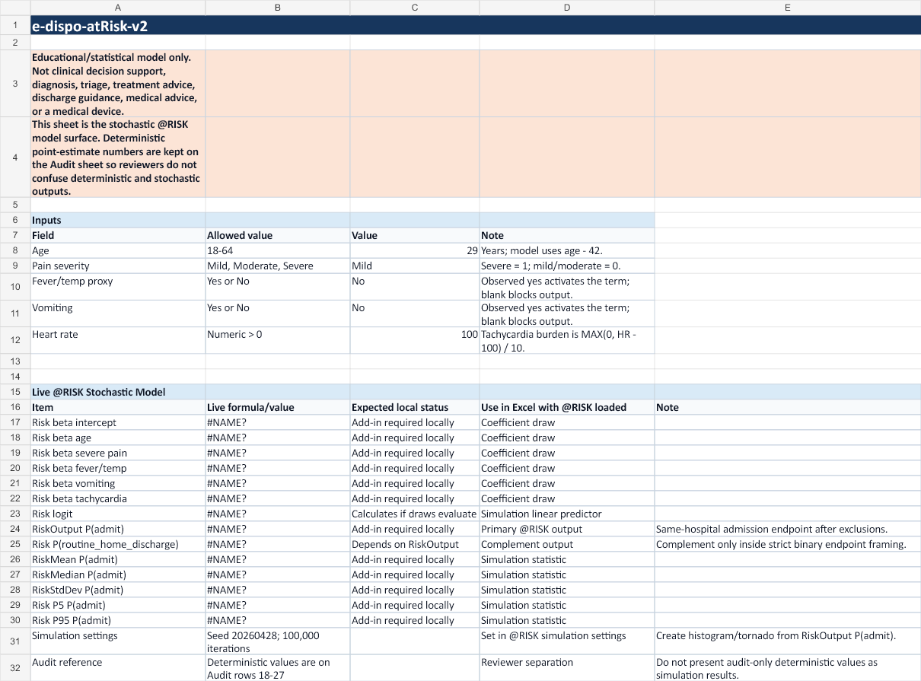
Main testing surface with inputs and live @RISK formulas.

Assumptions tab
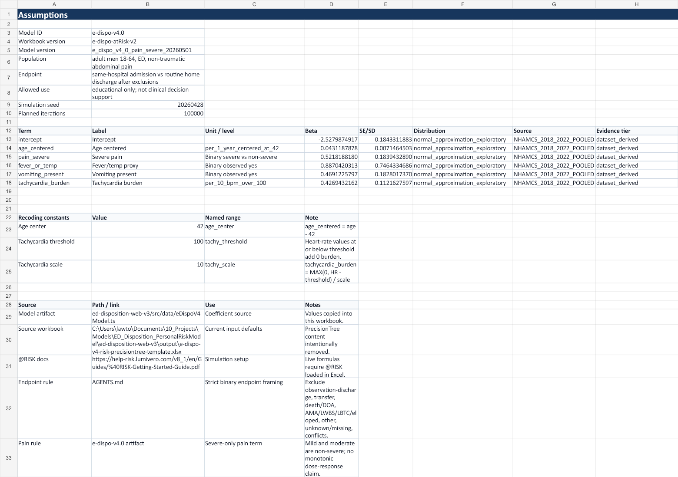
Reference tab with coefficients, source notes, and simulation assumptions.

Audit tab
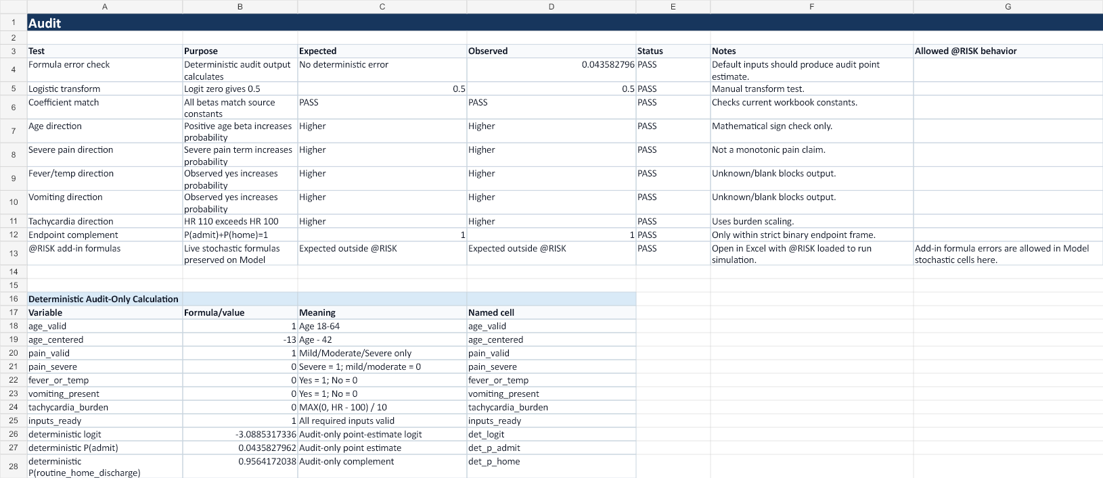
Technical check tab with deterministic audit-only calculations.

Source List
- docs/model-card.md
- docs/validation/validation-dossier-readme.md
- docs/validation/performance-report.md
- docs/validation/predictive-power-usability-review.md
- docs/validation/model-validation-handoff.md
- docs/validation/e-dispo-v4.0-pain-severe-decision.md
- docs/validation/probast-ai-risk-table.md
- docs/validation/deficiency-review-next-phase.md
- src/data/eDispoV4Model.ts
- outputs/nhamcs_pooled/e_dispo_v4_pain_severe_coefficients.csv
- outputs/nhamcs_pooled/e_dispo_v4_pain_severe_covariance.csv
- outputs/nhamcs_pooled/e_dispo_v4_pain_severe_draws.csv
- outputs/nhamcs_pooled/e_dispo_v4_pain_severe_calibration.csv
- outputs/nhamcs_pooled/e_dispo_v4_pain_severe_leave_one_year_out.csv
- output/e-dispo-atRisk-v2.xlsx

