Plain-Language Guide to the Excel @RISK Model
How to open, test, and understand e-dispo-atRisk-v2.xlsx
Item | Detail
Workbook | e-dispo-atRisk-v2.xlsx
Assumed software | Microsoft Excel with @RISK loaded
Model | e-dispo-v4.0
Use | Educational testing only, not patient care

Important: This is an educational/statistical workbook for testing and learning. It is not clinical decision support, diagnosis, triage, treatment advice, discharge guidance, medical advice, or a medical device.

Quick Start
Start here: Open the workbook in Excel with @RISK loaded, go to the Model sheet, edit the yellow input cells, run the @RISK simulation, and read the green output row for P(admit).

1. Open the workbook: Use Excel on a computer where @RISK is installed and active.
2. Use the Model sheet: This is the main testing surface. The Assumptions and Audit tabs are supporting material.
3. Enter a test case: Fill in age, pain severity, fever/temp proxy, vomiting, and heart rate.
4. Run @RISK: Use the documented settings: seed 20260428 and 100,000 iterations unless you intentionally choose a smaller trial run.
5. Read the result: Focus on P(admit), the histogram or distribution, and the 5th to 95th percentile range.

What This Workbook Is
The workbook estimates how a test case compares with a narrow group of emergency department visits in a historical national dataset.
The outcome is deliberately narrow: same-hospital admission versus routine ED discharge home after excluding unclear or different disposition types.
Plain meaning: P(admit) is the model's estimated probability for the same-hospital admission endpoint inside this restricted educational comparison. P(routine_home_discharge) is only the complement inside that same restricted frame.

What This Workbook Is Not
- It is not a tool for deciding what should happen to a patient.
- It is not a diagnosis, triage, treatment, discharge, or safety tool.
- It is not validated for use in a hospital or any real patient-care workflow.
- It is best used with invented examples or retrospective learning cases.

Who The Model Applies To
Question | Required answer
Age | Adult man age 18-64.
Setting | Already in the emergency department.
Reason for visit | Non-traumatic abdominal pain.
Outcome frame | Only compares same-hospital admission with routine ED discharge home after exclusions.
Required observed inputs | Pain severity and heart rate must be observed. Missing pain or missing heart rate should not be guessed.

Workbook Map
Tab | What your friend should do there
Model | Main testing tab. Enter inputs and run/read the @RISK model.
Assumptions | Reference tab. Shows the model ingredients, source notes, and simulation settings. Do not edit for normal testing.
Audit | Technical check tab. It keeps deterministic checks away from the stochastic model so the two are not confused.

Model sheet screenshot
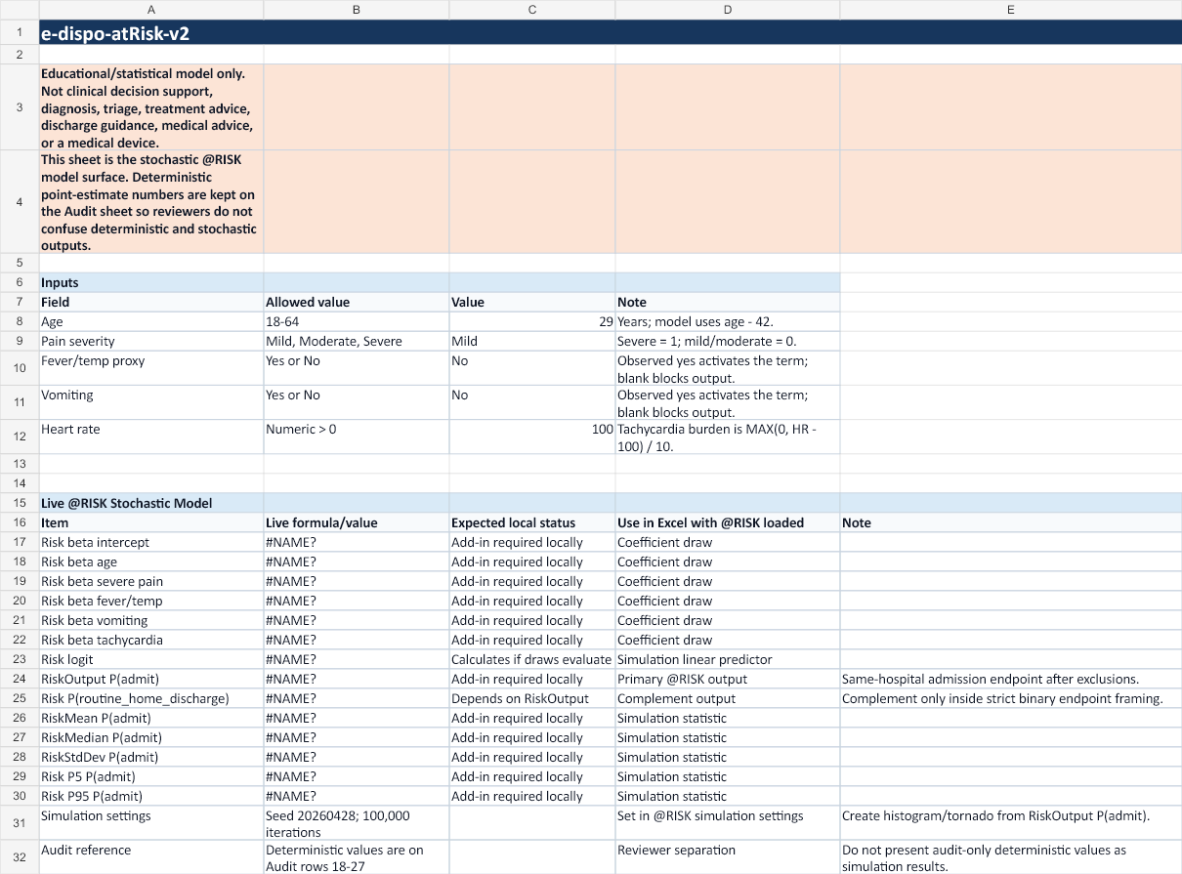
The Model sheet is where the user edits inputs and views the live @RISK output cells.

The Five Inputs
Input | What to enter | Plain-language meaning
Age | 18 to 64 | The model centers age around 42 internally. You only type the age.
Pain severity | Mild, Moderate, or Severe | Only Severe is treated as the severe-pain signal. Mild and Moderate are grouped as non-severe.
Fever/temp proxy | Yes or No | Use Yes only when fever or temperature proxy is observed.
Vomiting | Yes or No | Use Yes only when vomiting is observed.
Heart rate | Positive number | Heart rates at or below 100 add no tachycardia burden. Each 10 beats per minute above 100 adds one burden unit.

Pain note: The model does not say pain rises smoothly from mild to moderate to severe. It only uses severe versus not severe.

Step-By-Step Workbook Walkthrough
1. Open Excel with @RISK loaded: If @RISK is not loaded, the live model formulas may show #NAME? or #VALUE!. That is expected outside an @RISK Excel session.
2. Open e-dispo-atRisk-v2.xlsx: Use the file included in the friend package.
3. Go to the Model tab: This is the only tab needed for normal testing.
4. Edit the input cells: Enter the five values for an invented or retrospective test case.
5. Run the simulation: Use @RISK to run the simulation. The planned setting is 100,000 iterations with seed 20260428.
6. Read P(admit): This is the main @RISK output. Use the mean, median, and 5th to 95th percentile range to understand uncertainty.
7. Read the complement carefully: P(routine_home_discharge) is 1 minus P(admit), but only inside the strict two-outcome endpoint frame.
8. Record what happened: Use the testing log table at the end of this guide.

How To Read The @RISK Results
Output | How to explain it
Mean P(admit) | Average simulated estimate across many coefficient draws.
Median P(admit) | Middle simulated estimate. Half the simulated values are above it and half are below it.
Standard deviation | How spread out the simulated estimates are.
5th and 95th percentiles | A rough low-to-high range for the simulation output.
Histogram | A picture of where the simulated estimates cluster.
Tornado/sensitivity | A ranking of which uncertain model ingredients move the output most.

Do not overread: A higher number means the test case looks more like the historical admission group in this narrow dataset. It does not tell anyone what action to take.

Common Problems
What you see | Likely reason | What to do
#NAME? | @RISK is not loaded or Excel does not know the @RISK functions. | Open the workbook on a machine with @RISK loaded.
#VALUE! | A formula cannot calculate, often because @RISK is missing or an input is invalid. | Check @RISK first, then check that all inputs are valid.
Blank output | Required input is blank or out of scope. | Fill all five input fields with allowed values.
Unexpected deterministic number | You may be looking at the Audit tab. | Use the Model tab for the live stochastic model.
No histogram/tornado | Simulation outputs may not have been generated yet. | Run the @RISK simulation and create reports from RiskOutput P(admit).

Testing Log
Use this table for invented or retrospective test cases. Do not use it to record real-time patient-care decisions.
Case | Age | Pain | Fever | Vomit | HR | P admit | Notes

Limitations To Keep In Mind
- The model is educational/statistical only.
- It is based on pooled NHAMCS 2018-2022 derived artifacts, not live hospital data.
- It has moderate predictive signal, not strong patient-level performance.
- It has not been externally validated.
- It does not prove that the same estimates apply to another hospital, subgroup, or workflow.
- Missing pain and missing heart rate should not be guessed.
- Fever/temp and vomiting are proxy-supported predictors.
- The workbook uses independent normal coefficient draws for @RISK; full covariance simulation remains a review question.

Files In The Friend Package
File | Purpose
README_FIRST.txt | Start here. Short package instructions.
docs/e-dispo-atRisk-v2-layperson-guide.docx | This step-by-step guide.
docs/e-dispo-atRisk-v2-data-sources-appendix.docx | Plain-language source and data appendix.
workbook/e-dispo-atRisk-v2.xlsx | The Excel @RISK workbook to test.

