**Topic ：Hometown**

景色:

Stunning惊人的 gorgeous华丽的 picturesque风景如画的 idyllic田园诗般的 views/sceneries/For example,，XXX park, XXX lake……

is famous=renowned for its……

美食：

local delicacy当地美食 hotpot火锅 palatable非常好吃；

家乡人：

local people/residents居民/citizens市民/inhabitants居民 warm-hearted& hospitable热情好客的

Covid-19新冠 pandemic大流行病 willing to……would like to do……（当出现新冠流行病时，家乡人乐于做某事，去解释家乡人热情好客）

城市：

Big city vs small town; top-tier city顶级城市;1-tier;2-tier……

细节对比

public transport (traffic congestion交通拥堵、rush hour);

cost of living(relatively high/low、more pressure);

more/fewer education & medical resources;

opportunity for jobs/limited；

quality of air/water polluted;

表达喜欢的词语：like、be fond of、be into

**Topic ：use apps/in the future**

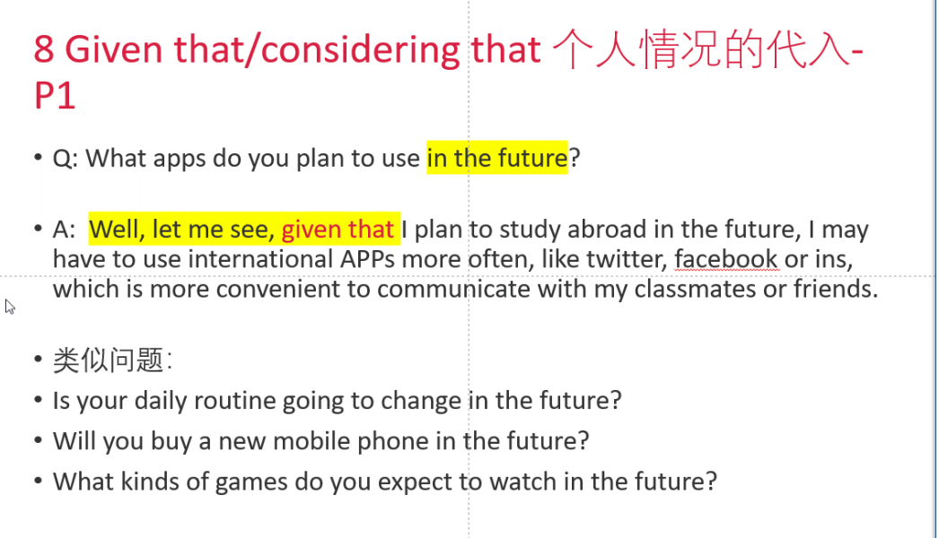

**Topic ：Do you work or are you a student?**

I am a freshman大一/sophomore大二/junior大三/senior student from lnnu，majoring主修/minoring辅修 in ……

选择主修/辅修学科原因：

it can give me a promising future;

it can be competitive after graduating with my major;