[**https://ttsreader.com/**](https://ttsreader.com/) **朗读网站**

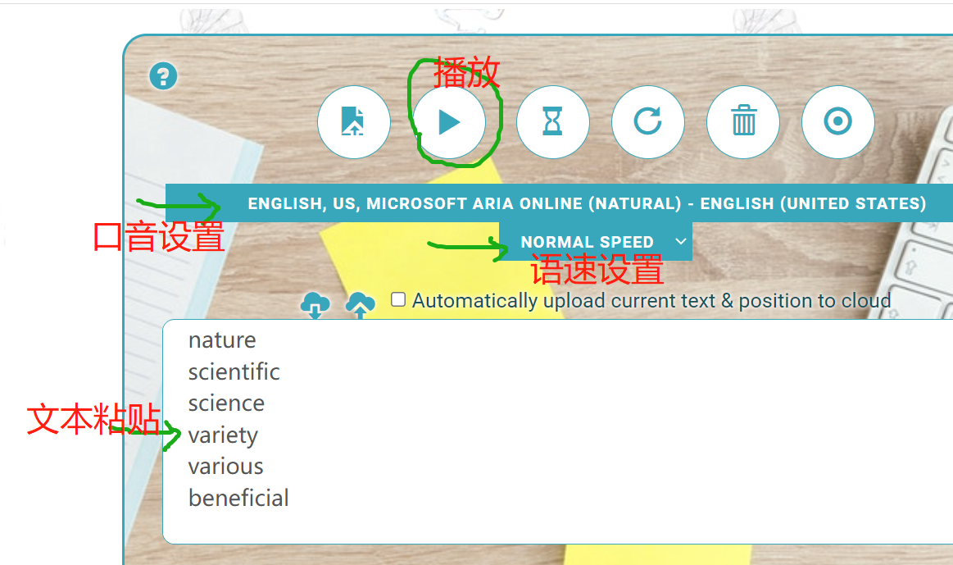

**真题地址汇总**

**69 Friendship Avenue**

**20 North Avenue**

**32 Bank Road**

**19 Gold Street**

**17 Broad Lane**

**95 Cross St**

**14 Hill Rd**

**20 Market Rd**

**17 Queens Avenue**

**40 Hope St**

**20 Eagle Rd**

**22 Oak St**

**16 Rose Garden**

**18 Riverside Road**

**20 Forrest Road**

**21 Blossom Street**

**15 Liberty Road**

**84 Liverpool Street**

**Circus Square**

**North Bay**

**Sunset Lounge**

**课上同根词**

**natural**

**nature**

**scientific**

**science**

**variety**

**various**

**beneficial**

**benefit**

**flexibility**

**flexible**

**maturity**

**mature**

**furnished**

**furniture**

**insured**

**insurance**

**spacious**

**space**

**analytically**

**analysis**

**analyze**

**strategic**

**strategy**

**parental**

**parent**

**atmospheric**

**atmosphere**

**allergic**

**allergy**

**theoretical**

**theory**

**statistical**

**statistics**

**domesticate**

**domestic**

**influential**

**influence**