Basavarajeswari group of institutions

BALLARI INSTITUTE OF TECHNOLOGY & MANAGEMENT

NACC Accredited Institution*


(Recognized by Govt. of Karnataka, approved by AICTE, New Delhi & Affiliated to Visvesvaraya Technological University, Belagavi)
"Jnana Gangotri" Campus, No.873/2, Ballari-Hospet Road, Allipur, Ballar1-583 104 (Karnataka) (India)
Ph: 08392 – 237100 / 237190, Fax: 08392 – 237197

DEPARTMENT OF CSE(DATA SCIENCE)

A Mini-Project Report On

“CHOCOLATE SALES ANALYSIS”

A report submitted in partial fulfillment of the requirements for the

DATA VISUALIZATION WITH POWER BI

Submitted By

Praveen Kumar USN: 3BR23CD068

Under the Guidance of Mr.Sundeep Sindhanoor
Asst. Professor
Dept of CSE (DATA SCIENCE),
BITM, Ballari



Visvesvaraya Technological University

Belagavi, Karnataka 2025-2026
BASAVARAJESWARI GROUP OF INSTITUTIONS

BALLARI INSTITUTE OF TECHNOLOGY & MANAGEMENT
NACC Accredited Institution*
(Recognized by Govt. of Karnataka, approved by AICTE, New Delhi & Affiliated to Visvesvaraya Technological University, Belagavi)
"Jnana Gangotri" Campus, No.873/2, Ballari- Hospet Road, Allipur , Ballari-583 104 (Karnataka) (India)
Ph: 08392 – 237100 / 237190, Fax: 08392 – 237197




DEPARTMENT OF CSE (DATA SCIENCE)
CERTIFICATE
This is to certify that the OPEN-ENDED PROJECT of DATA VISUALIZATION WITH POWER BI “Chocolate Sales Analysis” has been successfully presented by Praveen Kumar bearing USN 3BR23CD068 student of semester B.E for the partial fulfillment of the requirements for the award of Bachelor Degree in CSE(DS) of the BALLARI INSTITUTE OF TECHNOLOGY& MANAGEMENT, BALLARI during the academic year 2025-2026.

Signature of guide Signature of HOD

Mr. Sundeep Sindhanoor Dr. Aradhana D

The satisfactions that accompany the successful completion of our mini project on “Chocolate Sales Analysis” would be incomplete without the mention of people who made it possible, whose noble gesture, affection, guidance, encouragement and support crowned my efforts with success. It is our privilege to express our gratitude and respect to all those who inspired us in the completion of our mini-project. We are extremely grateful to our Guides Mr.Sundeep Sindhanoor for their noble gesture, support co-ordination and valuable suggestions given in completing the mini-project. We also thank Dr. Aradhana D, H.O.D. Department of CSE(DS), for his co-ordination and valuable suggestions given in completing the mini-project. We also thank the Principal, Management and non-teaching staff for their co-ordination and valuable suggestions given to us in completing the project.

NAME | USN
Praveen Kumar | 3BR23CD068

Table of Contents
Ch No | Chapter Name
1 | Introduction  - About the project  - Language used | 1  2
2 | Scope of the project  - Problem statement  - Objectives | 3
3 | System requirements  - Functional Requirements  - Non-Functional Requirements  - Hardware Requirements  - Software Requirements | 4-5
4 | Methodology  - Data Collection  - Data Preparation(Power Query)  - Data Visualization  - Filters and Interactivity  - Dashboard Design  - outcome | 6-8
5 | Implementation  - Dataset Description  - Data Loading  - Data Transformation(Power Query)  - Data Modelling  - DAX Measures(Key Calculations)  - Dashboard Visualization  - Filters / Slicers  - Dashboard Layout  - Integration  - Final output | 9-13
6 | Result | 14-16
 | Conclusion  References | 17  18

ABSTRACT

The “Chocolate Sales Analysis” project is designed to provide an interactive and insightful visualization of chocolate sales data using Power BI. The main objective of this project is to transform raw sales data into meaningful insights through dynamic dashboards, enabling users to analysis key business metrics such as total sales, profit, customer trends, product performance, and regional distribution.
The dashboard allows users to explore sales performance using various filters such as product category, region, and time period, helping in detailed and customized analysis. Key performance indicators (KPIs) like total revenue, total profit, and sales growth are displayed to give a quick overview of business performance. Visual elements such as bar charts, line graphs, and pie charts are used to highlight top-selling products, monthly sales trends, and category-wise distribution.
This analysis helps in identifying high-performing products, understanding customer purchasing behaviour, and detecting patterns in sales trends. It also assists businesses in making data-driven decisions related to inventory management, marketing strategies, and sales optimization.
Overall, the Chocolate Sales Analysis dashboard converts complex sales data into a simple, interactive, and visually appealing format, making it a valuable tool for business analysts, managers, and stakeholders to improve decision-making and enhance overall business performance.

CHAPTER 1
INTRODUCTION
1.1 About the Project
The analysis of sales data plays a crucial role in understanding business performance and improving decision-making in modern organizations. In the competitive food and retail industry, particularly in chocolate sales, it is essential to track customer preferences, product demand, and revenue trends to achieve business growth. The “Chocolate Sales Analysis” project is developed to provide a comprehensive and interactive solution for analysis chocolate sales data using Power BI.

This project focuses on transforming raw sales data into meaningful insights through visually appealing and interactive dashboards. The dataset includes important details such as product categories, sales amount, profit, customer information, region-wise sales, and time-based data. By organizing and analysis this data, the project helps in identifying key patterns such as best-selling products, high-revenue regions, and seasonal sales trends.

Using Power BI, the dashboard integrates various visualizations like bar charts, line graphs, pie charts, and KPI indicators to present data in an easy-to-understand format. It also provides filtering options that allow users to explore the data based on different parameters such as product type, location, and time period.

The main goal of this project is to simplify complex sales data and convert it into actionable insights. It helps business owners, analysts, and decision-makers to monitor performance, identify opportunities, and make informed decisions related to marketing strategies, inventory management, and overall business optimization.

1.2 Language Used

The core tools and technologies used in the Chocolate Sales Analysis project are:
- Power BI:
Used for data visualization and dashboard creation. It helps in converting raw chocolate sales data into interactive charts, graphs, and KPI indicators for better understanding of business performance.

- DAX (Data Analysis Expressions):
Used to create calculated measures such as total sales, total profit, average sales, and growth percentage. It enables advanced data analysis and comparison across different categories and time periods.

- M Language (Power Query):
Used for data cleaning and transformation. It helps in handling missing values, removing duplicates, and preparing the dataset for accurate analysis.

- CSV / Excel (Data Source):
The chocolate sales data is stored in CSV or Excel format, which is imported into Power BI for processing and visualization.

- These tools work together to efficiently collect, process, analyze, and visualize the data, resulting in an interactive and user-friendly sales dashboard.

2

CHAPTER 2

SCOPE OF THE PROJECT

Problem Statement

In the chocolate sales industry, businesses generate large amounts of data related to products, customers, regions, and sales transactions. However, this data is often unorganized and difficult to interpret, making it challenging for decision-makers to identify trends, measure performance, and improve sales strategies. Without proper analysis, it becomes difficult to understand which products perform well, which regions generate higher revenue, and how sales change over time.
To address this issue, the Chocolate Sales Analysis project aims to develop an interactive Power BI dashboard that converts raw sales data into meaningful insights. The dashboard helps users easily analysis key metrics such as total sales, profit, product performance, and regional distribution, enabling better understanding and faster decision-making.

Objectives
The main objectives of the project are:
- To analysis overall chocolate sales performance using interactive dashboards
- To identify top-selling products and high-revenue categories
- To track sales trends over time (monthly or yearly analysis)
- To analysis profit and revenue distribution across different regions
- To understand customer purchasing patterns and preferences
- To provide dynamic filtering options for detailed analysis (product, region, time)
- To support data-driven decision-making for improving sales and business strategies

CHAPTER 3

SYSTEM REQUIREMENTS

3.1 Functional Requirements
- Import chocolate sales data (sales, profit, product details, region, etc.) from CSV/Excel files into Power BI
- Perform data cleaning and transformation using Power Query (M Language)
- Provide interactive filters (slicers) such as product category, region, and date
- Calculate key metrics using DAX such as total sales, total profit, and average sales
- Create visualizations like bar charts, line charts, and pie charts to represent sales trends and performance
- Display Key Performance Indicators (KPIs) for quick insights
- Enable cross-filtering between visuals for dynamic analysis

3.2 Non-Functional Requirements
- Performance: Dashboard should load quickly and respond within a few seconds
- Usability: Interface should be simple, clear, and easy to understand
- Scalability: Should handle increasing data (more products, regions, or time periods)
- Maintainability: Easy to update data and modify reports
- Reliability: Should provide accurate and consistent results
- Security: Access should be restricted when deployed online

3.3 Hardware Requirements

- Operating System: Windows 10 / Windows 11
- Processor: Minimum 1.4 GHz (64-bit) or higher
- RAM: Minimum 4 GB (8 GB recommended)
- Storage: At least 2 GB free disk space

3.4 Software Requirements
- Microsoft Power BI Desktop – For data analysis and dashboard creation
- Microsoft Excel / CSV Files – For storing and managing chocolate sales data
- Power BI Service – For publishing and sharing dashboards
- Web Browser (Chrome / Edge) – For accessing reports online

CHAPTER 4

METHODOLOGY
The methodology of the Chocolate Sales Analysis project focuses on converting raw sales data into meaningful insights using Power BI. The process follows a structured approach that includes data collection, data preparation, data modeling, and data visualization to ensure accurate and effective analysis.
4.1 Data Collection
The dataset is collected in CSV/Excel format containing chocolate sales information
- It includes details such as:
- Product name and category
- Sales amount and profit
- Region/location of sales
- Date (month, year)
- This data serves as the foundation for analysis and dashboard creation

4.2 Data Preparation (Power Query)
Data is cleaned and transformed using Power Query

• Key steps include:
- Removing duplicate and null values
- Renaming columns for better understanding
- Changing data types (date, numeric values)
- Organizing the dataset for easy analysis
- This step ensures data accuracy and reliability
4.3 Data Visualization
Different types of visuals are created in Power BI to represent the data:
- KPI Cards → Show total sales, total profit, and overall performance
- Line Chart → Displays sales trends over time
- Bar Chart → Shows top-selling products and category-wise performance
- Pie/Donut Chart → Represents sales distribution by category or region
- These visuals help users quickly understand business performance

4.4 Filters and Interactivity
Interactive filters (slicers) are added for:
- Product category
- Region
- Time (month/year)
These allow users to explore data dynamically and perform customized analysis

4.5 Dashboard Design

The dashboard is designed in a structured layout:
  - Top Section → KPI indicators (Total Sales, Profit)
  - Center Section → Sales trend chart
  - Bottom Section → Product and regional performance charts
  - Side Panel → Filters (slicers)
This layout improves clarity and user experience

4.6 Outcome
- Development of an interactive dashboard for chocolate sales analysis
- Clear understanding of sales trends and product performance
- Easy identification of high-performing products and regions
- Better decision-making support for business growth
- Efficient and accurate data analysis using Power BI tools

CHAPTER 5

IMPLEMENTATION
The implementation phase focuses on converting raw chocolate sales data into meaningful insights using Power BI. This involves data loading, transformation, modeling, and dashboard creation.

5.1 Dataset Description
The dataset includes the following fields:
- Product Name – Name of chocolate product
- Category – Type of chocolate (dark, milk, etc.)
- Sales – Total sales amount
- Profit – Profit earned
- Region – Location of sales
- Date – Time-based data (month/year)
This dataset is imported into Power BI using CSV format.

5.2 Data Loading
- Data is imported into Power BI using Get Data (CSV/Excel)
- Dataset is verified for accuracy and completeness

5.3 Data Transformation (Power Query)
Using Power Query Editor, the dataset is cleaned and prepared:
- Removed missing and duplicate values
- Renamed columns for clarity
- Converted data types (date, numeric values)
- Structured data for better analysis

.5.4 Data Modeling
- A simple data model (single table) is used
- Relationships are managed within Power BI
- Time hierarchy (Year → Month) is created for trend analysis

5.5 DAX Measures (Key Calculations)
To generate insights, the following measures are created:
- Total Sales = SUM(Sales)
- Total Profit = SUM(Profit)
- Average Sales = AVERAGE(Sales)
- Profit Margin = DIVIDE(Profit, Sales)
These measures are used to generate insight

5.6 Dashboard Visualizations
Main Visuals
performance metrics across different trains.
- KPI Cards → Total Sales, Total Profit
- Line Chart → Sales trend over time
- Bar Chart → Top products
- Pie Chart → Category-wise sales

5.7 Filters / Slicers
- Product Category
- Region
- Date (Month/Year)
These filters enable dynamic analysis

5.8 Dashboard Layout
- Top → KPI cards
- Center → Trend charts
- Bottom → Product & regional analysis
- Side → Filters

5.9 Integration

All visuals are connected to one dataset

Filters update all charts dynamically

5.10 Final Output
- Interactive Power BI dashboard
- Clear visualization of sales performance
- Easy analysis of products, regions, and trends

CHAPTER 6

RESULT

The Chocolate Sales Analysis Dashboard successfully provides a clear and interactive view of chocolate sales performance. The dashboard displays important insights such as total sales, profit, product performance, and regional distribution.
The line chart helps in identifying sales trends over time, while bar charts highlight top-performing products. Pie charts show category-wise distribution, making it easier to understand market share. KPI cards provide a quick summary of key metrics.
Filters such as product category, region, and time allow users to explore data in detail. Overall, the dashboard helps in identifying trends, improving sales strategies, and making informed business decisions.

Fig 1 : Chocolate Sales Analysis

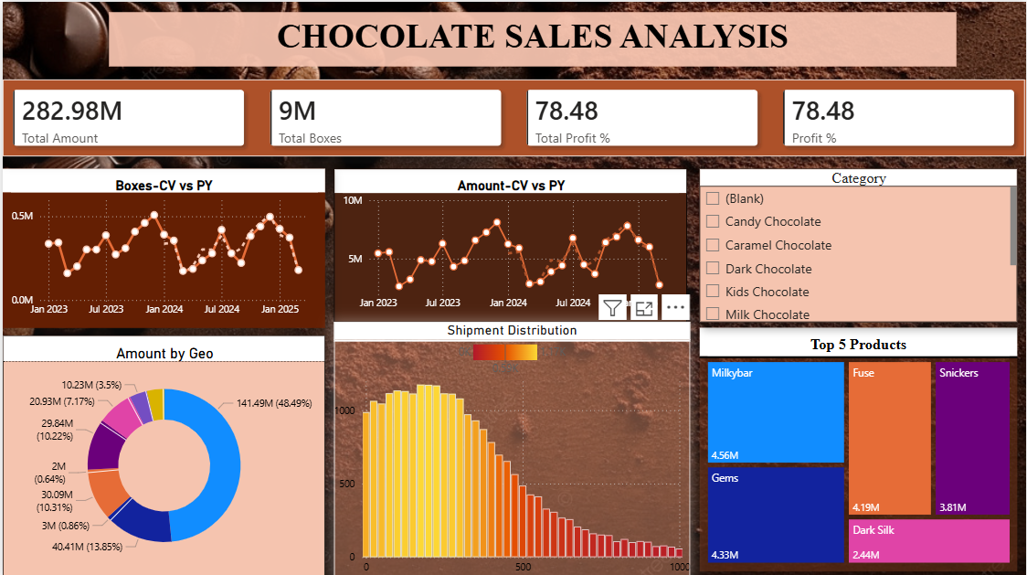

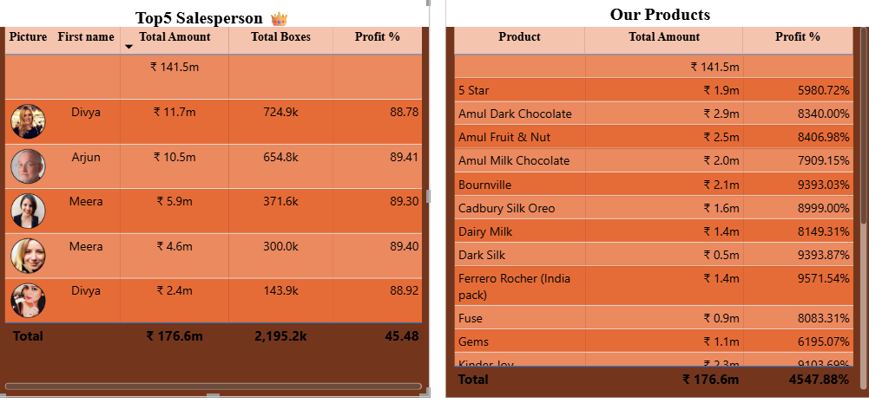

CONCLUSION
The Chocolate Sales Analysis project successfully demonstrates how raw sales data can be transformed into meaningful insights using Power BI. The interactive dashboard makes it easy to analysis sales trends, product performance, and regional distribution.
By using various visualizations and filters, the project enables better understanding of business performance and supports data-driven decision-making. It helps in identifying opportunities for growth, improving marketing strategies, and optimizing inventory management.
Overall, the project provides a simple, effective, and user-friendly solution for analysis chocolate sales and enhancing business efficiency.

REFERENCES

[1] Microsoft, Power BI Documentation, Microsoft Learn, 2024.
Available: https://learn.microsoft.com/en-us/power-bi/
[2] Microsoft, DAX (Data Analysis Expressions) Reference, Microsoft Learn, 2024.
Available: https://learn.microsoft.com/en-us/dax/
[3] Microsoft, Power Query Documentation, Microsoft Learn, 2024.
Available: https://learn.microsoft.com/en-us/power-query/
[4] Marco Russo and Alberto Ferrari,
The Definitive Guide to DAX: Business Intelligence with Microsoft Power BI, Microsoft Press, 2019.
[5] Alberto Ferrari,
Power BI Data Model with Microsoft Business Intelligence, Microsoft Press, 2023.
[6] Edward Tufte,
The Visual Display of Quantitative Information, Graphics Press, 2001.
[7] Chocolate Sales Dataset (CSV/Excel format) used for analysis of sales, profit, product categories, and regional performance in Power BI.

