Solar panels are basically diodes with n-type silicon on top and p-type silicon layer on bottom works.

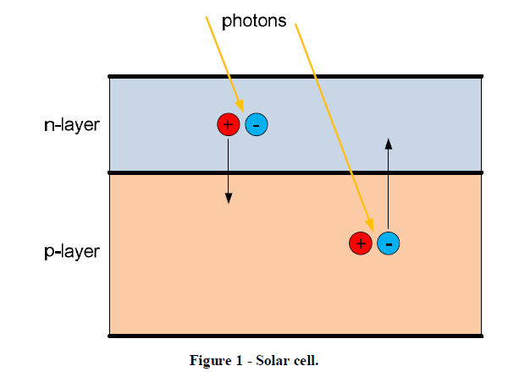

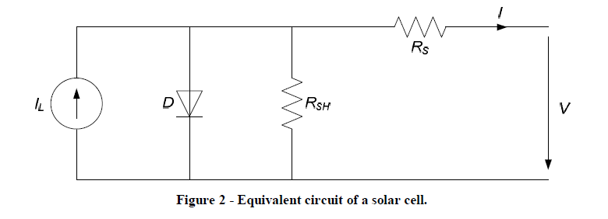This solar panel can modelled as circuit with a current emitter whose current is proportional to irradiance on it, a diode and some resistors to account for the losses from contacts in circuit (To understand the modelling a link is: -[https://www.youtube.com/watch?v=rjLd6eJYMsI&t=84s](https://www.youtube.com/watch?v=rjLd6eJYMsI&t=84s%20) ). Circuit and current law are given below: -

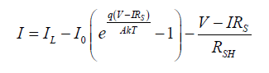

I-V characteristics of solar panels which can easily be visualised as the diode current has a negative sign and IL is constant with specific temperature and constant irradiance of solar panels. ISC is the current when the solar panels are short circuited VOC is the open circuit voltage of solar panels. This curve is at a constant temperature and irradiance of solar panels. The power extracted from solar panels is also plotted on the same graph with varying voltage or current, there is maxima for a particular Voltage VMPP and Current IMPP. The purpose of a MPPT is to track these voltage for a particular temperature and orientation of solar panels and operate on this voltage for gaining maximum power. The most common algorithms to track this voltage are listed below: -

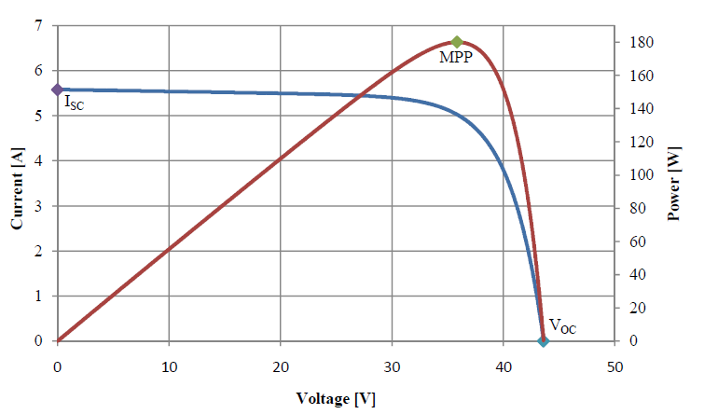

Hill Climbing technique: - Hill-climbing involves a perturbation on the duty cycle of the power converter and a perturbation in the operating voltage of the DC link between the solar panels and the power converter. Examples are Perturbation and observe and Incremental Conductance. Disadvantage is that the operating point oscillates about the MPP and algorithm takes time to be implemented so implementation in fast changing environment is not efficient. Also these algorithms cannot differentiate between if the power change is due to change in duty cycle or due to change in irradiation.

1. Perturbation and Observe (P&O): - A perturbation is made in the duty cycle and power obtained is observed (P=V*I) if power obtained is less than previously observed then the direction of perturbation is changed and vice-versa. This process is repeated until MPP is reached. PW-Sat2 used this technique for MPPT.
2. Incremental Conductance: - Uses the fact that the: - (del P)/(del V or I) is zero at MPP and have different signs around it, so perturbations are made accordingly. By comparing the increment of the power vs. the increment of the voltage (current) between two consecutives samples, the change in the MPP voltage can be determined.

Some solutions to drawbacks are also suggested: -

* Dp/P&O: - In this algorithm one reading of atmospheric things is also taken and then it is decided whether the change in power extracted is due to surroundings or due to the change in duty cycle.
* Another technique includes a stage in which the latest increment in the power is compared with the latest perturbation amplitude to determine if the power increment was due to a change in the irradiation. If this is the case, then the voltage perturbation is set to the same direction as the change in the power condition. The steady state error and the tracking speed are improved but it is not in use much.
* A solution is also that of variable duty cycle. If operating point is far away from MPP than large duty cycles are applied and vice-versa.

1. Fractional open circuit: - An approximate relation between VMPP and VOC is- VMPP = k*VOC where k is a constant depending on the characteristics of the PV array and it has to be determined beforehand by determining the VMPP and VOC for different levels of irradiation and different temperatures. After finding k VMPP can be found by constantly checking VOC. Drawbacks are power is lost when VOC is measured also MPP is not achieved as the equation is an approximation and the equation cannot be used when solar panel are partially irradiated. A solution for power loss is using a dummy Solar Panel array just to measure VOC. Same algorithm is devised for IMPP and ISC.
2. Current Sweep Method: - In this technique a sweep all over from ISC to zero current is made by variable perturbation and MPP is discovered. The sweep is made at continuous intervals. Advantage is that real MPP is discovered. Due to complexity involved it is not much in use. Can be used with other method to check at regular intervals to check whether the operating point is MPP or not.
3. Another simple method is to experiment with solar panels beforehand. On specific temperature what is MPP and applying it when temperature is reached.
4. A method used for AMSat: - A relation of VMPP is-

Where VMPP (T) is VMPP at temperature at solar panels are operating at. VMPP (Tref) is VMPP at reference temperature uvmpp is temperature coefficient which can be found in data sheet of solar panels. T is measured temperature of solar panels and Tref is reference temperature. This relation can be used to operate on VMPP.

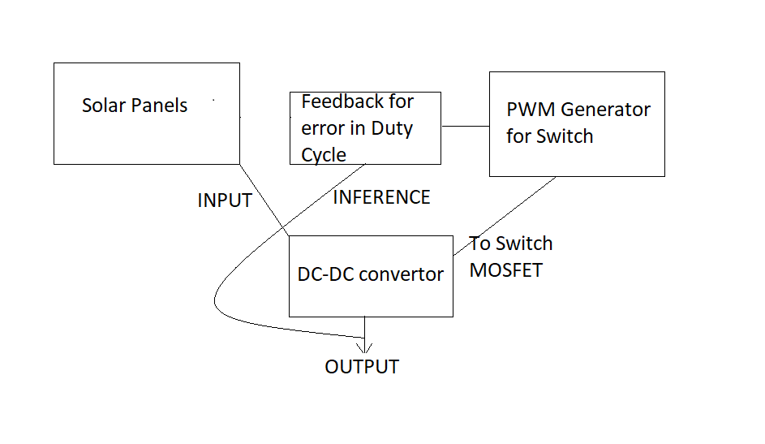Almost of the MPPT circuits are implemented with following building blocks in the circuit:-

I have successfully simulated the same block diagrams in Matlab-Simulink.

All the blocks will be easy to understand and relate to why they are in the diagram if we see the working of a DC-DC convertor:-

DC-Dc convertors are of two types:-

1. Buck convertor (Voltage Step down)
2. Buck-Boost (Voltage Step Up)

Understanding anyone of them will be enough. As in Pratham’s case we had a Panel voltage of 11.11V and working components under it so, Buck convertor will be fine.

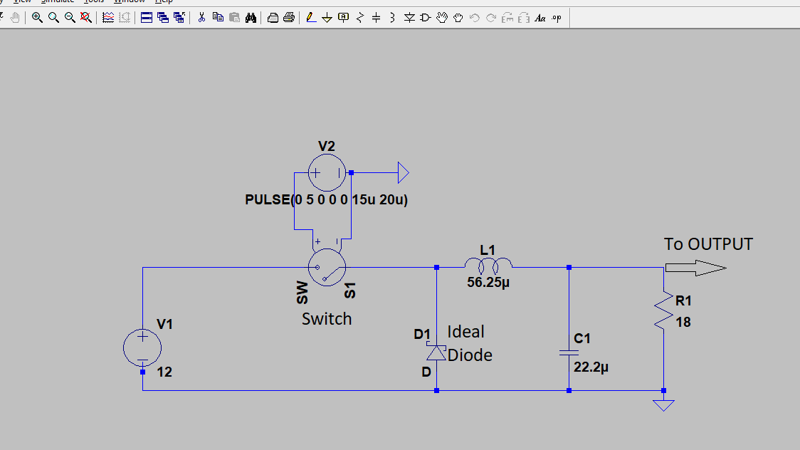This is a LT-Spice Model for a Buck convertor that converts 12V to 9V.

Now the respective blocks in this converter in our case will be:-

The 12V supply will be our PV module. Switch a MOSFET and the Voltage source that switches it on and off will be our PWM generator. The basic idea of MPPT will be to convert and operate the output from Buck convertor at Maximum Power Point of the I-V characteristics at that particular time of the Solar Panel Module. For understanding buck convertor [https://youtube.com/watch?v=OxlQhyAn9JE](https://youtube.com/watch?v=OxlQhyAn9JE%20) videos from NPTEL can be seen).

Now the circuit for Maximum Power Point Tracking can be implemented by two methods: -

1. An analog circuit that will consist of specifically selected ICs and components (that are very hard). That will do their respective task of PWM generation and correcting the Duty Cycle of MOSFET every time the Irradiation and Temperature of PV modules changes. The Cons of this circuit can be the circuit can be big enough as we have to implement it for four sides of our satellite and also the relevant components are very hard to find.
2. A digital circuit that will have a microcontroller that will change the duty cycle as per the power generated on the output end of buck convertor. The con of this circuit can be the frequency of PWM generated is less as compared to ICs specifically designed for PWM generation and pro can be as the MPPT circuit is to be implemented for every side of our satellite so using one microcontroller we can control the duty cycle of every Buck convertor.

Another way that is taken by most of the student satellites is just buying a MPPT circuit available as is in the market according to the voltage needs.

At the starting stage of Pratham MPPT was one of the circuit that was going to be there and a considerable work was done on it but for reasons unknown it was discarded. I have studied the IC based circuit that is given in the POWER CDR (2008) and was simulated in LT-Spice but when implemented on PCB unfortunately it was not working also I have simulated the same circuit in LT-Spice.

The difficulties I am facing right now is that I am unable to find components as per our needs in circuit.