# Pre-season Management Information: Timing and Diversion Rate Forecasts

Report Prepared by: J.A. Gill, M.J. Hague and A. Phung

Last updated April 2021

## Summary

Fisheries and Oceans Canada (DFO) provides the Pacific Salmon Commission with annual forecasts of the migration timing, and migration route around Vancouver Island in accordance with the Pacific Salmon Treaty. These forecasts are based on a series of different statistical models that include various environmental covariates. These models are evaluated retrospectively to assess the bias and precision of the forecast. The results of the top performing models are reduced to single forecasts by bootstrap sampling from the probability distributions of the different model forecasts. The uncertainty around the forecast is presented by reporting the 95% probability interval in addition to the median. The resulting preseason forecasts of timing and migration routes are important for pre-season expectations of abundance and planning of fisheries (Chapter A6) and serve as informative prior probability distribution inputs into the in-season stock assessment models (Chapter B19). DFO provides timing forecasts for Early Stuart and Chilko stocks, while diversion rates are produced for the aggregate Fraser River sockeye run. Work to increase the stock resolution of the timing and diversion rate forecasts is ongoing.

## Introduction

Fisheries and Oceans Canada (DFO) produces annual forecasts of the marine migration timing and migration route around Vancouver Island as part of their obligations under the Pacific Salmon Treaty (PSC 2019, Chapter 4, Folkes et al. 2018). Marine timing for Fraser River sockeye is defined as the date when 50% of a stock has passed through the marine areas on route to their natal freshwater stream for spawning (Folkes et al. 2017, Figure 1). It is common to use the DFO statistical area 20 (Area 20) in Juan de Fuca Strait as the reference location for the marine timing (Chapter B18). The Area 20 timing then refers to the date when 50% of a stock has passed Area 20 assuming the entire run migrated through Juan de Fuca Strait. The use of the Area 20 as a refence point for timing is largely due to the fact that IPFSC historically used catch data collected from the southern migration route to derive marine migration timing (Folkes et al. 2018). DFO only produces timing forecasts for the Early Stuart and Chilko stocks. PSC staff uses the correlations between timing estimates or the timing offsets between stocks to derive timing forecast of the other Fraser River sockeye stocks. The diversion rate refers the route an individual salmon might take to return to the Fraser River to spawn (Folkes et al. 2018). More specifically, the (northern) diversion rate indicates the proportion of the salmon that migrates through Johnstone Strait (northern approach) as opposed to Juan de Fuca Strait (southern approach, Figure 2). Estimates may reflect the diversion over a week or a few days or across the entire migration season. Diversion rates have traditionally been derived for the total Fraser River sockeye aggregate but could also be derived for individual stocks or management groups. The forecasts of timing and diversion rate can be combined with the pre-season run size forecasts and historical estimates of the length of the returning run (spread) to derive forecasts of daily abundances migrating through Juan de Fuca and Johnstone Strait.



Figure 1. Example of the method used to estimate marine timing, based on reconstructed abundance data. The marine timing is the date when the cumulative daily abundance exceeds 50% of the total abundance (horizontal dashed line) and is denoted by the vertical arrow (adapted from Folkes et al. 2018).

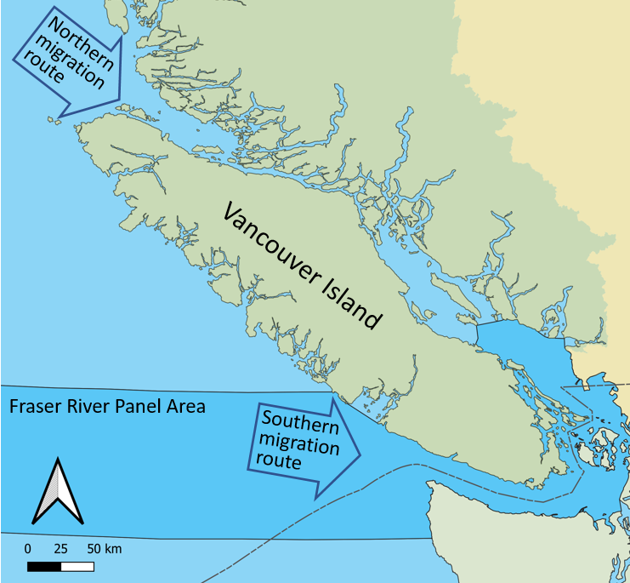

Figure 2. Southern B.C. coast map depicting the two routes taken by adult Fraser sockeye when returning to the Fraser River. The proportion of total run returning via the northern route is considered the diversion rate.

## Data

Annual estimates of marine migration timing for Early Stuart and Chilko are derived from post-season daily reconstruction abundances estimates (Chapter B18) based on daily hydroacoutic estimates obtained at Mission (Chapter B10) plus seaward catches. The timing is defined as the date when the cumulative abundance of these stock exceeds 50% of the total run size. Annual post-season estimates of northern diversion rate of the aggregate Fraser River sockeye population are estimated by dividing the total abundance migrating through the northern (Johnstone Strait) approach by the total abundance. (Folkes et al. 2018). Prior to 1995, estimates of diversion rate were based on commercial fishery catches along both migration routes (Folkes et al. 2018). Commercial catches of Fraser River sockeye started declining after 1995. Therefore, recent estimates of diversion are based on catch per unit effort (CPUE) data from test fisheries operating in Juan de Fuca and Johnstone Straits (Putman et al. 2014).

In addition to relying on historical estimates of migration timing and diversion rate, the methods to forecast these estimates also rely on environmental data that are assumed to impact timing and diversion. The full suite of environmental data used in Folkes et al. (2018) include three El Niño indices (Oceanic Niño Index (ONI), Southern Oscillation Index (SOI), and the Bivariate ENSO Timeseries (BEST)), Fraser River discharge, relative sea level, sea surface temperature (in the open ocean and near-shore), sea surface salinity, wind stress, ocean current velocity (from both the NEPSTAR (North East Pacific Salmon Tracking and Research) ocean model and the OSCAR (Ocean Surface Current Analysis Real-time) data series), and earth magnetic field estimates (intensity and inclination, Table 1).

Table 1. Environmental variables used as predictors of Fraser River sockeye salmon marine timing and northern diversion rate (adapted from Folkes et al. 2018).



## Method

A set of different models are used to produce the timing and diversion rate forecast (Table 2). These models range from naïve models that rely on historical data to linear regression models, generalized additive models (GAM) and shape constrained additive models (SCAM) that include environmental covariates (Table 1) at different levels of resolution (Folkes et al. 2017, Folkes et al. 2018). Using jack-knife and retrospective analyses, models are ranked annually against five performance measures to determine their ability to provide precise and unbiased predictions: mean raw error, absolute mean raw error, absolute mean error, mean square error, root mean squared error. The models to derive the forecasts are selected based on user tolerance of model uncertainty (Folkes et al. 2018). The results of the various models are reduced to a single forecast by bootstrap sampling from the probability distributions of the different model forecasts. The uncertainty around the forecast is presented by reporting the 50% and 95% probability intervals in addition to the median.

Table 2. The statistical models used to forecast migration timing or diversion rate (from Folkes et al. 2018).



Forecasts in each year are dependent on the performance of individual models and the available data. From an assessment point of view, there are three time periods for which forecasts are required: preliminary planning in February and April, updated planning in June and in-season assessments in July and August. At the time of the preseason planning in February, the forecast of timing and diversion rates are usually based on naïve models that account for differences between cycle line years. Models that include environmental covariates are only used in June as environmental data collected closer to the season has a better ability to predict timing and diversion. In-season these forecasts will be used as informative prior probability distributions within the in-season stock assessment models.

DFO only produces timing estimates for Early Stuart and Chilko. PSC staff uses the correlations between timing estimates or the timing offsets between stocks to produce timing forecast for the remainder of the stock groups modelled preseason and in-season. The Retrospective Evaluation Framework (REF) tool was created to standardize how decisions on pre-season migration timing are made. The REF tool allows PSC staff to retrospectively evaluate methods to obtain migration timing estimates across different stocks and cycle lines.

## Results

Timing forecasts are provided by DFO for both Early Stuart and Chilko stocks. Table 3 is an example of these forecasts for Chilko (Folkes et al. 2019a). The table lists the seven models that ranked highest in terms of model performance: four were naïve models including two auto regressive integrated moving average (ARIMA) models and three were multivariate models with environmental covariates. The forecast models are described in terms of the year and month in which the environmental data was collected that they rely on to produce the forecast, e.g. March [3] of the previous year [-1] or June [6] of the current year [0]. For covariates that are model derived, the description will also include details of the data used such as northward current velocity [v], eastward current velocity [u] and wind stress [n]. The last row of the table contains the bootstrapping results that combines the forecasts from the different models. The forecast is presented in terms of the median and the 50 and 95% probability intervals (PI). In this example the median timing forecast for Chilko is August 10 and the 95% probability interval ranges from August 1 to August 19, meaning that there is a 5% chance the actual migration timing will fall outside this range. The table to describe the diversion rate forecast (Table4) is similar to the timing forecast. In this case, one naïve model and six multivariate models were used to produce the forecast (Folkes et al. 2019b). When converting the annual Fraser River sockeye diversion rate forecast into daily estimates, it is important to take into account the general trend towards increased northern diversion as the season progresses (Figure 3).

Table 3. Chilko sockeye timing forecast. The columns Year Shift and Month indicate when the environmental data were collected in relation to the forecast year. The Data Type indicate the type of environmental data used within the forecast model. The final row is the bootstrap combination of the different forecasts (adapted from Folkes et al. 2018).



Table 4. Fraser sockeye diversion model forecasts. The columns Year Shift and Month indicate when the environmental data were collected in relation to the forecast year. The Data Type indicate the type of environmental data used within the forecast model. The final row is the bootstrap combination of the different forecasts (adapted from Folkes et al. 2018).





Figure 3. Pre-season forecasts of the annual northern diversion rate (DR) for Fraser River sockeye salmon (green dotted line), compared to in-season estimates of daily and annual rates.

## Planned Changes and Potential Areas for Improvement

Daily reconstructed abundance estimates are used to derive migration timing and diversion rate estimates. Historical reconstruction files however vary in stock-resolution, file structure, and data assumptions, leading to inconsistencies in stock specific timing and diversion rate estimates across years. Therefore, the historical reconstruction file system will be reworked with the aim to standardize file assumptions, increase the stock and spatial resolution of reconstructed abundances, and populate a run reconstruction database. Upon completion, it will be possible to query the resulting database to obtain improved yearly timing estimates at varying stock resolution as well as obtain annual and in-season diversion rate estimates at different stock resolution. The newly developed REF tool (Retrospective Evaluation Framework) will be used to analyze, validate and document differences in historical versus updated timing and diversion rate estimates.

## References

Folkes M., Thompson, R., and Hourston, R. 2019a. Forecast of Chilko sockeye marine timing for 2019. DFO, Nanaimo.

Folkes M., Thompson, R., and Hourston, R. 2019b. Forecast of Fraser sockeye diversion rate for 2019. DFO, Nanaimo.

Folkes, M.J.P, Thomson, R.E., and Hourston, R.A.S. 2017. Evaluating models to forecast salmon dynamics. NPAFC Doc. 1717. 11pp. Fisheries and Oceans Canada, Pacific Biological Station, and Fisheries and Oceans Canada, Institute of Ocean Sciences.

Folkes, M.J.P, Thomson, R.E., and Hourston, R.A.S. 2018. Evaluating models to forecast return timing and diversion rate of Fraser sockeye salmon. DFO Can. Sci. Advis. Sec. Res. Doc. 2017/021.

Pacific Salmon Commission. 2019. Treaty between the government of Canada and the government of the United States of America concerning Pacific salmon. Pacific Salmon Commission.

Putman, N.F., Jenkins, E.S., Michielsens, C.G.J. and Noakes, D.L.G. 2014. Geomagnetic imprinting predicts spatio-temporal variation in homing migration of pink and sockeye salmon. J. R. Soc. Interface 11: 20140542.

Wickett, W.P. 1977. Relationship of coastal oceanographic factors to the migration of Fraser River sockeye salmon (*Oncorhynchus nerka* W.). ICES CM M: 26: 18.