# Reconstructed Daily Abundances: In-season marine reconstructions

Report prepared by: M.J. Hague and C.G.J. Michielsens

Last updated Nov 2021

## Summary

Run reconstructions are a key tool for fisheries stock assessment and allow biologists to combine catch and escapement data to estimate daily abundances and annual run size. The Pacific Salmon Commission (PSC) is responsible for developing and applying run reconstruction models for Fraser River sockeye salmon as well as disseminating and archiving the resulting estimates. In-season reconstructions are applied both forward and backwards. Forward reconstructions predict stock-specific escapement into the river based on marine daily abundances derived from stock-specific catch-per-unit-effort (CPUE) data from marine test fisheries (Chapter B2) combined with assumptions about migration speed and delay behaviour. Backward reconstructions add stock-specific daily estimates of marine and lower river catches to stock-specific daily escapement estimates (Chapter B10) to reconstruct the total daily abundance in marine areas. The estimates are used to derive time series of marine timing, migration spread and diversion rate. Backward reconstructions also allow to update in-season test fishing catchability estimates (Chapter B4). The following report describes the basic structure and underlying assumptions of the reconstruction model, and the time series it generates.

## Introduction

Management of Fraser River sockeye salmon fundamentally relies on accurate estimates of run size (for deriving the amount of total allowable catch (TAC)), and migration behavior (to determine how to access the TAC). As part of the Pacific Salmon Treaty (PST) agreements (PST 2020, Chapter 4, paragraph 13(a)), Commission staff are responsible for providing in-season updates to Fraser River sockeye salmon run size, timing, and diversion rate.

Run reconstructions have been a key tool for salmon fisheries management for over 80 years; their application first thoroughly described by Starr and Hilborn (1988). PSC Secretariat Staff are responsible for developing and applying run reconstruction models for Fraser River sockeye (Cave and Gazey 1994) and archiving their results. Within these reconstruction models, stock-specific daily marine and lower river catches are added to stock-specific daily escapement estimates obtained by the PSC Mission hydro-acoustic facility (Conrad et al. 2019) to reconstruct daily abundances as the salmon run as it approaches the marine areas around Vancouver Island. In-season, daily reconstructed abundances are used to provide the best in-season estimate of run-size, timing, and diversion for Fraser River sockeye populations, either directly from the reconstructed abundance or when used within in-season assessment models (Michielsens and Cave 2018), project abundances of fish expected to be available to different fisheries, and update test fishery catchability estimates (Chapter B4).

After the fishing season concludes, reconstructions are used to update several time series of sockeye migration behaviour, including marine timing (date when 50% of a run has passed through marine areas), northern diversion (percent of a run migrating through Johnstone Strait), spread (number of days comprising 95% of the marine migration), and delay (days holding off the mouth of the Fraser River in the Straight of Georgia). In addition, Canada relies on historical time series of run size, timing, and diversion to generate pre-season forecasts (Chapters A1 and A2) which are critical inputs for pre-season planning and simulations (Cave and Gazey 1994; Chapter A6 and A7) and are also used as informative priors in Bayesian in-season run size models (Michielsens and Cave 2018, Chapter B19). In addition, historical run reconstructions are used in retrospective evaluations of fishery harvest rates (PSC 1995) and to develop decision rules for updating in-season test fishery catchability coefficients (Chapter B4).

## Data

The key data used to reconstruct daily marine abundances along the Johnstone Strait and Juan de Fuca route are: test fishery catch-per-unit-effort (CPUE) data (Chapter B2), test fishery catchability (Chapter B4), landed catches, Mission daily abundances (Chapter B10) and stock identification (Chapter B9). To populate the reconstruction model, information is also required regarding migration distances between fishery areas and the river, as well as assumed migration rates (Hague et al. 2019). Summer run sockeye are assumed to migrate a distance of 257km in 6-days, corresponding to an average daily migration rate of 43km/day between the Area 20 purse seine test fishing location and the Mission hydroacoustic site. Late-timed sockeye are assumed to take an average of 8-days, covering 32km/day, to make the same journey.

## Methods

The box-car run reconstruction model assumes salmon move in groups, i.e., box-cars, from the marine areas to the Fraser River through a series of fisheries that will impact the number of salmon in a group (Cave and Gazey 1996). The assessment of Fraser River sockeye relies on two different reconstruction approaches: backward reconstruction and forward reconstruction, and both are used to assess Fraser River sockeye salmon (Figure 1).

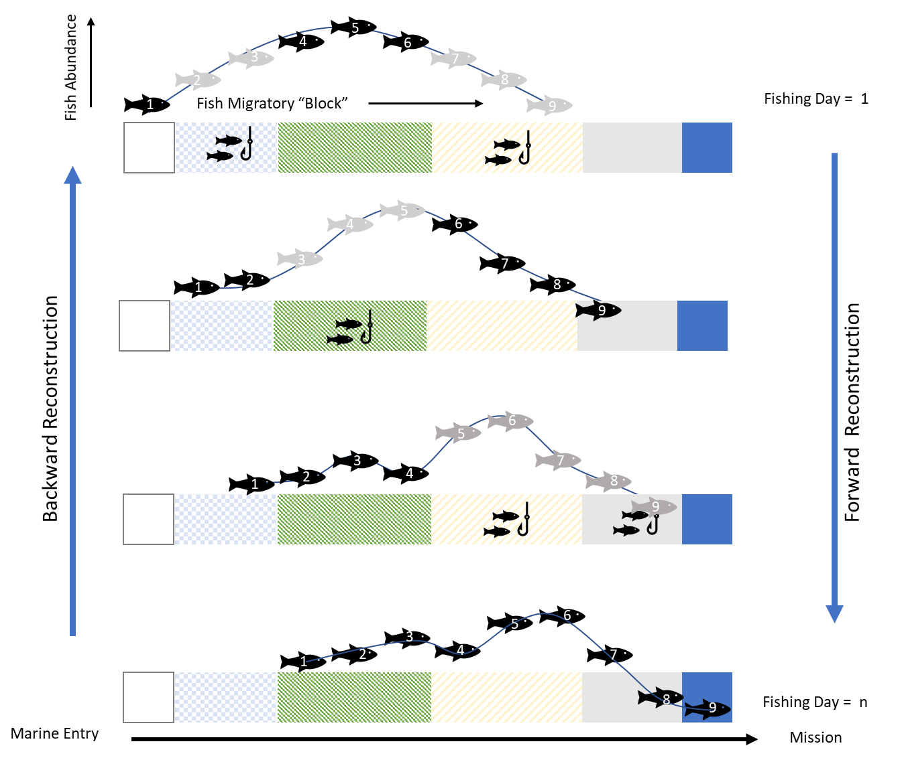

**Figure 1** Schematic illustration of a basic box-car run reconstruction model. The colored bars represent different statistical fishing areas, with the left most square representing the most seaward location. Each “fish/hook” represents one day of fishing. Each fish represents one daily block of fish. Black fish in each panel are not exposed to a fishery opening on a given day, while grey fish are. Each panel represents a daily time-step. The top panel represents the shape of the unfished run prior to entering marine approach fisheries. The bottom panel represents the shape of the run at Mission, with certain days of abundance reduced due to catch removals.

The backwards box-car reconstruction is used to estimate total daily marine abundances by adding seaward catches (*C*) onto daily abundance estimates (*N*) at Mission. To simplify the reconstruction, dates (*d*) associated with the daily catch report (the catch date) from each fishery (*f*) in each statistical area (*A*) and the daily abundance data at Mission (the upstream migration date) are adjusted to the date associated with a geographical reference point. For the reconstruction and assessment of Fraser River sockeye salmon the reference point used is the site of the Area 20 purse seine test fishery located at the seaward entrance of Juan de Fuca Strait. The dates associated with the data from other areas are adjusted based on the amount of time (rounded to the day) it takes for sockeye to migrate to these areas from the reference point. Assuming it takes 6 days for Summer run sockeye to migrate between Area 20 (*A20*) and Mission (*AMission*) implies a 6 day offset (*oA20, Mission*) that would result in the Area 20 date (*dA20*) associated with abundance estimates at Mission (*NMissio*n) to be 6 days earlier than the actual date:

1. $N_{d_{A20},A_{Mission}}=N_{\left(d-o_{A20,Mission}\right),A_{Mission}}=N_{\left(d-6\right),A_{Mission}}$.

The same assumptions about migration speeds and associated offsets are also made for the sockeye migrating through Johnstone Strait. For example, it takes about 7 days to migrate from the Area 12 purse seine test fishing site to Mission, resulting in an offset of -1, making the corresponding Area 20 date for catches caught by purse seine test fishery (*fPS,TF*) in the Area 12 (*A1*2) one day later than the actual date:

1. $C_{d_{A20},f_{PS,TF},A_{12}}=C_{\left(d-o_{A20,A12}\right),{f_{PS,TF},A}_{12}}=C_{\left(d+1\right),f_{PS,TF},A_{12}}$.

The following description assumes that all the dates associated with the data have already been adjusted to the correspond to the Area 20 reference date. Also, the reconstruction is implemented for individual stocks (*s*) but this has been omitted from the descriptions to simplify the equations. Information on the application of stock ID within the reconstructions can be found in Chapter B17.

In addition to adjusting all dates to a common reference date, reported catch data that may include catches across several ‘blocks’ of fish (due to the large size of the statistical area for which they are reported) are spread across *n* migration days depending on the fishery and the statistical area so that the sum of the catch proportions (*pn*) equals the total catch reported:

1. $C_{d_{20},f,A}={\sum_{1}^{n}{p_{n}∙}C}_{d_{20}-n+1,f,A}$.

For the actual backward reconstruction, all the daily seaward catches along both approach routes are added to the daily Mission passage estimates to reconstruct the total daily abundance ($N_{d_{A20}}$) at the entry of the marine fishing areas:

1. $N_{d_{A20}}=N_{d_{A20},A_{Mission}}+\sum{C_{d_{A20},f,A}}$.

In-season, forward reconstructions are used that remove the daily catches between the marine area and Mission from the daily marine abundance estimates to predict daily abundances at Mission.

1. $N_{d_{A20,A_{Mission}}}=N_{d_{A20}}-\sum{C_{d_{A20},f,A}}$.

In this case, the daily marine reconstruction estimates are based on test fishery CPUE data (Chapter B2), used in combination with catchability estimates (Chapter B4). CPUE-based marine abundances and the derived Mission abundances are important in-season as they provide an early indication of abundances prior to fish arriving at Mission. Both gillnet and purse seine CPUE data are relied upon in-season. Each day, the marine reconstruction model allows stock assessment biologists to select which test fisheries to rely upon as well as to average estimates when data from more than one test fishery are available for a particular area. Within the reconstruction files, marine test fishery CPUE data are also combined with reconstructed abundances from Mission to provide in-season updated catchability estimates (Chapter B4). This further allows the selection of catchability estimates for the different test fisheries in the reconstruction, i.e. rely on historical pre-season expansion lines or a variety of different in-season and adjusted in-season expansion lines depending on the available test fishery data.

**Derived time series**

Both forward and backward reconstructions are essential to derive additional time series of diversion through Johnstone Strait, the proportion of Late run delaying its upstream migration, the timing of the run and the spread.

The daily (northern) diversion rate estimates, i.e. the proportion of the total daily estimate migrating through Johnstone Strait, are based on CPUE data from test fisheries operating in Juan de Fuca and Johnstone Straits (Putman et al. 2014).

The reconstruction is also used to derive daily estimates of delaying Late run and Harrison stocks (Lapointe et al. 2003). Delaying Fraser River sockeye stocks are defined as holding in the Strait of Georgia for an extended number of days (or weeks) prior to redistributing and migrating upstream, resulting in a roughly bi-model distribution. Instead of using Mission passage to update test fishing catchability estimates for delaying stocks, the difference between marine abundances and upstream escapement is used to estimate the number of salmon delaying their upstream migration. The quality of these predictions will depend on the quality of the CPUE-based daily abundance estimates. Post-season, the estimates of delay can be improved by rescaling the CPUE-based abundances so that the total of CPUE-based daily abundances equals the total post-season run size, i.e. the sum of the total reconstructed daily abundance estimates at Mission plus seaward catch. It should be noted that in the case of delaying stocks, it is not possible to run the backward reconstruction as the box-car movement assumption is broken and the Mission escapement and catches cannot be aligned with seaward abundances.

The reconstructed daily abundance time series are also used to derive estimates of timing and spread. The marine migration date, also referred to as the Area 20 date or marine 50% date, indicate the date when half (50%) of the run would have passed through Area 20 assuming all fish migrated via that route. The spread is defined as the number of days of migration comprising 95% of the run.

These historical time series are used in forecasting models (Chapter A2) that set pre-season expectations, allow for the prediction of fisheries impacts (Chapter A6 and A9) and serve as informative prior probability distribution inputs into the in-season stock assessment models (Michielsens and Cave 2019, Chapter B19).

## Potential Areas for Improvement

More complex post-season reconstruction files are already in development, with increased stock resolution, improved flexibility and transparency in migration assumptions, and the ability to reconstruct abundance time series to multiple locations of interest (Hague et al. 2019). The post-season files also incorporate additional information and a more complex series of decision rules to derive marine abundances used in forward reconstructions and for delaying stock groups. While several of these improvements are only possible post-season, the ability to reconstruct time series to key index locations would improve the capacity for evaluating route-specific catches and abundances as well as generate projections of species and stock-specific encounter rates in-season.

## References

Cave, J.D. and W.J. Gazey. 1994. A preseason simulation model for fisheries on Fraser River sockeye salmon (*Oncorhynchus nerka*). Can. J. Fish. Aquat. Sci. 51 :1535-1549.

Conrad, B., A. Dufault, M. Hawkshaw, A. Huang, E. Jenkins, C. Lagasse, M. Lapointe, M. Litz, F. Martens, C. Michielsens, J. Scroggie, M. Staley, T. Whitehouse, C. Wor, and Y. Xie. 2019. Hydroacoustics Review Technical Summary. Pacific Salmon Comm. Tech. Rep. No. 41: 369 p.

Hague, M.H, Phung, A., McMillan, M. and, C.G.J Michielsens. 2019. S1-FRP02 Improving pre-season planning and in-season estimates of Fraser River sockeye stocks through stock- and cycle line-specific estimates. SEF Final Report.

Lapointe, M.F., Cooke, S.J., Hinch, S.G., Farrell, A.P., Jones, S., MacDonald, S., Patterson, D., Healey, M.C., and Van Der Kraak, G. 2003. Late-run sockeye salmon in the Fraser River, British Columbia are experiencing early upstream migration and unusually high rates of mortality: what is going on? In Proceedings of the 2003 Georgia Basin/Puget Sound Research Conference, Vancouver, B.C.

Michielsens, C.G.J. and Cave, J.D. 2019. In-season assessment and management of salmon stocks using a Bayesian time-density model. Can. J. Fish. Aquat. Sci. 76: 1073-1085.

Pacific Salmon Commission. 1995. Pacific Salmon Commission run-size estimation procedures: An analysis of the 1994 shortfall in escapement of late-run Fraser River sockeye salmon. PSC Tech. Rep.: 6

Pacific Salmon Commission. 2019. Treaty between the government of Canada and the government of the United States of America concerning Pacific salmon. Pacific Salmon Commission.

Putman, N.F., Jenkins, E.S., Michielsens, C.G.J. and Noakes, D.L.G. 2014. Geomagnetic imprinting predicts spatio-temporal variation in homing migration of pink and sockeye salmon. J. R. Soc. Interface 11: 20140542.

Starr, P., and 8. Hilborn. 1988. Reconstruction of harvest rates and stock contribution in gauntlet salmon fisheries: application to British Columbia and Washington sockeye *Oncorynchus nerka*). CJFAS 45: 2216-2229.