1. Early stuart timing median day vs. current velocity u (eastward) and v (northward)

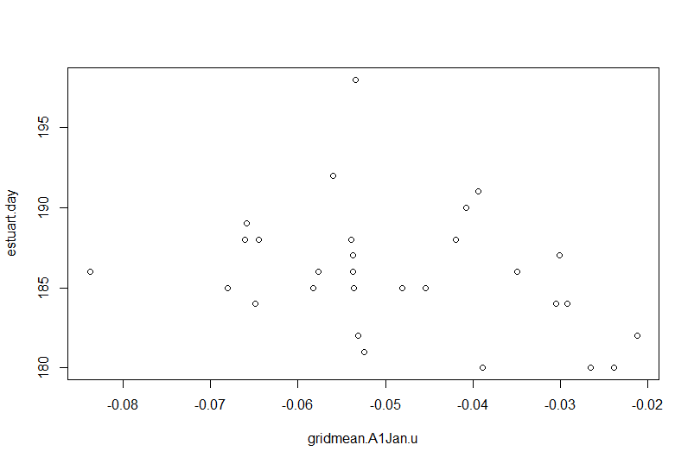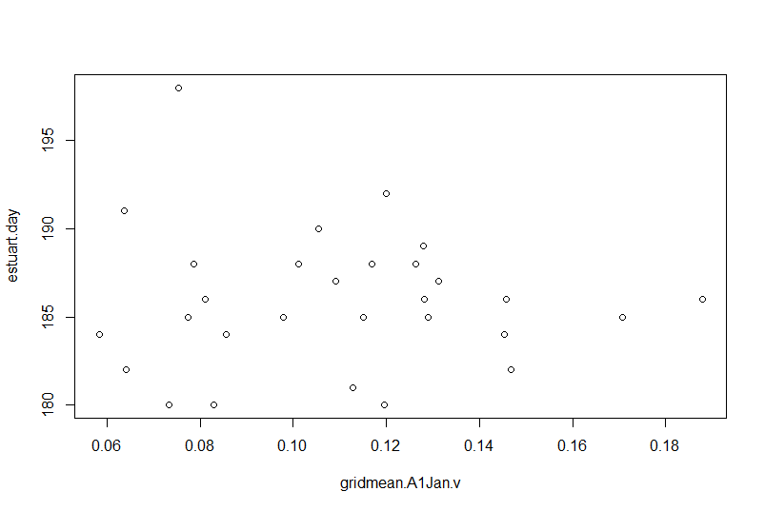’

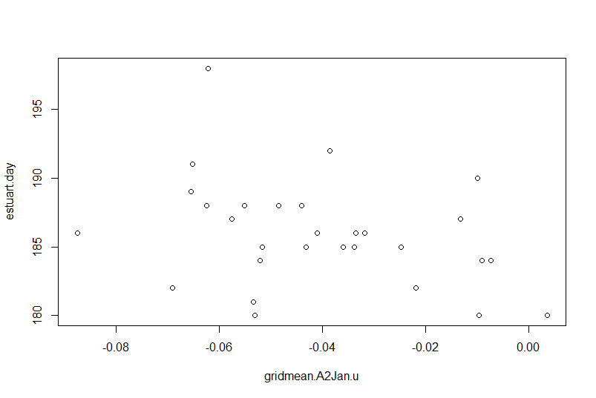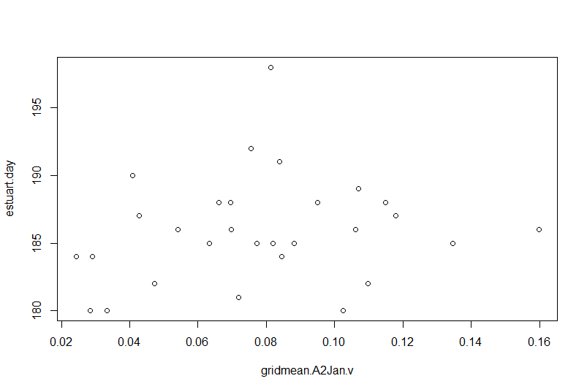

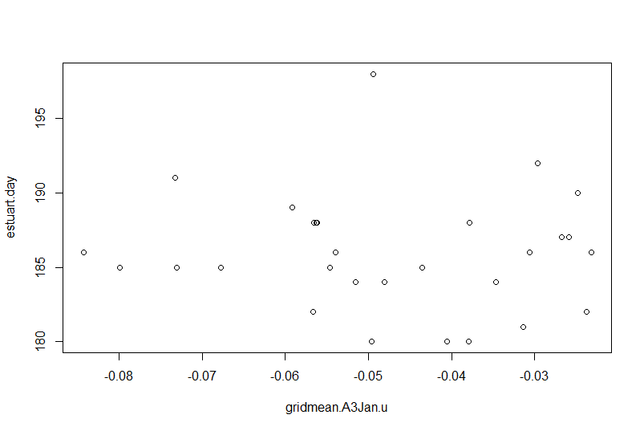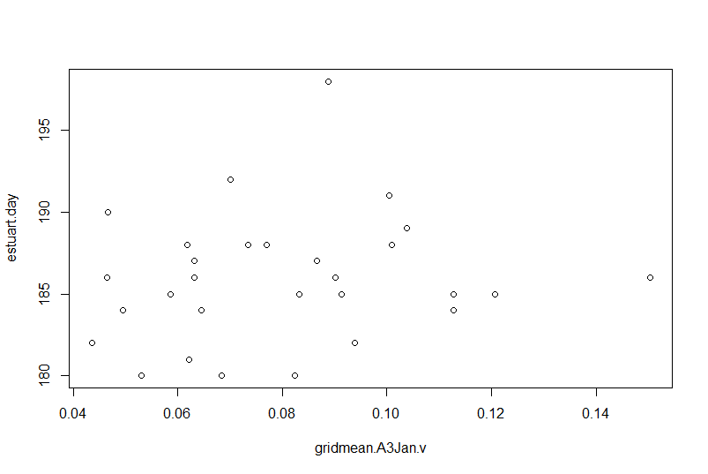

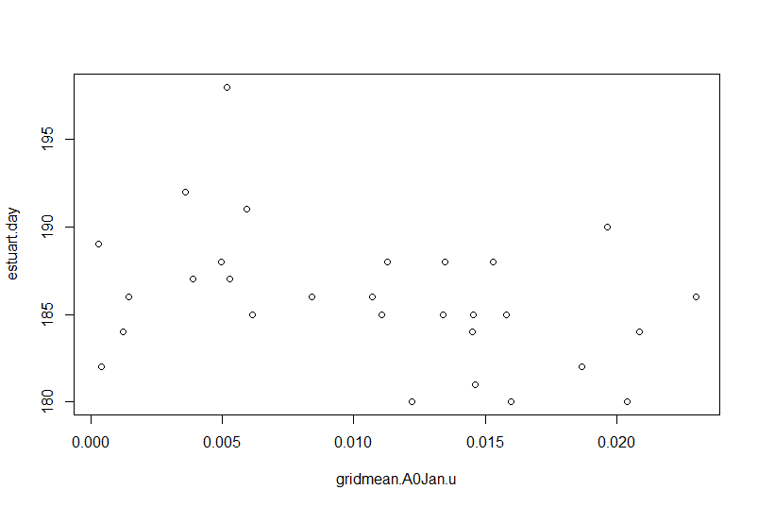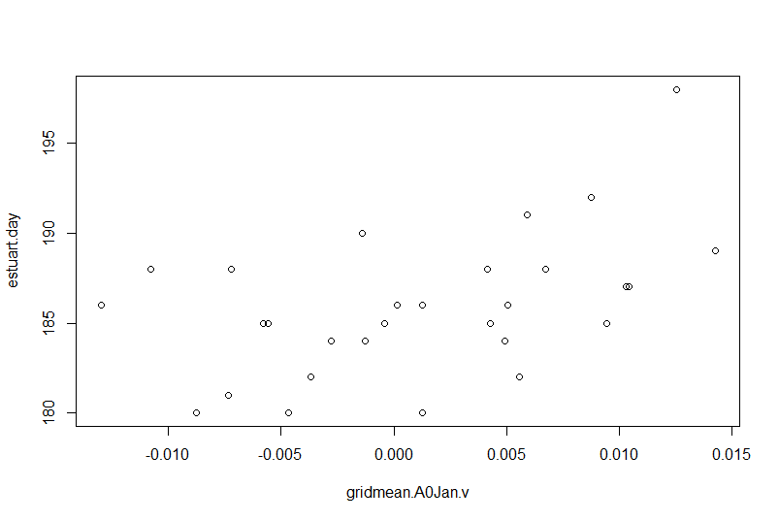

1. Chilko timing median day vs. current velocity u (eastward) and v (northward)

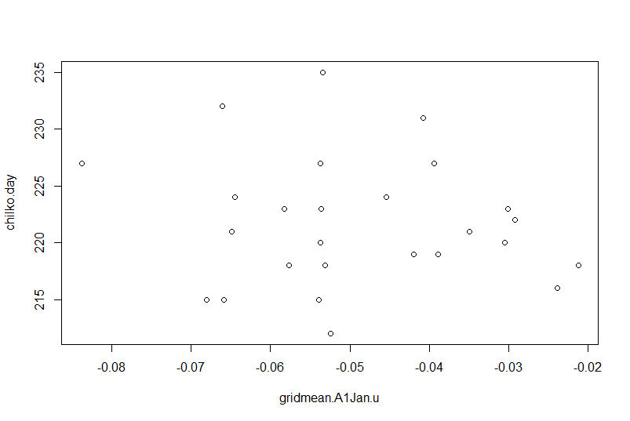 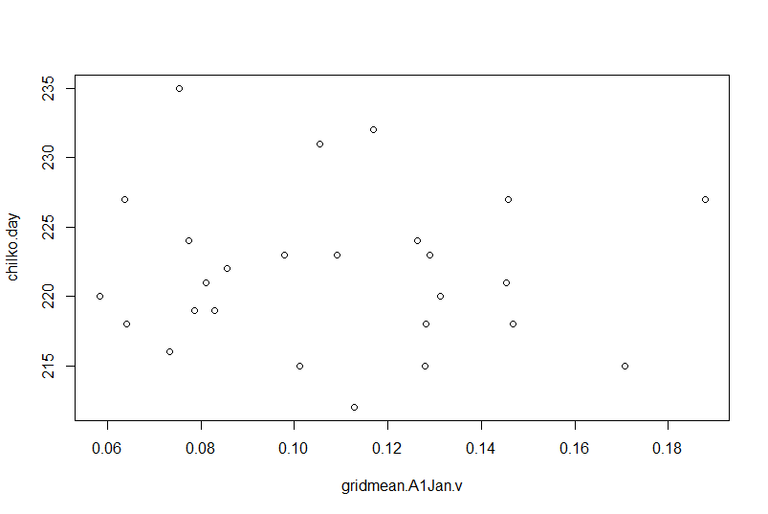

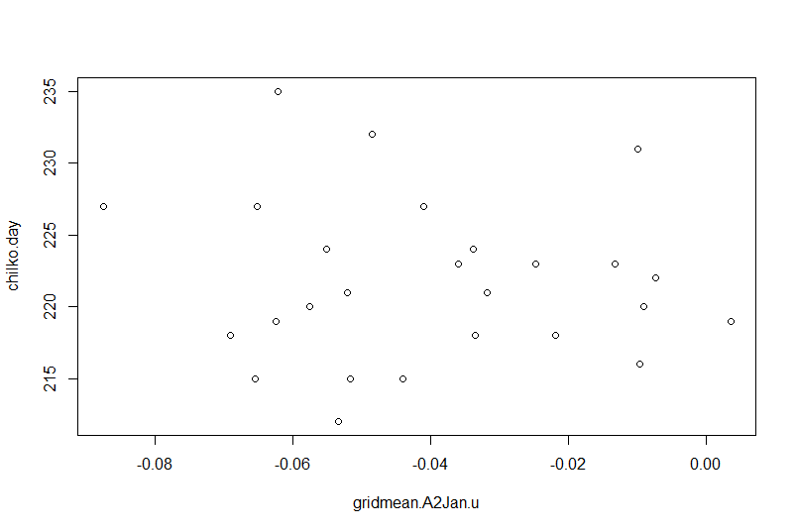 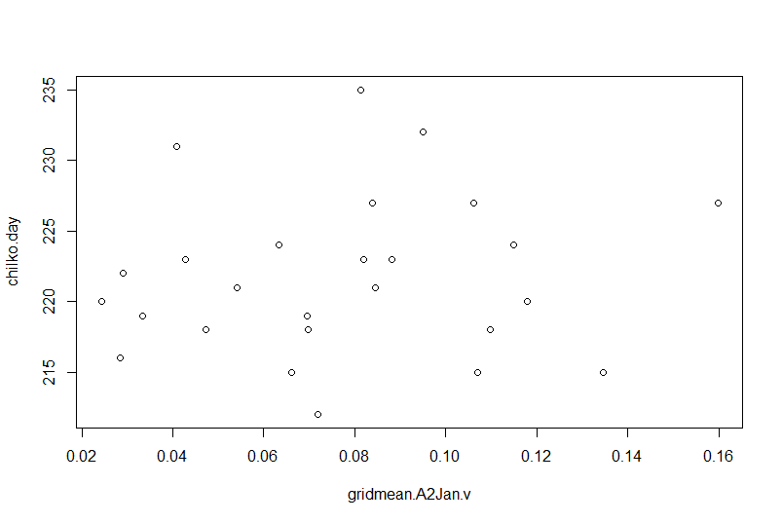

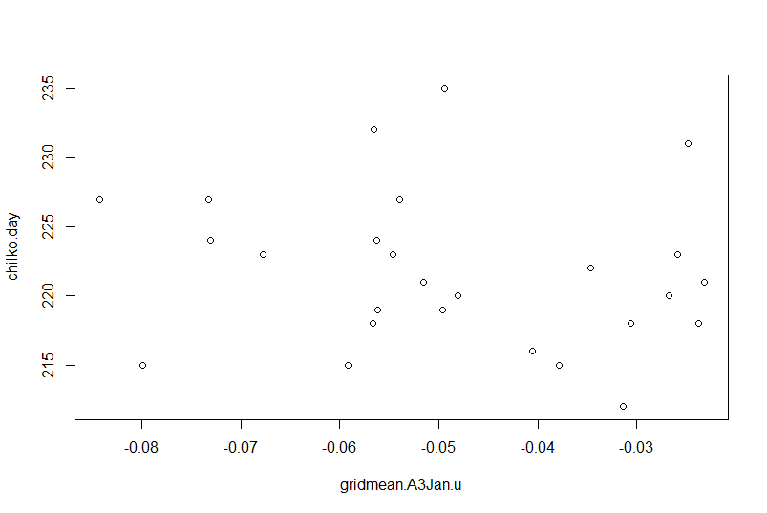 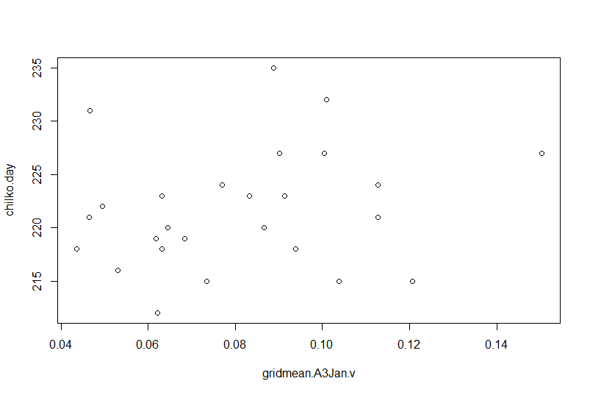

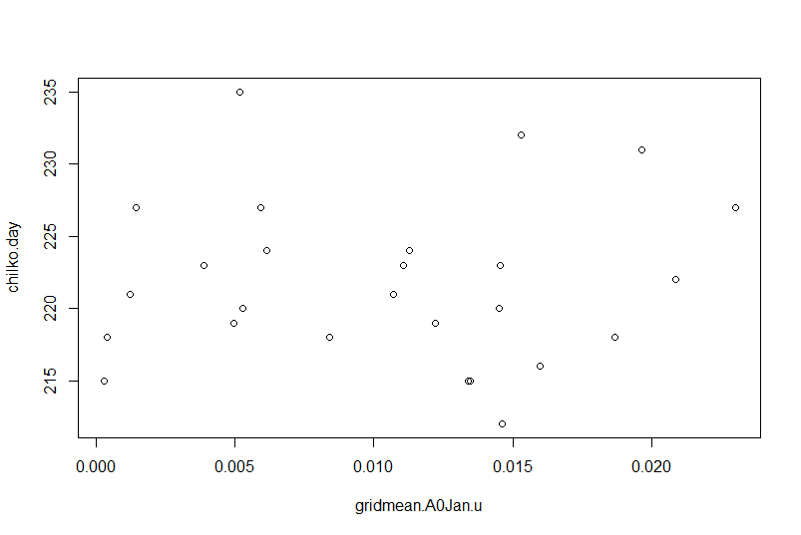 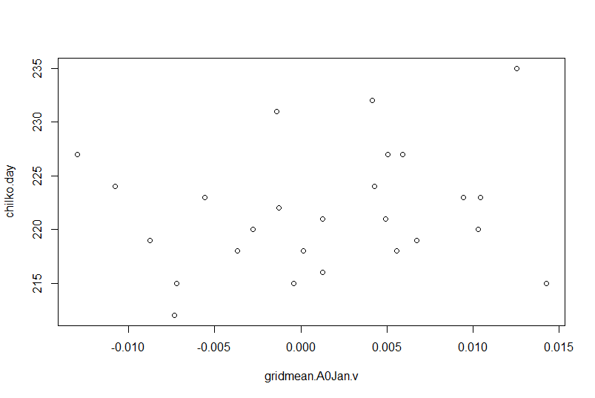

1. Diversion rate vs. current velocity u (eastward) and v (northward)

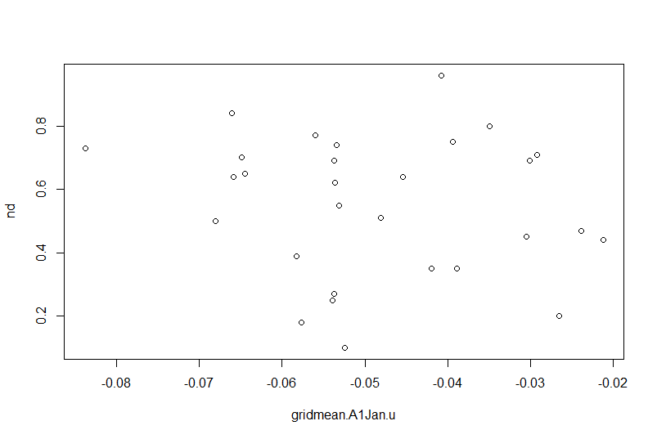 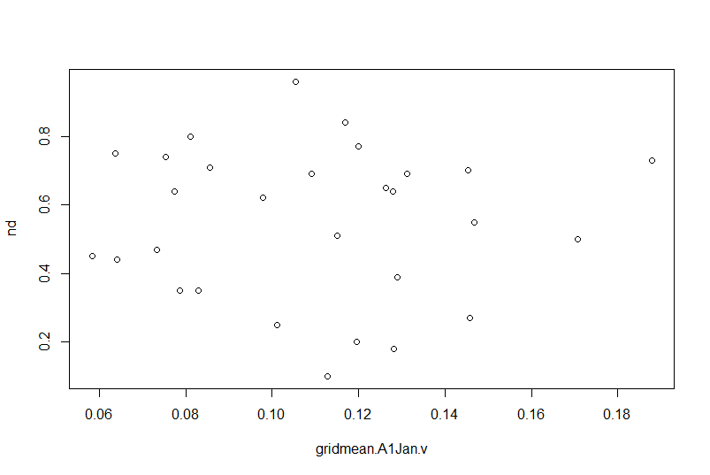

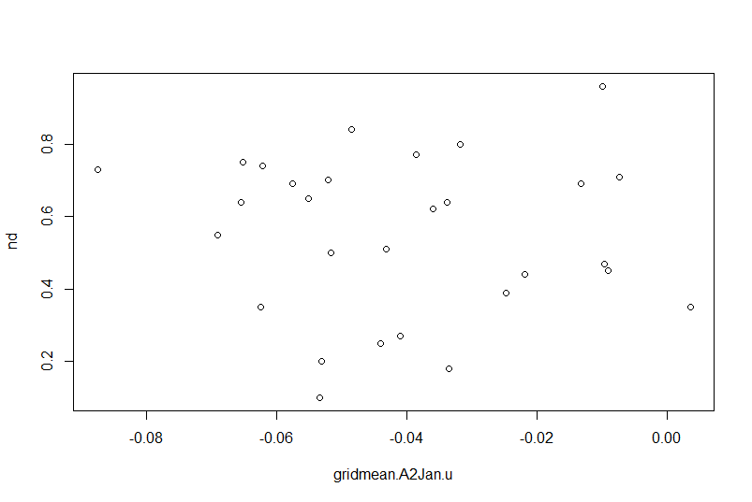 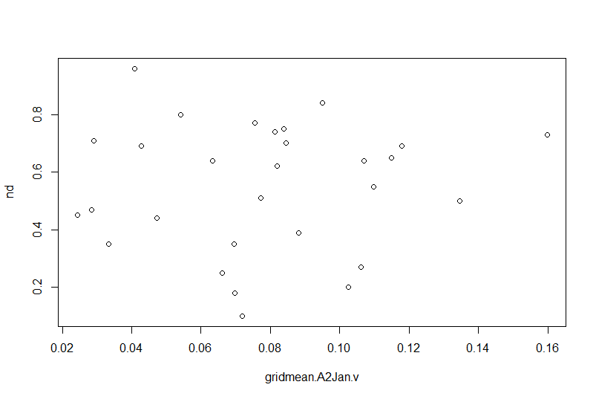

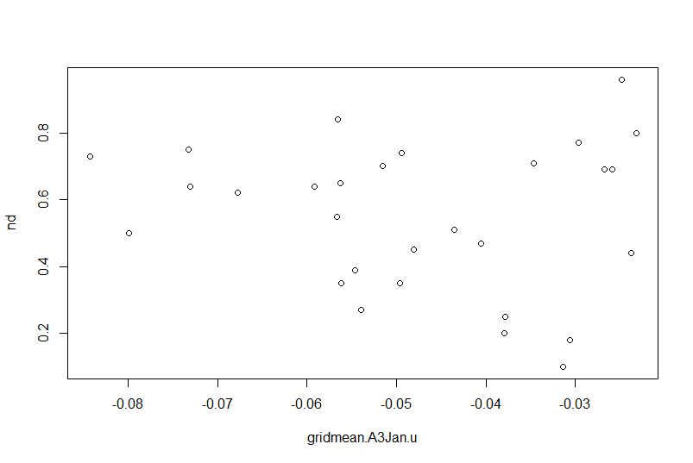 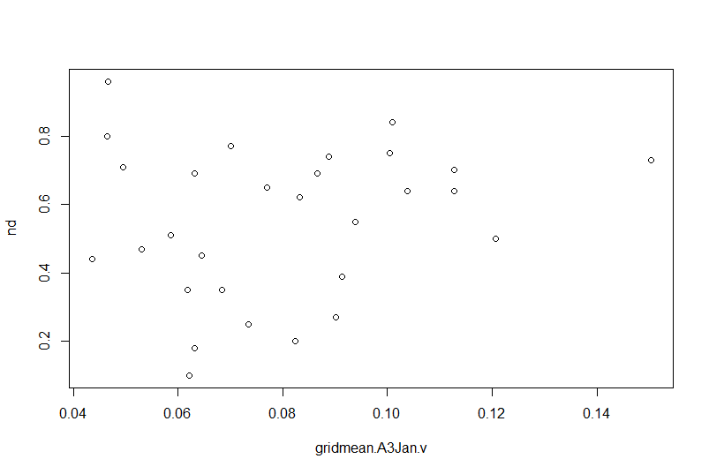

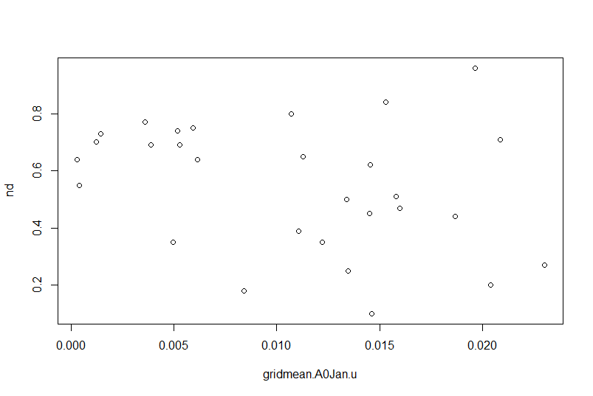 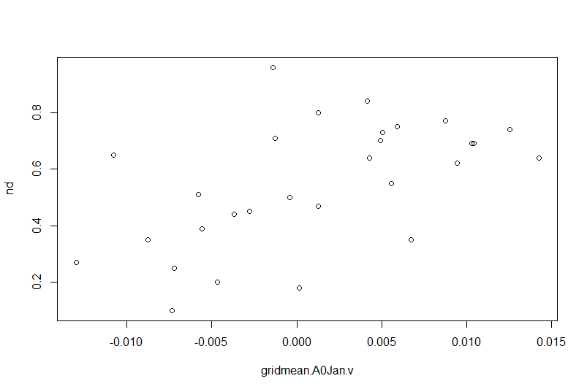

|  |  |  |  |
| --- | --- | --- | --- |
| R2 | ES.timing | CK.timing | ND |
| Area1.Jan.u | 0.1086 | 0.01809 | 0.02028 |
| Area1.Jan.v | 0.002521 | 0.002222 | 0.000256 |
| Area2.Jan.u | 0.1076 | 0.006792 | 0.003052 |
| Area2.Jan.v | 0.03124 | 0.01267 | 0.00265 |
| Area3.Jan.u | 0.005414 | 0.03268 | 0.008697 |
| Area3.Jan.v | 0.02253 | 0.04525 | 0.02975 |
| Area0.Jan.u | 0.1269 | 0.001978 | 0.09264 |
| Area0.Jan.v | 0.2226 | 0.03318 | 0.306 |