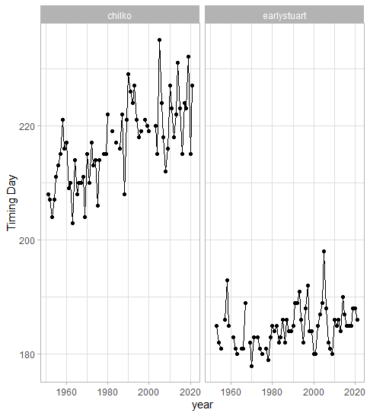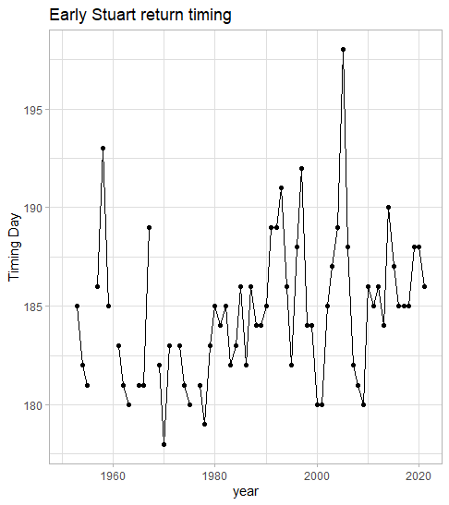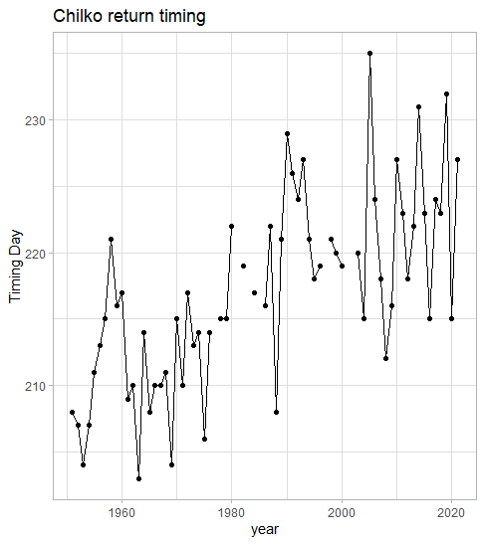

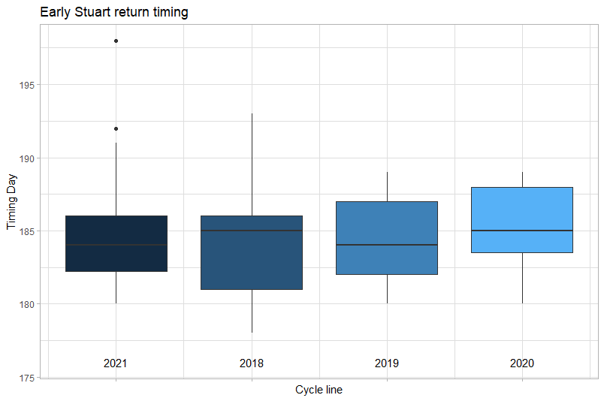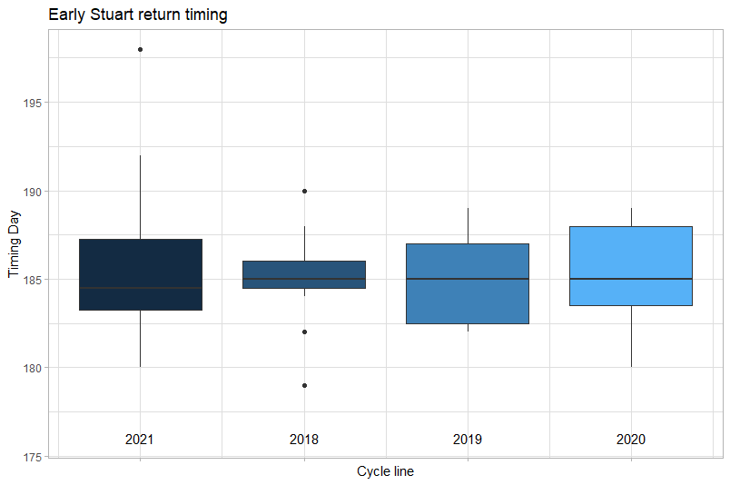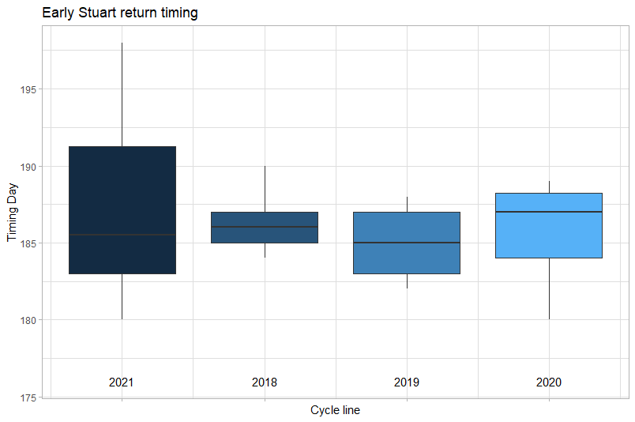

Estuart Cycle line, all year (1953-2021), 1977, 1992

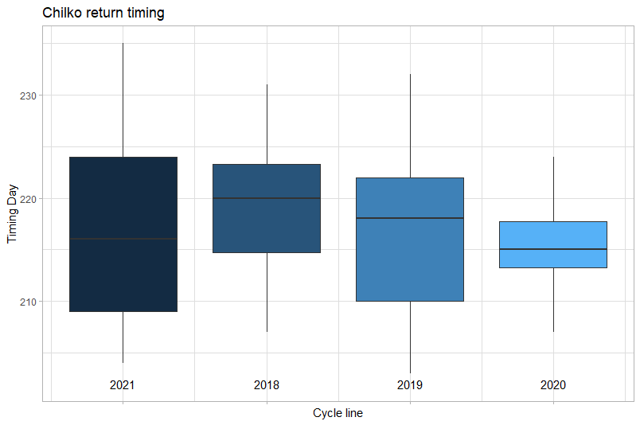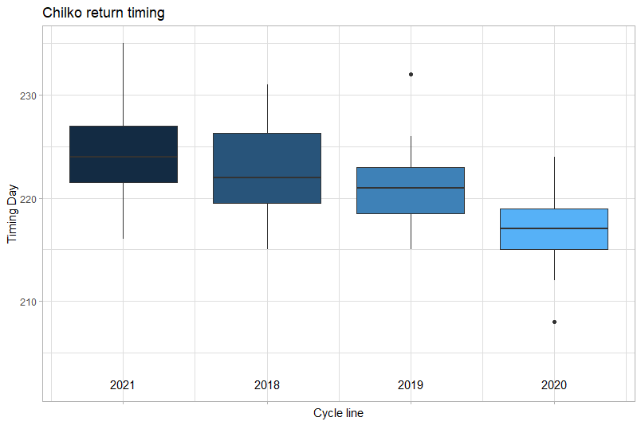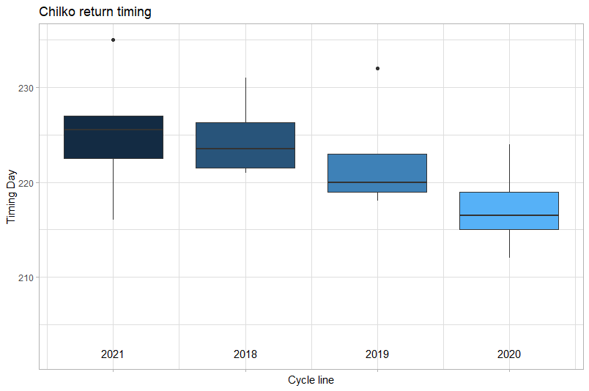

Chilko Cycle line, all year (1951-2021), 1977, 1992

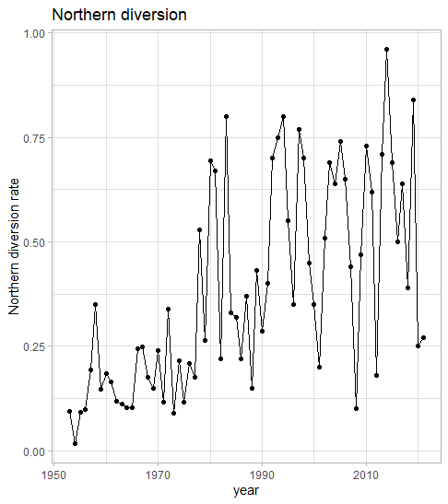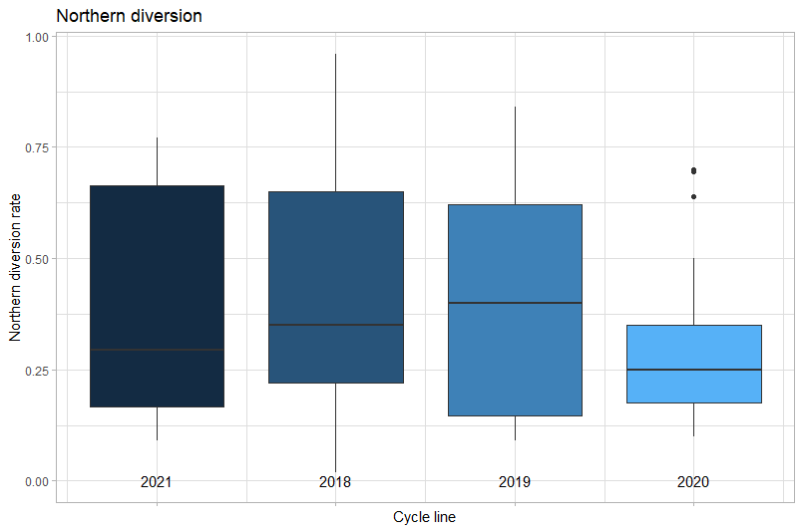

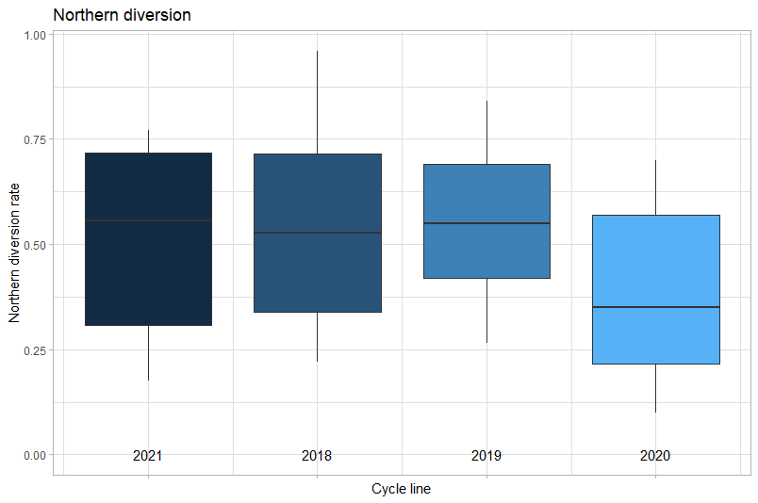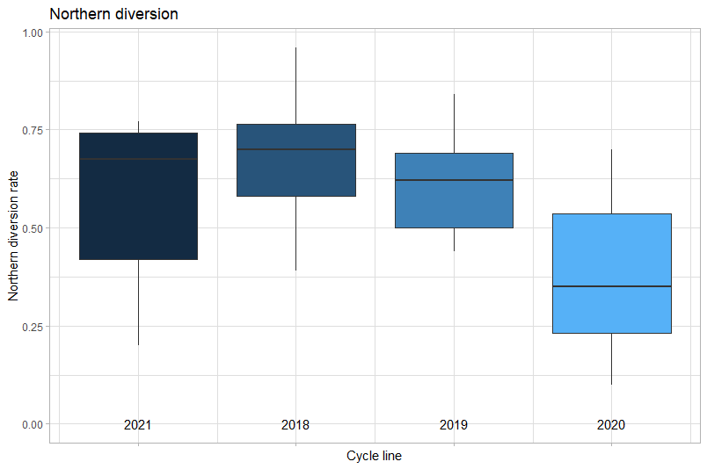

ND Cycle line, all year (1953-2021), 1977, 1992

# return timing data exploration

setwd("C:/Users/liuq/Desktop/salmon migration timing/timing_diversion_forecasting/timing_diversion_forecasting/DATAIN")

rm(list = ls(all=T))

library(tidyverse)

library(dplyr)

#return timing

sockeye.timing <- read.csv("ChilkoTimingForecastData.csv")

#overall timing

ggplot(data = sockeye.timing, mapping = aes(x = year, y = A20.day)) +

geom_line() +

geom_point() +

facet_wrap(~ Stock) +

theme_light() +

labs(x = "year", y = "Timing Day")

#early stuart timing

stuart.timing <- filter(sockeye.timing, Stock == "earlystuart")

ggplot(data = stuart.timing, mapping = aes(x = year, y = A20.day)) +

geom_line() +

geom_point() +

theme_light() +

labs(x = "year", y = "Timing Day", title = "Early Stuart return timing")

#early stuart timing cycle line all year

ggplot(data = stuart.timing, mapping = aes(x = Cycle, y = A20.day, group = Cycle)) +

geom_boxplot(mapping = aes(fill = Cycle),

show.legend = FALSE) +

theme_light() +

labs(x = "Cycle line", y = "Timing Day", title = "Early Stuart return timing") +

theme(axis.text.x = element_blank())+

annotate("text", x=1:4, y=176, label=c("2021", "2018", "2019", "2020"))

#scale_x_discrete(breaks = c(1, 2, 3, 4), labels= cycleyear)

#early stuart timing from 1977 cycle line

ggplot(data = filter(stuart.timing, year >=1977), mapping = aes(x = Cycle, y = A20.day, group = Cycle)) +

geom_boxplot(mapping = aes(fill = Cycle),

show.legend = FALSE) +

theme_light() +

labs(x = "Cycle line", y = "Timing Day", title = "Early Stuart return timing") +

theme(axis.text.x = element_blank())+

annotate("text", x=1:4, y=176, label=c("2021", "2018", "2019", "2020"))

#early stuart timing from 1992 cycle line

ggplot(data = filter(stuart.timing, year >=1992), mapping = aes(x = Cycle, y = A20.day, group = Cycle)) +

geom_boxplot(mapping = aes(fill = Cycle),

show.legend = FALSE) +

theme_light() +

labs(x = "Cycle line", y = "Timing Day", title = "Early Stuart return timing") +

theme(axis.text.x = element_blank())+

annotate("text", x=1:4, y=176, label=c("2021", "2018", "2019", "2020"))

#chilko timing

chilko.timing <- filter(sockeye.timing, Stock == "chilko")

ggplot(data = chilko.timing, mapping = aes(x = year, y = A20.day)) +

geom_line() +

geom_point() +

theme_light() +

labs(x = "year", y = "Timing Day", title = "Chilko return timing")

#chilko timing cycle line all year

ggplot(data = chilko.timing, mapping = aes(x = Cycle, y = A20.day, group = Cycle)) +

geom_boxplot(

mapping = aes(fill = Cycle),

show.legend = FALSE) +

theme_light() +

labs(x = "Cycle line", y = "Timing Day", title = "Chilko return timing") +

theme(axis.text.x = element_blank())+

annotate("text", x=1:4, y=202, label=c("2021", "2018", "2019", "2020"))

#scale_x_discrete(breaks = c(1, 2, 3, 4), labels= cycleyear)

#chilko timing from 1977, cycle line

ggplot(data = filter(chilko.timing, year >= 1977), mapping = aes(x = Cycle, y = A20.day, group = Cycle)) +

geom_boxplot(

mapping = aes(fill = Cycle),

show.legend = FALSE) +

theme_light() +

labs(x = "Cycle line", y = "Timing Day", title = "Chilko return timing") +

theme(axis.text.x = element_blank())+

annotate("text", x=1:4, y=202, label=c("2021", "2018", "2019", "2020"))

#scale_x_discrete(breaks = c(1, 2, 3, 4), labels= cycleyear)

#chilko timing from 1992, cycle line

ggplot(data = filter(chilko.timing, year >= 1992), mapping = aes(x = Cycle, y = A20.day, group = Cycle)) +

geom_boxplot(

mapping = aes(fill = Cycle),

show.legend = FALSE) +

theme_light() +

labs(x = "Cycle line", y = "Timing Day", title = "Chilko return timing") +

theme(axis.text.x = element_blank())+

annotate("text", x=1:4, y=202, label=c("2021", "2018", "2019", "2020"))

#northern diversion

sockeye.ND <- read.csv("NorthernDiversion.csv")

ggplot(data = sockeye.ND, mapping = aes(x = year, y = nd)) +

geom_line() +

geom_point() +

theme_light() +

labs(x = "year", y = "Northern diversion rate", title = "Northern diversion")

#northern diversion cycle line, all years

ggplot(data = sockeye.ND, mapping = aes(x = Cycle, y = nd, group = Cycle)) +

geom_boxplot(mapping = aes(fill = Cycle), show.legend = FALSE) +

#geom_line(mapping = aes(color = Cycle)) +

#geom_point() +

theme_light() +

labs(x = "Cycle line", y = "Northern diversion rate", title = "Northern diversion") +

theme(axis.text.x = element_blank())+

annotate("text", x=1:4, y=0, label=c("2021", "2018", "2019", "2020"))

#ND from 1977, cycle line

ggplot(data = filter(sockeye.ND, year >= 1977), mapping = aes(x = Cycle, y = nd, group = Cycle)) +

geom_boxplot(mapping = aes(fill = Cycle), show.legend = FALSE) +

theme_light() +

labs(x = "Cycle line", y = "Northern diversion rate", title = "Northern diversion") +

theme(axis.text.x = element_blank())+

annotate("text", x=1:4, y=0, label=c("2021", "2018", "2019", "2020"))

#ND from 1992, cycle line

ggplot(data = filter(sockeye.ND, year >= 1992), mapping = aes(x = Cycle, y = nd, group = Cycle)) +

geom_boxplot(mapping = aes(fill = Cycle), show.legend = FALSE) +

#geom_line(mapping = aes(color = Cycle)) +

#geom_point() +

theme_light() +

labs(x = "Cycle line", y = "Northern diversion rate", title = "Northern diversion") +

theme(axis.text.x = element_blank())+

annotate("text", x=1:4, y=0, label=c("2021", "2018", "2019", "2020"))