Lab 1
Student ID: 36557854
Student Name: Liu Qi

1.1
Original Code:
class Car {
String brand;
}
// Can the main method be written like this?
public static void main(String[] args) {
Car myCar = new Car();
}

Optimize code:
// Define a Car class
class Car {
// Instance variable to store the car's brand
String brand;
}
// Main class
public class CarExample {
// main method
public static void main(String[] args) {

// Create a Car object
Car myCar = new Car();

// Assign a value to the object's brand field
myCar.brand = "Honda";

// Print the car brand
System.out.println("Car brand: " + myCar.brand);
}
}
• What is wrong (if anything) with the given code? Explain your answer.
// Main method is floating outside any class now(Syntact Error).
• Where should the main method be located in a Java program?
// Must be inside a class and public static void main(String[] args)
• Write an example of two interacting classes in Java and explain their roles.
// AExample.java
class AExample {
String brand;

void aisa() {
System.out.println(brand + " is a car");
}
}
// BExample.java
public class BExample {
public static void main(String[] args) {
AExample myCar = new AExample();
myCar.brand = "Honda";
myCar.aisa();
}
}
1.2
1. Review the explanations and examples above on Type Casting in Java.
Yes.

2. Explain widening (implicit casting) and narrowing (explicit casting) in your logbook.
// Widening is converting from a smaller data type to a larger data type automatically.
// Narrowing is converting from a larger data type to a smaller data type manually.

3. Summarize the key takeaways in your own words.
// Widening:
Moves from lower precision to higher precision & Happens automatically.
// Narrowing:
Moves from longer precision to lower precision & Happens manually.

4. Provide at least one example (different from the given examples) to demonstrate both
implicit and explicit casting.
// Widening:
byte smallNumber = 67;
int mediumNumber = smallNumber;
double largeNumber = mediumNumber;
System.out.println(smallNumber);
System.out.println(mediumNumber);
System.out.println(largeNumber);
// Narrowing:
double decimalNumber = 677.666;
int wholeNumber = (int) decimalNumber;
byte tinyNumber = (byte) wholeNumber;

System.out.println(decimalNumber);
System.out.println(wholeNumber);
System.out.println(tinyNumber);

Source \  Destination | byte | short | int | long | float | double | char | boolean
byte | yes | yes | yes | yes | yes | yes | no | no
short | no | yes | yes | yes | yes | yes | no | no
int | no | no | yes | yes | yes | yes | no | no
long | no | no | no | yes | yes | yes | no | no
float | no | no | no | no | yes | yes | no | no
double | no | no | no | no | no | yes | no | no
char | no | no | yes | yes | yes | yes | yes | no
boolean | no | no | no | no | no | no | no | yes
1.3
Modified Code:

class Elephant {
String name; // Instance variable to store elephant's name
}
public class ElephantTest {
public static void main(String[] args) {
Elephant a; // Declare reference variable a
a = new Elephant(); // Create new Elephant object , 'a' points to Object1 in memory
a.name = "Elephant1"; // Set name of first elephant , Object1.name = "Elephant1"

Elephant b; // Declare reference variable b
b = new Elephant(); // Create NEW Elephant object (different from a), , 'b' points to Object1 in memory
b.name = "Elephant2"; // Set name of second elephant, Object1.name = "Elephant2"

System.out.println("a is " + a.name + ", b is " + b.name);
}
}

Output:
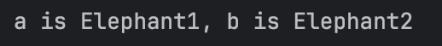

1.4
write in your logbook, an example of method.

public double calculateArea(double length, double width) {
double area = length * width; // Calculate area
return area;
}

Give one example each for built-in-methods and user-defined methods
// Built-in-methods
String text = "Hello World";

int len = text.length();
System.out.println("Length: " + len);

// user-defined methods
public boolean isEven(int number) {
if (number % 2 == 0) {
return true;
} else {
return false;
}
}

public static void main(String[] args) {
MyClass obj = new MyClass();
boolean result = obj.isEven(10);
System.out.println("Is 10 even? " + result);
}

1.4.1
Method Type | Parameters  (Yes/No) | Return  Type  (Yes/No) | Example
No Parameters, No Return  Type | No | NO | public void a() {  System.out.println("Hello!");  }
Has Parameters, No Return  Type | Yes | No | public void displayA(int a) {  System.out.println("A: " + a);  }
No Parameters, Has Return  Type | NO | Yes | import java.util.Random;  public int getRandom() {  return (int)(Math.random() * 100);  }
Has Parameters, Has Return  Type | Yes | Yes | public int add(int a, int b) {  return a + b;  }

1.4.2:
Original Code:
class Example {
static void _____() { // Fill in the method name
System.out.println("This is a method belonging to the class.");
}
void _____() { // Fill in the method name
System.out.println("This is a method belonging to an instance.");
}
}
public class Main {
public static void main(String[] args) {
_______; // Call the static method
Example obj = new Example();
_______; // Call the non-static method
}
}
Complete Code:
class Example {
static void displayClassMessage() {

System.out.println("This is a method belonging to the class.");
}

void displayInstanceMessage() {
System.out.println("This is a method belonging to an instance.");
}
}

public class StaticMethodExample {
public static void main(String[] args) {
Example.displayClassMessage();

Example obj = new Example();

obj.displayInstanceMessage();

}
}
Output:
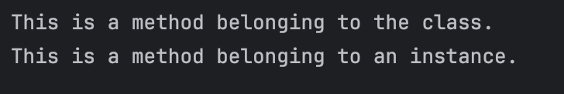
2. HackerRank Programming Exercise

2.1

Code:
import java.util.*;
public class Solution {
public static void main(String[] args) {
Scanner scan = new Scanner(System.in);
int a = scan.nextInt();
// Complete this line
int b = scan.nextInt();
// Complete this line
int c = scan.nextInt();

System.out.println(a);
System.out.println(b);
System.out.println(c);
// Complete this line
// Complete this line
}
}
Output:
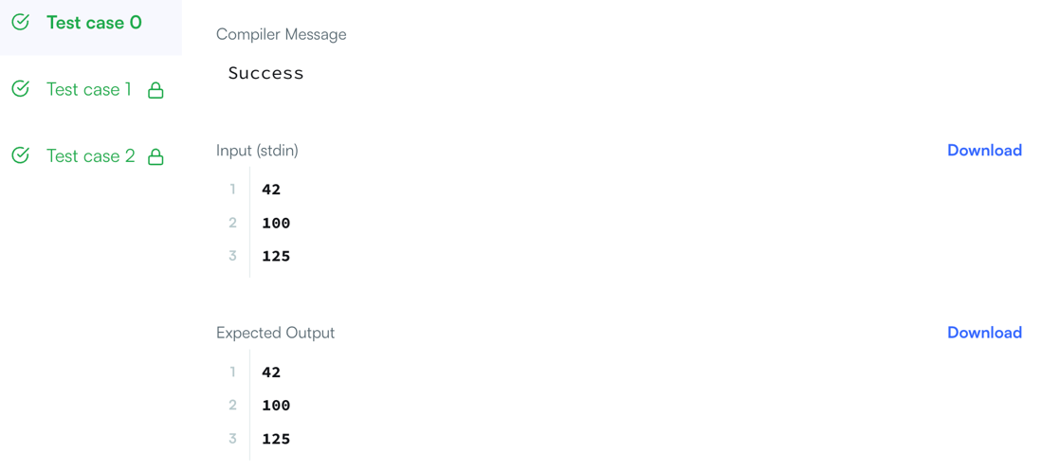

2.2
Code:

import java.util.Scanner;
public class Solution {
public static void main(String[] args) {
Scanner scan = new Scanner(System.in);
int i = scan.nextInt();
// Write your code here.
double d = scan.nextDouble();
scan.nextLine(); // consume leftover newline
String s = scan.nextLine();

System.out.println("String: " + s);
System.out.println("Double: " + d);
System.out.println("Int: " + i);
}
}

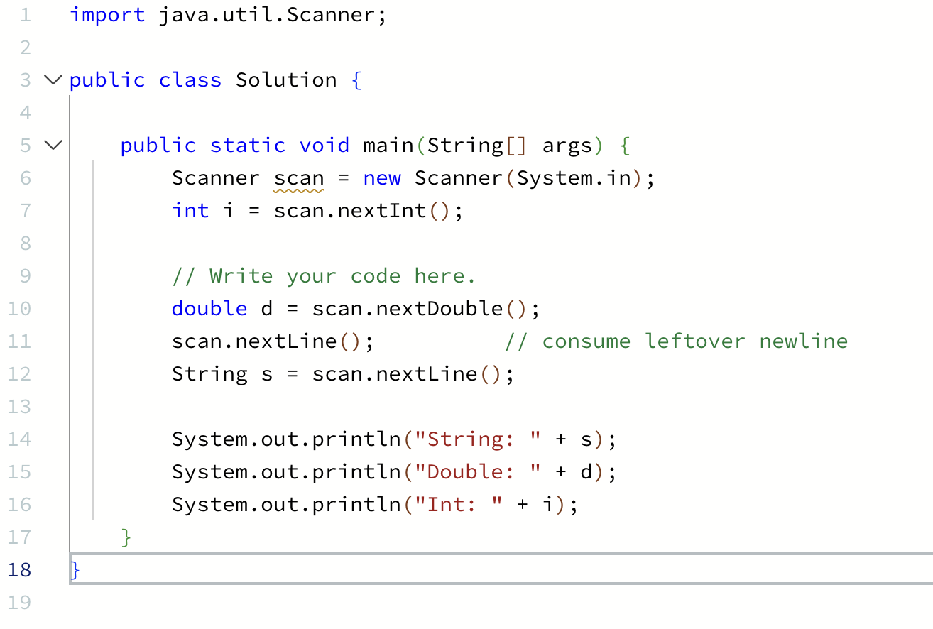
Output:
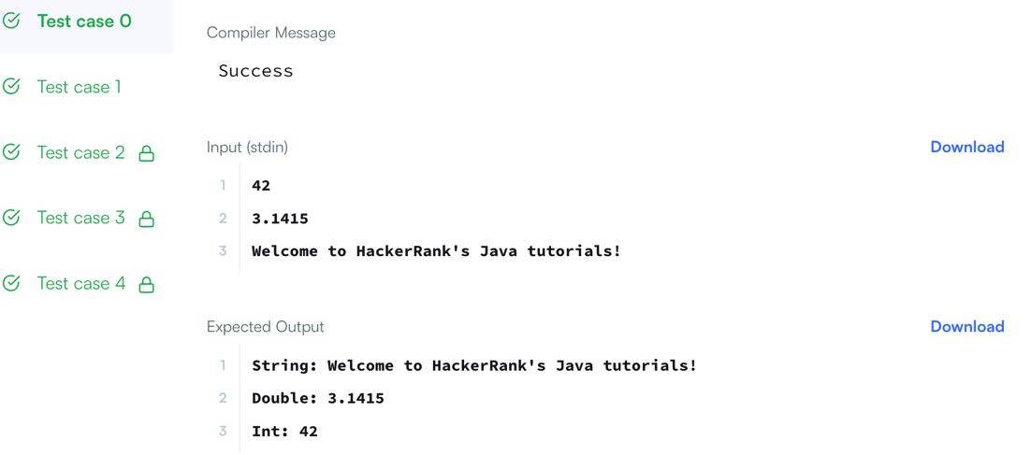
2.3
Code:

import java.util.Scanner;
public class Solution {
public static void main(String[] args) {
Scanner sc=new Scanner(System.in);
System.out.println("================================");
for(int i=0;i<3;i++){
String s1=sc.next();
int x=sc.nextInt();
//Complete this line
System.out.printf("%-15s%03d%n",s1,x);

}
System.out.println("================================");
}
}
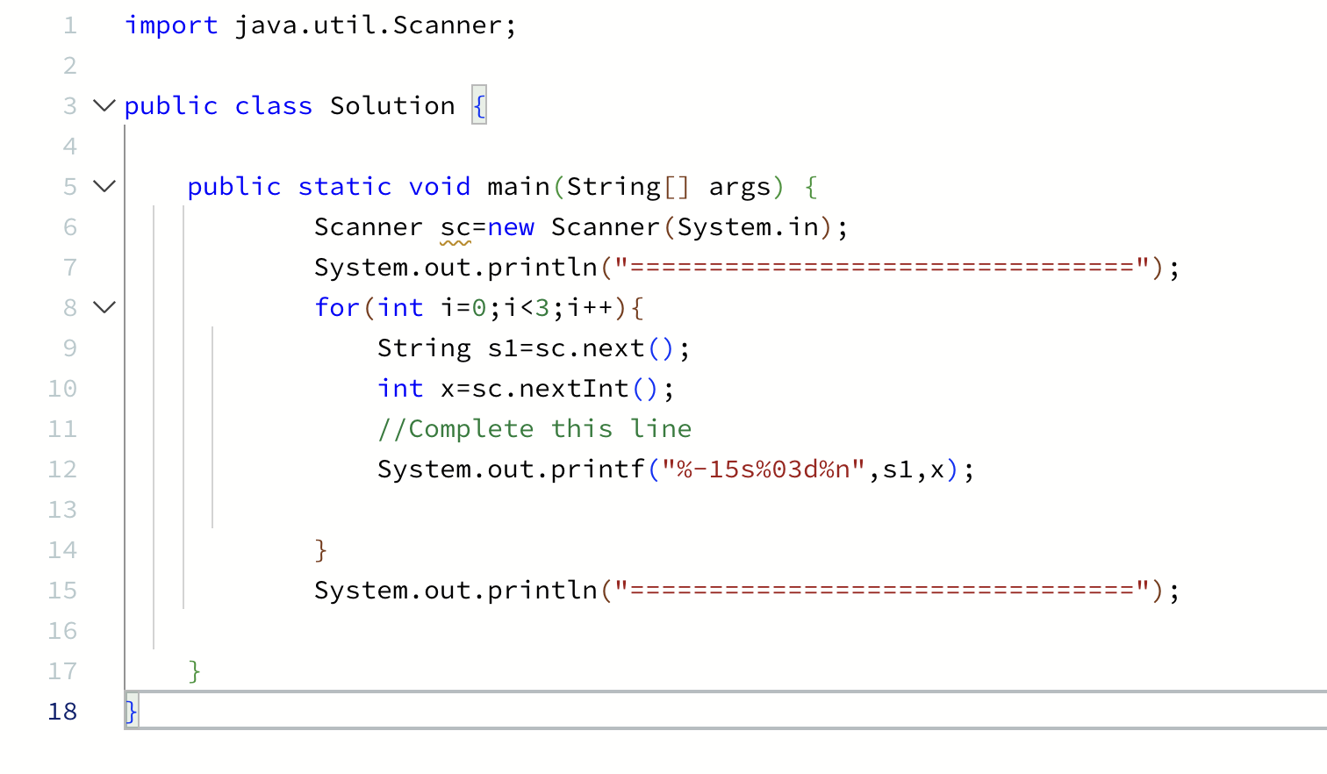
Output:
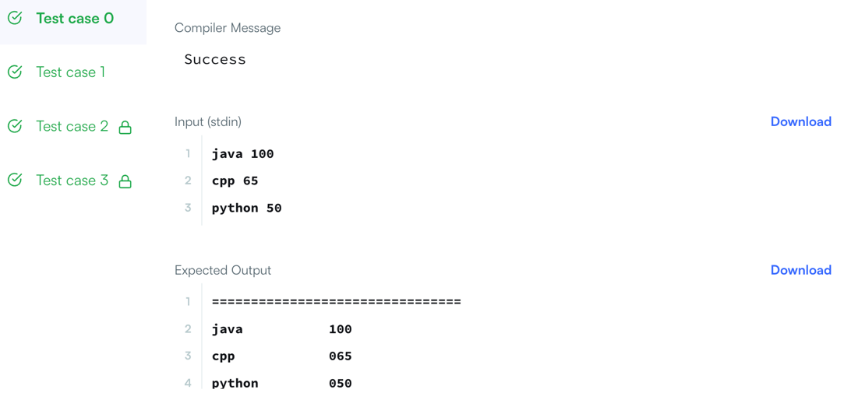
2.4
Code:

import java.util.*;
import java.io.*;
class Solution{
public static void main(String []argh)
{

Scanner sc = new Scanner(System.in);
int t=sc.nextInt();
for(int i=0;i<t;i++)
{
try
{
long x=sc.nextLong();
System.out.println(x+" can be fitted in:");
if(x>=-128 && x<=127)System.out.println("* byte");
//Complete the code
if (x >= Short.MIN_VALUE && x <= Short.MAX_VALUE)
System.out.println("* short");
if (x >= Integer.MIN_VALUE && x <= Integer.MAX_VALUE)
System.out.println("* int");
if (x >= Long.MIN_VALUE && x <= Long.MAX_VALUE)
System.out.println("* long");
}
catch(Exception e)
{
System.out.println(sc.next()+" can't be fitted anywhere.");
}
}
}
}
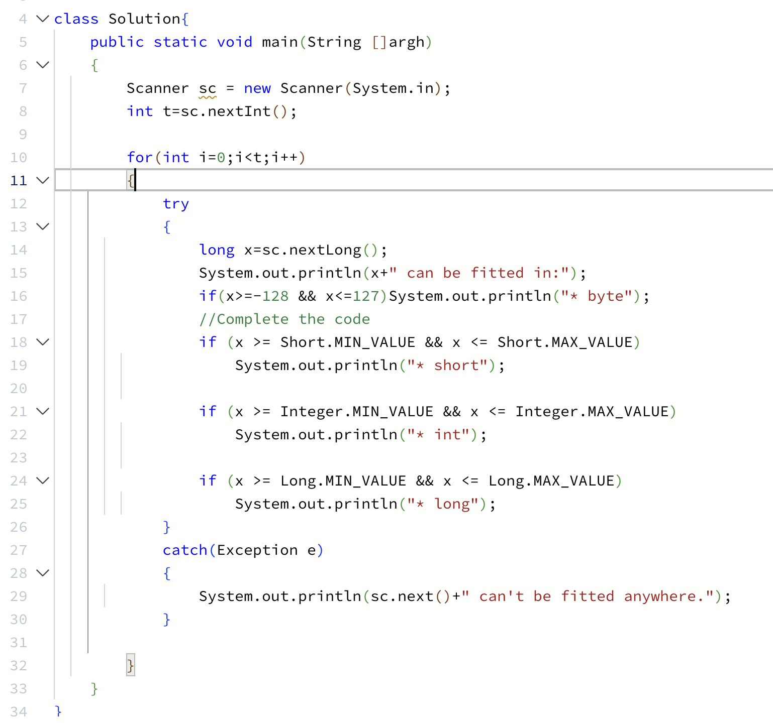
Output:
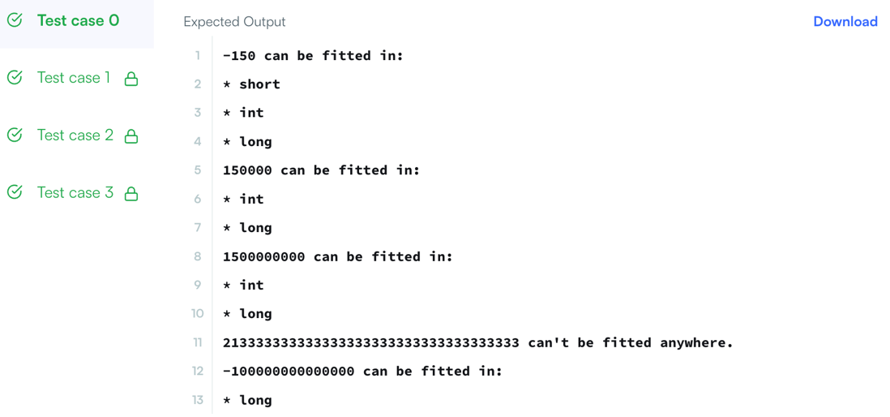
2.5
Code:

import java.util.*;
import java.text.*;
public class Solution {
public static void main(String[] args) {
Scanner scanner = new Scanner(System.in);
double payment = scanner.nextDouble();
scanner.close();
NumberFormat usFormat = NumberFormat.getCurrencyInstance(Locale.US);
NumberFormat indiaFormat = NumberFormat.getCurrencyInstance(new Locale("en", "IN"));
NumberFormat chinaFormat = NumberFormat.getCurrencyInstance(Locale.CHINA);
NumberFormat franceFormat = NumberFormat.getCurrencyInstance(Locale.FRANCE);
String us = usFormat.format(payment);
String india = indiaFormat.format(payment);
String china = chinaFormat.format(payment);
String france = franceFormat.format(payment);
System.out.println("US: " + us);
System.out.println("India: " + india);
System.out.println("China: " + china);
System.out.println("France: " + france);
}
}
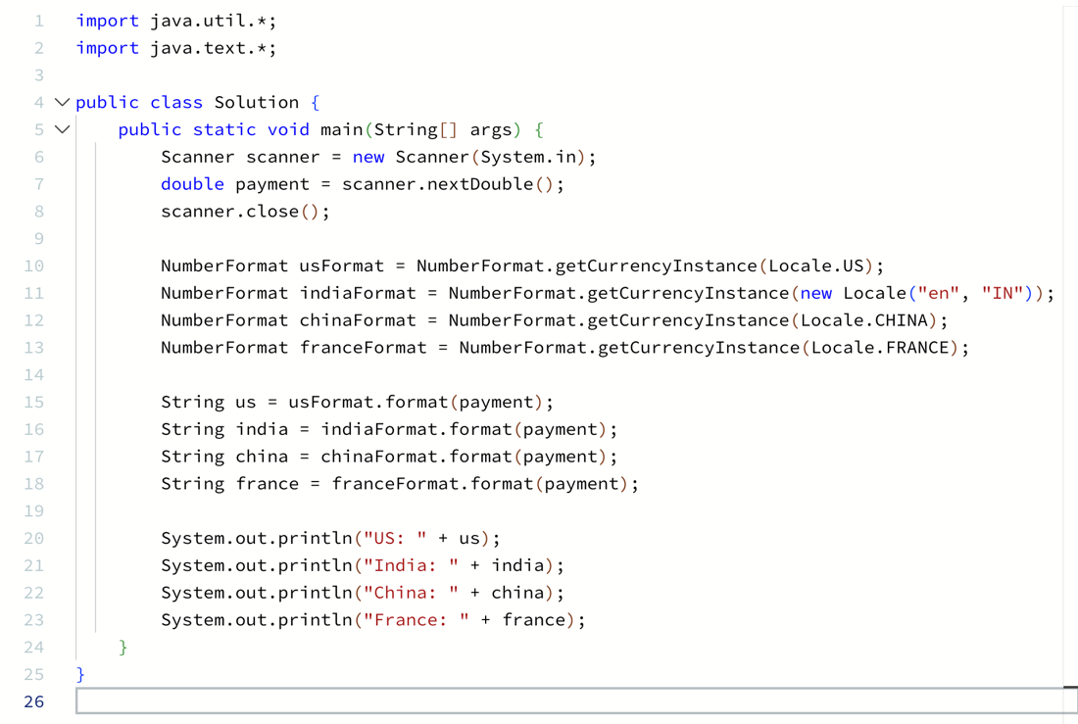
Output:
