# 性能测试报告

——学者网

课程名称：软件测试与质量

姓 名：李祺

学 号：20152005031

专 业：软件工程

日期:2018-06-11

目录

1 项目概述 3

1.1 标识 3

1.2 系统概述 3

1.3 性能指标 3

2 测试目的 4

3 测试依据和范围 4

3.1 测试依据 4

3.2 测试范围 4

4 系统环境 4

4.1 服务器环境配置 4

5 测试工具及监控指标 6

5.1 测试工具 6

5.2 系统资源监控 6

5.2.1 应用程序性能监控指标 6

5.2.2 服务器性能监控指标 7

6 测试方法 7

6.1 性能测试策略 7

6.2 性能测试分析 8

7 测试方案 8

7.1进入\退出准则 8

7.2测试前的准备 9

7.3定义测试场景 9

7.3.1 基准测试场景 9

7.3.2 负载测试场景 10

7.3.3 稳定性测试场景 11

8 测试结果 12

8.1 基准测试结果 13

8.2 负载测试结果 18

8.3 稳定性测试结果 23

9 测试结果说明 30

## 1 项目概述

### 1.1 标识

系统名称：学者网

客户名称：广东省服务计算工程技术研究开发中心

### 1.2 系统概述

学者网具备信息管理、文献检索、学术网盘、站内通讯、在线交流、学者日历以及课程平台等功能;平台的推荐功能能够查找具有相同研究兴趣的学者，及时了解他们的最新动态及分享学术成就。同时能够构建个人、团队和机构的学术主页，实现协同及更加详尽地展示其学术成就，为学者和机构提供发布学术主页的服务。

### 1.3 性能指标

* 关键业务服务端响应速度在10秒以内。
* 根据80/20原则，80%的用户会集中在20%的时间进行操作，计算出试运营阶段最大并发数为：(25000*0.8)/(24*3600*0.2)≈2人，考虑到24小时中集中时间段在早上，中午，晚上各2小时，因此最大并发数约为：10人/秒;依次推算出拓展阶段最大并发数为：25人/秒，全覆盖阶段最大并发数为75人/秒。
* 稳定性测试25人并发做半个小时，确保系统在CPU和内存饱和长时间运行状态下的稳定性。

## 2 测试目的

本次测试的主要目的是对系统登录、搜索、查看个人信息和发布动态开展性能评测，以此分析系统的稳定性。

## 3 测试依据和范围

### 3.1 测试依据

“学者网”的性能测试依据客户要求，以及与开发项目组、客户通过业务系统评估建议书明确的目的和需求。

### 3.2 测试范围

➢ 

➢ 学者网的登录；

➢ 学者网的学者查询；

➢ 学者网的查看个人信息；

➢ 学者网的发布动态；

## 4 系统环境

### 4.1 服务器环境配置

测试机的配置如下：

|  |  |  |
| --- | --- | --- |
| 测试机 | 名称 | 清华同方测试机（1台） |
| 硬件 | CPU：Intel(R) Core(TM) i5-6500 CPU @ 3.20GHz 3.20GHz 内存：8G 硬盘:175G |
|
|
| 软件 | 操作系统：windows 7 专业版 64bit 应用软件：Loadrunner |
|

## 5 测试工具及监控指标

### 5.1 测试工具

测试工具: Loadrunner

监控工具: Windows perfmon \ 程序日志 \ Loadrunner自带工具\Mssql自带工具

### 5.2 系统资源监控

本次性能测试将使用Windows perfmon \ 程序日志 \ Loadrunner自带工具\Mssql自带工具相结合监控关键业务的处理速度及服务器资源消耗，下面列出常用的一些参考指标：

#### 5.2.1 应用程序性能监控指标

* 关键事务响应时间
* 运行的虚拟用户数
* 关键事务吞吐率

#### 5.2.2 服务器性能监控指标

* CPU\CPU%(User%+Sys%) 处理器使用率。
* DISK\Disk %Busy 磁盘使用率。
* Disk IOPS 磁盘读些速度
* MEM\Memfree 空闲的物理内存。

## 6 测试方法

### 6.1 性能测试策略

➢

➢ 基准测试

针对单用户对单一业务的进行的测试，为系统的性能测试提供一个基线，用来作为性能测试的基准，通过对比得出最终的结论。

➢

➢ 负载测试

针对某一个业务的采用从小并发量逐渐加大的方式施压，考察业务是否可以满足性能需求，如果存在性能瓶颈便于进一步定位到根源。

➢

➢ 稳定性测试

长时间对系统施加负载压力，通过响应速度和吞吐率来判断被测系统是否可以提供持续稳定的服务

### 6.2 性能测试分析

➢

➢ 业务分析

经过初步分析，将本次性能测试的重点确定为搜索学者以及查看个人信息。

➢

➢ 测试数据分析

考虑到本次性能评估主要目的是提高系统的稳定性，因此所有数据按照实际情况，查看个人信息10用户，搜索学者10用户，发布动态5用户。

➢

➢ 监控方案

本次性能测试将使用Windows perfmon \ 程序日志 \ Loadrunner自带工具\Mssql自带工具和人工查看相结合监控测试场景执行过程中各种性能指标数据。

## 7 测试方案

### 7.1进入\退出准则

➢

➢ 进入准则（所有条件全要具备）：

* 性能测试目的明确；
* 相关人员到位，相关设备准备完毕；
* 系统通过功能测试，程序版本稳定；
* 测试环境与测试用数据准备完毕；
* 测试后系统恢复机制准备完毕；（备份数据库）
* 系统业务、技术以及测试需求已经通过相关人员理解完毕。

➢

➢ 退出准则（任一条件具备）：

* 所有执行工作按照方案顺利完成；
* 由于程序存在问题导致业务流程无法走通或者并发执行错误率超过5%；
* 执行过程中缺乏相关人员配合、测试环境不可用或者缺少必要设备导致延期2天；
* 执行过程中发生严重性能问题，经相关负责人同意直接进行优化整改。

### 7.2测试前的准备

1. 测试工具以及人员的选择；

2. 搭建测试环境（包括网络、服务器，数据量的录入等）；

3. 提供系统相关的账号密码；

4. 场景执行过程中产生的各种数据脚本；

5. 测试过程中所需的测试数据（用户名、密码等）。

### 7.3定义测试场景

本次测试环境部署在实验室环境，需要与互联网进行交互。

#### 7.3.1 基准测试场景

|  |  |  |  |  |  |  |
| --- | --- | --- | --- | --- | --- | --- |
| 基准测试场景 | | | | | |  |
| **ID** | **场景描述** | **事务描述** | **用户数量（个）** | **用户加载方式** | **Think Time（秒）** | **循环间隔（秒）** |
| 1 | 搜索学者 | 用户输入搜索内容，点击查询进行查询 | 1 | 单用户 | 1 | 1 |
| 2 | 查看个人信息 | 进入系统首页后点击个人信息查看个人信息 | 1 | 单用户 | 1 | 1 |
| 3 | 发布动态 | 进入首页后，点击发布动态，输入标题以及内容，保存 | 1 | 单用户 | 1 | 1 |

#### 7.3.2 负载测试场景

|  |  |  |  |  |  |  |
| --- | --- | --- | --- | --- | --- | --- |
| 负载测试场景 | | | | | |  |
| **ID** | **场景描述** | **事务描述** | **并发用户数（个）** | **用户加载方式** | **Think Time（秒）** | **循环间隔（秒）** |
| 1 | 搜索学者 | 用户输入搜索内容，点击查询进行查询 | 搜索学者 | 15个用户同时并发 | 1 | 1 |
| 2 | 查看个人信息 | 进入系统首页后点击个人信息查看个人信息 | 查看个人信息 | 15个用户同时并发 | 1 | 1 |
| 3 | 发布动态 | 进入首页后，点击发布动态，输入标题以及内容，保存 | 进入团队 | 10个用户同时并发 | 1 | 1 |

#### 7.3.3 稳定性测试场景

|  |  |  |  |  |  |  |
| --- | --- | --- | --- | --- | --- | --- |
| 稳定性测试场景 | | | | | |  |
| **ID** | **场景描述** | **事务描述** | **并发用户数（个）** | **用户加载方式** | **Think Time（秒）** | **持续时间（Hour）** |
| 1 | 搜索学者 | 用户输入搜索内容，点击查询进行查询 | 10 | 10个用户同时并发 | 1 | 1 |
| 2 | 查看个人信息 | 进入系统首页后点击个人信息查看个人信息 | 10 | 10个用户同时并发 | 1 | 1 |
| 3 | 发布动态 | 进入首页后，点击发布动态，输入标题以及内容，保存 | 5 | 5个用户同时并发 | 1 | 1 |

## 8 测试结果

### 8.1 基准测试结果

业务流程

|  |  |  |  |  |  |  |
| --- | --- | --- | --- | --- | --- | --- |
| 运行名称 | 组名 | 脚本名称 | 并发 Vuser 数 | 总 Vuser 数的 % | 每小时事务数 | 思考时间 |
| Scenariol.lrr |  | WebHttpHtml2 | 1 | 3 |  | 按录制时的原样回放, 限制为 1 秒 |
| Scenariol.lrr |  | WebHttpHtml3 | 1 | 3 |  | 按录制时的原样回放 |
| Scenariol.lrr |  | Fabudongtai | 1 | 3 |  | 按录制时的原样回放 |
|  |  | 总计: | 3 | 100% |  |  |

性能概要描述

|  |  |
| --- | --- |
| 度量 | res.lrr |
| 最大运行 Vuser 数 | 3 |
| 每秒平均点击次数 | 34.405 |
| 总点击次数 | 2890 |
| 每秒通过的事务总数 |  |
| 每分钟通过的事务总数 |  |
| 事务总数 | 7 |

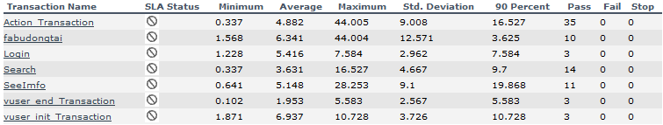

|  |  |
| --- | --- |
| 运行 Vuser | |
| 标题 | 运行 Vuser |
| 当前结果 | H:\学者网测试\2脚本基准测试\Session1.lrr |
| 筛选器 | Vuser 状态 = (Run) |
| 分组方式 |  |
| 粒度 | 2 秒 |

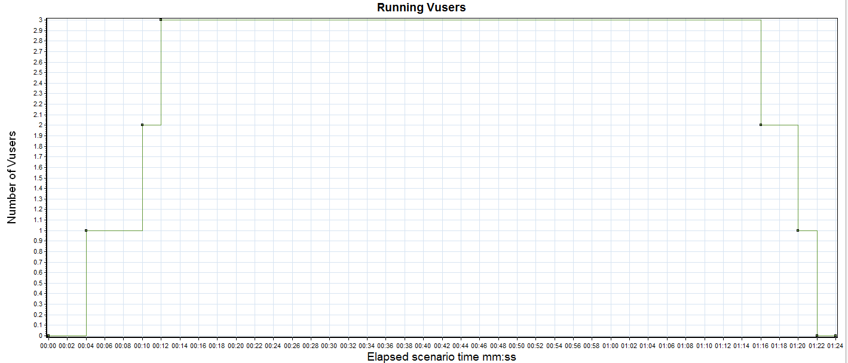

|  |  |  |  |  |  |  |
| --- | --- | --- | --- | --- | --- | --- |
| 颜色 | 比例 | 度量 | 图最小值 | 图平均值 | 图最大值 | 图中间值 |
|  | 1 | Run | 0 | 1.125 | 3.000 | 1.000 |

描述: 显示负载测试的每秒期间执行 Vuser 脚本的 Vuser 的数目及其状态。此图对于确定任何指定时刻服务器上的 Vuser 负载非常有用。

|  |  |  |  |  |  |  |  |  |  |  |  |  |  |  |  |  |  |  |  |  |  |  |  |  |  |  |  |  |  |  |  |  |  |  |  |  |  |  |  |  |  |  |  |  |  |  |  |
| --- | --- | --- | --- | --- | --- | --- | --- | --- | --- | --- | --- | --- | --- | --- | --- | --- | --- | --- | --- | --- | --- | --- | --- | --- | --- | --- | --- | --- | --- | --- | --- | --- | --- | --- | --- | --- | --- | --- | --- | --- | --- | --- | --- | --- | --- | --- | --- |
| 每秒点击次数 | | | | | | | | | | | | | | | | | | | | | | | | | | | | | | | | | | | | | | | | | | | | | | | |
|  |  |  |  |  |  | |  |  |  |  |  |  |  |  |  |  |  |  |  |  |  |  |  |  |  |  |  |  |  |  |  |  |  |  |  |  |  |  |  |  |  |  |  |  |  |  |  | |
| 标题 | | | | | | 每秒点击次数 | | | | | | | | | | | | | | | | | | | | | | | | | | | | | | | | | | | | | | | | | |
| 当前结果 | | | | | | H:\学者网测试\2脚本基准测试\Session1.lrr | | | | | | | | | | | | | | | | | | | | | | | | | | | | | | | | | | | | | | | | | |
| 筛选器 | | | | | | 无 | | | | | | | | | | | | | | | | | | | | | | | | | | | | | | | | | | | | | | | | | |
| 分组方式 | | | | | |  | | | | | | | | | | | | | | | | | | | | | | | | | | | | | | | | | | | | | | | | | |
| 粒度 | | | | | | 5 秒 | | | | | | | | | | | | | | | | | | | | | | | | | | | | | | | | | | | | | | | | | |

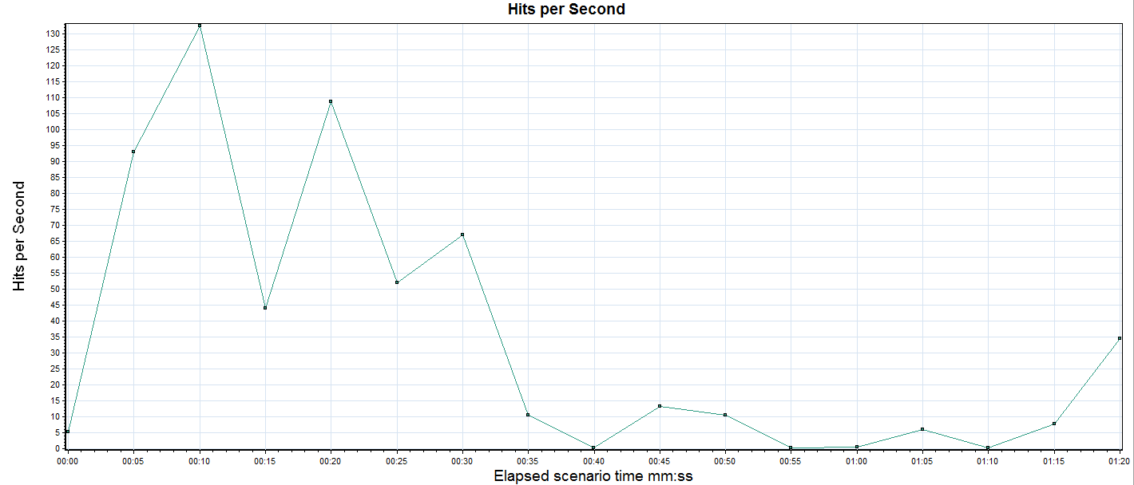

|  |  |  |  |  |  |  |
| --- | --- | --- | --- | --- | --- | --- |
| 颜色 | 比例 | 度量 | 图最小值 | 平均值 | 图最大值 | 图中间值 |
|  | 1 | 点击次数 | 0.200 | 34.405 | 132.400 | 10.400 |

描述: 显示负载测试期间每秒内 Vuser 在 Web 服务器上点击的次数。

|  |  |  |  |  |  |  |  |  |  |  |  |  |  |  |  |  |  |  |  |  |  |  |  |  |  |  |  |  |  |  |  |  |  |  |  |  |  |  |  |  |  |  |  |  |  |  |  |  |  |  |
| --- | --- | --- | --- | --- | --- | --- | --- | --- | --- | --- | --- | --- | --- | --- | --- | --- | --- | --- | --- | --- | --- | --- | --- | --- | --- | --- | --- | --- | --- | --- | --- | --- | --- | --- | --- | --- | --- | --- | --- | --- | --- | --- | --- | --- | --- | --- | --- | --- | --- | --- |
| 吞吐量 | | | | | | | | | | | | | | | | | | | | | | | | | | | | | | | | | | | | | | | | | | | | | | | |  | | |
|  |  |  |  |  |  | |  |  |  |  |  |  |  |  |  |  |  |  |  |  |  |  |  |  |  |  |  |  |  |  |  |  |  |  |  |  |  |  |  |  |  |  |  |  |  |  |  | | |
| 标题 | | | | | | 吞吐量 | | | | | | | | | | | | | | | | | | | | | | | | | | | | | | | | | | | | | | | | | | |
| 当前结果 | | | | | | H:\学者网测试\2脚本基准测试\Session1.lrr | | | | | | | | | | | | | | | | | | | | | | | | | | | | | | | | | | | | | | | | | | |
| 筛选器 | | | | | | 无 | | | | | | | | | | | | | | | | | | | | | | | | | | | | | | | | | | | | | | | | | | |
| 分组方式 | | | | | |  | | | | | | | | | | | | | | | | | | | | | | | | | | | | | | | | | | | | | | | | | | |
| 粒度 | | | | | | 5 秒 | | | | | | | | | | | | | | | | | | | | | | | | | | | | | | | | | | | | | | | | | | |

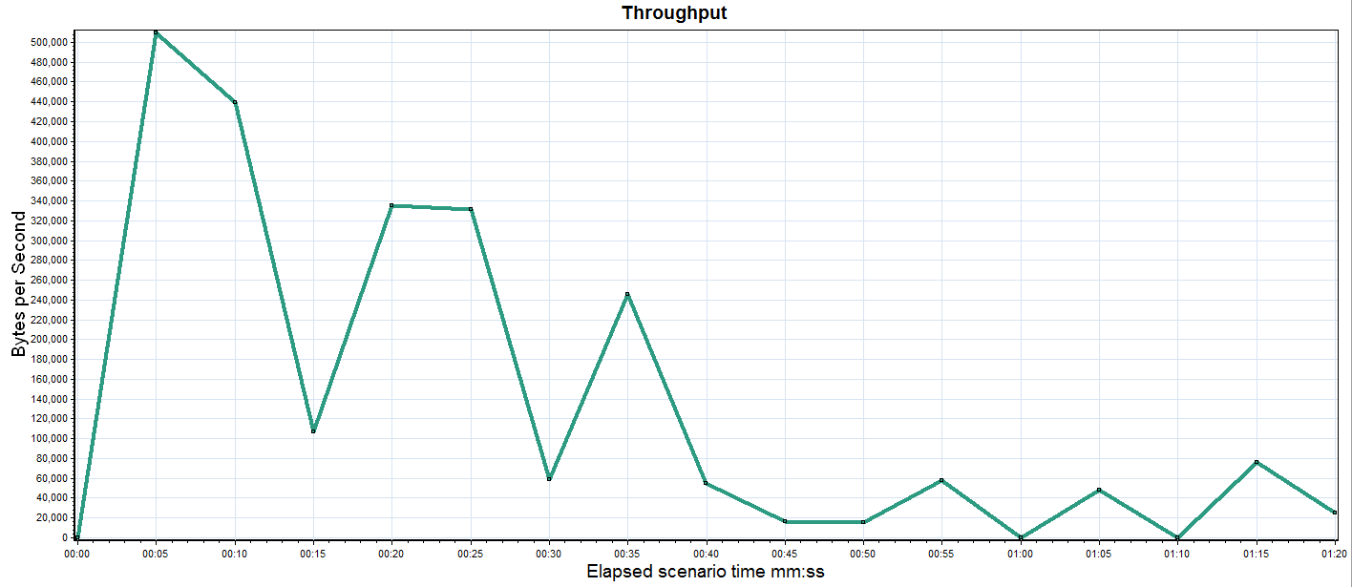

|  |  |  |  |  |  |  |
| --- | --- | --- | --- | --- | --- | --- |
| 颜色 | 比例 | 度量 | 图最小值 | 平均值 | 图最大值 | 图中间值 |
|  | 1 | Throughput | 0 | 137841.405 | 509606.400 | 162400.579 |

描述: 显示负载测试期间 Web 服务器上的吞吐量(字节)。吞吐量表示在任何指定秒内 Vuser 从服务器接收到的数据量，此次测试服务器的平均吞吐量是137K，并且与点击数图像相似，不存在性能缺陷。

|  |  |  |  |  |  |  |  |  |  |  |  |  |  |  |  |  |  |  |  |  |  |  |  |  |  |  |  |  |  |  |  |  |  |  |  |  |  |  |  |  |  |  |  |  |  |  |  |  |  |  |
| --- | --- | --- | --- | --- | --- | --- | --- | --- | --- | --- | --- | --- | --- | --- | --- | --- | --- | --- | --- | --- | --- | --- | --- | --- | --- | --- | --- | --- | --- | --- | --- | --- | --- | --- | --- | --- | --- | --- | --- | --- | --- | --- | --- | --- | --- | --- | --- | --- | --- | --- |
| 事务摘要 | | | | | | | | | | | | | | | | | | | | | | | | | | | | | | | | | | | | | | | | | | | | | | | |  | | |
|  |  |  |  |  |  | |  |  |  |  |  |  |  |  |  |  |  |  |  |  |  |  |  |  |  |  |  |  |  |  |  |  |  |  |  |  |  |  |  |  |  |  |  |  |  |  |  | | |
| 标题 | | | | | | 事务摘要 | | | | | | | | | | | | | | | | | | | | | | | | | | | | | | | | | | | | | | | | | | |
| 当前结果 | | | | | | H:\学者网测试\2脚本基准测试\Session1.lrr | | | | | | | | | | | | | | | | | | | | | | | | | | | | | | | | | | | | | | | | | | |
| 筛选器 | | | | | | (未 包括思考时间) | | | | | | | | | | | | | | | | | | | | | | | | | | | | | | | | | | | | | | | | | | |
| 分组方式 | | | | | |  | | | | | | | | | | | | | | | | | | | | | | | | | | | | | | | | | | | | | | | | | | |

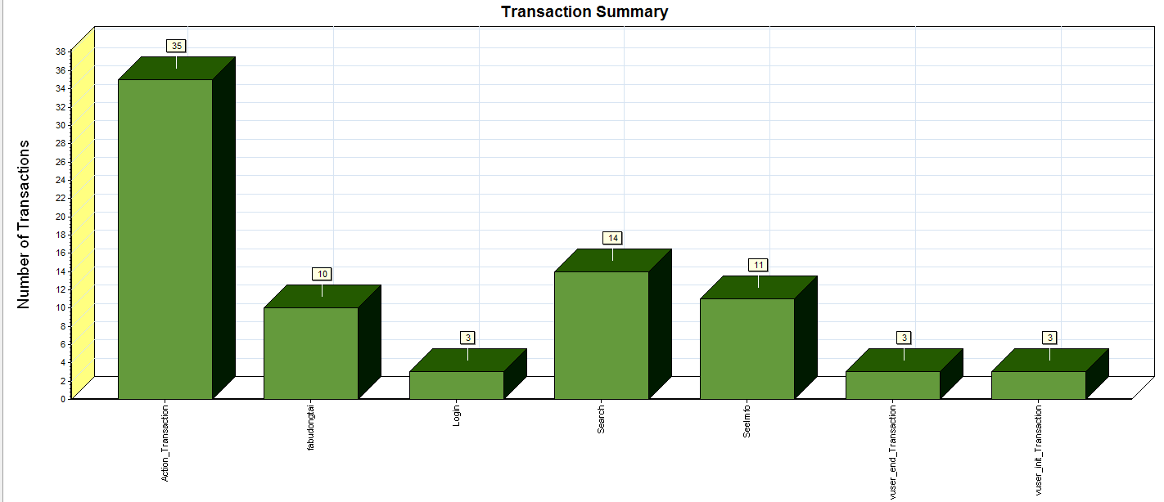

|  |  |  |  |  |  |  |  |  |  |  |  |  |  |  |  |  |  |  |  |  |  |  |  |  |  |  |  |  |  |  |  |  |  |  |  |  |  |  |  |  |  |  |  |  |  |  |  |  |  |  |  |  |  |  |  |  |  |  |  |  |  |  |  |
| --- | --- | --- | --- | --- | --- | --- | --- | --- | --- | --- | --- | --- | --- | --- | --- | --- | --- | --- | --- | --- | --- | --- | --- | --- | --- | --- | --- | --- | --- | --- | --- | --- | --- | --- | --- | --- | --- | --- | --- | --- | --- | --- | --- | --- | --- | --- | --- | --- | --- | --- | --- | --- | --- | --- | --- | --- | --- | --- | --- | --- | --- | --- | --- |
| 颜色 | | | 比例 | | 度量 | | | | | | | | | | | | | | | | | | | | | | | | | | | | | | | | | | | | | | | | | | | | | | | | | | | | | | | | | | |
|  | | | 1 | | Pass | | | | | | | | | | | | | | | | | | | | | | | | | | | | | | | | | | | | | | | | | | | | | | | | | | | | | | | | | | |
|  |  |  |  |  |  |  |  |  |  |  |  |  |  |  |  |  |  |  |  |  |  |  |  |  |  |  |  |  |  |  |  |  |  |  |  |  |  |  |  |  |  |  |  |  |  |  |  |  |  |  |  |  |  |  |  |  |  |  |  |  |  |  |
| 描述: 显示通过、失败、停止或因为出错而结束的事务的数目。 | | | | | | | | | | | | | | | | | | | | | | | | | | | | | | | | | | | | | | | | | | | | | | | | | | | | | | | | | | | | | | | |

|  |  |  |  |  |  |  |  |  |  |  |  |  |  |  |  |  |  |  |  |  |  |  |  |  |  |  |  |  |  |  |  |  |  |  |  |  |  |  |  |  |  |  |  |  |  |  |  |  |  |  |  |  |  |  |  |  |  |  |  |  |  |  |  |
| --- | --- | --- | --- | --- | --- | --- | --- | --- | --- | --- | --- | --- | --- | --- | --- | --- | --- | --- | --- | --- | --- | --- | --- | --- | --- | --- | --- | --- | --- | --- | --- | --- | --- | --- | --- | --- | --- | --- | --- | --- | --- | --- | --- | --- | --- | --- | --- | --- | --- | --- | --- | --- | --- | --- | --- | --- | --- | --- | --- | --- | --- | --- | --- |
| 平均事务响应时间 | | | | | | | | | | | | | | | | | | | | | | | | | | | | | | | | | | | | | | | | | | | | | | | | | | | | | | | | | | | | | | | |
|  |  |  |  |  |  |  |  |  |  |  |  |  |  |  |  |  |  |  |  |  |  |  |  |  |  |  |  |  |  |  |  |  |  |  |  |  |  |  |  |  |  |  |  |  |  |  |  |  |  |  |  |  |  |  |  |  |  |  |  |  |  |  |
| 标题 | | | | | | 平均事务响应时间 | | | | | | | | | | | | | | | | | | | | | | | | | | | | | | | | | | | | | | | | | | | | | | | | | | | | | | | | | |
| 当前结果 | | | | | | H:\学者网测试\2脚本基准测试\Session1.lrr | | | | | | | | | | | | | | | | | | | | | | | | | | | | | | | | | | | | | | | | | | | | | | | | | | | | | | | | | |
| 筛选器 | | | | | | 事务结束状态 = (Pass), (未 包括思考时间) | | | | | | | | | | | | | | | | | | | | | | | | | | | | | | | | | | | | | | | | | | | | | | | | | | | | | | | | | |
| 分组方式 | | | | | |  | | | | | | | | | | | | | | | | | | | | | | | | | | | | | | | | | | | | | | | | | | | | | | | | | | | | | | | | | |
| 粒度 | | | | | | 2 秒 | | | | | | | | | | | | | | | | | | | | | | | | | | | | | | | | | | | | | | | | | | | | | | | | | | | | | | | | | |

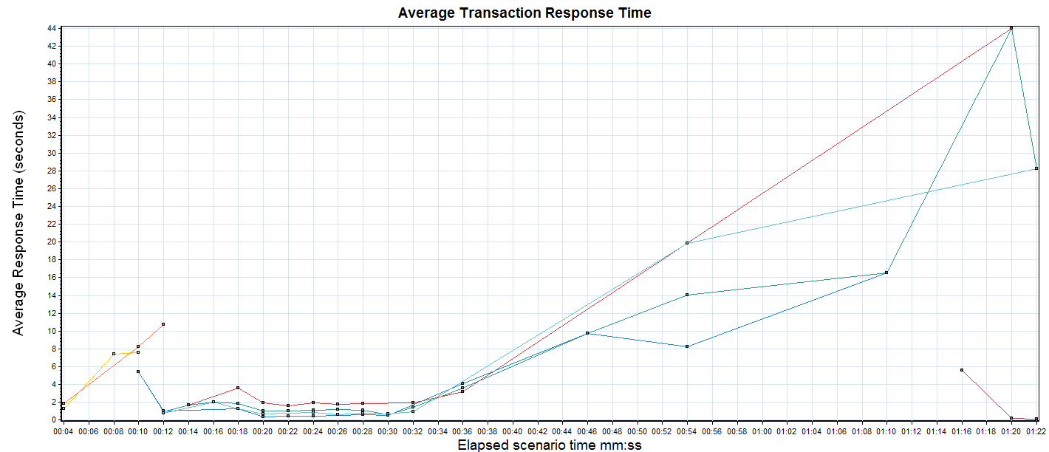

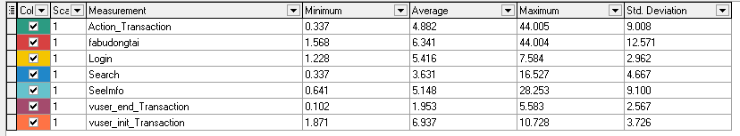

描述: 显示负载测试期间每秒内执行事务所需的平均时间。由本次测是结果可以看出各事务响应时间都短，不需要优化。

|  |  |  |  |  |  |  |  |  |  |  |  |  |  |  |  |  |  |  |  |  |  |  |  |  |  |  |  |  |  |  |  |  |  |  |  |  |  |  |  |  |  |  |  |  |  |  |  |  |  |  |  |  |  |  |  |  |  |  |  |  |  |  |  |
| --- | --- | --- | --- | --- | --- | --- | --- | --- | --- | --- | --- | --- | --- | --- | --- | --- | --- | --- | --- | --- | --- | --- | --- | --- | --- | --- | --- | --- | --- | --- | --- | --- | --- | --- | --- | --- | --- | --- | --- | --- | --- | --- | --- | --- | --- | --- | --- | --- | --- | --- | --- | --- | --- | --- | --- | --- | --- | --- | --- | --- | --- | --- | --- |
| Windows 资源 | | | | | | | | | | | | | | | | | | | | | | | | | | | | | | | | | | | | | | | | | | | | | | | | | | | | | | | | | | | | | | | |
|  |  |  |  |  |  |  |  |  |  |  |  |  |  |  |  |  |  |  |  |  |  |  |  |  |  |  |  |  |  |  |  |  |  |  |  |  |  |  |  |  |  |  |  |  |  |  |  |  |  |  |  |  |  |  |  |  |  |  |  |  |  |  |
| 标题 | | | | | | Windows 资源 | | | | | | | | | | | | | | | | | | | | | | | | | | | | | | | | | | | | | | | | | | | | | | | | | | | | | | | | | |
| 当前结果 | | | | | | H:\学者网测试\2脚本基准测试\Session1.lrr | | | | | | | | | | | | | | | | | | | | | | | | | | | | | | | | | | | | | | | | | | | | | | | | | | | | | | | | | |
| 筛选器 | | | | | | 无 | | | | | | | | | | | | | | | | | | | | | | | | | | | | | | | | | | | | | | | | | | | | | | | | | | | | | | | | | |
| 分组方式 | | | | | |  | | | | | | | | | | | | | | | | | | | | | | | | | | | | | | | | | | | | | | | | | | | | | | | | | | | | | | | | | |
| 粒度 | | | | | | 2 秒 | | | | | | | | | | | | | | | | | | | | | | | | | | | | | | | | | | | | | | | | | | | | | | | | | | | | | | | | | |

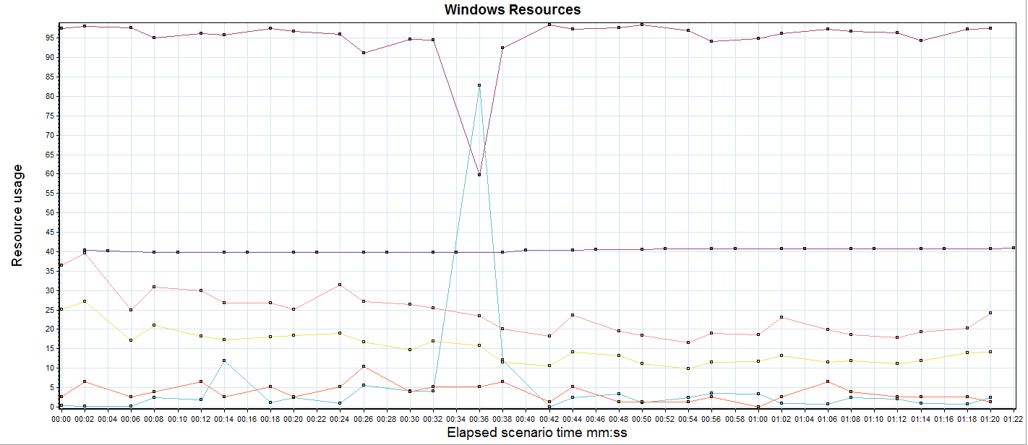

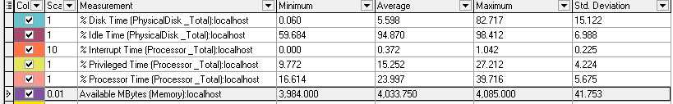

描述: 显示每台基于 Windows 的主机的系统资源使用情况的摘要。

### 8.2 并发测试结果

|  |
| --- |
| 业务流程 |

|  |  |  |  |  |  |  |  |  |
| --- | --- | --- | --- | --- | --- | --- | --- | --- |
| 运行名称 | 组名 | 脚本名称 | | 并发 Vuser 数 | 总 Vuser 数的 % | | 每小时事务数 | 开始时间 |
| Scenario2.lrr |  | WebHttpHtml2 | | 15 | 60 | |  |  |
| Scenario2.lrr |  | WebHttpHtml3 | | 15 | 60 | |  |  |
| Scenario2.lrr |  | Fabudongtai | | 10 | 60 | |  |  |
| 工作负载特性 | | | | | | | | | | | |
| 度量 | | | | Scenario2.lrr | | | | | | | |
| 最大运行 Vuser 数 | | | | 36 | | | | | | | |
| 每秒平均点击次数 | | | | 266.383 | | | | | | | |
| 总点击次数 | | | | 12520 | | | | | | | |
| 每秒通过的事务总数 | | | | 0.709 | | | | | | | |
| 每分钟通过的事务总数 | | | | 42.54 | | | | | | | |
| 事务总数 | | | | 7 | | | | | | | |
| 性能概述 | | | | | | | | | | | |
| 度量 | | | | | | | | 值 | | | | |
| 运行名称 | | | | | | | | Scenario2.lrr | | | | |
| 事务响应时间的加权平均值 | | | | | | | | 4.324 | | | | |
| 通过事务总数 | | | | | | | | 200 | | | | |
| 失败事务总数 | | | | | | | | 0 | | | | |
| 事务成功率(%) | | | | | | | | 100 | | | | |
| 每秒错误总数 | | | | | | | | 0 | | | | |
| 总错误数 | | | | | | | | 0 | | | | |

事务详情

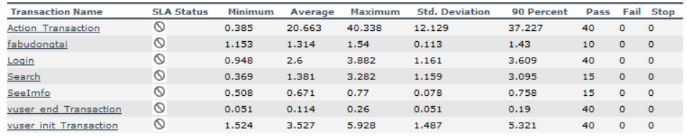

运行 Vuser

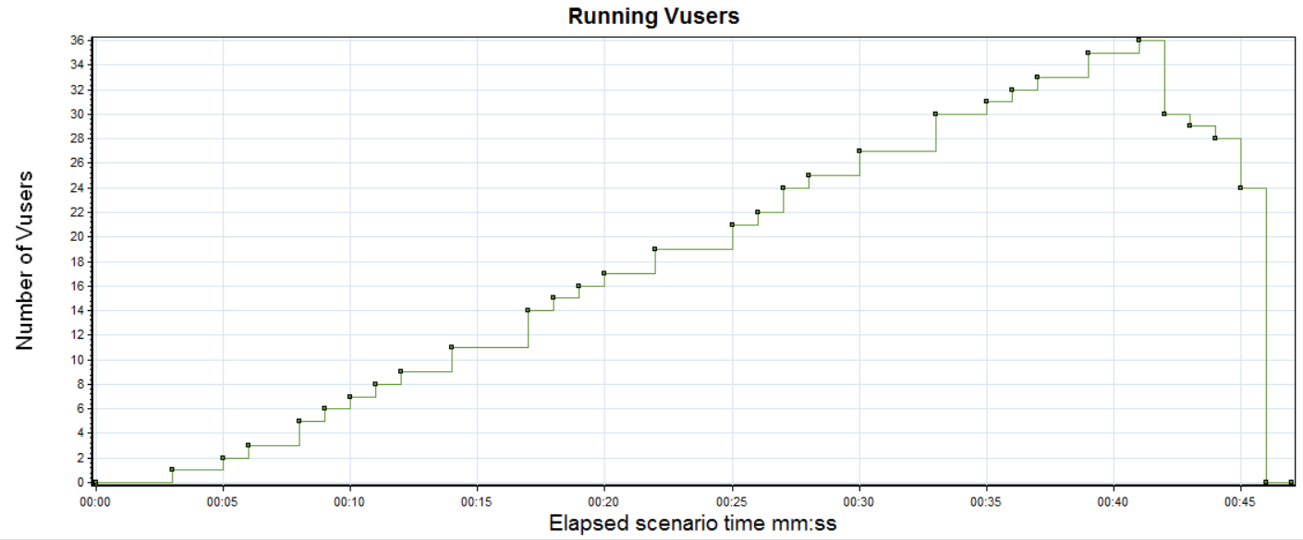

|  |  |  |  |  |  |  |  |  |  |  |  |  |  |  |  |  |  |  |  |  |  |  |  |  |  |  |  |  |  |  |  |  |  |  |  |  |  |  |  |  |  |  |  |  |  |  |  |  |  |  |  |  |  |  |  |  |  |  |  |  |  |  |
| --- | --- | --- | --- | --- | --- | --- | --- | --- | --- | --- | --- | --- | --- | --- | --- | --- | --- | --- | --- | --- | --- | --- | --- | --- | --- | --- | --- | --- | --- | --- | --- | --- | --- | --- | --- | --- | --- | --- | --- | --- | --- | --- | --- | --- | --- | --- | --- | --- | --- | --- | --- | --- | --- | --- | --- | --- | --- | --- | --- | --- | --- | --- |
| 颜色 | | | 比例 | | 度量 | | | | | | | | | | | | | | | | | | 图最小值 | | | | | | | | | | | | | | | | | | | 图平均值 | | | | | | | | | | | | | 图最大值 | | | | | | | |
|  | | | 1 | | Run | | | | | | | | | | | | | | | | | | 0 | | | | | | | | | | | | | | | | | | | 17.500 | | | | | | | | | | | | | 36 | | | | | | | |
| 描述: 显示负载测试的每秒期间执行 Vuser 脚本的 Vuser 的数目及其状态。 | | | | | | | | | | | | | | | | | | | | | | | | | | | | | | | | | | | | | | | | | | | | | | | | | | | | | | | | | | | | | | | |
| 每秒点击次数 | | | | | | | | | | | | | | | | | | | | | | | | | | | | | | | | | | | | | | | | | | | | | | | | | | | | | | | | | | | | | | | |
|  |  |  |  |  |  |  |  |  |  |  |  |  |  |  |  |  |  |  |  |  |  |  |  |  |  |  |  |  |  |  |  |  |  |  |  |  |  |  |  |  |  |  |  |  |  |  |  |  |  |  |  |  |  |  |  |  |  |  |  |  |  |  |
| 标题 | | | | | | 每秒点击次数 | | | | | | | | | | | | | | | | | | | | | | | | | | | | | | | | | | | | | | | | | | | | | | | | | | | | | | | | | |
| 当前结果 | | | | | | H:\学者网测试\并发测试\Scenario2.lrr | | | | | | | | | | | | | | | | | | | | | | | | | | | | | | | | | | | | | | | | | | | | | | | | | | | | | | | | | |
| 筛选器 | | | | | | 无 | | | | | | | | | | | | | | | | | | | | | | | | | | | | | | | | | | | | | | | | | | | | | | | | | | | | | | | | | |
| 分组方式 | | | | | |  | | | | | | | | | | | | | | | | | | | | | | | | | | | | | | | | | | | | | | | | | | | | | | | | | | | | | | | | | |
| 粒度 | | | | | | 5秒 | | | | | | | | | | | | | | | | | | | | | | | | | | | | | | | | | | | | | | | | | | | | | | | | | | | | | | | | | |

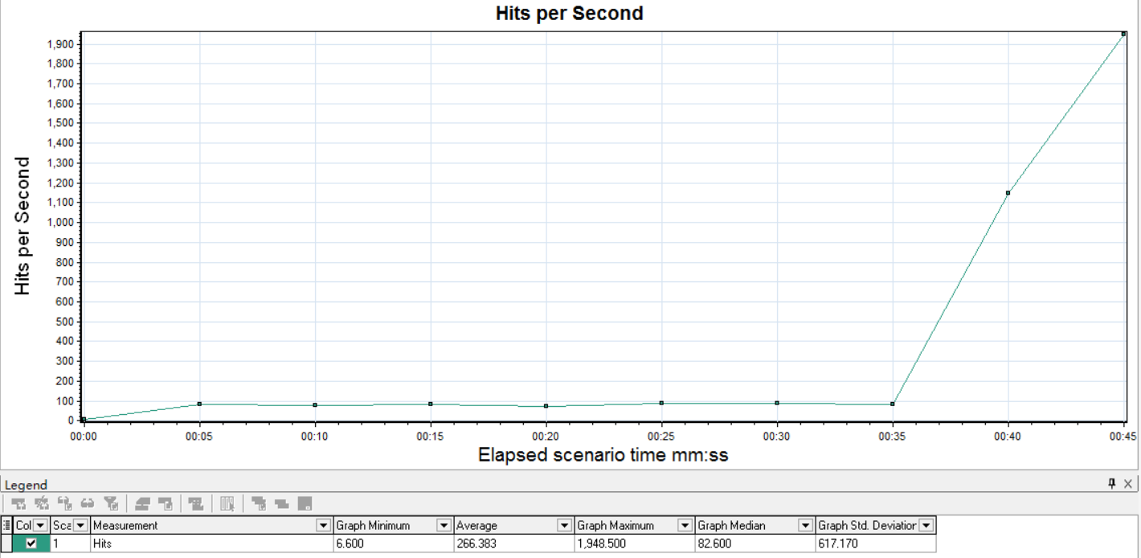

描述: 显示负载测试期间每秒内 Vuser 在 Web 服务器上点击的次数。

|  |  |  |  |  |  |  |  |  |  |  |  |  |  |  |  |  |  |  |  |  |  |  |  |  |  |  |  |  |  |  |  |  |  |  |  |  |  |  |  |  |  |  |  |  |  |  |  |  |  |  |  |  |  |  |  |  |  |  |  |  |  |  |  |
| --- | --- | --- | --- | --- | --- | --- | --- | --- | --- | --- | --- | --- | --- | --- | --- | --- | --- | --- | --- | --- | --- | --- | --- | --- | --- | --- | --- | --- | --- | --- | --- | --- | --- | --- | --- | --- | --- | --- | --- | --- | --- | --- | --- | --- | --- | --- | --- | --- | --- | --- | --- | --- | --- | --- | --- | --- | --- | --- | --- | --- | --- | --- | --- |
| 吞吐量 | | | | | | | | | | | | | | | | | | | | | | | | | | | | | | | | | | | | | | | | | | | | | | | | | | | | | | | | | | | | | | | |
|  |  |  |  |  |  |  |  |  |  |  |  |  |  |  |  |  |  |  |  |  |  |  |  |  |  |  |  |  |  |  |  |  |  |  |  |  |  |  |  |  |  |  |  |  |  |  |  |  |  |  |  |  |  |  |  |  |  |  |  |  |  |  |
| 标题 | | | | | | 吞吐量 | | | | | | | | | | | | | | | | | | | | | | | | | | | | | | | | | | | | | | | | | | | | | | | | | | | | | | | | | |
| 当前结果 | | | | | | H:\学者网测试\并发测试\Scenario2.lrr | | | | | | | | | | | | | | | | | | | | | | | | | | | | | | | | | | | | | | | | | | | | | | | | | | | | | | | | | |
| 筛选器 | | | | | | 无 | | | | | | | | | | | | | | | | | | | | | | | | | | | | | | | | | | | | | | | | | | | | | | | | | | | | | | | | | |
| 分组方式 | | | | | |  | | | | | | | | | | | | | | | | | | | | | | | | | | | | | | | | | | | | | | | | | | | | | | | | | | | | | | | | | |
| 粒度 | | | | | | 5秒 | | | | | | | | | | | | | | | | | | | | | | | | | | | | | | | | | | | | | | | | | | | | | | | | | | | | | | | | | |

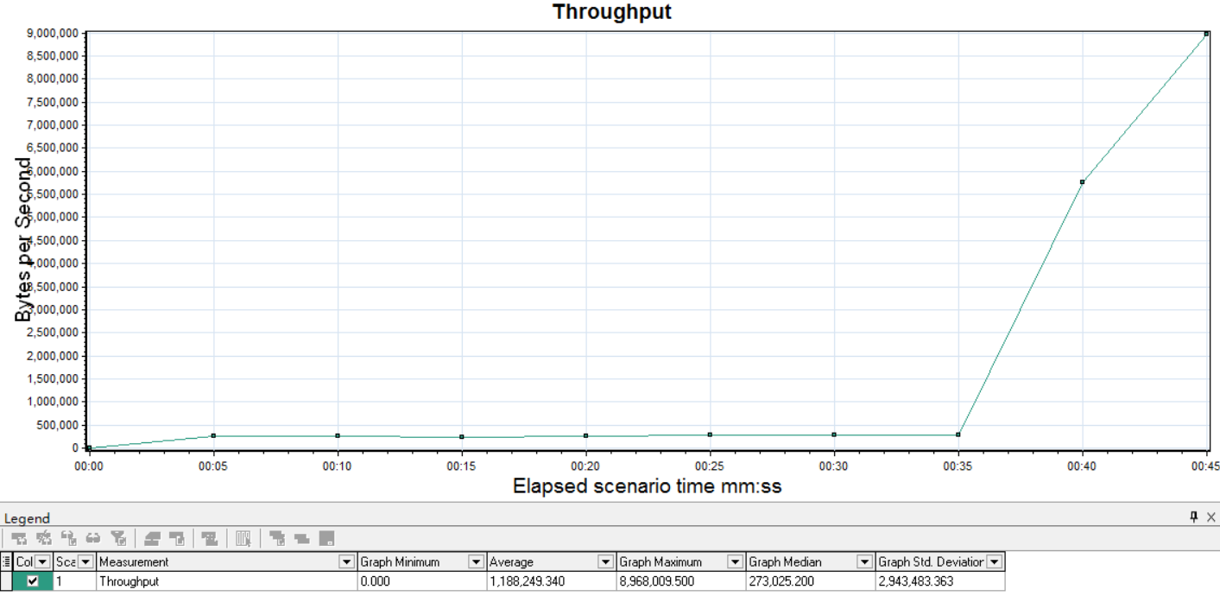

描述: 显示负载测试期间 Web 服务器上的吞吐量(字节)。

|  |  |  |  |  |  |  |  |  |  |  |  |  |  |  |  |  |  |  |  |  |  |  |  |  |  |  |  |  |  |  |  |  |  |  |  |  |  |  |  |  |  |  |  |  |  |  |  |  |  |  |  |  |  |  |  |  |  |  |  |  |  |  |  |
| --- | --- | --- | --- | --- | --- | --- | --- | --- | --- | --- | --- | --- | --- | --- | --- | --- | --- | --- | --- | --- | --- | --- | --- | --- | --- | --- | --- | --- | --- | --- | --- | --- | --- | --- | --- | --- | --- | --- | --- | --- | --- | --- | --- | --- | --- | --- | --- | --- | --- | --- | --- | --- | --- | --- | --- | --- | --- | --- | --- | --- | --- | --- | --- |
| 事务摘要 | | | | | | | | | | | | | | | | | | | | | | | | | | | | | | | | | | | | | | | | | | | | | | | | | | | | | | | | | | | | | | | |
|  |  |  |  |  |  |  |  |  |  |  |  |  |  |  |  |  |  |  |  |  |  |  |  |  |  |  |  |  |  |  |  |  |  |  |  |  |  |  |  |  |  |  |  |  |  |  |  |  |  |  |  |  |  |  |  |  |  |  |  |  |  |  |
| 标题 | | | | | | 事务摘要 | | | | | | | | | | | | | | | | | | | | | | | | | | | | | | | | | | | | | | | | | | | | | | | | | | | | | | | | | |
| 当前结果 | | | | | | H:\学者网测试\并发测试\Scenario2.lrr | | | | | | | | | | | | | | | | | | | | | | | | | | | | | | | | | | | | | | | | | | | | | | | | | | | | | | | | | |
| 筛选器 | | | | | | (未 包括思考时间) | | | | | | | | | | | | | | | | | | | | | | | | | | | | | | | | | | | | | | | | | | | | | | | | | | | | | | | | | |
| 分组方式 | | | | | |  | | | | | | | | | | | | | | | | | | | | | | | | | | | | | | | | | | | | | | | | | | | | | | | | | | | | | | | | | |

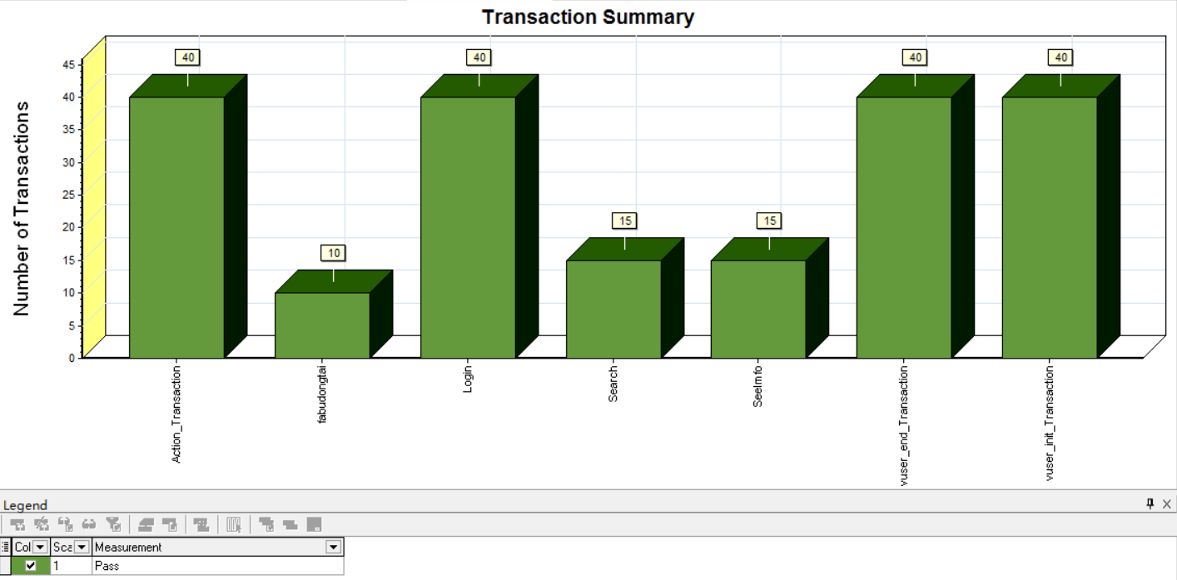

描述: 显示通过、失败、停止或因为出错而结束的事务的数目。

|  |  |  |  |  |  |  |  |  |  |  |  |  |  |  |  |  |  |  |  |  |  |  |  |  |  |  |  |  |  |  |  |  |  |  |  |  |  |  |  |  |  |  |  |  |  |  |  |  |  |  |  |  |  |  |  |  |  |  |  |  |  |  |  |
| --- | --- | --- | --- | --- | --- | --- | --- | --- | --- | --- | --- | --- | --- | --- | --- | --- | --- | --- | --- | --- | --- | --- | --- | --- | --- | --- | --- | --- | --- | --- | --- | --- | --- | --- | --- | --- | --- | --- | --- | --- | --- | --- | --- | --- | --- | --- | --- | --- | --- | --- | --- | --- | --- | --- | --- | --- | --- | --- | --- | --- | --- | --- | --- |
| 平均事务响应时间 | | | | | | | | | | | | | | | | | | | | | | | | | | | | | | | | | | | | | | | | | | | | | | | | | | | | | | | | | | | | | | | |
|  |  |  |  |  |  |  |  |  |  |  |  |  |  |  |  |  |  |  |  |  |  |  |  |  |  |  |  |  |  |  |  |  |  |  |  |  |  |  |  |  |  |  |  |  |  |  |  |  |  |  |  |  |  |  |  |  |  |  |  |  |  |  |
| 标题 | | | | | | 平均事务响应时间 | | | | | | | | | | | | | | | | | | | | | | | | | | | | | | | | | | | | | | | | | | | | | | | | | | | | | | | | | |
| 当前结果 | | | | | | H:\学者网测试\并发测试\Scenario2.lrr | | | | | | | | | | | | | | | | | | | | | | | | | | | | | | | | | | | | | | | | | | | | | | | | | | | | | | | | | |
| 筛选器 | | | | | | 事务结束状态 = (Pass), (未 包括思考时间) | | | | | | | | | | | | | | | | | | | | | | | | | | | | | | | | | | | | | | | | | | | | | | | | | | | | | | | | | |
| 分组方式 | | | | | |  | | | | | | | | | | | | | | | | | | | | | | | | | | | | | | | | | | | | | | | | | | | | | | | | | | | | | | | | | |
| 粒度 | | | | | | 1 秒 | | | | | | | | | | | | | | | | | | | | | | | | | | | | | | | | | | | | | | | | | | | | | | | | | | | | | | | | | |

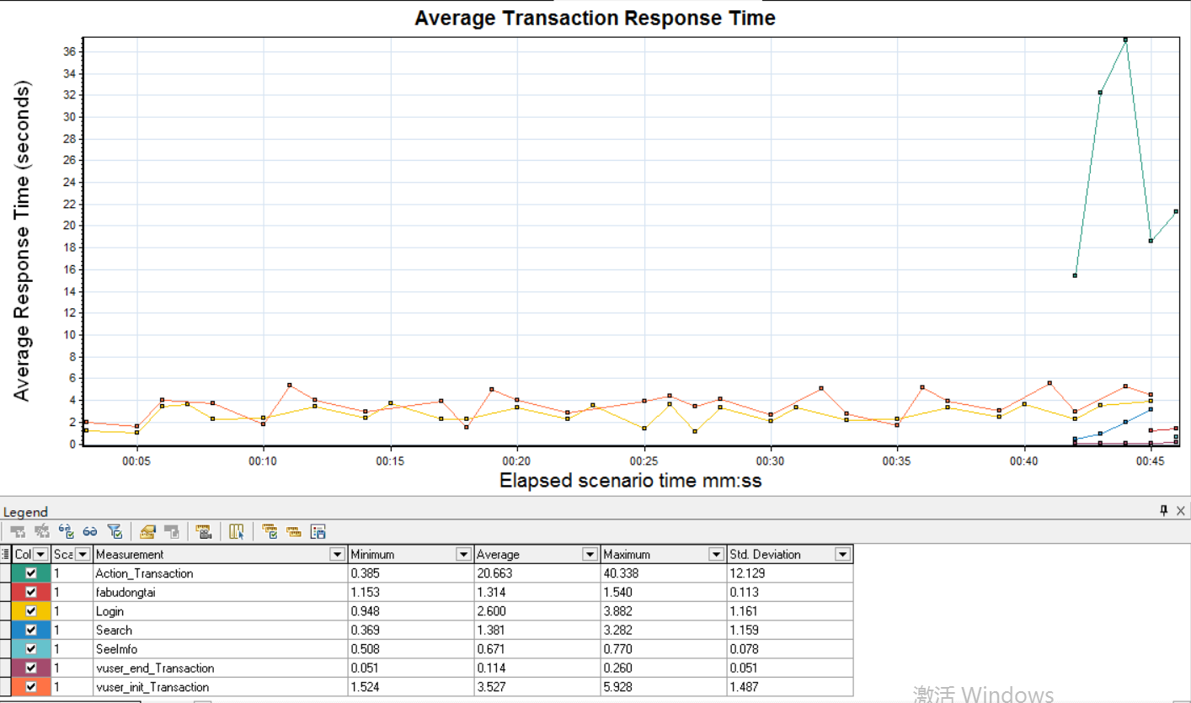

描述: 显示负载测试期间每秒内执行事务所需的平均时间。

|  |  |  |  |  |  |  |  |  |  |  |  |  |  |  |  |  |  |  |  |  |  |  |  |  |  |  |  |  |  |  |  |  |  |  |  |  |  |  |  |  |  |  |  |  |  |  |  |  |  |  |  |  |  |  |  |  |  |  |  |  |  |  |  |
| --- | --- | --- | --- | --- | --- | --- | --- | --- | --- | --- | --- | --- | --- | --- | --- | --- | --- | --- | --- | --- | --- | --- | --- | --- | --- | --- | --- | --- | --- | --- | --- | --- | --- | --- | --- | --- | --- | --- | --- | --- | --- | --- | --- | --- | --- | --- | --- | --- | --- | --- | --- | --- | --- | --- | --- | --- | --- | --- | --- | --- | --- | --- | --- |
| Windows 资源 | | | | | | | | | | | | | | | | | | | | | | | | | | | | | | | | | | | | | | | | | | | | | | | | | | | | | | | | | | | | | | | |
|  |  |  |  |  |  |  |  |  |  |  |  |  |  |  |  |  |  |  |  |  |  |  |  |  |  |  |  |  |  |  |  |  |  |  |  |  |  |  |  |  |  |  |  |  |  |  |  |  |  |  |  |  |  |  |  |  |  |  |  |  |  |  |
| 标题 | | | | | | Windows 资源 | | | | | | | | | | | | | | | | | | | | | | | | | | | | | | | | | | | | | | | | | | | | | | | | | | | | | | | | | |
| 当前结果 | | | | | | H:\学者网测试\并发测试\Scenario2.lrr | | | | | | | | | | | | | | | | | | | | | | | | | | | | | | | | | | | | | | | | | | | | | | | | | | | | | | | | | |
| 筛选器 | | | | | | 无 | | | | | | | | | | | | | | | | | | | | | | | | | | | | | | | | | | | | | | | | | | | | | | | | | | | | | | | | | |
| 分组方式 | | | | | |  | | | | | | | | | | | | | | | | | | | | | | | | | | | | | | | | | | | | | | | | | | | | | | | | | | | | | | | | | |
| 粒度 | | | | | | 1秒 | | | | | | | | | | | | | | | | | | | | | | | | | | | | | | | | | | | | | | | | | | | | | | | | | | | | | | | | | |

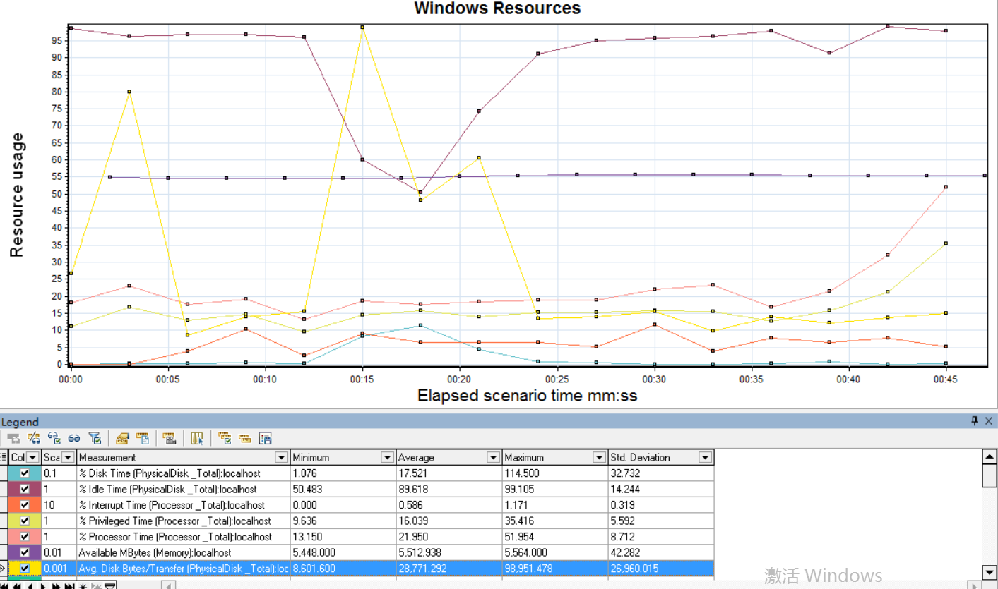

描述: 显示每台基于 Windows 的主机的系统资源使用情况的摘要。

### 8.3 综合场景测试结果

见稳定性测试报告

## 9 测试结果说明

本次测试一共测试了三种场景，结果总结如下

基准场景测试：由于是单用户操作，整个过程中没有出现错误，大部分的操作页面响应时间在2s以上，服务器系统资源占有率较高，未达到要求；

并发场景测试：用户并发达到40人，本次测试的模块中，没有出现错误，各性能指标正常；

综合场景测试：用户在25人并发的时候，持续操作半个小时；本次测试中，未出现页面错误的情况，页面响应成功率达到了100%，另外，仍然存在个别页面响应超过10s，需要优化，总体不影响系统的稳定性。

通过本次测试，系统在25人同时登录并执行相关操作的情况下，稳定运行半个小时，完全满足全覆盖阶段系统性能方面的要求；测试过程中出现个别页面响应超时，主要是该页面要通过互联网下载网络资源，可通过增加网络带宽和调整本地缓存来优化。