# 综合场景性能测试结果分析

——学者网

课程名称：软件测试与质量

姓 名：李祺

学 号：20152005031

专 业：软件工程

日期:2018-06-11

业务流程

|  |  |  |  |  |  |  |
| --- | --- | --- | --- | --- | --- | --- |
| 运行名称 | 组名 | 脚本名称 | 并发 Vuser 数 | 总 Vuser 数的 % | 每小时事务数 | 思考时间 |
| Scenariol.lrr |  | WebHttpHtml2 | 10 | 25 |  | 按录制时的原样回放 |
| Scenariol.lrr |  | WebHttpHtml3 | 10 | 25 |  | 按录制时的原样回放 |
| Scenariol.lrr |  | Fabudongtai | 5 | 25 |  | 按录制时的原样回放 |
|  |  | 总计: | 25 | 100% |  |  |

一、性能概要描述

|  |  |
| --- | --- |
| 度量 | res.lrr |
| 最大运行 Vuser 数 | 24 |
| 每秒平均点击次数 | 32.116 |
| 总点击次数 | 61405 |
| 每秒通过的事务总数 |  |
| 每分钟通过的事务总数 |  |
| 事务总数 | 7 |

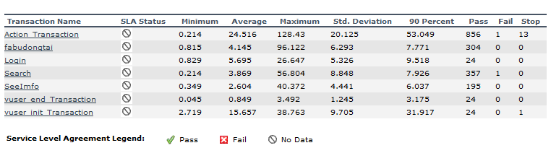

|  |  |
| --- | --- |
| 运行 Vuser | |
| 标题 | 运行 Vuser |
| 当前结果 | H:\学者网测试\综合场景测试\Session1.lrr |
| 筛选器 | Vuser 状态 = (Run) |
| 分组方式 |  |
| 粒度 | 64秒 |

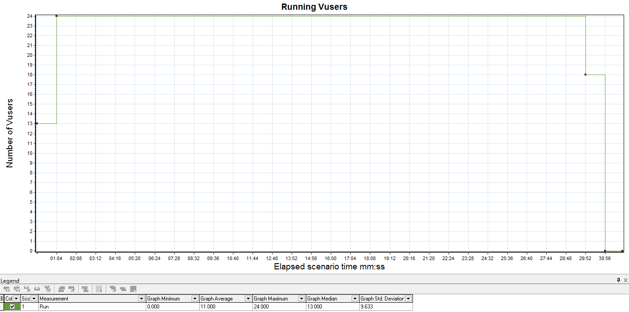

描述: 显示负载测试的每秒期间执行 Vuser 脚本的 Vuser 的数目及其状态。此图对于确定任何指定时刻服务器上的 Vuser 负载非常有用。

|  |  |  |  |  |  |  |  |  |  |  |  |  |  |  |  |  |  |  |  |  |  |  |  |  |  |  |  |  |  |  |  |  |  |  |  |  |  |  |  |  |  |  |  |  |  |  |  |
| --- | --- | --- | --- | --- | --- | --- | --- | --- | --- | --- | --- | --- | --- | --- | --- | --- | --- | --- | --- | --- | --- | --- | --- | --- | --- | --- | --- | --- | --- | --- | --- | --- | --- | --- | --- | --- | --- | --- | --- | --- | --- | --- | --- | --- | --- | --- | --- |
| 每秒点击次数 | | | | | | | | | | | | | | | | | | | | | | | | | | | | | | | | | | | | | | | | | | | | | | | |
|  |  |  |  |  |  | |  |  |  |  |  |  |  |  |  |  |  |  |  |  |  |  |  |  |  |  |  |  |  |  |  |  |  |  |  |  |  |  |  |  |  |  |  |  |  |  |  | |
| 标题 | | | | | | 每秒点击次数 | | | | | | | | | | | | | | | | | | | | | | | | | | | | | | | | | | | | | | | | | |
| 当前结果 | | | | | | H:\学者网测试\综合场景测试\Session1.lrr | | | | | | | | | | | | | | | | | | | | | | | | | | | | | | | | | | | | | | | | | |
| 筛选器 | | | | | | 无 | | | | | | | | | | | | | | | | | | | | | | | | | | | | | | | | | | | | | | | | | |
| 分组方式 | | | | | |  | | | | | | | | | | | | | | | | | | | | | | | | | | | | | | | | | | | | | | | | | |
| 粒度 | | | | | | 64 秒 | | | | | | | | | | | | | | | | | | | | | | | | | | | | | | | | | | | | | | | | | |

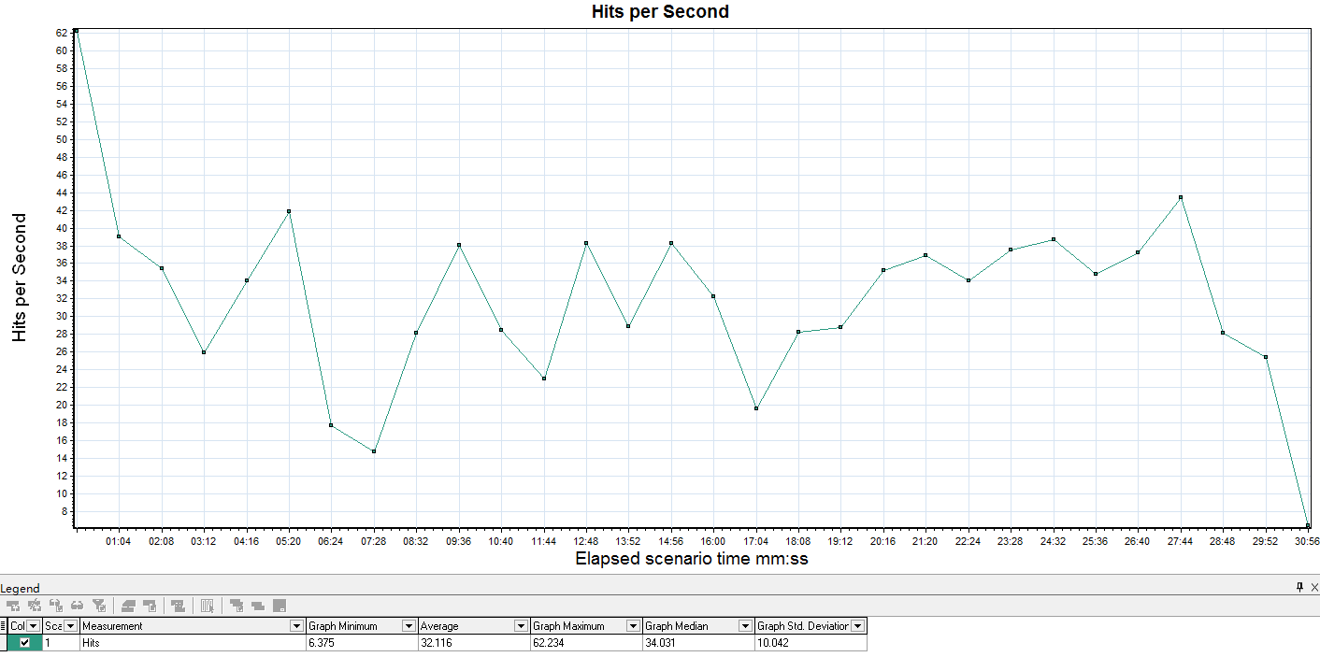

描述: 显示负载测试期间每秒内 Vuser 在 Web 服务器上点击的次数。

|  |  |  |  |  |  |  |  |  |  |  |  |  |  |  |  |  |  |  |  |  |  |  |  |  |  |  |  |  |  |  |  |  |  |  |  |  |  |  |  |  |  |  |  |  |  |  |  |
| --- | --- | --- | --- | --- | --- | --- | --- | --- | --- | --- | --- | --- | --- | --- | --- | --- | --- | --- | --- | --- | --- | --- | --- | --- | --- | --- | --- | --- | --- | --- | --- | --- | --- | --- | --- | --- | --- | --- | --- | --- | --- | --- | --- | --- | --- | --- | --- |
| 吞吐量 | | | | | | | | | | | | | | | | | | | | | | | | | | | | | | | | | | | | | | | | | | | | | | | |
|  |  |  |  |  |  | |  |  |  |  |  |  |  |  |  |  |  |  |  |  |  |  |  |  |  |  |  |  |  |  |  |  |  |  |  |  |  |  |  |  |  |  |  |  |  |  |  | |
| 标题 | | | | | | 吞吐量 | | | | | | | | | | | | | | | | | | | | | | | | | | | | | | | | | | | | | | | | | |
| 当前结果 | | | | | | H:\学者网测试\综合场景测试\Session1.lrr | | | | | | | | | | | | | | | | | | | | | | | | | | | | | | | | | | | | | | | | | |
| 筛选器 | | | | | | 无 | | | | | | | | | | | | | | | | | | | | | | | | | | | | | | | | | | | | | | | | | |
| 分组方式 | | | | | |  | | | | | | | | | | | | | | | | | | | | | | | | | | | | | | | | | | | | | | | | | |
| 粒度 | | | | | | 64 秒 | | | | | | | | | | | | | | | | | | | | | | | | | | | | | | | | | | | | | | | | | |

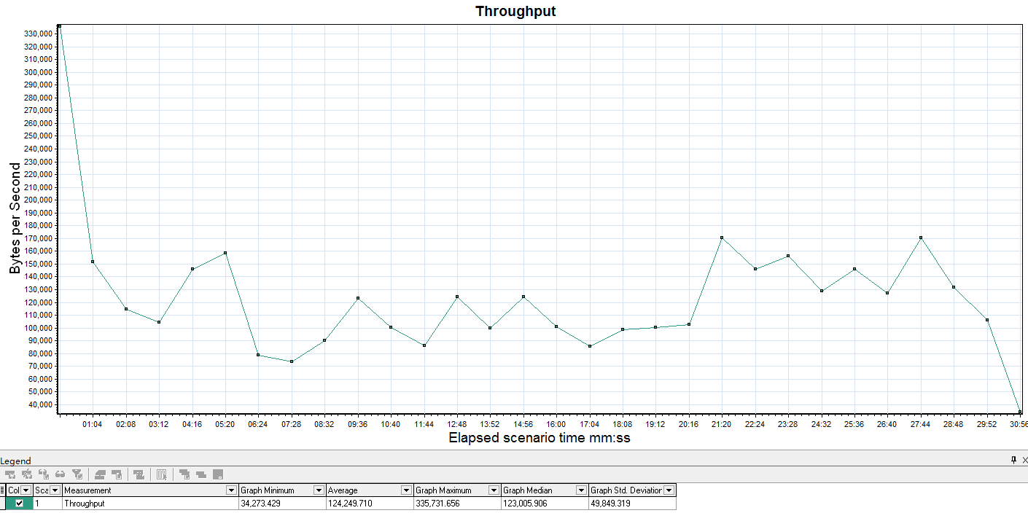

描述: 显示负载测试期间 Web 服务器上的吞吐量(字节)。吞吐量表示在任何指定秒内 Vuser 从服务器接收到的数据量。

|  |  |  |  |  |  |  |  |  |  |  |  |  |  |  |  |  |  |  |  |  |  |  |  |  |  |  |  |  |  |  |  |  |  |  |  |  |  |  |  |  |  |  |  |  |  |  |  |
| --- | --- | --- | --- | --- | --- | --- | --- | --- | --- | --- | --- | --- | --- | --- | --- | --- | --- | --- | --- | --- | --- | --- | --- | --- | --- | --- | --- | --- | --- | --- | --- | --- | --- | --- | --- | --- | --- | --- | --- | --- | --- | --- | --- | --- | --- | --- | --- |
| 事务摘要 | | | | | | | | | | | | | | | | | | | | | | | | | | | | | | | | | | | | | | | | | | | | | | | |
|  |  |  |  |  |  | |  |  |  |  |  |  |  |  |  |  |  |  |  |  |  |  |  |  |  |  |  |  |  |  |  |  |  |  |  |  |  |  |  |  |  |  |  |  |  |  |  | | |
| 标题 | | | | | | 事务摘要 | | | | | | | | | | | | | | | | | | | | | | | | | | | | | | | | | | | | | | | | | | |
| 当前结果 | | | | | | H:\学者网测试\综合场景测试\Session1.lrr | | | | | | | | | | | | | | | | | | | | | | | | | | | | | | | | | | | | | | | | | | |
| 筛选器 | | | | | | (未 包括思考时间) | | | | | | | | | | | | | | | | | | | | | | | | | | | | | | | | | | | | | | | | | | |
| 分组方式 | | | | | |  | | | | | | | | | | | | | | | | | | | | | | | | | | | | | | | | | | | | | | | | | | |

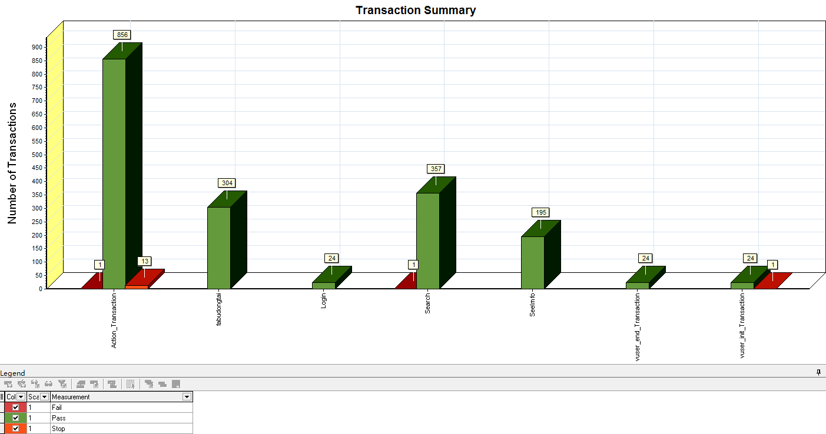

描述: 显示通过、失败、停止或因为出错而结束的事务的数目。

|  |  |  |  |  |  |  |  |  |  |  |  |  |  |  |  |  |  |  |  |  |  |  |  |  |  |  |  |  |  |  |  |  |  |  |  |  |  |  |  |  |  |  |  |  |  |  |  |  |  |  |  |  |  |  |  |  |  |  |  |  |  |  |  |
| --- | --- | --- | --- | --- | --- | --- | --- | --- | --- | --- | --- | --- | --- | --- | --- | --- | --- | --- | --- | --- | --- | --- | --- | --- | --- | --- | --- | --- | --- | --- | --- | --- | --- | --- | --- | --- | --- | --- | --- | --- | --- | --- | --- | --- | --- | --- | --- | --- | --- | --- | --- | --- | --- | --- | --- | --- | --- | --- | --- | --- | --- | --- | --- |
| 平均事务响应时间 | | | | | | | | | | | | | | | | | | | | | | | | | | | | | | | | | | | | | | | | | | | | | | | | | | | | | | | | | | | | | | | |
|  |  |  |  |  |  |  |  |  |  |  |  |  |  |  |  |  |  |  |  |  |  |  |  |  |  |  |  |  |  |  |  |  |  |  |  |  |  |  |  |  |  |  |  |  |  |  |  |  |  |  |  |  |  |  |  |  |  |  |  |  |  |  |
| 标题 | | | | | | 平均事务响应时间 | | | | | | | | | | | | | | | | | | | | | | | | | | | | | | | | | | | | | | | | | | | | | | | | | | | | | | | | | |
| 当前结果 | | | | | | H:\学者网测试\综合场景测试\Session1.lrr | | | | | | | | | | | | | | | | | | | | | | | | | | | | | | | | | | | | | | | | | | | | | | | | | | | | | | | | | |
| 筛选器 | | | | | | 事务结束状态 = (Pass), (未 包括思考时间) | | | | | | | | | | | | | | | | | | | | | | | | | | | | | | | | | | | | | | | | | | | | | | | | | | | | | | | | | |
| 分组方式 | | | | | |  | | | | | | | | | | | | | | | | | | | | | | | | | | | | | | | | | | | | | | | | | | | | | | | | | | | | | | | | | |
| 粒度 | | | | | | 64秒 | | | | | | | | | | | | | | | | | | | | | | | | | | | | | | | | | | | | | | | | | | | | | | | | | | | | | | | | | |

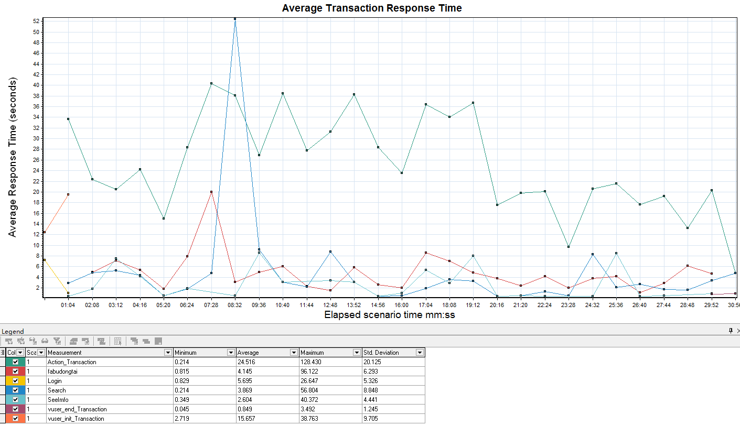

描述: 显示负载测试期间每秒内执行事务所需的平均时间。

|  |  |  |  |  |  |  |  |  |  |  |  |  |  |  |  |  |  |  |  |  |  |  |  |  |  |  |  |  |  |  |  |  |  |  |  |  |  |  |  |  |  |  |  |  |  |  |  |  |  |  |  |  |  |  |  |  |  |  |  |  |  |  |  |
| --- | --- | --- | --- | --- | --- | --- | --- | --- | --- | --- | --- | --- | --- | --- | --- | --- | --- | --- | --- | --- | --- | --- | --- | --- | --- | --- | --- | --- | --- | --- | --- | --- | --- | --- | --- | --- | --- | --- | --- | --- | --- | --- | --- | --- | --- | --- | --- | --- | --- | --- | --- | --- | --- | --- | --- | --- | --- | --- | --- | --- | --- | --- | --- |
| Windows 资源 | | | | | | | | | | | | | | | | | | | | | | | | | | | | | | | | | | | | | | | | | | | | | | | | | | | | | | | | | | | | | | | |
|  |  |  |  |  |  |  |  |  |  |  |  |  |  |  |  |  |  |  |  |  |  |  |  |  |  |  |  |  |  |  |  |  |  |  |  |  |  |  |  |  |  |  |  |  |  |  |  |  |  |  |  |  |  |  |  |  |  |  |  |  |  |  |
| 标题 | | | | | | Windows 资源 | | | | | | | | | | | | | | | | | | | | | | | | | | | | | | | | | | | | | | | | | | | | | | | | | | | | | | | | | |
| 当前结果 | | | | | | H:\学者网测试\综合场景测试\Session1.lrr | | | | | | | | | | | | | | | | | | | | | | | | | | | | | | | | | | | | | | | | | | | | | | | | | | | | | | | | | |
| 筛选器 | | | | | | 无 | | | | | | | | | | | | | | | | | | | | | | | | | | | | | | | | | | | | | | | | | | | | | | | | | | | | | | | | | |
| 分组方式 | | | | | |  | | | | | | | | | | | | | | | | | | | | | | | | | | | | | | | | | | | | | | | | | | | | | | | | | | | | | | | | | |
| 粒度 | | | | | | 64秒 | | | | | | | | | | | | | | | | | | | | | | | | | | | | | | | | | | | | | | | | | | | | | | | | | | | | | | | | | |

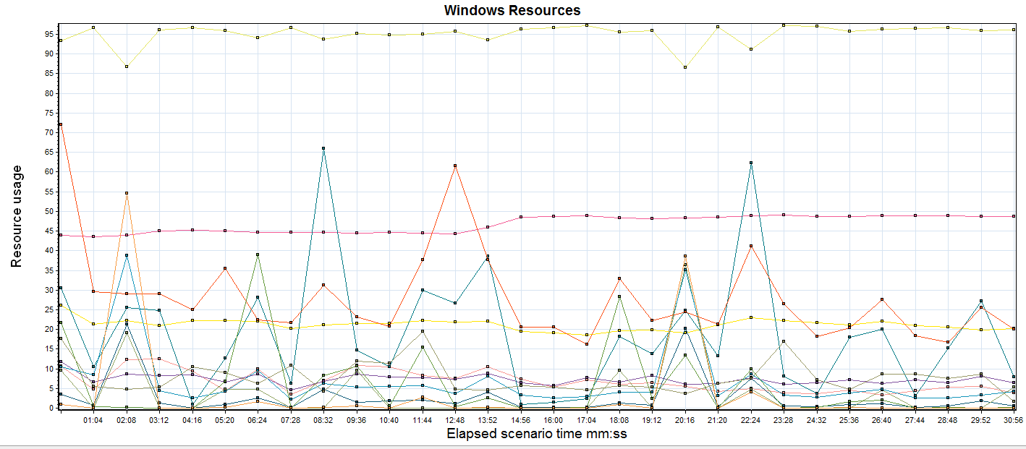

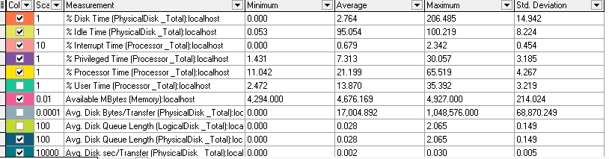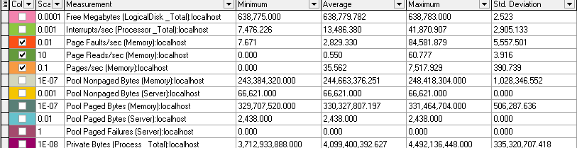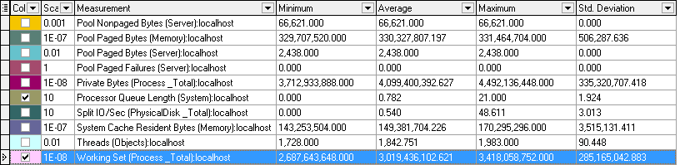

描述: 显示每台基于 Windows 的主机的系统资源使用情况的摘要。

1. **查看处理器**
2. 判断处理器队列是否堵塞：

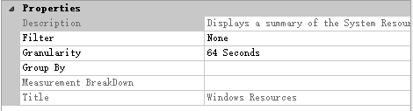

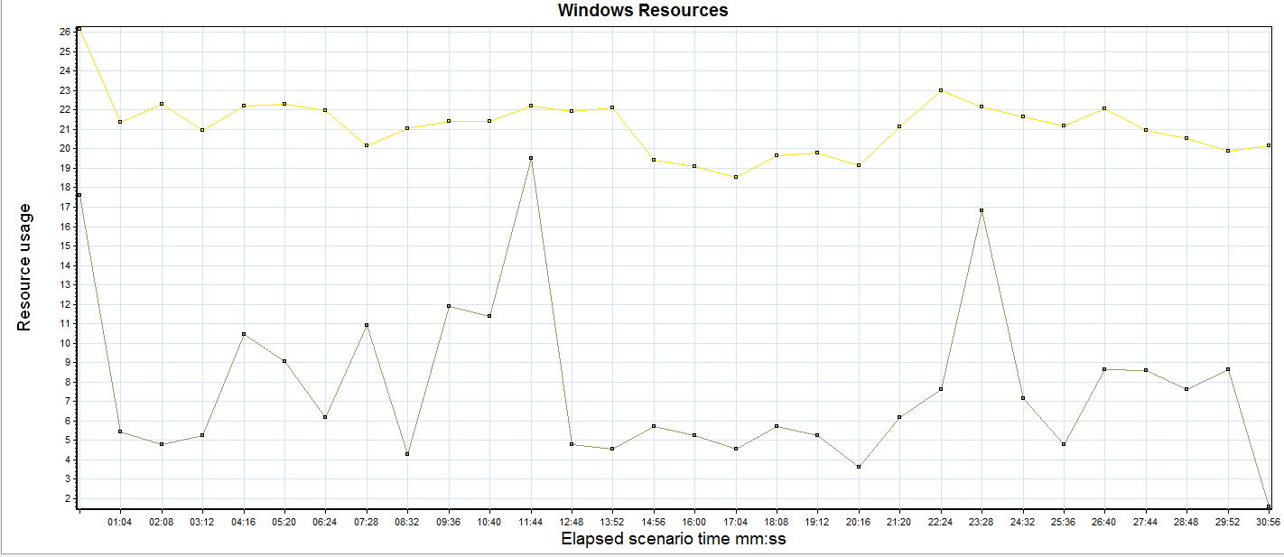

综合-堵塞1综合-堵塞2

分析：从上图可以看出处理器利用(% Processor Time)一直很高， Processor Queue Length大于2，不存在处理器堵塞。

1. 判断处理器是否瓶颈：

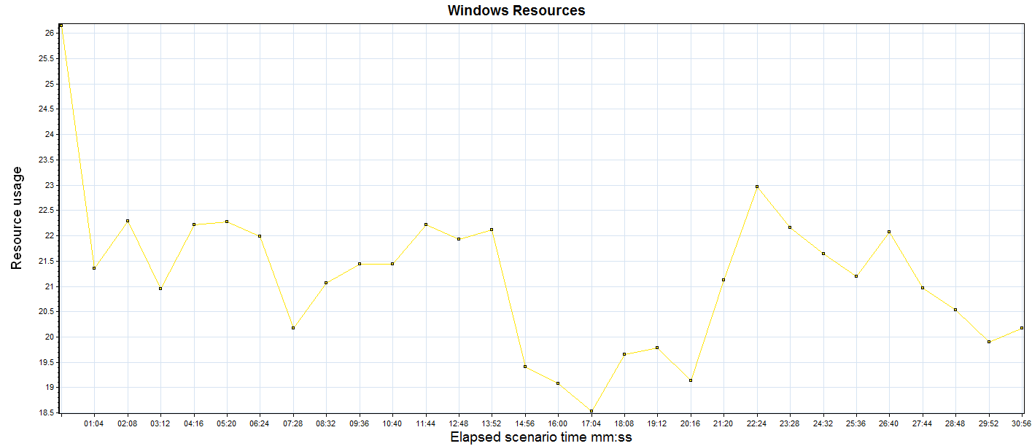

综合-堵塞1

分析：从上图的处理器利用(% Processor Time)可以看出，并没有一个或多个处理器的相应数值持续超过90%,处理器不可能是瓶颈点。

1. 监控% Interrupt Time

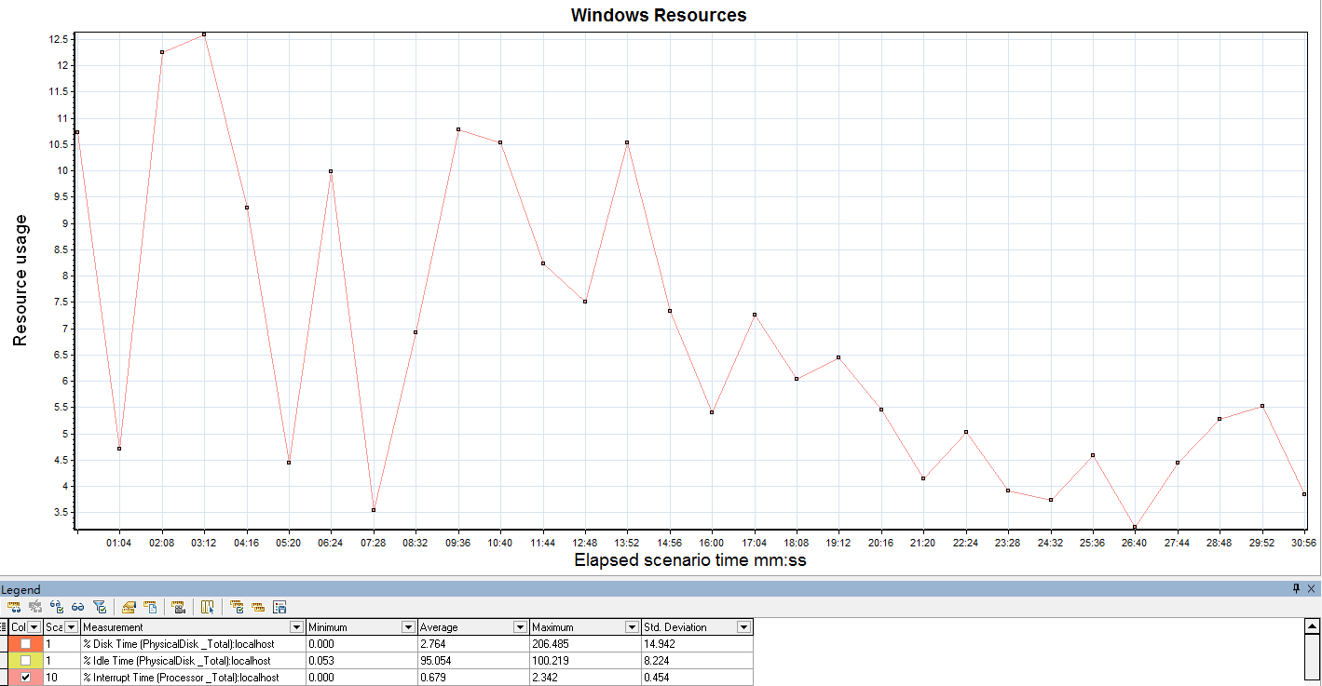

分析：从上图可以看出，% Interrupt Time计数器持续低于15%，而处理器使用率也未超过90%，就可以断定处理器负荷不重，可以满足业务增长的需要。

1. **查看内存**

（1）通过 Pages/sec指标判断是否存在内存问题。

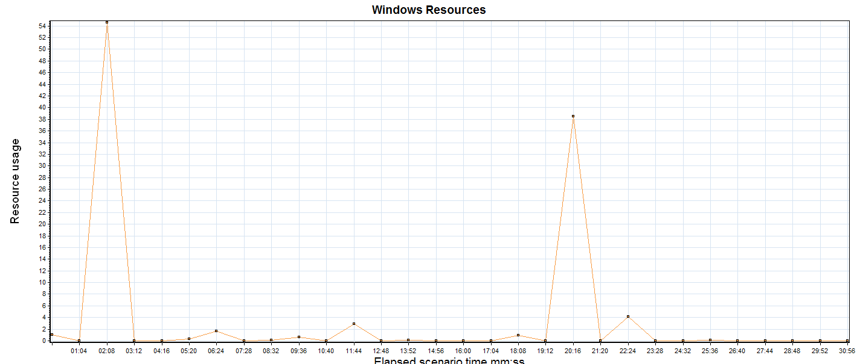

综合-pagesec1

分析：从上图可以看出， Pages/sec较低，不存在内存问题。

1. 通过 Available Mbytes来判断是否存在严重内存泄漏。

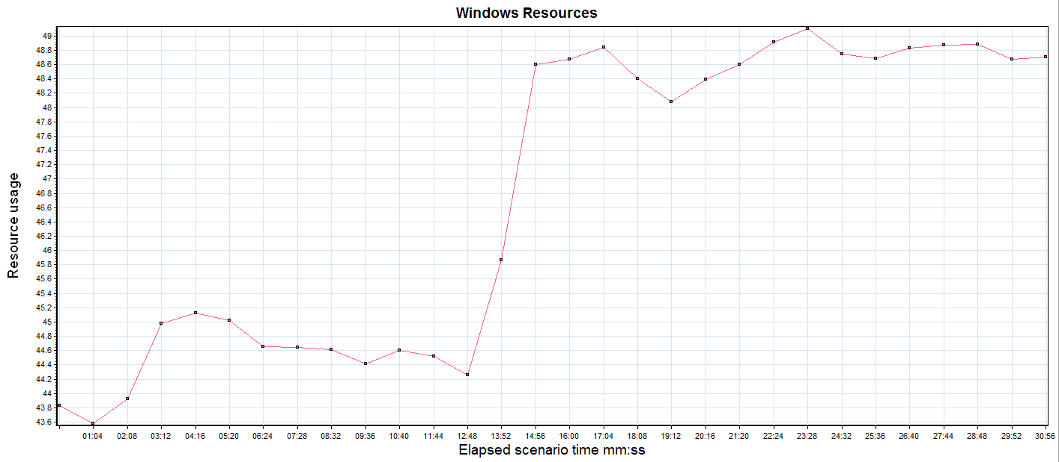

综合-Available1

分析：从上图可以看出，Available Mbytes的值没有出现低于4MB或更小的情况，说明计算机上总的内存充足。

1. 通过 Page Read/sec来判断内存瓶颈。

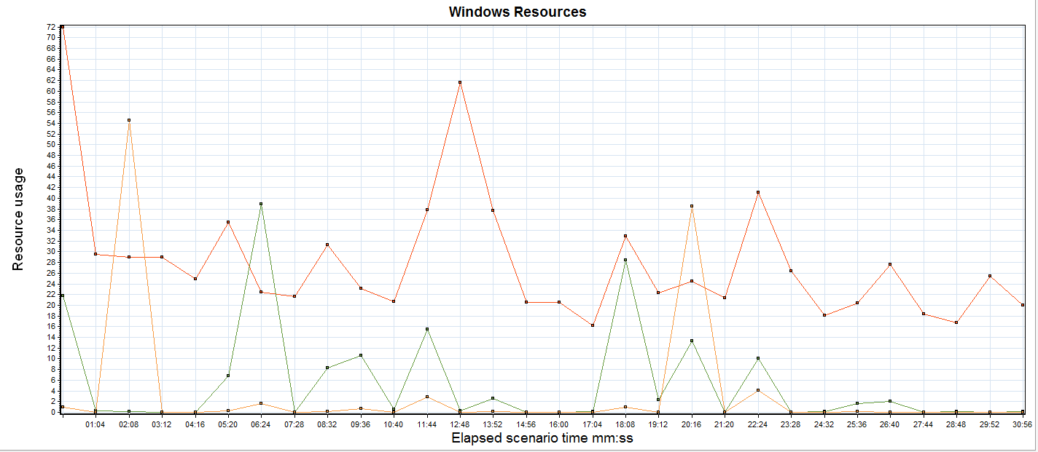

综合-pagesec瓶颈1

分析：从上图可以看出， Page Read/sec表示每秒页的硬故障数。系统为了解析对内存的引用，必须要知道读取页文件的次数。 Page Read/sec阈值为>5。数值大表示缓存中没有相应的内容，而需要从磁盘读取了。结合其他两个计数器指标 Pages/sec和 Page Faults/sec考虑，Pages/se和 Page Faults/sec的值持续很高，这时判断可能是内存有问题，此时再检查 Pages Read的值是否超过5，如果是大于5，则100%确定存在内存问题。

1. 结合Disk计数器来判断是内存问题还是磁盘问题，避免混淆。

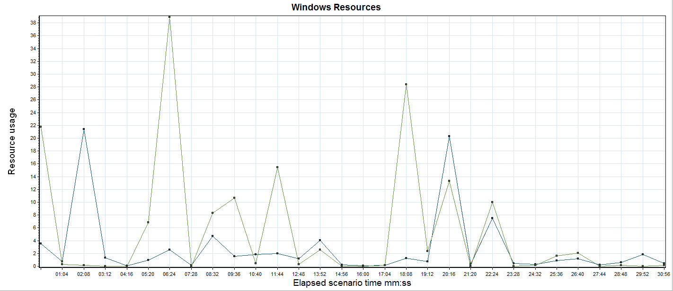综合-Disk1综合-Disk2综合-Disk3

分析：从上图可以看出， 页面读取操作速率 Page Reads/sec指标的值不低，同时% Disk Time和Avg Disk Queue Length的值也不高，确定不是磁盘瓶颈。但 Avg Disk Queue Length队列长度指标增加的同时 Page Reads/sec页面读取速率指标并未降低，确定为内存不足。

1. 用增大法来判断内存问题。

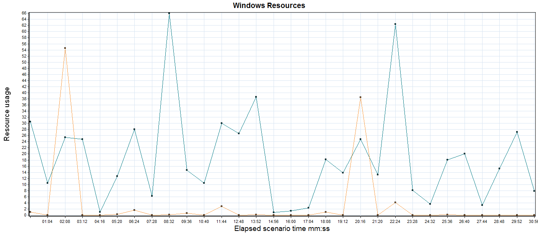综合-增大法1综合-增大法2

分析：将 Physical Diski\\Avg.Disk sec/T ransfer和Memory\\pages/sec计数器的值增大数倍。这些计数器指标的值结果超过了并未一直超过0.1。运行系统的物理内存充足。

1. **查看磁盘**

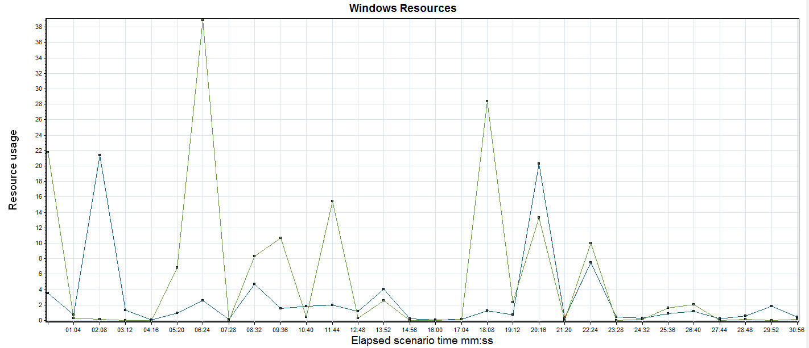综合-磁盘瓶颈1综合-磁盘瓶颈2综合-磁盘瓶颈3

分析：Disk Time指标和 Avg Disk Queue Length指标的值都一致，Page Reads/sec面读取操作速率并不低，确定为不存在磁盘瓶颈。

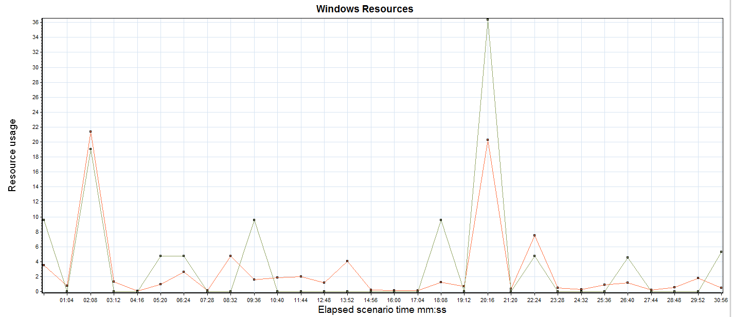

综合-current1综合-current2

分析：Current Disk Queue Length指标的值平均小于2。如果% Disk Time较小，不存在系统磁盘处理性能障碍。