**OVERVIEW**

This document describes the high-level architecture and design of a socket-based chat application with client-server architecture, supporting multiple concurrent users, account registration/login, and persistent chat history.

**SYSTEM ARCHITECTURE**

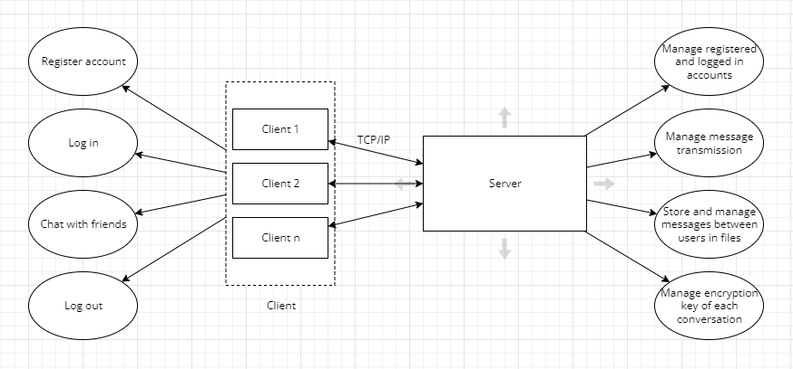

**PROTOCOL SPECIFICATION**

**Message frame format:   
 |** Sender ID(4 bytes) | Receiver ID(4 bytes) | Cmd(4 bytes) | Payload(100 bytes) |

**BUILD**

To generate an executable file: make all  
To run server: ./server  
To run client (Can run client on multiple terminal): ./client

**APPLICATION USAGE GUIDE**

Almost in **client** file because in the field of server, you just need to run the executable file.

After run ./client, you need to input your option first (1 or 2)

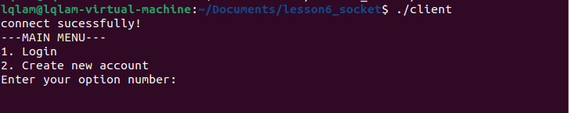

In the typing process, both when typing account or typing message, input “:q” to exit current job.

If you want to exit server application, please press Ctrl+C to free all the resources of app.

**REVOLUTION**

Integrate message encryption.