

MINISTRY OF EDUCATION ANDTRAINING

Bike Rescue

Software Requirement Specification

Project Code: <BR001>

Document Code: <BR>– v1.0

**Ho Chi Minh, 13/07/2021**

Record of change

*A - Added M - Modified D - Deleted

|  |  |  |  |  |
| --- | --- | --- | --- | --- |
| Effective Date | Changed Items | A* M, D | Change Description | New Version |
|  |  |  |  |  |
|  |  |  |  |  |
|  |  |  |  |  |
|  |  |  |  |  |
|  |  |  |  |  |
|  |  |  |  |  |
|  |  |  |  |  |
|  |  |  |  |  |
|  |  |  |  |  |
|  |  |  |  |  |
|  |  |  |  |  |
|  |  |  |  |  |
|  |  |  |  |  |
|  |  |  |  |  |
|  |  |  |  |  |
|  |  |  |  |  |
|  |  |  |  |  |
|  |  |  |  |  |
|  |  |  |  |  |
|  |  |  |  |  |
|  |  |  |  |  |

SIGNATURE PAGE

**ORIGINATOR:** Le Quang Vinh 13/07/2021

Leader

Huynh Thi Khanh Tram 13/07/2021

Member

Pham Viet Tai 13/07/2021

Member

**REVIEWERS:** Lai Duc Hung 13/07/2021

Instructor

**APPROVAL:** Lai Duc Hung 13/07/2021

Instructor

Table of Contents

1. Introduction 7

1.1. Purpose 7

1.2. Scope 7

1.3. Definitions, Acronyms, and Abbreviations 7

1.4. References 7

1.5. Overview 8

2. Overall Description 9

2.1. Product Perspective 9

2.2. Product features 9

2.3. Operating environment 10

3. FUNCTIONAL Requirements 11

3.1. Use Cases Diagram 11

3.2. View profile 11

3.3. Edit profile 13

3.4. Log out 15

3.5. Get notification 16

3.6. Register bike 17

3.7. Create problem 20

3.8. View the nearest repair shop 22

3.9. Choose shop to repair 23

3.10. View service 25

3.11. View customer’s feedbacks 26

3.12. Send problem 28

3.13. Receive notifications from staff 29

3.14. View staff 31

3.15. View the bill 32

3.16. Pay 34

3.17. Send feedback about service 35

3.18. View customer’s history 37

3.19. View problem 39

3.20. Edit problem 41

3.21. Cancel problem 43

3.22. Receive problem 44

3.23. View Problem 46

3.24. Accept Problem 48

3.25. Cancel Problem 49

3.26. Call for help 51

3.27. Create bill 52

3.28. View staff’s history 55

3.29. Send feedback about customer 56

3.30. Manage repair shop 59

3.31. Approve the repair shop’s account 60

3.32. View repair shop 62

3.33. Disable repair shop 64

3.34. Get the list staff’s feedbacks 65

3.35. View staff’s feedbacks 67

3.36. View customer 69

3.37. Disable customer 70

3.38. Register an account 72

3.39. Register Bike 74

3.40. Login 76

3.41. Login with Gmail 78

3.42. View staff’s account 79

3.43. Disable staff's account 81

3.44. Get the list of customer’s feedback 83

3.45. View customer’s feedbacks 84

3.46. Create account for staff 85

3.47. Get the list of bills 87

3.48. View a bill 88

3.49. Create service 90

3.50. Edit service 92

3.51. View service 94

3.52. Delete service 95

4. NON-FUNCTIONAL Requirements 98

4.1. Usability 98

4.2. Reliability 98

4.3. Performance 98

5. Supporting Information 99

# Introduction

The Bike Rescue is an application that makes it easy for users to find the nearest repair shop.

Users can easily view detailed information about that store: reviews, services, location.

## Purpose

The purpose of this application is to help users easily find the nearest repair shop anywhere, even in deserted places.

## Scope

The Bike Rescue is an application that runs on a smartphone platform.

Users can book the repair shop they want, see the service and rating of the repair shop. Besides, the user can cancel the booking and feedback the repairer.

The staff working at the repair shop can view the problem, then the staff can accept or cancel the problem.

## Definitions, Acronyms, and Abbreviations

Bike Rescue: The name of the application

Staff: a person that is paid to repair things

Repair shop owner: a shop owner who manages staff

Customer: the person book and using the service.

Admin: The person manages the repair shop and the customer.

SRS: Software Requirement Specification

## References

N/A

## Overview

The rest of this SRS contains the following information:

* Overall Description
* Functional Requirements
* Non-functional Requirements
* Supporting Information

# Overall Description

## Product Perspective

The database system stores user information:

* **Customer description:**

It includes customer code, name, password, address and phone number.

* **Staff detail:**

It includes staff code, name, password, address and phone number.

* **Booking description:**

It includes booking code, problem details, date of booking, status, customer code and staff code.

* This information may be used for keeping the records of the customer for any emergency or for any other kind of information.

## Product features

The major features of the booking repair shop database system are shown in below entity-relationship model (ERD)

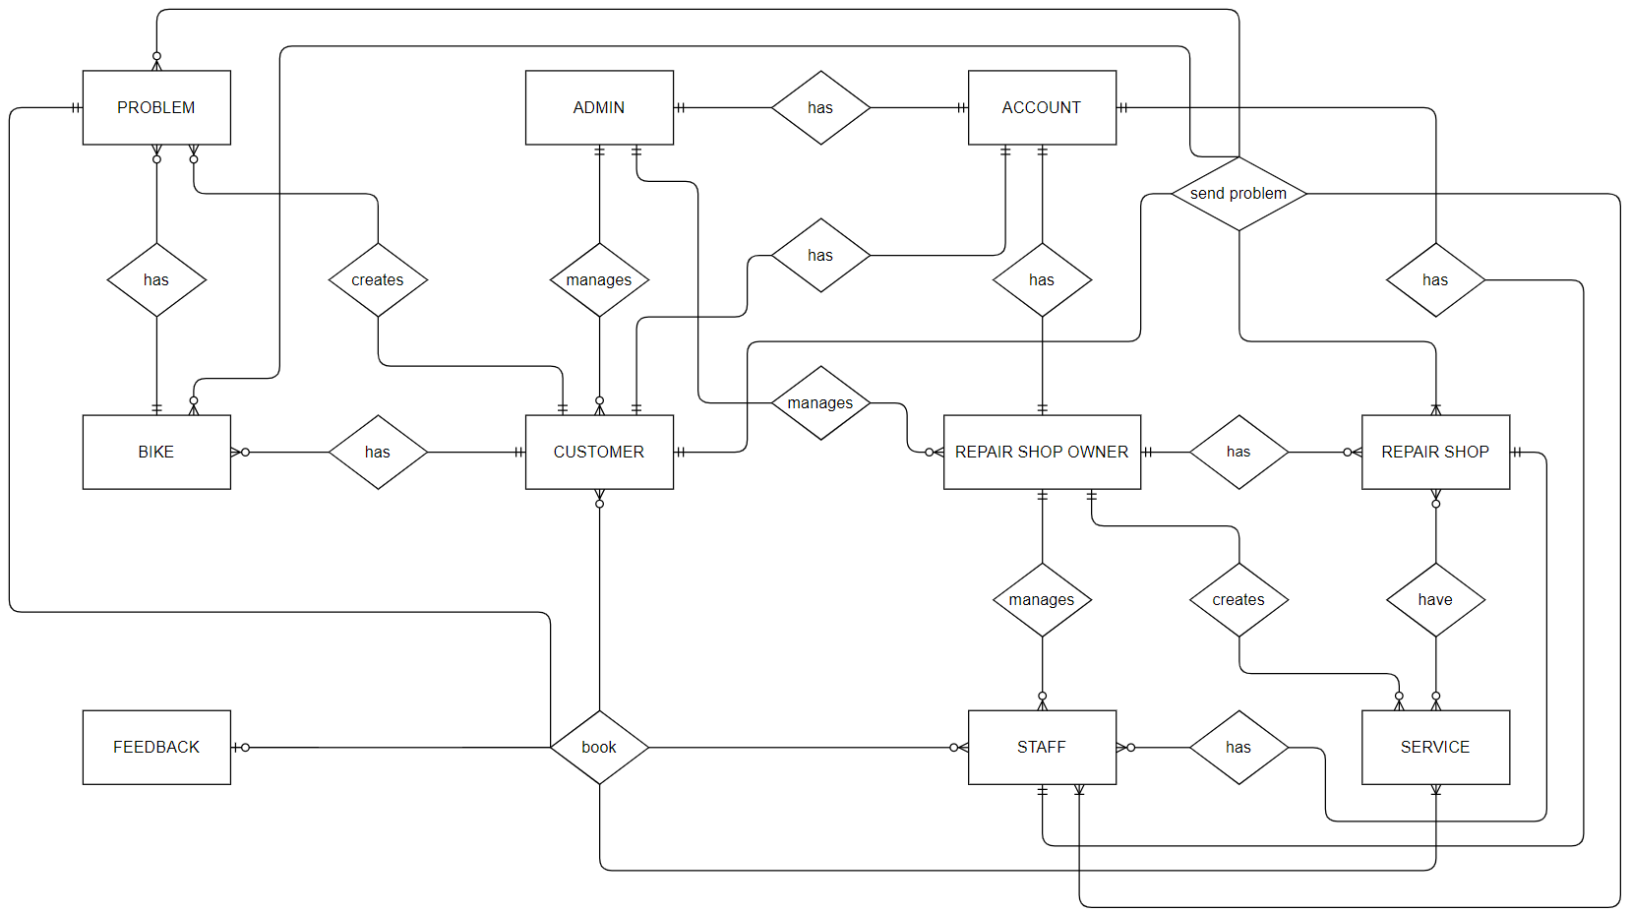

## Operating environment

The operating environment for the booking repair shop management system is listed below.

* Client/server system
* Operating system: Android, IOS.
* Database: SQL server
* Platform: .Net/Java

# FUNCTIONAL Requirements

## Use Cases Diagram

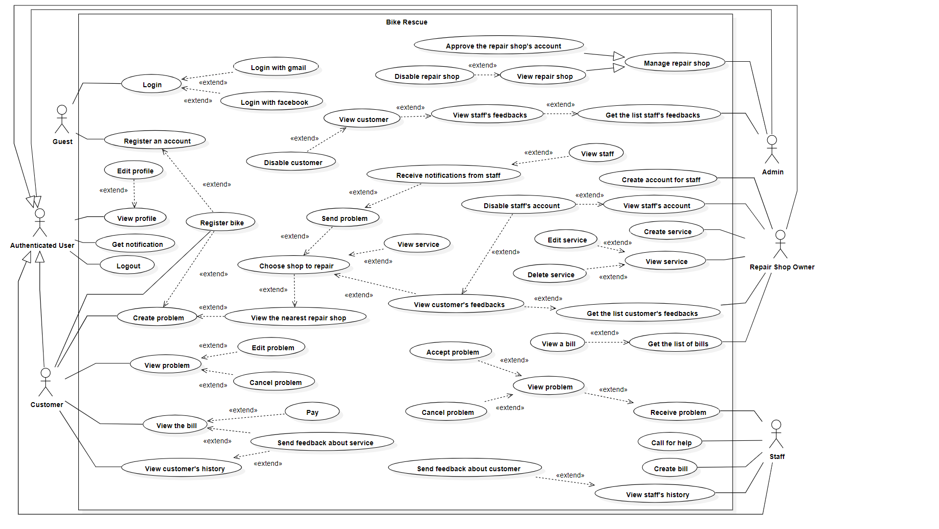

## View profile

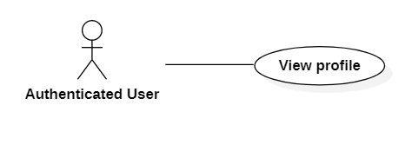

|  |  |  |  |  |
| --- | --- | --- | --- | --- |
| **USE CASE-001** | | | | |
| **Use-case No.** | UC001 | **Use-case Version** | | 3.0 |
| **Use-case Name** | View profile | | | |
| **Author** | Le Quang Vinh | | | |
| **Date** | 30/06/2021 | **Priority** | Normal | |
| **Actor:**   * Authenticated user   **Summary:**   * This use case allows the authenticated user to view the profile.   **Goal:**   * The authenticated user can view the profile.   **Triggers:**   * The authenticated user touches the “View profile” button.   **Preconditions:**   * The authenticated user must log in. * The user must have an internet connection.   **Post Conditions:**   * Success: The authenticated user can view the profiles. * Fail: Do nothing.   **Main Success Scenario:**   |  |  |  | | --- | --- | --- | | **STEP** | **ACTOR ACTION** | **SYSTEM RESPONSE** | | 1 | The authenticated user touches the “View profile” button. | The system displays authenticated user information:   * Customer name * Phone number * Address * Email * Image |   **Alternative Scenario:**  N/A  **Exceptions:**  N/A  **Relationships:**  N/A  **Business Rules:**  N/A | | | | |

## Edit profile

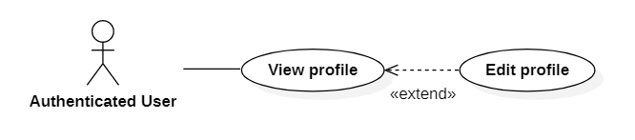

|  |  |  |  |  |
| --- | --- | --- | --- | --- |
| **USE CASE-002** | | | | |
| **Use-case No.** | UC002 | **Use-case Version** | | 3.0 |
| **Use-case Name** | Edit profile | | | |
| **Author** | Le Quang Vinh | | | |
| **Date** | 30/06/2021 | **Priority** | Normal | |
| **Actor:**   * Authenticated user   **Summary:**   * This use case allows the authenticated user to edit the profile.   **Goal:**   * The authenticated user can edit the profile.   **Triggers:**   * The authenticated user touches the “Edit profile” button.   **Preconditions:**   * The authenticated user must log in. * The authenticated user must view profile.   **Post Conditions:**   * Success: The authenticated user can edit the profile. * Fail: The system shows the error message.   **Main Success Scenario:**   |  |  |  | | --- | --- | --- | | **STEP** | **ACTOR ACTION** | **SYSTEM RESPONSE** | | 1 | The authenticated user touches the “Edit profile” button. | The system shows a page:   * Customer name: textbox, type: string, required. * Phone number: textbox, type: number, required. * Address: textbox, type: string, required. * Email: textbox, type: string, required. * Image: picture box, type: .jpg, required. | | 2 | Authenticated user enters information and clicks the button “Submit”. | * The system checks the information entered by the authenticated user. * The system will update authenticated user information. * The system displays a successful message: “Edit profile successfully”   [Exception 1, 2, 3, 4, 5] |   **Alternative Scenario:** N/A  **Exceptions:**   |  |  |  | | --- | --- | --- | | **No** | **ACTOR ACTION** | **SYSTEM RESPONSE** | | 1 | Name is empty or longer than 50 characters | The system shows the error message: “The name cannot be empty and less than 50 characters” | | 2 | Phone number less than 10 digits or more than 12 digits | The system shows the error message: “Phone number must than 10 digits or less 12 digits” | | 3 | The address is empty or longer than 100 characters | The system shows the error message: “The address must not empty and less than 100 characters” | | 4 | Email is empty or longer than 100 characters | The system shows the error message: “The email must not empty and less than 100 characters” | | 5 | Images is empty | The system shows the error message: “The images must be selected” |   **Relationships:**   * Edit profile extend view profile   **Business Rules:**   * The information entered by the authenticated user must be checked such as: name, phone, address, email, image. * When the authenticated user touches the “Submit” button:   + Success: The profile will be edit with the input information. | | | | |

## Log out

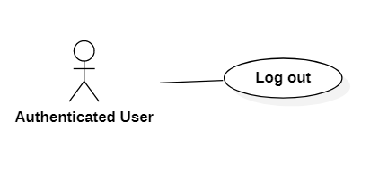

|  |  |  |  |  |
| --- | --- | --- | --- | --- |
| **USE CASE-003** | | | | |
| **Use-case No.** | UC003 | **Use-case Version** | | 3.0 |
| **Use-case Name** | Log out | | | |
| **Author** | Le Quang Vinh | | | |
| **Date** | 28/05/2021 | **Priority** | Normal | |
| **Actor:**   * Authenticated user   **Summary:**   * This use case allows the authenticated user log out.   **Goal:**   * The authenticated user can log out.   **Triggers:**   * The authenticated user touches the “Log out” button.   **Preconditions:**   * The authenticated user must log in. * The customer must have an internet connection.   **Post Conditions:**   * Success: The authenticated user can log out. * Fail: Do nothing.   **Main Success Scenario:**   |  |  |  | | --- | --- | --- | | **STEP** | **ACTOR ACTION** | **SYSTEM RESPONSE** | | 1 | Authenticated user presses the button “Log out” | The system will log out the user. |   **Alternative Scenario:**  N/A  **Exceptions:**  N/A  **Relationships:**  N/A  **Business Rules:**  N/A | | | | |

## Get notification

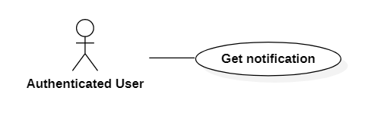

|  |  |  |  |  |
| --- | --- | --- | --- | --- |
| **USE CASE-004** | | | | |
| **Use-case No.** | UC004 | **Use-case Version** | | 3.0 |
| **Use-case Name** | Get notification | | | |
| **Author** | Le Quang Vinh | | | |
| **Date** | 28/05/2021 | **Priority** | Normal | |
| **Actor:**   * Authenticated user.   **Summary:**   * This use case allows the authenticated user to get the notification.   **Goal:**   * The authenticated user can get the notification.   **Triggers:**  N/A  **Preconditions:**   * The authenticated user must log in. * The customer must have an internet connection.   **Post Conditions:**   * Success: The authenticated user can get the notification. * Fail: Do nothing.   **Main Success Scenario:**   |  |  |  | | --- | --- | --- | | **Step** | **ACTOR ACTION** | **SYSTEM RESPONSE** | | 1 |  | The system will display a message to the user |   **Alternative Scenario:**  N/A  **Exceptions:**  N/A  **Relationships:**  N/A  **Business Rules:**  N/A | | | | |

## Register bike

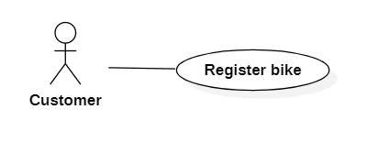

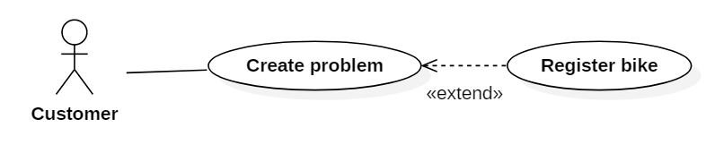

|  |  |  |  |  |
| --- | --- | --- | --- | --- |
| **USE CASE-005** | | | | |
| **Use-case No.** | UC005 | **Use-case Version** | | 3.0 |
| **Use-case Name** | Register bike | | | |
| **Author** | Le Quang Vinh | | | |
| **Date** | 28/05/2021 | **Priority** | Normal | |
| **Actor:**   * Customer * Guest   **Summary:**   * This use case allows the customer to register the bike.   **Goal:**   * Customer registers the bike for repair.   **Triggers:**   * The customer touches the “Register bike” button.   **Preconditions:**   * The customer must log in. * The customer must have an internet connection.   **Post Conditions:**   * Success: The system will create bikes for customers. * Fail: The system shows the error message.   **Main Success Scenario:**   |  |  |  | | --- | --- | --- | | **STEP** | **ACTOR ACTION** | **SYSTEM RESPONSE** | | 1 | Customer presses the button “Register bike” | The system shows a page:   * Owner name: textbox, type: string, required. * Bike type: combo box. * Color: combo box. * License plates: textbox, type: string, required. * Image: picture box, type: .jpg, required. | | 2 | Customer enters information and clicks the button “Submit”. | * The system checks the information entered by the customer. * The system will create the bike for customers. * The system displays a successful message: “Create bikes successfully”   [Exception 1, 2, 3, 4, 5] |   **Alternative Scenario:**  N/A  **Exceptions:**   |  |  |  | | --- | --- | --- | | **No** | **ACTOR ACTION** | **SYSTEM RESPONSE** | | 1 | Owner name is empty or longer than 50 characters | The system shows the error message: “The name cannot be empty and less than 50 characters” | | 2 | Bike type is empty | The system shows the error message: “Bike type must be selected” | | 3 | Color is empty | The system shows the error message: “Color must be selected” | | 4 | License plates is empty or longer than 50 characters | The system shows the error message: “The license plates must not empty and less than 100 characters” | | 5 | Images are not .jpg | The system shows the error message: “The images must be selected” |   **Relationships:**   * Register bike extend create problem.   **Business Rules:**   * The information entered by the customer must be checked such as: owner name, color, bike type, license plates, image. * When the customer touches the “Submit” button:   + Success: The bike will be registered with the input information. | | | | |

## Create problem

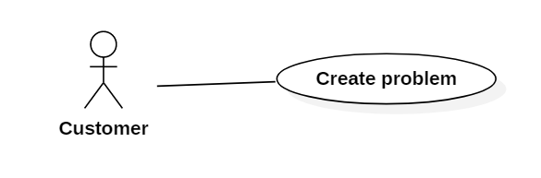

|  |  |  |  |  |
| --- | --- | --- | --- | --- |
| **USE CASE-006** | | | | |
| **Use-case No.** | UC006 | **Use-case Version** | | 3.0 |
| **Use-case Name** | Create problem | | | |
| **Author** | Le Quang Vinh | | | |
| **Date** | 28/05/2021 | **Priority** | Normal | |
| **Actor:**   * Customer   **Summary:**   * This use case allows the customer to create the problem.   **Goal:**   * The customer can create the problem information.   **Triggers:**   * The customer touches the “Create problem” button.   **Preconditions:**   * The customer must log in. * The customer must have an internet connection.   **Post Conditions:**   * Success: The system will create the customer's problem. * Fail: The system shows the error message.   **Main Success Scenario:**   |  |  |  | | --- | --- | --- | | **STEP** | **ACTOR ACTION** | **SYSTEM RESPONSE** | | 1 | Customer presses the button “Create problem” | The system shows a page:   * Address: textbox, type: string, required. * Image: picture box, type: .jpg, required. * Description of the problem: string, required. * Bike: combo box | | 2 | Customer enters information and clicks the button “Submit”. | * The system checks the information entered by the customer. * The system will create the problem for customers. * The system displays a successful message: “Create problem successfully”   [Exception 1, 2, 3, 4] |   **Alternative Scenario:**  N/A  **Exceptions:**   |  |  |  | | --- | --- | --- | | **No** | **ACTOR ACTION** | **SYSTEM RESPONSE** | | 1 | Address is empty or longer than 100 characters | The system shows the error message: “The address cannot be empty and less than 100 characters” | | 2 | Image is empty | The system shows the error message: “Image must be selected” | | 3 | Description of the problem is empty or longer than 200 characters | The system shows the error message: “Description of the problem cannot be empty and less than 100 characters” | | 4 | Bike is empty | The system shows the error message: “Bike must be selected” |   **Relationships:**  N/A  **Business Rules:**   * The information entered by the customer must be checked such as: address, image, description of the problem, bike * When the customer touches the “Submit” button:   + Success: The problem will be created with the input information. | | | | |

## View the nearest repair shop

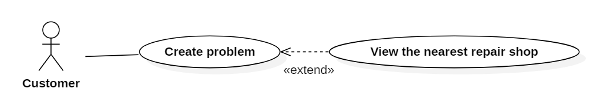

|  |  |  |  |  |
| --- | --- | --- | --- | --- |
| **USE CASE-007** | | | | |
| **Use-case No.** | UC007 | **Use-case Version** | | 3.0 |
| **Use-case Name** | View the nearest repair shop | | | |
| **Author** | Le Quang Vinh | | | |
| **Date** | 28/05/2021 | **Priority** | Normal | |
| **Actor:**   * Customer   **Summary:**   * This use case allows the customer to view the nearest repair shop.   **Goal:**   * Customers view the nearest repair shop.   **Triggers:**   * The user creates the problem successfully.   **Preconditions:**   * The customer must log in. * The user's location has been determined via GPS. * The customer must have an internet connection.   **Post Conditions:**   * Success: Customer can view the nearest repair shops * Fail: Do nothing.   **Main Success Scenario:**   |  |  |  | | --- | --- | --- | | **STEP** | **ACTOR ACTION** | **SYSTEM RESPONSE** | | 1 | The user creates the problem successfully | The system will display a list of the nearest repair shops based on the customer's location:   * Repair shop name * Address * Image   [Exception 1] |   **Alternative Scenario:**  N/A  **Exceptions:**   |  |  |  | | --- | --- | --- | | **No** | **ACTOR ACTION** | **SYSTEM RESPONSE** | | 1 | No repair shop was found nearby | The system shows the message: “The system did not find any recent repair shops.” |   **Relationships:**   * View the nearest repair shop extend create problem.   **Business Rules:**  N/A | | | | |

## Choose shop to repair

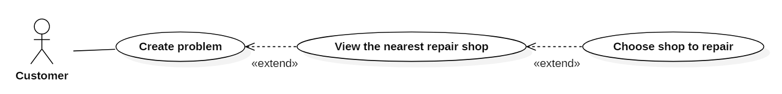

|  |  |  |  |  |
| --- | --- | --- | --- | --- |
| **USE CASE-008** | | | | |
| **Use-case No.** | UC008 | **Use-case Version** | | 3.0 |
| **Use-case Name** | Choose shop to repair | | | |
| **Author** | Le Quang Vinh | | | |
| **Date** | 28/05/2021 | **Priority** | Normal | |
| **Actor:**   * Customer   **Summary:**   * This use case allows the customer to choose the shop to repair.   **Goal:**   * Customer chooses the shop to repair.   **Triggers:**   * The customer touches the “Choose it” button.   **Preconditions:**   * The customer must log in. * The customer must have an internet connection.   **Post Conditions:**   * Success: Customers can choose shop to repair * Fail: Do nothing.   **Main Success Scenario:**   |  |  |  | | --- | --- | --- | | **STEP** | **ACTOR ACTION** | **SYSTEM RESPONSE** | | 1 | Customer clicks "Choose repair shop" button. | * The system will send the customer's request to each staff working in that repair shop. * The system will display the message: "The request has been sent." |   **Alternative Scenario:**  N/A  **Exceptions:**  N/A  **Relationships:**   * Choose shop to repair extend view the nearest repair shop.   **Business Rules:**  N/A | | | | |

## View service



|  |  |  |  |  |
| --- | --- | --- | --- | --- |
| **USE CASE-009** | | | | |
| **Use-case No.** | UC009 | **Use-case Version** | | 3.0 |
| **Use-case Name** | View service | | | |
| **Author** | Le Quang Vinh | | | |
| **Date** | 28/05/2021 | **Priority** | Normal | |
| **Actor:**   * Customer   **Summary:**   * This use case allows the customer to view service.   **Goal:**   * The customer views service.   **Triggers:**   * The customer touches the “View service” button.   **Preconditions:**   * The customer must log in. * The customer must choose a repair shop to repair. * The customer must have an internet connection.   **Post Conditions:**   * Success: Customers can view the shop repair's services. * Fail: Do nothing.   **Main Success Scenario:**   |  |  |  | | --- | --- | --- | | **STEP** | **ACTOR ACTION** | **SYSTEM RESPONSE** | | 1 | The customer touches the “View service” button. | The system will display a list of services of that repair shop:   * Service name * Price * Description   [Exception 1] |   **Alternative Scenario:**  N/A  **Exceptions:**   |  |  |  | | --- | --- | --- | | **No** | **ACTOR ACTION** | **SYSTEM RESPONSE** | | 1 | Repair shop does not have any service | The system shows the message: “Service is empty” |   **Relationships:**   * View service extend choose shop to repair.   **Business Rules:**  N/A | | | | |

## View customer’s feedbacks



|  |  |  |  |  |
| --- | --- | --- | --- | --- |
| **USE CASE-010** | | | | |
| **Use-case No.** | UC010 | **Use-case Version** | | 3.0 |
| **Use-case Name** | View customer’s feedbacks | | | |
| **Author** | Le Quang Vinh | | | |
| **Date** | 28/05/2021 | **Priority** | Normal | |
| **Actor:**   * Customer   **Summary:**   * This use case allows the customer to view the customer’s feedbacks.   **Goal:**   * The customer can view the customer’s feedbacks.   **Triggers:**   * The customer touches the “View feedbacks” button.   **Preconditions:**   * The customer must log in. * The customer must choose a repair shop to repair. * The customer must have an internet connection.   **Post Conditions:**   * Success: Customers can view the customer’s feedbacks. * Fail: Do nothing.   **Main Success Scenario:**   |  |  |  | | --- | --- | --- | | **STEP** | **ACTOR ACTION** | **SYSTEM RESPONSE** | | 1 | The customer touches the “View feedbacks” button. | The system will display a list of feedback from other customers about that repair shop:   * User name * Content feedback * Star   [Exception 1] |   **Alternative Scenario:**  N/A  **Exceptions:**   |  |  |  | | --- | --- | --- | | **No** | **ACTOR ACTION** | **SYSTEM RESPONSE** | | 1 | The repair shop doesn't have any feedback from customers | The system shows the message: “Feedback is empty” |   **Relationships:**   * View customer’s feedbacks extend choose shop to repair.   **Business Rules:**  N/A | | | | |

## Send problem

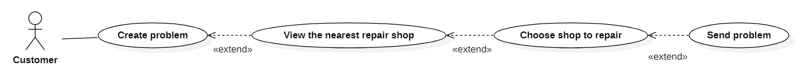

|  |  |  |  |  |
| --- | --- | --- | --- | --- |
| **USE CASE-011** | | | | |
| **Use-case No.** | UC011 | **Use-case Version** | | 3.0 |
| **Use-case Name** | Send problem | | | |
| **Author** | Le Quang Vinh | | | |
| **Date** | 28/05/2021 | **Priority** | Normal | |
| **Actor:**   * Customer   **Summary:**   * This use case allows the customer to send the problem.   **Goal:**   * Customers send the problem information to a nearby repair shop.   **Triggers:**   * The customer touches the “Send problem” button.   **Preconditions:**   * The customer must log in. * Customer must create the problem first. * Customer must choose a repair shop to repair. * The customer must have an internet connection.   **Post Conditions:**   * Success: The customer's request can send to the repair shop. * Fail: Do nothing.   **Main Success Scenario:**   |  |  |  | | --- | --- | --- | | **STEP** | **ACTOR ACTION** | **SYSTEM RESPONSE** | | 1 | Customer touches the “Send problem” button. | * The customer's request will be sent to the repair shop. * The staff working in the repair shop will receive customer's requests. * The system will display the message: "Request sent successfully." |   **Alternative Scenario:**  N/A  **Exceptions:**  N/A  **Relationships:**   * Send the problem extend choose shop to repair.   **Business Rules:**  N/A | | | | |

## Receive notifications from staff

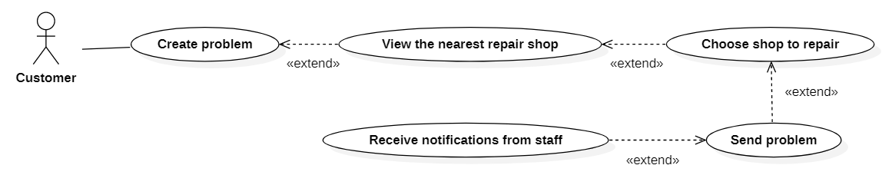

|  |  |  |  |  |
| --- | --- | --- | --- | --- |
| **USE CASE-012** | | | | |
| **Use-case No.** | UC012 | **Use-case Version** | | 3.0 |
| **Use-case Name** | Receive notifications from staff | | | |
| **Author** | Le Quang Vinh | | | |
| **Date** | 28/05/2021 | **Priority** | Normal | |
| **Actor:**   * Customer   **Summary:**   * This use case allows the customer to receive the notifications from staff.   **Goal:**   * Customer receives the notifications from staff.   **Triggers:**  N/A  **Preconditions:**   * The customer must log in. * Customer must send the problem successfully. * The customer must have an internet connection.   **Post Conditions:**   * Success: Customer can see the information of that staff. * Fail: Do nothing.   **Main Success Scenario:**   |  |  |  | | --- | --- | --- | | **STEP** | **ACTOR ACTION** | **SYSTEM RESPONSE** | | 1 |  | The screen will display a message: "A staff member has accepted your request." |   **Alternative Scenario:**  N/A  **Exceptions:**  N/A  **Relationships:**   * Receive notifications from staff extend send problem.   **Business Rules:**  N/A | | | | |

## View staff

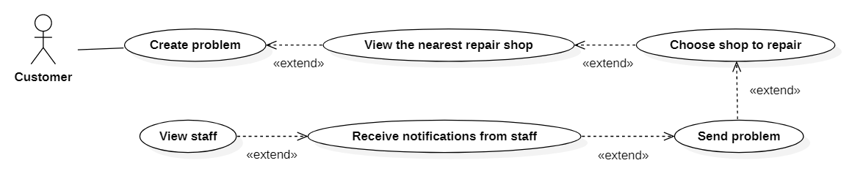

|  |  |  |  |  |
| --- | --- | --- | --- | --- |
| **USE CASE-013** | | | | |
| **Use-case No.** | UC013 | **Use-case Version** | | 3.0 |
| **Use-case Name** | View staff | | | |
| **Author** | Le Quang Vinh | | | |
| **Date** | 28/05/2021 | **Priority** | Normal | |
| **Actor:**   * Customer   **Summary:**   * This use case allows the customer to view the staff.   **Goal:**   * The customer views the staff who accepted the customer’s problem.   **Triggers:**   * The customer touches the “View” button.   **Preconditions:**   * The customer must log in. * Customer received notifications from the staff. * The customer must have an internet connection.   **Post Conditions:**   * Success: Customer can view the staff who accepted the customer’s problem. * Fail: Do nothing.   **Main Success Scenario:**   |  |  |  | | --- | --- | --- | | **STEP** | **ACTOR ACTION** | **SYSTEM RESPONSE** | | 1 | Customer click “View” button. | The screen will display staff information including:   * Staff’s name * Repair shop’s name * Image * Address * Phone number   [Exception 1] |   **Alternative Scenario:**  N/A  **Exceptions:**   |  |  |  | | --- | --- | --- | | **No** | **ACTOR ACTION** | **SYSTEM RESPONSE** | | 1 | The repair shop doesn't have any staff. | The system shows the message: “Staff is empty” |   **Relationships:**   * View staff extend receive notifications from staff.   **Business Rules:**  N/A | | | | |

## View the bill

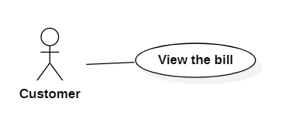

|  |  |  |  |  |
| --- | --- | --- | --- | --- |
| **USE CASE-014** | | | | |
| **Use-case No.** | UC014 | **Use-case Version** | | 3.0 |
| **Use-case Name** | View the bill | | | |
| **Author** | Le Quang Vinh | | | |
| **Date** | 28/05/2021 | **Priority** | Normal | |
| **Actor:**   * Customer   **Summary:**   * This use case allows the customer to view the bill.   **Goal:**   * The customer can view the bill.   **Triggers:**   * The customer touches the “View bill” button.   **Preconditions:**   * The customer must log in. * The staff must complete the repair. * The customer must have an internet connection.   **Post Conditions:**   * Success: Customer can pay and send feedback about service. * Fail: Do nothing.   **Main Success Scenario:**   |  |  |  | | --- | --- | --- | | **STEP** | **ACTOR ACTION** | **SYSTEM RESPONSE** | | 1 | Customer presses the button “View bill”. | The system will display information of the bill including:   * Staff’s name * Customer’s name * Repair shop’s name * Repair date * Address * Service’s name * Price * Total |   **Alternative Scenario:**  N/A  **Exceptions:**  N/A  **Relationships:**  N/A  **Business Rules:**  N/A | | | | |

## Pay

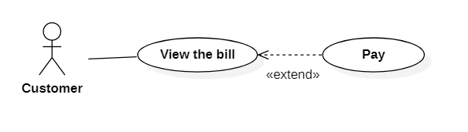

|  |  |  |  |  |
| --- | --- | --- | --- | --- |
| **USE CASE-015** | | | | |
| **Use-case No.** | UC015 | **Use-case Version** | | 3.0 |
| **Use-case Name** | Pay | | | |
| **Author** | Le Quang Vinh | | | |
| **Date** | 28/05/2021 | **Priority** | Normal | |
| **Actor:**   * Customer   **Summary:**   * This use case allows the customer to pay.   **Goal:**   * The customer can pay.   **Triggers:**  N/A  **Preconditions:**   * The customer must log in. * Customer must see the bill first. * The customer must have an internet connection.   **Post Conditions:**   * Success: Customer can pay. * Fail: Do nothing.   **Main Success Scenario:**   |  |  |  | | --- | --- | --- | | **STEP** | **ACTOR ACTION** | **SYSTEM RESPONSE** | | 1 | Staff confirmed receipt of money on the bill. | If the staff accepts:   * The system will display the message: "Payment successful." |   **Alternative Scenario:**  N/A  **Exceptions:**  N/A  **Relationships:**   * Pay extend view the bill.   **Business Rules:**  N/A | | | | |

## Send feedback about service

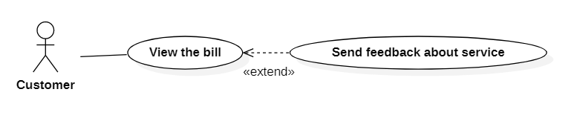

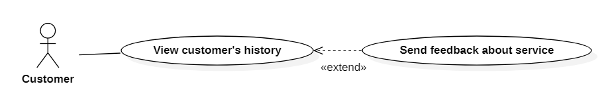

|  |  |  |  |  |
| --- | --- | --- | --- | --- |
| **USE CASE-016** | | | | |
| **Use-case No.** | UC016 | **Use-case Version** | | 3.0 |
| **Use-case Name** | Send feedback about service | | | |
| **Author** | Le Quang Vinh | | | |
| **Date** | 28/05/2021 | **Priority** | Normal | |
| **Actor:**   * Customer   **Summary:**   * This use case allows the customer to send the feedback about the service.   **Goal:**   * The customers can send feedback about the service.   **Triggers:**   * The customer touches the “Send feedback” button.   **Preconditions:**   * The customer must log in. * The customer must see the bill first or view the customer’s history first. * The customer must have an internet connection.   **Post Conditions:**   * Success: The customer feedback will be sent to the repair shop. * Fail: The system shows the error message.   **Main Success Scenario:**   |  |  |  | | --- | --- | --- | | **STEP** | **ACTOR ACTION** | **SYSTEM RESPONSE** | | 1 | Customer touches the “Send feedback” button. | The system shows a page:   * Title feedback: textbox, type: string, required. * Content feedback: textbox, type: string, required. * Image: picture box, type: .jpg, required. * Star: number | | 2 | Customer enters information and clicks the button “Submit”. | * The system checks the information entered by the customer * The customer feedback will be sent to the repair shop * The system will display the message: "Feedback has been sent successfully"   [Exception 1, 2, 3, 4] |   **Alternative Scenario:**  N/A  **Exceptions:**   |  |  |  | | --- | --- | --- | | **No** | **ACTOR ACTION** | **SYSTEM RESPONSE** | | 1 | Title feedback is empty or longer than 100 characters | The system shows the error message: “Title feedback cannot be empty and less than 100 characters” | | 2 | Content feedback is empty or longer than 200 characters | The system shows the error message: “Content feedback cannot be empty and less than 200 characters” | | 3 | Image is empty | The system shows the error message: “Image must be selected” | | 4 | Star is empty | The system shows the error message: “Star must be selected” |   **Relationships:**   * Send feedback about service extend view the bill. * Send feedback about service extend view customer’s history.   **Business Rules:**   * The information entered by the customer must be checked such as: title feedback, content feedback, image, license plates, star. * When the customer touches the “Submit” button:   + Success: The feedback will be sent with the input information. | | | | |

## View customer’s history

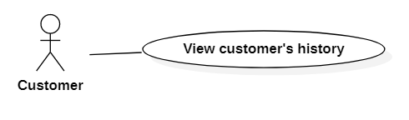

|  |  |  |  |  |
| --- | --- | --- | --- | --- |
| **USE CASE-017** | | | | |
| **Use-case No.** | UC0017 | **Use-case Version** | | 3.0 |
| **Use-case Name** | View customer’s history | | | |
| **Author** | Le Quang Vinh | | | |
| **Date** | 28/05/2021 | **Priority** | Normal | |
| **Actor:**   * Customer   **Summary:**   * This use case allows the customer to view the customer’s history.   **Goal:**   * The customer views the customer’s history.   **Triggers:**   * The customer touches the “View history” button.   **Preconditions:**   * The customer must log in. * The customer must have an internet connection.   **Post Conditions:**   * Success: Customer can view the customer’s history. * Fail: Do nothing.   **Main Success Scenario:**   |  |  |  | | --- | --- | --- | | **STEP** | **ACTOR ACTION** | **SYSTEM RESPONSE** | | 1 | Customer touches the “View history” button. | The system will display a list of previous repair history.   * Problem name * Staff’s name * Repair shop’s name * Repair date * Address * Service’s name * Price * Total   [Exception 1] |   **Alternative Scenario:**  N/A  **Exceptions:**   |  |  |  | | --- | --- | --- | | **No** | **ACTOR ACTION** | **SYSTEM RESPONSE** | | 1 | The customer doesn't have any history. | The system shows the message: “History is empty” |   **Relationships:**  N/A  **Business Rules:**  N/A | | | | |

## View problem

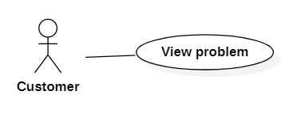

|  |  |  |  |  |
| --- | --- | --- | --- | --- |
| **USE CASE-018** | | | | |
| **Use-case No.** | UC018 | **Use-case Version** | | 3.0 |
| **Use-case Name** | View problem | | | |
| **Author** | Le Quang Vinh | | | |
| **Date** | 28/05/2021 | **Priority** | Normal | |
| **Actor:**   * Customer   **Summary:**   * This use case allows the customer to view the problem.   **Goal:**   * The customer can view the problem.   **Triggers:**   * The customer touches the “View problem” button.   **Preconditions:**   * The customer must log in. * The customer must create the problem. * The customer must have an internet connection.   **Post Conditions:**   * Success: Customers can view the problem. * Fail: Do nothing.   **Main Success Scenario:**   |  |  |  | | --- | --- | --- | | **STEP** | **ACTOR ACTION** | **SYSTEM RESPONSE** | | 1 | The customer touches the “View problem” button. | The system will display a problem:   * Problem name * Description * Address * Image * Bike |   **Alternative Scenario:**  N/A  **Exceptions:**  N/A  **Relationships:**  N/A  **Business Rules:**  N/A | | | | |

## Edit problem

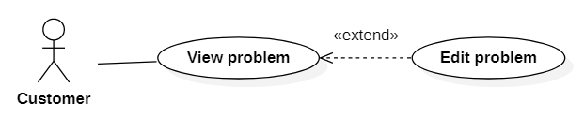

|  |  |  |  |  |
| --- | --- | --- | --- | --- |
| **USE CASE-019** | | | | |
| **Use-case No.** | UC019 | **Use-case Version** | | 3.0 |
| **Use-case Name** | Edit problem | | | |
| **Author** | Le Quang Vinh | | | |
| **Date** | 28/05/2021 | **Priority** | Normal | |
| **Actor:**   * Customer   **Summary:**   * This use case allows the customer to edit the problem.   **Goal:**   * The customers can edit the problem.   **Triggers:**   * The customer touches the “Edit problem” button.   **Preconditions:**   * The customer must log in. * The customer must view the problem. * The customer must have an internet connection.   **Post Conditions:**   * Success: The customer can edit the problem. * Fail: The system shows the error message.   **Main Success Scenario:**   |  |  |  | | --- | --- | --- | | **STEP** | **ACTOR ACTION** | **SYSTEM RESPONSE** | | 1 | Customer presses the button “Edit problem” | The system shows a page:   * Address: textbox, type: string, required. * Image: picture box, type: .jpg, required. * Description of the problem: string, required. * Bike: combo box | | 2 | Customer enters information and clicks the button “Submit”. | * The system checks the information entered by the customer. * The system will create the problem for customers. * The system displays a successful message: “Edit problem successfully”   [Exception 1, 2, 3, 4] |   **Alternative Scenario:**  N/A  **Exceptions:**   |  |  |  | | --- | --- | --- | | **No** | **ACTOR ACTION** | **SYSTEM RESPONSE** | | 1 | Address is empty or longer than 100 characters | The system shows the error message: “The address cannot be empty and less than 100 characters” | | 2 | Image is empty | The system shows the error message: “Image must be selected” | | 3 | Description of the problem is empty or longer than 200 characters | The system shows the error message: “Description of the problem cannot be empty and less than 100 characters” | | 4 | Bike is empty | The system shows the error message: “Bike must be selected” |   **Relationships:**   * Edit problem extend view problem   **Business Rules:**   * The information entered by the customer must be checked such as: address, image, description of the problem, bike * When the customer touches the “Submit” button:   + Success: The problem will be edit with the input information. | | | | |

## Cancel problem

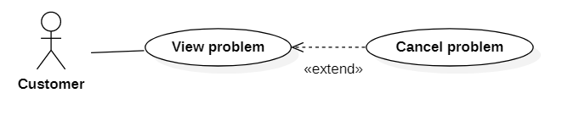

|  |  |  |  |  |
| --- | --- | --- | --- | --- |
| **USE CASE-020** | | | | |
| **Use-case No.** | UC020 | **Use-case Version** | | 3.0 |
| **Use-case Name** | Cancel problem | | | |
| **Author** | Le Quang Vinh | | | |
| **Date** | 28/05/2021 | **Priority** | Normal | |
| **Actor:**   * Customer   **Summary:**   * This use case allows the customer to cancel the problem.   **Goal:**   * The customer can cancel the problem.   **Triggers:**   * The customer touches the “Cancel problem” button.   **Preconditions:**   * The customer must log in. * The customer must view the problem. * The customer must have an internet connection.   **Post Conditions:**   * Success: Customers can cancel the problem. * Fail: Do nothing.   **Main Success Scenario:**   |  |  |  | | --- | --- | --- | | **STEP** | **ACTOR ACTION** | **SYSTEM RESPONSE** | | 1 | The customer touches the “Cancel problem” button. | The system will cancel the customer’s problem. |   **Alternative Scenario:**  N/A  **Exceptions:**  N/A  **Relationships:**   * Cancel problem extend view problem   **Business Rules:**  N/A | | | | |

## Receive problem

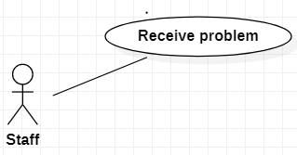

|  |  |  |  |  |
| --- | --- | --- | --- | --- |
| **USE CASE-021** | | | | |
| **Use-case No.** | UC021 | **Use-case Version** | | 3.0 |
| **Use-case Name** | Receive problem | | | |
| **Author** | Huynh Thi Khanh Tram | | | |
| **Date** | 28/06/2021 | **Priority** | Normal | |
| **Actor:**  Staff  **Summary:**  This function allows staff to receive the customer’s problem.  **Goal:**  Staff can receive the customer’s problem.  **Triggers**  N/A  **Preconditions:**  The user must login to the system as staff.  Customer must send information about their problem successfully.  The user must have a stable network connection.  **Post Conditions:**  Success: Staff can see the customer's problem.  **Main Success Scenario:**   |  |  |  | | --- | --- | --- | | Step | Actor Action | System Response | | 1 |  | The system will display the message: "Someone needs help."  -View: button |   **Alternative Scenario:**   |  |  |  | | --- | --- | --- | | Step | Actor Action | System Response | | 1 | A staff is repairing presses the "Help" button. | The system will display the message: "Someone needs help."  -View: button |   **Exceptions:**  N/A  **Relationships:**  N/A  **Business Rules:**  N/A | | | | |

## View Problem

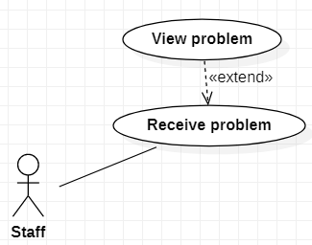

|  |  |  |  |  |
| --- | --- | --- | --- | --- |
| **USE CASE-022** | | | | |
| **Use-case No.** | UC022 | **Use-case Version** | | 3.0 |
| **Use-case Name** | View problem | | | |
| **Author** | Huynh Thi Khanh Tram | | | |
| **Date** | 28/06/2021 | **Priority** | Normal | |
| **Actor:**  Staff  **Summary:**  This function allows staff to view the customer’s problem.  **Goal:**  Staff can view the customer’s problem.  **Triggers**  When staff clicks the “View” button.  **Preconditions:**  The user must login to the system as staff.  Customer must send information about their problem successfully.  The user must have a stable network connection.  **Post Conditions:**  Success: Staff can choose to accept or cancel the problem.  **Main Success Scenario:**   |  |  |  | | --- | --- | --- | | Step | Actor Action | System Response | | 1 | Staff clicks the “View” button. | The screen will display information:  -Customer name  -Phone number  -Image  -Location  -Description  -Bike  +Accept: button  +Cancel: button |   **Alternative Scenario:**  N/A  **Exceptions:**  N/A  **Relationships:**  View Problem extend Receive Problem.  **Business Rules:**  N/A | | | | |

## Accept Problem

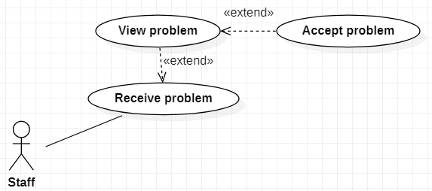

|  |  |  |  |  |
| --- | --- | --- | --- | --- |
| **USE CASE-023** | | | | |
| **Use-case No.** | UC023 | **Use-case Version** | | 3.0 |
| **Use-case Name** | Accept problem | | | |
| **Author** | Huynh Thi Khanh Tram | | | |
| **Date** | 28/06/2021 | **Priority** | Normal | |
| **Actor:**  Staff  **Summary:**  This function allows staff to accept the customer’s problem.  **Goal:**  Staff can accept the customer’s problem.  **Triggers**  When staff clicks the “Accept” button.  **Preconditions:**  The user must login to the system as staff.  Customer must send information about their problem successfully.  The user must have a stable network connection.  **Post Conditions:**  Success:  -The system will send a notification to the customer.  - The system will display a success message.  **Main Success Scenario:**   |  |  |  | | --- | --- | --- | | Step | Actor Action | System Response | | 1 | Staff clicks the “Accept” button. | The system will display a message :” Accepted successfully.” | | 2 |  | The system sends a notification to the customer: "A staff member has accepted your request." |   **Alternative Scenario:**  N/A  **Exceptions:**  N/A  **Relationships:**  Accept Problem extend View Problem.  **Business Rules:**  N/A | | | | |

## Cancel Problem

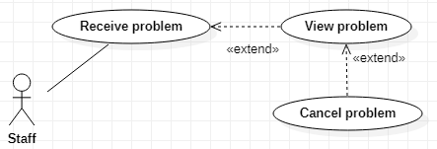

|  |  |  |  |  |
| --- | --- | --- | --- | --- |
| **USE CASE-024** | | | | |
| **Use-case No.** | UC024 | **Use-case Version** | | 3.0 |
| **Use-case Name** | Cancel problem | | | |
| **Author** | Huynh Thi Khanh Tram | | | |
| **Date** | 28/06/2021 | **Priority** | Normal | |
| **Actor:**  Staff  **Summary:**  This function allows staff to cancel the customer’s problem.  **Goal:**  Staff can cancel the customer’s problem.  **Triggers**  When staff clicks the “Cancel” button.  **Preconditions:**  The user must login to the system as staff.  Customer must send information about their problem successfully.  The user must have a stable network connection.  **Post Conditions:**  Success: The system will display a success message.  **Main Success Scenario:**   |  |  |  | | --- | --- | --- | | Step | Actor Action | System Response | | 1 | Staff clicks the “Cancel” button. | The system will display the message: "Cancel successfully." |   **Alternative Scenario:**  N/A  **Exceptions:**  N/A  **Relationships:**  Cancel Problem extend View Problem.  **Business Rules:**  N/A | | | | |

## Call for help

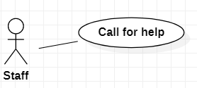

|  |  |  |  |  |
| --- | --- | --- | --- | --- |
| **USE CASE-025** | | | | |
| **Use-case No.** | UC025 | **Use-case Version** | | 3.0 |
| **Use-case Name** | Call for help | | | |
| **Author** | Huynh Thi Khanh Tram | | | |
| **Date** | 28/06/2021 | **Priority** | Normal | |
| **Actor:**  Staff  **Summary:**  This function allows staff to call for help from the remaining staff.  **Goal:**  Staff can call for help.  **Triggers**  When staff clicks the “Help” button.  **Preconditions:**  The user must login to the system as staff.  Customer must send information about their problem successfully.  At least one staff member has accepted that problem already.  There is at least one staff left in the repair shop.  The user must have a stable network connection.  **Post Conditions:**  Success:  -The remaining staffs in that repair shop member will receive the problem that this staff sent.  - The system will display a success message.  **Main Success Scenario:**   |  |  |  | | --- | --- | --- | | Step | Actor Action | System Response | | 1 | Staff clicks the “Help” button. | The system will send the request of this staff to the remaining staff working in the repair shop. | | 2 |  | The system will display the message: "Request sent successfully." |   **Alternative Scenario:**  N/A  **Exceptions:**  N/A  **Relationships:**  N/A  **Business Rules:**  N/A | | | | |

## Create bill

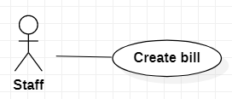

|  |  |  |  |  |
| --- | --- | --- | --- | --- |
| **USE CASE-026** | | | | |
| **Use-case No.** | UC026 | **Use-case Version** | | 3.0 |
| **Use-case Name** | Create bill | | | |
| **Author** | Huynh Thi Khanh Tram | | | |
| **Date** | 28/06/2021 | **Priority** | Normal | |
| **Actor:**  Staff  **Summary:**  This function allows staff to create the bill.  **Goal:**  Staff can create the bill.  **Triggers**  When staff clicks the “Create bill” button.  **Preconditions:**  The user must login to the system as staff.  The user must have a stable network connection.  Staff must accept customer's problem.  **Post Conditions:**  Success: The system will send detailed information of the bill to the customer.  Fail: The system shows the error message.  **Main Success Scenario:**   |  |  |  | | --- | --- | --- | | Step | Actor Action | System Response | | 1 | Staff clicks the “Create bill” button. | The screen will display form to enter:  -Customer name: textbox, type: string, required.  -Address: textbox, type: string, required.  -Service name: textbox, type: string, required.  -Bike: combo box  -Price: float, required  -Total: float, required  +Create: button | | 2 | Staff fills in all the information and clicks the “Create” button. | -The system will check for input errors.  -The system will send detailed information of the bill to the customer.  -The system will show a message: ”Create bill successfully.”  - Insert new bill into the database.  [Exception 1, 2, 3, 4, 5, 6] |   **Alternative Scenario:**  N/A  **Exceptions:**   |  |  |  | | --- | --- | --- | | No | Actor Action | System Response | | 1 | Customer name is empty or greater than 100 characters. | The system will show the message: “Customer name cannot be empty and less than 100 characters.” | | 2 | Address is empty or greater than 100 characters. | The system will show the message: “Address cannot be empty and less than 100 characters.” | | 3 | Service name is empty or greater than 100 characters. | The system will show the message: “Service name cannot be empty and less than 100 characters.” | | 4 | Bike is empty. | The system will show the message: “Bike must be selected.” | | 5 | Price is empty or text or special character. | The system will show the message: “Price cannot be empty. Price must be a digit.” | | 6 | Total is empty or text or special character. | The system will show the message: “Total cannot be empty. Price must be a digit.” |   **Relationships:**  N/A  **Business Rules:**  Staff must enter correct information about: customer name, location, service name, bike, price, total. | | | | |

## View staff’s history

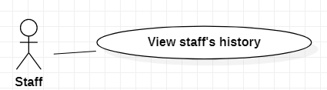

|  |  |  |  |  |
| --- | --- | --- | --- | --- |
| **USE UC027** | | | | |
| **Use-case No.** | UC027 | **Use-case Version** | | 3.0 |
| **Use-case Name** | View staff’s history | | | |
| **Author** | Huynh Thi Khanh Tram | | | |
| **Date** | 28/06/2021 | **Priority** | Normal | |
| **Actor:**  Staff  **Summary:**  This function allows staff to view the staff's history.  **Goal:**  Staff can view the staff’s history.  **Triggers**  When staff click the “View history” button.  **Preconditions:**  The user must login to the system as staff.  The user must have a stable network connection.  **Post Conditions:**  Success: Staff can send feedback about customer.  **Main Success Scenario:**   |  |  |  | | --- | --- | --- | | Step | Actor Action | System Response | | 1 | Staff clicks the “View history” button. | The system will display information including:  -Date  -Customer name  -Bike  -Problem name  +Send feedback: button. |   **Alternative Scenario:**  N/A  **Exceptions:**  N/A  **Relationships:**  N/A  **Business Rules:**  N/A | | | | |

## Send feedback about customer

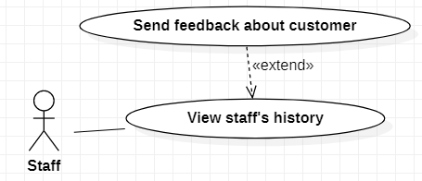

|  |  |  |  |  |
| --- | --- | --- | --- | --- |
| **USE CASE-028** | | | | |
| **Use-case No.** | UC028 | **Use-case Version** | | 3.0 |
| **Use-case Name** | Send feedback about customer | | | |
| **Author** | Huynh Thi Khanh Tram | | | |
| **Date** | 28/06/2021 | **Priority** | Normal | |
| **Actor:**  Staff  **Summary:**  This function allows staff to send feedback about the customer.  **Goal:**  Staff can send feedback about the customer.  **Triggers**  When staff click the “Send feedback” button.  **Preconditions:**  The user must login to the system as staff.  Staff must view history first.  The user must have a stable network connection.  **Post Conditions:**  Success: The system will display a success message.  Fail: The system shows the error message.  **Main Success Scenario:**   |  |  |  | | --- | --- | --- | | Step | Actor Action | System Response | | 1 | Staff clicks the “Send feedback” button. | The screen will display form to enter including:  -Staff name: textbox, type: string, required.  -Customer name: textbox, type: string, required.  -Image: picture box, type: .jpg  -Description: textbox, type: string, required.  +Send: button | | 2 | Staff fills in all information and clicks the “Send” button. | -The system will check for input errors.  -The system will send detailed information of the feedback to the admin.  -The system will show a message: ”Sent feedback successfully.”  - Insert new feedback into the database.  [Exception 1, 2, 3, 4] |   **Alternative Scenario:**  N/A  **Exceptions:**   |  |  |  | | --- | --- | --- | | No | Actor Action | System Response | | 1 | Staff name is empty or greater than 100 characters. | The system will show the message: “Staff name cannot be empty and less than 100 characters.” | | 2 | Customer name is empty or greater than 100 characters. | The system will show the message: “Customer name cannot be empty and less than 100 characters.” | | 3 | Image is empty. | The system will show the message: “The image must be selected.” | | 4 | Description is empty or greater than 1000 characters. | The system will show the message: “Description cannot be empty and less than 1000 characters.” |   **Relationships:**  Send feedback about customer extend View staff’s history.  **Business Rules:**  Staff must enter correct information about: staff name, customer name, image, description. | | | | |

## Manage repair shop

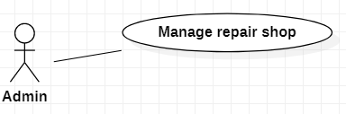

|  |  |  |  |  |
| --- | --- | --- | --- | --- |
| **USE CASE-029** | | | | |
| **Use-case No.** | UC029 | **Use-case Version** | | 3.0 |
| **Use-case Name** | Manage repair shop | | | |
| **Author** | Huynh Thi Khanh Tram | | | |
| **Date** | 28/06/2021 | **Priority** | Normal | |
| **Actor:**  Admin  **Summary:**  This function allows the admin to manage the repair shop.  **Goal:**  Admin can manage the repair shop.  **Triggers**  N/A  **Preconditions:**  The user must login to the system as admin.  The user must have a stable network connection.  **Post Conditions:**  Success: The system will display a list of repair shops.  **Main Success Scenario:**   |  |  |  | | --- | --- | --- | | Step | Actor Action | System Response | | 1 |  | The system will display a list of repair shops including:  -Repair shop name  -Address  -Image  +View: button |   **Alternative Scenario:**  N/A  **Exceptions:**  N/A  **Relationships:**  N/A  **Business Rules:**  N/A | | | | |

## Approve the repair shop’s account

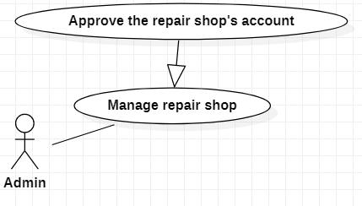

|  |  |  |  |  |
| --- | --- | --- | --- | --- |
| **USE CASE-030** | | | | |
| **Use-case No.** | UC030 | **Use-case Version** | | 3.0 |
| **Use-case Name** | Approve the repair shop’s account | | | |
| **Author** | Huynh Thi Khanh Tram | | | |
| **Date** | 28/06/2021 | **Priority** | Normal | |
| **Actor:**  Admin  **Summary:**  This function allows the admin to approve the repair shop’s account.  **Goal:**  Admin can approve the repair shop’s account.  **Triggers**  When admin clicks the “Accept” button.  **Preconditions:**  The user must login to the system as admin.  Repair shop owner sent information about their shop successfully.  The user must have a stable network connection.  **Post Conditions:**  Success: The repair shop’s account is activated.  **Main Success Scenario:**   |  |  |  | | --- | --- | --- | | Step | Actor Action | System Response | | 1 |  | The system display repair shop's information includes:  -Repair shop name  -Repair shop owner name  -Address  -Image  +Accept: button  +Cancel: button  [Exception 1] | | 2 | Admin clicks the “Accept” button. | - Set the repair shop's status to active in the database.  -The system will display the message: "The repair shop's account is activated." |   **Alternative Scenario:**  N/A  **Exceptions:**   |  |  |  | | --- | --- | --- | | No | Actor Action | System Response | | 1 | Admin clicks the “Cancel” button. | The system will display the message: "Canceled successfully." |   **Relationships:**  Approve the repair shop’s account generalize Manage repair shop.  **Business Rules:**  N/A | | | | |

## View repair shop

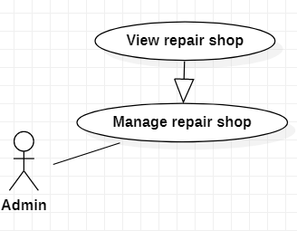

|  |  |  |  |  |
| --- | --- | --- | --- | --- |
| **USE CASE-031** | | | | |
| **Use-case No.** | UC031 | **Use-case Version** | | 3.0 |
| **Use-case Name** | View repair shop | | | |
| **Author** | Huynh Thi Khanh Tram | | | |
| **Date** | 28/06/2021 | **Priority** | Normal | |
| **Actor:**  Admin  **Summary:**  This function allows the admin to view the repair shop.  **Goal:**  Admin can view the repair shop.  **Triggers**  When admin clicks the “View” button.  **Preconditions:**  Repair shop's account must be activated.  The user must login to the system as admin.  The user must have a stable network connection.  **Post Conditions:**  Success: Admin can disable repair shop.  **Main Success Scenario:**   |  |  |  | | --- | --- | --- | | Step | Actor Action | System Response | | 1 | Admin clicks the “View” button. | The screen will display information including:  -Repair shop name  -Repair shop owner name  -Address  -Image  -Location  -Create date  -Status |   **Alternative Scenario:**  N/A  **Exceptions:**  N/A  **Relationships:**  View repair shop generalize Manage repair shop.  **Business Rules:**  N/A | | | | |

## Disable repair shop

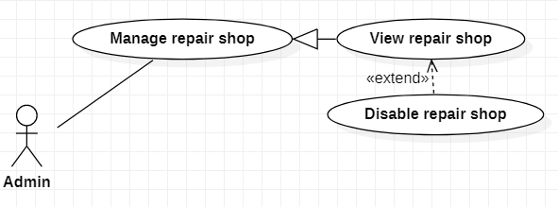

|  |  |  |  |  |
| --- | --- | --- | --- | --- |
| **USE CASE-032** | | | | |
| **Use-case No.** | UC032 | **Use-case Version** | | 3.0 |
| **Use-case Name** | Disable repair shop | | | |
| **Author** | Huynh Thi Khanh Tram | | | |
| **Date** | 28/06/2021 | **Priority** | Normal | |
| **Actor:**  Admin  **Summary:**  This function allows the admin to disable the repair shop.  **Goal:**  Admin can disable the repair shop.  **Triggers**  When admin clicks the “Disable” button.  **Preconditions:**  Admin must view repair shop first.  The user must login to the system as admin.  The user must have a stable network connection.  **Post Conditions:**  Success: Repair shop will be disabled.  **Main Success Scenario:**   |  |  |  | | --- | --- | --- | | Step | Actor Action | System Response | | 1 | Admin clicks the “Disable” button. | - Update the repair shop's status to inactive in the database.  -The system will display the message: "Repair shop is disabled." |   **Alternative Scenario:**  N/A  **Exceptions:**  N/A  **Relationships:**  Disable repair shop extend View repair shop.  **Business Rules:**  N/A | | | | |

## Get the list staff’s feedbacks

|  |  |  |  |  |
| --- | --- | --- | --- | --- |
| **USE CASE-033** | | | | |
| **Use-case No.** | UC033 | **Use-case Version** | | 3.0 |
| **Use-case Name** | Get the list staff’s feedbacks | | | |
| **Author** | Huynh Thi Khanh Tram | | | |
| **Date** | 28/06/2021 | **Priority** | Normal | |
| **Actor:**  Admin  **Summary:**  This function allows the admin to get the list staff’s feedbacks.  **Goal:**  Admin can get the list staff’s feedbacks.  **Triggers**  N/A  **Preconditions:**  The user must login to the system as admin.  The user must have a stable network connection.  **Post Conditions:**  Success: Admin can view staff's feedbacks.  **Main Success Scenario:**   |  |  |  | | --- | --- | --- | | Step | Actor Action | System Response | | 1 |  | The system will send all staff's feedbacks to the admin. |   **Alternative Scenario:**  N/A  **Exceptions:**  N/A  **Relationships:**  N/A  **Business Rules:**  N/A | | | | |

## View staff’s feedbacks

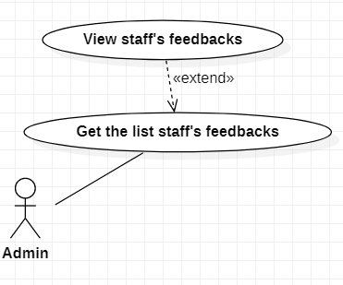

|  |  |  |  |  |
| --- | --- | --- | --- | --- |
| **USE CASE-034** | | | | |
| **Use-case No.** | UC034 | **Use-case Version** | | 3.0 |
| **Use-case Name** | View staff’s feedbacks | | | |
| **Author** | Huynh Thi Khanh Tram | | | |
| **Date** | 28/06/2021 | **Priority** | Normal | |
| **Actor:**  Admin  **Summary:**  This function allows the admin to view staff’s feedbacks.  **Goal:**  Admin can view staff’s feedbacks.  **Triggers**  When admin clicks the “View feedback” button.  **Preconditions:**  The user must login to the system as admin.  The user must have a stable network connection.  **Post Conditions:**  Success: Admin can view customer in that feedback.  **Main Success Scenario:**   |  |  |  | | --- | --- | --- | | Step | Actor Action | System Response | | 1 | Admin clicks the “View feedback” button. | The screen will display information about a list of staff's feedbacks including:  -Staff name  -Customer name  -Description  -Image  +View customer: button  [Exception 1] |   **Alternative Scenario:**  N/A  **Exceptions:**   |  |  |  | | --- | --- | --- | | Step | Actor Action | System Response | | 1 | Admin clicks “View feedback” button. | The system will display the message: "Empty!!!" when there is no staff's feedback to display. |   **Relationships:**  View staff’s feedbacks extend Get the list staff’s feedbacks.  **Business Rules:**  N/A | | | | |

## View customer

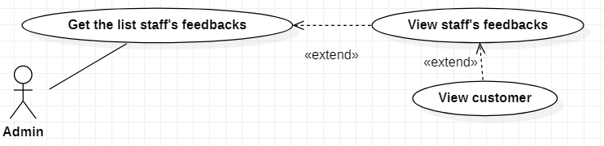

|  |  |  |  |  |
| --- | --- | --- | --- | --- |
| **USE CASE-035** | | | | |
| **Use-case No.** | UC035 | **Use-case Version** | | 3.0 |
| **Use-case Name** | View customer | | | |
| **Author** | Huynh Thi Khanh Tram | | | |
| **Date** | 28/06/2021 | **Priority** | Normal | |
| **Actor:**  Admin  **Summary:**  This function allows the admin to view the customer.  **Goal:**  Admin can view the customer.  **Triggers**  When admin click the “View customer” button.  **Preconditions:**  The user must login to the system as admin.  Admin must view staff’s feedbacks first.  The user must have a stable network connection.  **Post Conditions:**  Success: Admin can disable customer.  **Main Success Scenario:**   |  |  |  | | --- | --- | --- | | Step | Actor Action | System Response | | 1 | Admin clicks the “View customer” button. | The screen will display customer information including:  -Customer name  -Image  -Address  -Email  -Phone number  +Disable: button |   **Alternative Scenario:**  N/A  **Exceptions:**  N/A  **Relationships:**  View customer extend View staff’s feedbacks.  **Business Rules:**  N/A | | | | |

## Disable customer

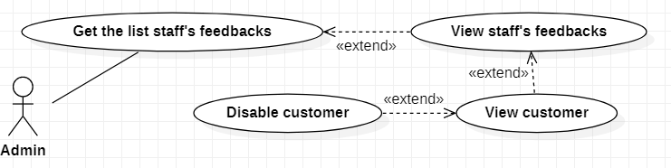

|  |  |  |  |  |
| --- | --- | --- | --- | --- |
| **USE CASE-036** | | | | |
| **Use-case No.** | UC036 | **Use-case Version** | | 3.0 |
| **Use-case Name** | Disable customer | | | |
| **Author** | Huynh Thi Khanh Tram | | | |
| **Date** | 28/06/2021 | **Priority** | Normal | |
| **Actor:**  Admin  **Summary:**  This function allows the admin to disable the customer.  **Goal:**  Admin can disable the customer.  **Triggers**  When admin clicks the “Disable” button.  **Preconditions:**  The user must login to the system as admin.  Admin must view staff’s feedbacks and view customer first.  The user must have a stable network connection.  **Post Conditions:**  Success: That customer's account will be disabled.  **Main Success Scenario:**   |  |  |  | | --- | --- | --- | | Step | Actor Action | System Response | | 1 | Admin clicks the “Disable” button. | - Update the customer's status to inactive in the database.  -The system will display the message: "Customer has been successfully disabled." |   **Alternative Scenario:**  N/A  **Exceptions:**  N/A  **Relationships:**  Disable customer extend View customer.  **Business Rules:**  N/A | | | | |

## Register an account

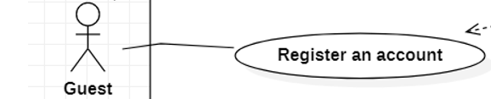

|  |  |  |  |
| --- | --- | --- | --- |
| **USE CASE-037** | | | |
| **Use Case No.** | UC037 | **Use Case Version** | 3.0 |
| **Use Case Name** | Register account | | |
| **Author** | Pham Viet Tai | | |
| **Date** | 01-07-2021 | **Priority** | Normal |
| **Actor**: - Guest. **Summary**: - This use case allows guests to register an account to the system. **Goal**: - Guest can register an account to the system. **Triggers**: - Guest touches the “Register Account” button. **Precondition**:  - The guest must have an internet connection. **Post Conditions**: - Success: Guess register an account to the system successfully.  - Fail: The system shows the error message. **Main Success Scenario**: | | | |
| **Step** | **Actor Action** | **System Response** | |
| 1 | Guest choose “Register account” button. | The screen will show registration information including:   * Name: textbox, required * Telephone Number: textbox, required * Address: textbox, required * Email: textbox, required * Password: textbox, required * Image: camera image | |
| 2 | Guest press the “Submit” button. | - The system will validate the data:  Exception[1,2,3,4,5]  - Insert a new guest account into the  database.  -Show a message ”Register successfully”. | |
| **Alternative Scenario**: N/A | | | |
| **Exceptions**: | | | |
| **No** | **Actor Action** | **System Response** | |
| 1 | The length of "Staff's Name" is between 8 and 20 characters. | System show message the " Staff's name must be greater than 8 and less than 20 characters ". | |
| 2 | The length of ”Phone” is 10 numbers. | System show message the "Phone is 10 numbers and starts with [+84]". | |
| 3 | The length of "Password" is not between 7 to 20. | System show message the " Password must be greater than 7 and less than 20 characters ".. | |
| 4 | The length of “Email” is over 30 characters. | Show error message: “You can only enter the email up to 30 characters”. | |
| 5 | The length of “Address” is over 50 characters. | Show error message: “You can only enter the address up to 50 characters”. | |
| **Relationships**: N/A | | | |
| **Business Rules**: - Password is encrypted before being sent to the system.  - When a Guest clicks the ”Submit” button:  + A new customer/repairer account will be created in the system with the input information. | | | |

## Register Bike

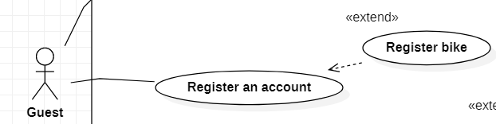

|  |  |  |  |
| --- | --- | --- | --- |
| **USE CASE-038** | | | |
| **Use Case No.** | UC038 | **Use Case Version** | 3.0 |
| **Use Case Name** | Register Bike | | |
| **Author** | Pham Viet Tai | | |
| **Date** | 01-07-2021 | **Priority** | Normal |
| **Actor**: - Guest **Summary**: - This use case allows guests to register bikes to the system. **Goal**: - Guest can register a bike to the system. **Triggers**: - Guest touches the “Register Bike” button. **Precondition**:  - Users must be registered for an account.  - The guest must have an internet connection. **Post Conditions**: - Success: Guest registers bike to the system successfully.  - Fail: The system shows the error message. **Main Success Scenario**: | | | |
| **Step** | **Actor Action** | **System Response** | |
| 1 | Guest touches on the “Register Bike” button. | The screen will show registration information including:   * Bike Name: textbox, required * Bike Color: Combobox * License Plate: textbox, required * Bike image: camera image * Submit: button * Cancel: button | |
| 2 | Guest touches on the “Submit” button. | - The system will validate the data:  Exception[1,2,3]  - Insert a new bike into the database.  - Show a message" Register successfully". | |
| **Alternative** **Scenario**: N/A | | | |
| **Exceptions**: | | | |
| **No** | **Actor Action** | **System Response** | |
| 1 | The length of "Bike name" is not between 5 to 20. | System show message the " Please enter Bike name". | |
| 2 | Bike color must be selected. | System show message the "Please choose bike color". | |
| 3 | The license plate must be entered. | System show message the " Please enter License Plate”. | |
| **Relationships**: Register bike extend Register an Account. | | | |
| **Business** **Rules**:  - The user must enter the license plate number.  - The photo of the vehicle must be clear and include the license plate.  - When a Guest clicks the ”Submit” button:  + Success: A new bike will be created in the system with the input information. | | | |

## Login

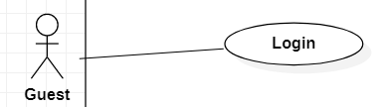

|  |  |  |  |
| --- | --- | --- | --- |
| **USE CASE-039** | | | |
| **Use Case No.** | UC039 | **Use Case Version** | 3.0 |
| **Use Case Name** | Login | | |
| **Author** | Pham Viet tai | | |
| **Date** | 01-07-2021 | **Priority** | Low |
| **Actor**: - Guest **Summary**: - This use case allows guests to log in to the system **Goal**: - Guest can log in to the system **Triggers**: - Guest choose the "Login account" option  **Precondition**: - The guest must have an internet connection. **Post Conditions**: - Success: Guest login the system successfully.  - Fail: The system shows the error message. **Main** **Success Scenario**: | | | |
| **Step** | **Actor Action** | **System Response** | |
| 1 | Guest choose “Login account” button. | The screen will show login information including: - User name: textbox, required - Password: textbox, required | |
| 2 | Guest choose the “Login” button. | The system checks validation and redirects to the homepage.  - Show a message “Login successfully” [Exception 1]. | |
| **Alternative Scenario**: N/A | | | |
| **Exception**: | | | |
| **No** | **Actor Action** | **System Response** | |
| 1 | User or Password was wrong. | - Show a message “Login failure”. | |
| **Relationships**: N/A **Business Rules**: - Password is encrypted before being sent to the server. - After login to the system, the guest will redirect to a specific view based on their role on the system: repairer, customer, or admin. - If the role is “Customer”, the system will display to Customer view. - If the role is “Repairer”, the system will display to Repairer view. | | | |

## Login with Gmail

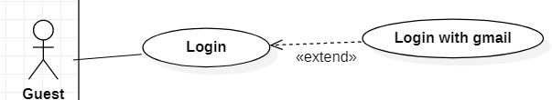

|  |  |  |  |
| --- | --- | --- | --- |
| **USE CASE-040** | | | |
| **Use Case No.** | UC040 | **Use Case Version** | 3.0 |
| **Use Case Name** | Login with gmail | | |
| **Author** | Pham Viet Tai | | |
| **Date** | 01-07-2021 | **Priority** | Low |
| **Actor**: - Guest. **Summary**: - This use case allows guests to log in to the system. **Goal**: - Guest can log in to the system. **Triggers**: - Guest choose the "Login with Gmail" option.  **Precondition**: - Guest must have a Gmail account.  - The guest must have an internet connection. **Post Conditions**: - Success: Guest login the system successfully.  - Fail: The system shows the error message. **Main Success Scenario**: | | | |
| **Step** | **Actor Action** | **System Response** | |
| 1 | Guest choose “Login with Gmail” button | -The system will redirect to the google login page - Google returns the user's Gmail for login  [Exception 1] | |
| **Alternative Scenario**: N/A | | | |
| **Exception**: | | | |
| **No** | **Actor Action** | **System Response** | |
| 1 |  | System show message “Login failure”. | |
| **Relationships**: Login with Gmail extend Login **Business Rules**: - Password is encrypted before being sent to the server. - After login to the system, the guest will redirect to a specific view based on their role on the system: repairer or customer. - If the role is “Customer”, the system will display to Customer view. - If the role is “Repair Shop”, the system will display to Repairer view.  - Users who enter incorrect login information for the 6th time in a row will have their account locked for 30 minutes. | | | |

## View staff’s account

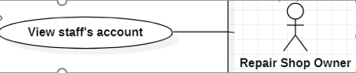

|  |  |  |  |
| --- | --- | --- | --- |
| **USE CASE-041** | | | |
| **Use Case No.** | UC041 | **Use Case Version** | 3.0 |
| **Use Case Name** | View staff’s account | | |
| **Author** | Pham Viet Tai | | |
| **Date** | 01-07-2021 | **Priority** | Low |
| **Actor**: - Repair Shop Owner. **Summary**: - Show the information of the staff. **Goal**:  - The repairing shop owner can view the staff’s account.  **Triggers**: - The shop owners choose the " View staff’s account " button. **Precondition**:  - User must be the repair shop owner.  - The shop owner must have an internet connection.  **Post Conditions**: - Success: Show the staff's accounts. **Main Success Scenario**: | | | |
| **Step** | **Actor Action** | **System Response** | |
| 1 | The shop owners choose the " View staff’s account " button | The screen will show the information of staff include:  - Staff’s name  - Phone  - Image  - Address  - Disable: button  Exception [1] | |
| **Alternative Scenario**: N/A | | | |
| **Exception**: | | | |
| **No** | **Actor Action** | **System Response** | |
| 1 | The shop owners have no staff | System show message “You do not have any staff” | |
| **Relationships**: N/A. **Business Rules**:  - The staff’s profile view has the following information: name, phone, image, address.  - System show staff’s information from the database. | | | |

## Disable staff's account

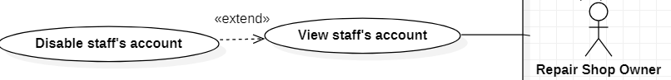

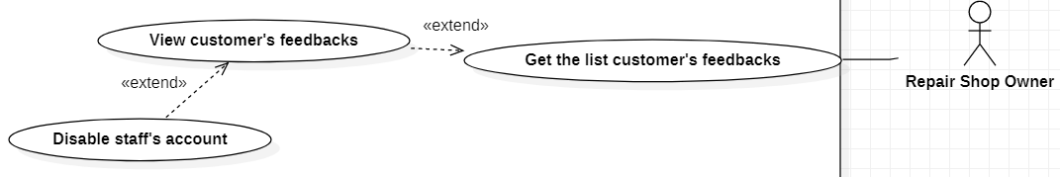

|  |  |  |  |
| --- | --- | --- | --- |
| **USE CASE-042** | | | |
| **Use Case No.** | UC042 | **Use Case Version** | 3.0 |
| **Use Case Name** | Disable staff's account | | |
| **Author** | Pham Viet Tai | | |
| **Date** | 01-07-2021 | **Priority** | High |
| **Actor**: - Repair Shop Owner. **Summary**: - Help the shop owner disable the staff’s account. **Goal**: - The repair shop owners can disable the staff’s account.  **Triggers**:  - Customer chooses the “Disable staff’s account” button. **Precondition**: - The user must be the repair shop’s owner.  - The shop owners must have an internet connection. **Post Conditions**: - Success: Disable staff’s account. **Main Success Scenario**: | | | |
| **Step** | **Actor Action** | **System Response** | |
| 1 | The shop owners choose the” Disable account” button. | - Show the message ”Are you sure you want to disable the account?”:  + “OK”: button  + “Cancel”: button | |
| 2 | The shop owners choose the “OK” button. | - Show the message ”Disable successfully”. | |
| **Alternative** **Scenario**: N/A | | | |
| |  |  |  | | --- | --- | --- | | Step | Actor Action | System Response | | 1 | Shop owner received feedback from customers. |  | | 2 | The repair shop owner chooses the "View Feedback" button. | The repair shop owner views the list of customer’s feedback including:  - Customer’s name  - Content feedback  - Date of creating feedbacks  - Disable: button | | 3 | The repair shop owner chooses the " Disable account " button. | Show the message ”Are you sure you want to disable the account?”:  + “OK”: button  + “Cancel”: button | | 4 | The shop owners choose the “OK” button. | - Show the message ”Disable successfully”. | | | | |
| **Exceptions**: | | | |
| **No** | **Actor Action** | **System Response** | |
| 1 | The shop owners choose the “Cancel” button. | - Show message ”Disable is canceled”. | |
| **Relationships**: Disable staff's account extend View staff's account, Disable staff's account extend View customer’s feedbacks. **Business Rules**:  -When the shop owner presses the "Ok" button:  + The system will update the status in the database to "False". | | | |

## Get the list of customer’s feedback

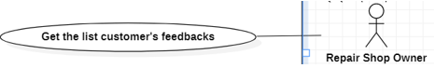

|  |  |  |  |
| --- | --- | --- | --- |
| **USE CASE-043** | | | |
| **Use Case No.** | UC043 | **Use Case Version** | 3.0 |
| **Use Case Name** | Get the list of customer’s feedbacks | | |
| **Author** | Pham Viet Tai | | |
| **Date** | 01-07-2021 | **Priority** | High |
| **Actor**: - Repair Shop Owner **Summary**: - Help the shop owner get the list of customer’s feedback. **Goal**: - The repair shop owners can get the list of customer’s feedback.  **Triggers**: N/A **Precondition**: - The user must be the repair shop’s owner.  - The customers send feedback to the shop owner.  - The shop owners must have an internet connection.  **Post Conditions**: N/A **Main Success Scenario**: | | | |
| **No** | **Actor Action** | **System Response** | |
| 1 |  | The repair shop owners get the list of customer’s feedback. | |
| **Alternative** **Scenario**:N/A | | | |
| **Exceptions**:N/A | | | |
| **Relationships**: N/A **Business Rules**: N/A | | | |

## View customer’s feedbacks



|  |  |  |  |
| --- | --- | --- | --- |
| **USE CASE-044** | | | |
| **Use Case No.** | UC044 | **Use Case Version** | 3.0 |
| **Use Case Name** | View customer’s feedbacks | | |
| **Author** | Pham Viet Tai | | |
| **Date** | 01-07-2021 | **Priority** | High |
| **Actor**: - Repair Shop Owner. **Summary**: - Help the shop owner view customer’s feedbacks. **Goal**: - The repair shop owners can view customer’s feedbacks.  **Triggers**:  - The repair shop owner chooses the "View Feedback" button.  - The shop owners must have an internet connection. **Precondition**: - The user must be the repair shop’s owner.  - The user must have a stable network connection. **Post Conditions**:  Success: Show feedback page.  Fail: Show error message. **Main Success Scenario**: | | | |
| **Step** | **Actor Action** | **System Response** | |
| 1 | The repair shop owner choose the "View Feedback" button. | The repair shop owner views the list of customer’s feedback including:  - Customer’s name  - Content feedback  - Date of creating feedbacks  - Disable: button | |
| **Alternative** **Scenario**: N/A | | | |
| **Exceptions**: | | | |
| **No** | **Actor Action** | **System Response** | |
| 1 | Event link is broken. | Show the message "System is busy". | |
| **Relationships**: View customer’s feedback extend Get the list customer’s feedback. **Business Rules**:  - The customer’s feedback view has the following information: name, content feedback, date of creating feedbacks.  - System show customer feedback from the database. | | | |

## Create account for staff

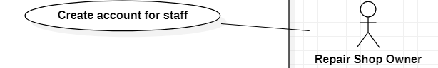

|  |  |  |  |
| --- | --- | --- | --- |
| **USE CASE-045** | | | |
| **Use Case No.** | UC045 | **Use Case Version** | 3.0 |
| **Use Case Name** | Create an account for staff | | |
| **Author** | Pham Viet Tai | | |
| **Date** | 01-07-2021 | **Priority** | High |
| **Actor**: - Repair Shop Owner. **Summary**: - Help the shop owner create an account for staff. **Goal**: - The repair shop owners can create an account for staff.  **Triggers**:  - The repair shop owner chooses the "Create account" button.Feedback" button **Precondition**: - The user must be the repair shop’s owner.  - The user must have a stable network connection. **Post Conditions**:  - Success: A new account was created successfully.  - Fail: The system shows the error message. **Main Success Scenario**: | | | |
| **Step** | **Actor Action** | **System Response** | |
| 1 | The repair shop owner chooses the "Create account" button. | The system requires the following input from the shop owner including:  - Staff’s name: textbox, required  - Phone: textbox, required  - Address: textbox, required  - Email: textbox, required  - Date of creating an account: DateTime picker, required  - Create: button | |
| 2 | The repair shop owner input information and click “Create” button. | - The system will check the data:  Exception[1,2,3,4,5] | |
| 3 |  | -Insert a new account into the database.  -The system will show a message" The account is created successfully ". | |
| **Alternative** **Scenario**: N/A | | | |
| **Exceptions**: | | | |
| **No** | **Actor Action** | **System Response** | |
| 1 | Length of ”Staff’s Name” is not in range, lower than min. | System show message the "Staff’s name must be at least 8 characters". | |
| 2 | Length of ”Staff’s Name” is not in range, higher than min. | System show message the "Staff’s name must be less than 50 characters". | |
| 3 | The length of ”Phone” is 10 numbers. | System show message the "Phone is 10 numbers and starts with [+84]". | |
| 4 | The length of “Email” is over 30 characters. | Show error message: “You can only enter the email up to 30 characters”. | |
| 5 | The length of “Address” is over 50 characters. | Show error message: “You can only enter the address up to 50 characters”. | |
| **Relationships**: N/A  **Business Rules:**  - Staff's name from 8 to 50 characters.  - Date of creating an account must be greater than the current date.  - Phone: 10 numbers and starts with [+84].  - When the repair shop owner clicks the ”Create” button:  +Success: Show massage “The account is created successfully”. | | | |

## Get the list of bills

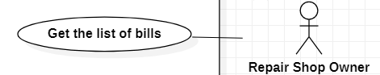

|  |  |  |  |
| --- | --- | --- | --- |
| **USE CASE-046** | | | |
| **Use Case No.** | UC046 | **Use Case Version** | 3.0 |
| **Use Case Name** | Get the list of bills | | |
| **Author** | Pham Viet Tai | | |
| **Date** | 01-07-2021 | **Priority** | High |
| **Actor**: - Repair Shop Owner. **Summary**: - Help the shop owner get the list of bills. **Goal**: - The repair shop owners can get the list of bills.  **Triggers**: N/A **Precondition**: - The user must be the repair shop’s owner.  - The staff creates the bill for the customer.  - The user must have a stable network connection. **Post Conditions**: N/A **Main Success Scenario**: | | | |
| **Step** | **Actor Action** | **System Response** | |
| 1 |  | The repair shop owners get list the staff’s bills. | |
| **Alternative** **Scenario**: N/A | | | |
| **Exceptions**:N/A | | | |
| **Relationships**: N/A **Business Rules**: N/A | | | |

## View a bill

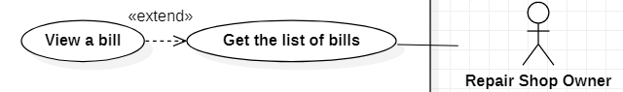

|  |  |  |  |
| --- | --- | --- | --- |
| **USE CASE-047** | | | |
| **Use Case No.** | UC047 | **Use Case Version** | 3.0 |
| **Use Case Name** | View a bill | | |
| **Author** | Pham Viet Tai | | |
| **Date** | 01-07-2021 | **Priority** | High |
| **Actor**: - Repair Shop Owner. **Summary**: - Help the shop owner view the bill. **Goal**: - The repair shop owners can view the bill.  **Triggers**:  - The repair shop owner choose the "View a bill" button." .button **Precondition**: - The user must be the repair shop’s owner.  - The user must have a stable network connection. **Post Conditions**:  - Success: Show the bill.  - Fail: Show error message. **Main Success Scenario**: | | | |
| **Step** | **Actor Action** | **System Response** | |
| 1 | The repair shop owner chooses the "View a bill" button. | The repair shop owner views a bill the staff’s including:  - Code bill  - Problem Name  - Date of creating the bill  - Quantity  - Price  Exception [1] | |
| **Alternative** **Scenario**: N/A | | | |
| **Exceptions**: | | | |
| **No** | **Actor Action** | **System Response** | |
| 1 |  | System show message the "System is busy" when the internet is lost. | |
| **Relationships**: View a bill extend Get the list of bills. **Business Rules**:  - The Shop owner views the bill including code bill, problem name, date of creating the bill, quantity, price.  - The system shows the bill when the employee creates the bill. | | | |

## Create service

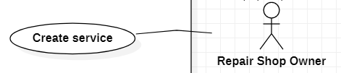

|  |  |  |  |
| --- | --- | --- | --- |
| **USE CASE-048** | | | |
| **Use Case No.** | UC048 | **Use Case Version** | 3.0 |
| **Use Case Name** | Create service | | |
| **Author** | Pham Viet Tai | | |
| **Date** | 01-07-2021 | **Priority** | High |
| **Actor**: - Repair Shop Owner. **Summary**: - Help the shop owner create service. **Goal**: - The repair shop owners can create service.  **Triggers**:  - The repair shop owner chooses the "Create service" button.utton **Precondition**: - The user must be the repair shop’s owner.  - The user must have a stable network connection. **Post Conditions**:  - Success: A new service created successfully.  - Fail: The system shows the error message. **Main Success Scenario**: | | | |
| **Step** | **Actor Action** | **System Response** | |
| 1 | The repair shop owner chooses the "Create Service" button. | The system requires the following input from the shop owner including:  - Service’s name: textbox, required  - Date of creating service: DateTime picked, required  - Price: textbox, required  - Description: textbox, required  - Create: button | |
| 2 | The repair shop owner input information and click the “Create” button. | The system will check the data:  Exception[1,2,3,4] | |
| 3 |  | - Insert a new service into the database.  - The system will show a message" Service created successfully”. | |
| **Alternative** **Scenario**: N/A | | | |
| **Exceptions**: | | | |
| **No** | **Actor Action** | **System Response** | |
| 1 | The length of "Service Name" is at least 8 characters. | System show message the " Service’s name must be at least 8 characters". | |
| 2 | The length "Service Name" longest is 50 characters | System show message the " Service’s name must be less than 50 characters". | |
| 3 | Time is not picked in ”Date of creating service”. | System show message the "The date of creating service must be selected". | |
| 4 | The price must be greater than 0 | System show message the " The price must be greater than 0". | |
| **Relationships**: N/A  **Business Rules:**  - Price: Price must be greater than 0.  - Date of creating an account must be greater than the current date.  - When the repair shop owner clicks the “Create” button:  + Success: Show massage “Service created successfully”. | | | |

## Edit service

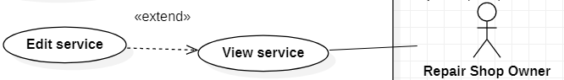

|  |  |  |  |
| --- | --- | --- | --- |
| **USE CASE-049** | | | |
| **Use Case No.** | UC049 | **Use Case Version** | 3.0 |
| **Use Case Name** | Edit service | | |
| **Author** | Pham Viet Tai | | |
| **Date** | 01-07-2021 | **Priority** | High |
| **Actor**: - Repair Shop Owner. **Summary**: - Help the shop owner edit the service. **Goal**: - The repair shop owners can edit the service.  **Triggers**:  - The repair shop owner choose the "Edit Service" button.button **Precondition**: - The user must be the repair shop’s owner.  - The user must have a stable network connection. **Post Conditions**:  Success: The service was edited successfully. **Main Success Scenario**: | | | |
| **Step** | **Actor Action** | **System Response** | |
| 1 | The repair shop owner chooses the "Edit Service" button. | The system requires the following edit from the shop owner including:  - Service’s name: textbox, required  - Date of creating service: DateTime picked, required  - Price: textbox, required  - Description: textbox, required  - Submit: button | |
| 2 | The repair shop owner input information and click the “Submit” button. | - The system will check the data:  Exception[1,2,3]  - Show the message “Edit successfully” | |
| **Alternative** **Scenario**: N/A | | | |
| **Exceptions**: | | | |
| **No** | **Actor Action** | **System Response** | |
| 1 | Length of ”Service’s Name” is not in range, lower than min. | System show message the " Service’s name must be at least 8 characters". | |
| 2 | Length of” Service’s Name” is not in range, higher than min. | System show message the " Service’s name must be less than 50 characters". | |
| 3 | Time is not picked in the” Date of edit service”. | System show message the "The date of editing service must be selected". | |
| 4 | The price must be greater than 0 | System show message the " The price must be greater than 0". | |
| **Relationships**: Edit service extend View service.  **Business Rules:**  - Date of creating an account must be greater than the current date.  - Price must be greater than 0.  - When the repair shop owner clicks the ”Submit” button:  + Success: Show massage “Service edited successfully”. | | | |

## View service

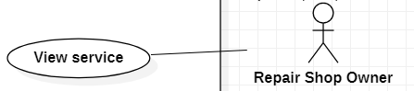

|  |  |  |  |
| --- | --- | --- | --- |
| **USE CASE-050** | | | |
| **Use Case No.** | UC050 | **Use Case Version** | 3.0 |
| **Use Case Name** | View service | | |
| **Author** | Pham Viet Tai | | |
| **Date** | 01-07-2021 | **Priority** | High |
| **Actor**: - Repair Shop Owner **Summary**: - Help the shop owner view the service. **Goal**: - The repair shop owners can view the service.  **Triggers**:  - The repair shop owner chooses the "View Service" button. **Precondition**: - The user must be the repair shop’s owner.  - The user must have a stable network connection. **Post Conditions**:  Success: Show the bill. **Main Success Scenario**: | | | |
| **Step** | **Actor Action** | **System Response** | |
| 1 | The repair shop owner chooses the "View Service” button. | The repair shop owner views a bill the staff’s including:  - Service’s name  - Date of creating service  - Price  - Description  - Delete service: button  - Edit service: button | |
| **Alternative** **Scenario**: N/A | | | |
| **Exceptions**: | | | |
| **No** | **Actor Action** | **System Response** | |
| 1 |  | System show message the "System is busy" when the internet is lost. | |
| **Relationships**: N/A  **Business Rules**:  - The shop owner views all services including service’s name, date of creating service, description, price.  - System show service from the database. | | | |

## Delete service

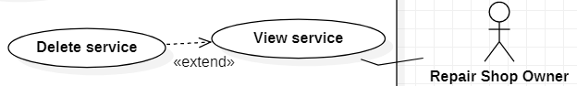

|  |  |  |  |
| --- | --- | --- | --- |
| **USE CASE-051** | | | |
| **Use Case No.** | UC051 | **Use Case Version** | 3.0 |
| **Use Case Name** | Delete service | | |
| **Author** | Pham Viet Tai | | |
| **Date** | 01-07-2021 | **Priority** | High |
| **Actor**: - Repair Shop Owner. **Summary**: - Help the shop owner delete the service. **Goal**: - The repair shop owners can delete the service.  **Triggers**:  - The repair shop owner chooses the "Delete service" button. **Precondition**: - The user must be the repair shop’s owner.  - The user must have a stable network connection. **Post Conditions**:  Success: The service Deleted successfully. **Main Success Scenario**: | | | |
| **Step** | **Actor Action** | **System Response** | |
| 1 | The repair shop owner chooses the "Delete service" button. | - Show the message” Are you sure you want to delete?”.  + “OK” button. | |
| 2 | The repair shop owner chooses the "OK" button. | - Show the message” Deleted Successfully”. | |
| **Alternative** **Scenario**:   |  |  |  | | --- | --- | --- | | Step | Actor Action | System Response | | 1 | The repair shop owner chooses the "Cancel" button. | - Show the message “Cancelled”. | | | | |
| **Exceptions**: N/A | | | |
| **Relationships**: Delete service extend View service.  **Business Rules:**  - When the repair shop owner clicks the ”OK” button:  + Success: The system will update the service status to "false". | | | |

# NON-FUNCTIONAL Requirements

## Usability

Repair Shop Owner, Admin, Staff should need less than two days of training to be productive with the system.

## Reliability

The average application error frequency should be less than 3 times / 1 year.

## Performance

The application’s load time should not be more than three seconds for users.

The application meets the minimum number of simultaneous accesses of 3000 people.

# Supporting Information

N/A