PYTHON SOFTWARE DEVELOPMENT PROJECT
BY
COMPUTER SCIENCE

COLLEGE OF NATURAL AND APPLIED SCIENCE
BELLS UNIVERSITY OF TECHNOLOGY NEW HORIZONS Team Members:
Ayalomhe Isaac (Head Developer)
Sanni Samiat (Assistant Developer/Presenter)
Ojekemi Oluwatomisin (Repository Manager)
Sinjeganji Samson (Report Documentation Officer)
Chux-Emmanuel Mercy
November, 2025 – January, 2025
Python, PyQt5, SQLite3, MatplotLib and ReportLabs
ICT 323
Productivity Suite and Budget Tracking Application
Submitted to Ayuba Mohammed

TABLE OF CONTENTS

Chapter 1: Introduction

Chapter 2: Literature Review and Project Research

Chapter 3: System Design and Architecture

Chapter 4: Implementation and Results

Chapter 5: Development Process

Chapter 6: Conclusions and Recommendations

Chapter 7: References

CHAPTER 1: INTRODUCTION

1.1 Project Overview
The Productivity Suite and Budget Tracking Application is a comprehensive desktop-based digital assistant designed to streamline the academic and financial lives of students at Bells University of Technology. Developed using Python and the PyQt5 framework, the application integrates essential organizational tools—a To-Do List, a Pomodoro Timer, and a Budget Planner—into a single, unified interface. By centralizing these features, the system eliminates the need for multiple disparate apps, providing a seamless workflow for time management and financial discipline.

1.2 Problem Statement
Contemporary students face a "triple threat" of organizational challenges that hinder academic success:
- Time Mismanagement: The inability to prioritize tasks leading to rushed assignments and diminished focus.
- Lack of Productivity Structure: Procrastination often sets in due to the absence of a structured study method or a way to visualize progress.
- Financial Instability: Students often lack the tools to track irregular spending, leading to preventable financial stress.
Existing solutions are often fragmented, forcing users to switch between different platforms, which creates "app fatigue" and leads to inconsistent usage. There is a critical need for a localized, unified system that addresses both academic output and financial health.

1.3 Objectives of the Study
The primary objective of this project is to develop a functional, user-friendly desktop application that enhances student discipline. Specific objectives include:
- To Implement Task Management: Create a CRUD-based (Create, Read, Update, Delete) To-Do list for academic planning.
- To Integrate Time-Boxing Techniques: Develop a Pomodoro Timer to facilitate focused study sessions.
- To Provide Data Visualization: Utilize Matplotlib to generate real-time productivity analytics and spending charts.
- To Ensure Data Persistence: Implement an SQLite3 database to securely store user tasks and financial records locally.
- To Automate Documentation: Include a feature for generating PDF receipts and expense reports via ReportLabs.

1.4 Significance of the Study
This study holds significant value for multiple stakeholders:
- For Students: It provides a practical tool to boost CGPA through better time management and reduce anxiety through financial transparency.
- For the Institution: It promotes digital literacy and self-management skills among the student body, aligning with the standards of excellence at Bells University.
- For the Developer Team: It serves as a practical application of Software Engineering principles, including GUI design, database management, and version control (Git).

1.5 Scope and Limitations
Scope:
- Core Modules: Task Management, Pomodoro Timer, Budget Tracking, and Analytics.
- Technology Stack: Python 3.x, PyQt5 (UI), SQLite3 (Database), Matplotlib (Charts), and ReportLabs (PDFs).
- Environment: Cross-platform desktop application (Windows/macOS/Linux).
Limitations:
- The application is a standalone desktop tool and does not currently support cloud synchronization or multi-device login.
- Biometric authentication and advanced mobile integrations are outside the current development phase.

1.6 Definition of Terms
- PyQt5: A comprehensive set of Python bindings for Qt libraries used to create modern, cross-platform graphical user interfaces.
- Pomodoro Technique: A time management method involving 25-minute intervals of focused work separated by short breaks.
- CRUD: An acronym for Create, Read, Update, and Delete—the four basic functions of persistent storage.
- SQLite3: A C-language library that implements a small, fast, self-contained, high-reliability, full-featured, SQL database engine.
- Productivity Analytics: The computational analysis of study data to provide insights into efficiency and focus trends.

CHAPTER 2: LITERATURE REVIEW AND PROJECT RESEARCH

2.1 Introduction
Modern academic success is increasingly dependent on the integration of digital tools that manage the dual pressures of cognitive load (assignments/exams) and administrative responsibility (finances). This chapter reviews the conceptual framework of productivity tools and justifies the technical selection of the "Productivity Suite and Budget Tracking Application" as a unified solution.

2.2 Review of Productivity Frameworks
The application is built upon two core psychological and organizational frameworks:
- The Pomodoro Technique: Research shows that the human brain maintains peak focus in short bursts. By implementing 25-minute intervals, the application mitigates "attention residue" and prevents burnout, which is a leading cause of academic underperformance.
- The Eisenhower Matrix Logic: The To-Do list module allows for task categorization, enabling students to differentiate between "urgent" and "important" tasks, thereby reducing the stress associated with deadline mismanagement.

2.3 Analysis of Existing Systems
A review of current market solutions (such as Trello for tasks or Mint for budgeting) reveals a "fragmentation gap." While these tools are powerful, they exist as separate entities.
- Gap Identification: Switching between multiple applications leads to "context switching," which can reduce productivity by up to 40%.
- Proposed Solution: Our system bridges this gap by merging academic time-tracking with financial monitoring, ensuring the student has a single "Source of Truth" for their daily responsibilities.

2.4 Technical Justification of the Stack
Based on project research, the following technologies were selected to maximize the benefits to the end-user:
- PyQt5 for UI/UX: Unlike standard libraries, PyQt5 allows for a professional, CSS-styled interface that mimics modern commercial software, improving user retention.
- Matplotlib for Analytics: Visualizing data through charts is essential for "Reflective Learning." By seeing a pie chart of expenses or a bar graph of study hours, students can make data-driven decisions to improve their habits.
- SQLite3 for Data Persistence: Research into student needs highlighted the requirement for offline functionality. SQLite provides a lightweight, serverless database that ensures data is saved even without an internet connection.

2.4 Benefits of Integrated Budgetary Control
Financial literacy is a core component of student well-being. The integration of a Budget Tracker serves several research-backed benefits:
- Expense Categorization: Automated sorting of spending (Food, Transport, Books) helps identify "leaking" funds.
- Report Generation: The inclusion of ReportLabs for PDF generation allows students to maintain physical or digital records of their financial history, fostering long-term accountability.

2.6 Impact on Digital Literacy and Career Readiness
Beyond academic grades, the use of this suite prepares students for the modern workforce by familiarizing them with:
- Data Interpretation: Understanding the analytics dashboard builds "Data Fluency."
- Resource Management: Managing a finite budget and limited study hours mirrors professional project management.
- Software Interaction: Navigating a complex, multi-tabbed GUI environment improves general digital competence.

2.7 Summary
The research conducted for this project confirms that a unified suite is superior to fragmented applications. By combining the Pomodoro Technique, CRUD-based task management, and SQL-driven financial tracking, the application provides a robust framework for improving both the academic performance and the personal development of the student user.

CHAPTER 3: SYSTEM DESIGN AND ARCHITECTURE

3.1 Introduction
This chapter outlines the technical blueprint of the Productivity Suite and Budget Tracking Application. It transitions from the conceptual objectives to the structural design, detailing how the software components—GUI, Database, and Logic—interact to create a cohesive user experience.

3.2 System Objectives and Requirements
The primary goal is to provide an integrated environment for task management and financial tracking.
- Functional Requirements: The system must perform CRUD (Create, Read, Update, Delete) operations on tasks, manage a countdown threading for the Pomodoro timer, and generate PDF summaries.
- Non-Functional Requirements: The application must be cross-platform (via Python), have a response time of under 2 seconds for data retrieval, and feature a modern, intuitive GUI using the PyQt5 library.

3.3 User Interface (UI) Design
The interface is designed using a Sidebar Navigation Pattern. This allows users to switch between the Dashboard, To-Do List, Pomodoro Timer, and Budget Tracker without losing state.
- Color Palette: Professional blues and greys to reduce eye strain during long study sessions.
- Responsiveness: Use of PyQt5 Layout Managers (QVBoxLayout, QHBoxLayout) to ensure the UI adapts to different screen resolutions.

3.4 System Flowchart (Logic)
The operational logic of the application follows a modular flow. When a user interacts with a module (e.g., completes a Pomodoro session), the logic layer triggers a database update and refreshes the Matplotlib charts on the dashboard.

3.5 Database and File Structure
The application utilizes a relational database model via SQLite3. This ensures data persistence and structural integrity.
• Tables:
- Tasks: Fields include; id, task_name, status, priority. o Pomodoro_sessions: Fields include; id, date, duration_minutes.
- Expenses: Fields include; id, amount, category, date, description. • File Organization:
- main.py: Entry point of the application. o database.db: The local SQLite file. o /assets/: Directory for icons and styling (QSS) files.

3.6 Development Workflow
Following the guidelines provided by New Horizons, the project utilizes Git for version control.
- Branching Strategy: Feature-based branching (e.g., feature/pomodoro-timer, feature/budget-ui) to ensure collaborative efficiency among team members.
- Repository Management: The code is hosted on GitHub, featuring a comprehensive _{README.md} and a requirements.txt file for easy deployment.

3.7 PDF Generation Logic (ReportLabs)
A key architectural component is the reporting engine. Using the ReportLabs library, the system fetches data from the _{expenses} table and maps it to a PDF template, allowing students to export their financial history as a professional document.

3.8 Summary
Chapter 3 has detailed the "how" of the project. By defining the UI wireframes, the SQLite schema, and the systemic flowchart, we have established a robust framework that ensures the objectives mentioned in the previous chapters are technically achievable and scalable.

CHAPTER 4: IMPLEMENTATION AND RESULTS

4.1 Introduction
This chapter explains how the Productivity Suite and Budget Tracking Application was developed. It includes the development methodology, tools used, design process, database structure, coding implementation, and testing.
Throughout this chapter, specific placeholders will show where to insert images of your actual code and the corresponding program output.

4.2 Development Methodology
The application was developed using the Incremental Development Model, where each module (To-Do List, Pomodoro Timer, Analytics, and Budget Planner) was built and tested individually before integration.

4.3 Tools and Technologies Used

• Python 3.12
- PyQt5 (Primary GUI)
- SQLite3 (Database)
- Matplotlib (Charts)
- ReportLab (PDF generation)

• Visual Studio Code (IDE)
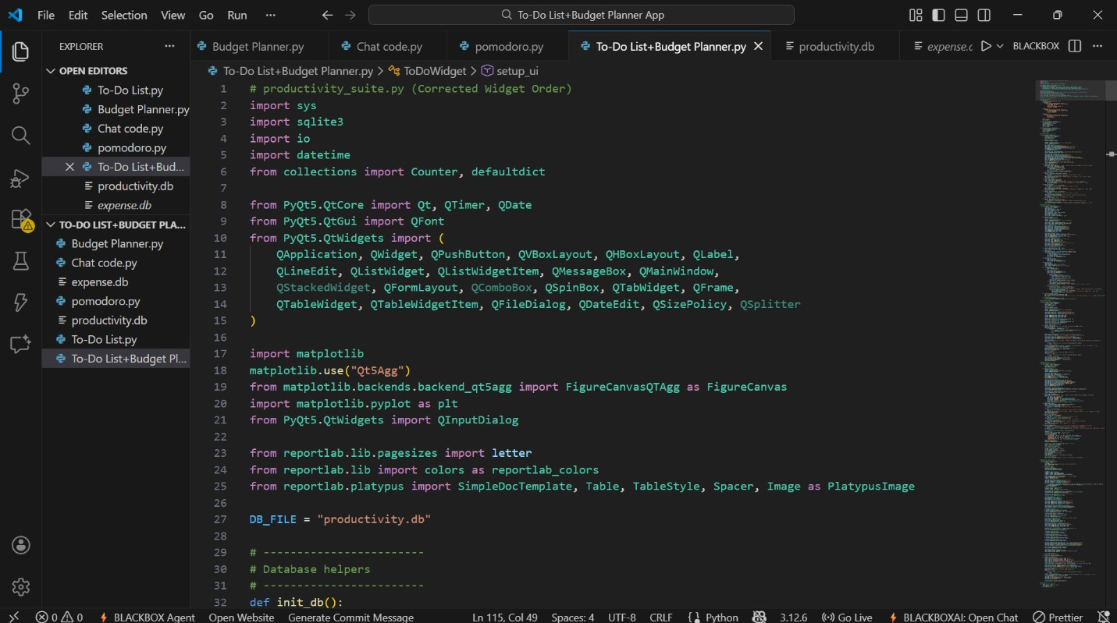
Figure 4.1 – Visual Studio Code used for writing and testing the program

4.4 System Design
The system was divided into four core modules:
- To-Do List
- Pomodoro Timer
- Productivity Analytics
- Budget Planner
Each module communicates with a shared SQLite database.
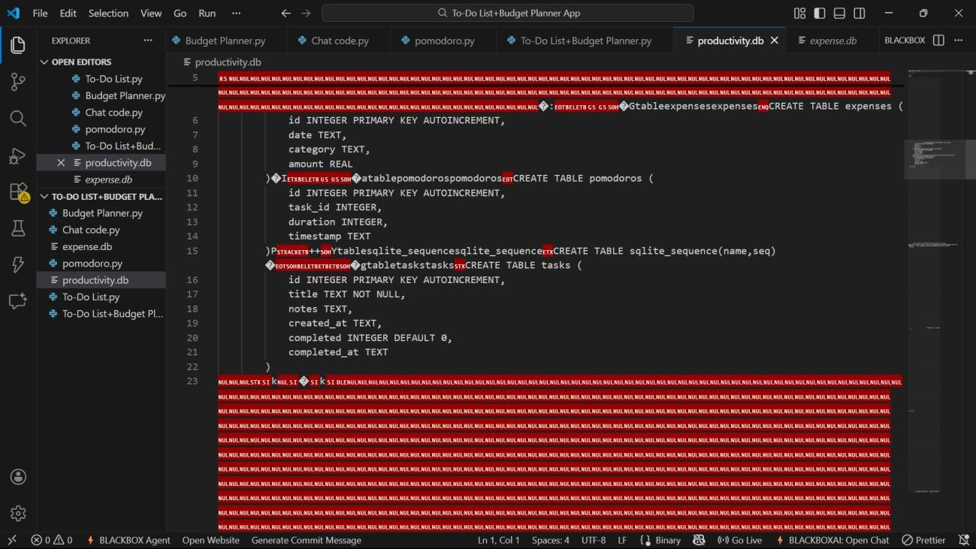
Figure 4.2 – SQLite database used to store tasks, sessions, and expenses

4.5 User Interface (UI) Design
The application uses a sidebar navigation layout to switch between the modules.
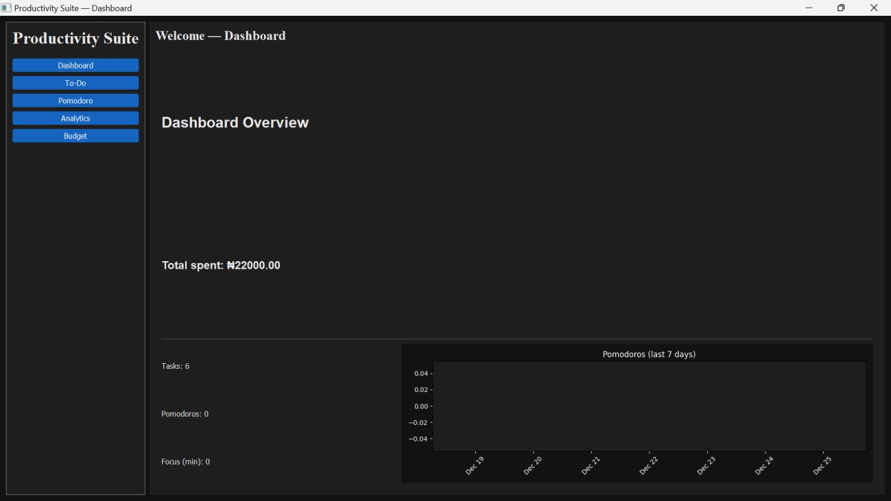

Figure 4.3 – Application dashboard showing navigation sidebar
4.6 Implementation
This section includes code implementation and actual output images.
4.6.1 To-Do List Module
The To-Do List allows users to add, edit, delete, and complete tasks.
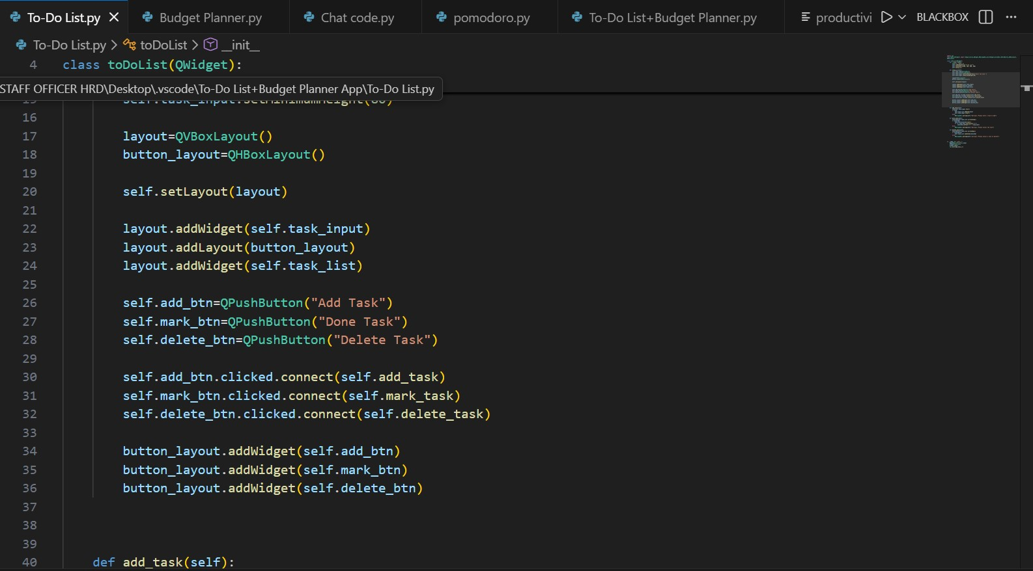

Figure 4.4 – Python code for implementing the To-Do List module
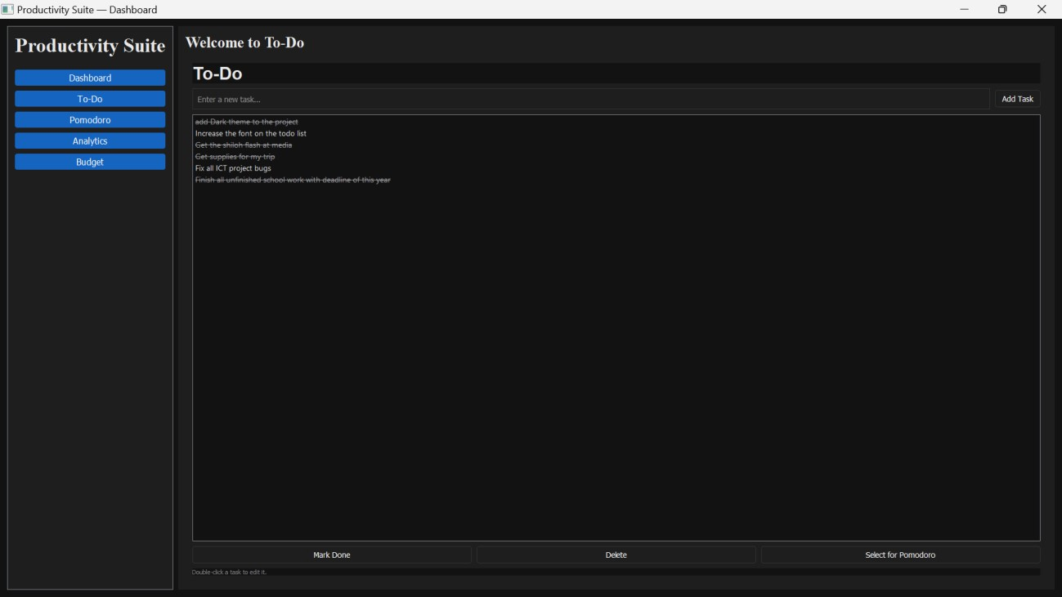

Figure 4.5 – To-Do List interface showing tasks and actions
4.6.2 Pomodoro Timer Module
This module implements the 25-minute study timer with break intervals.
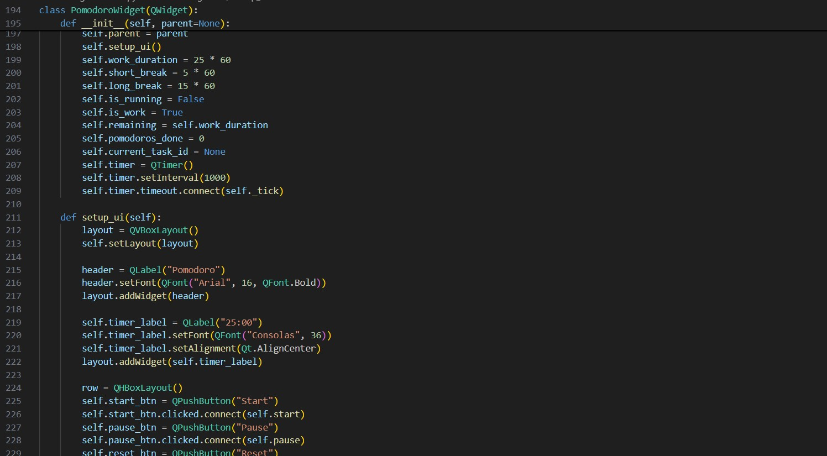

Figure 4.6 – Python code for implementing the Pomodoro Timer module
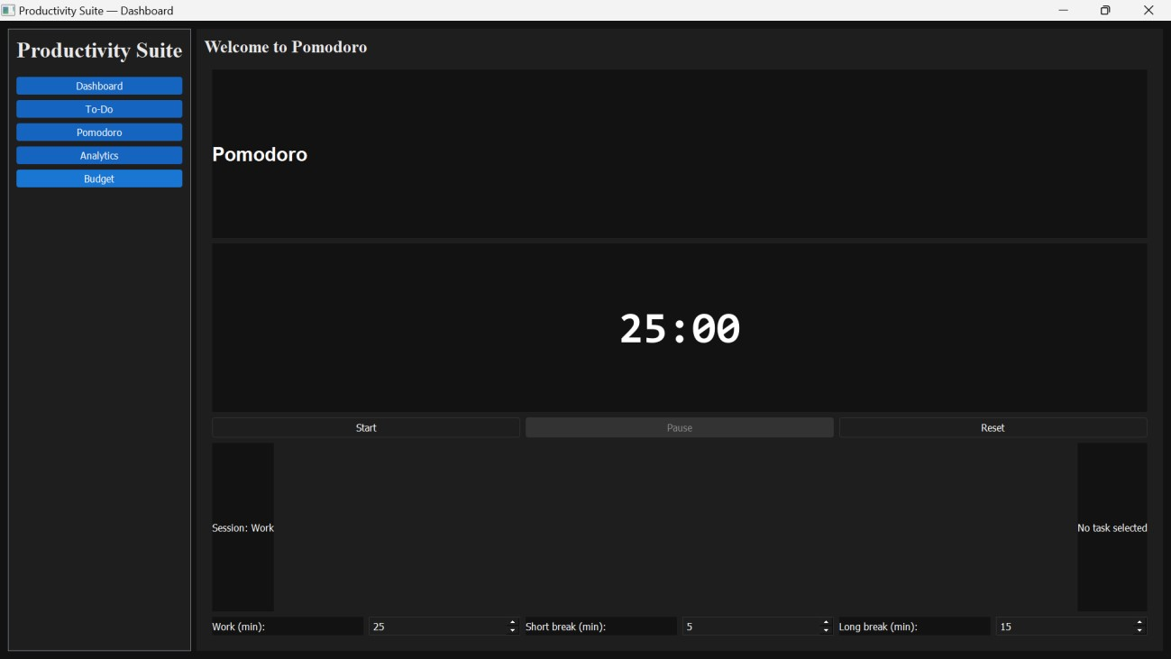

Figure 4.7 – Pomodoro Timer interface showing countdown
4.6.3 Productivity Analytics Module
This module visualizes:
- Completed tasks
- Pomodoro sessions
- Weekly productivity trends

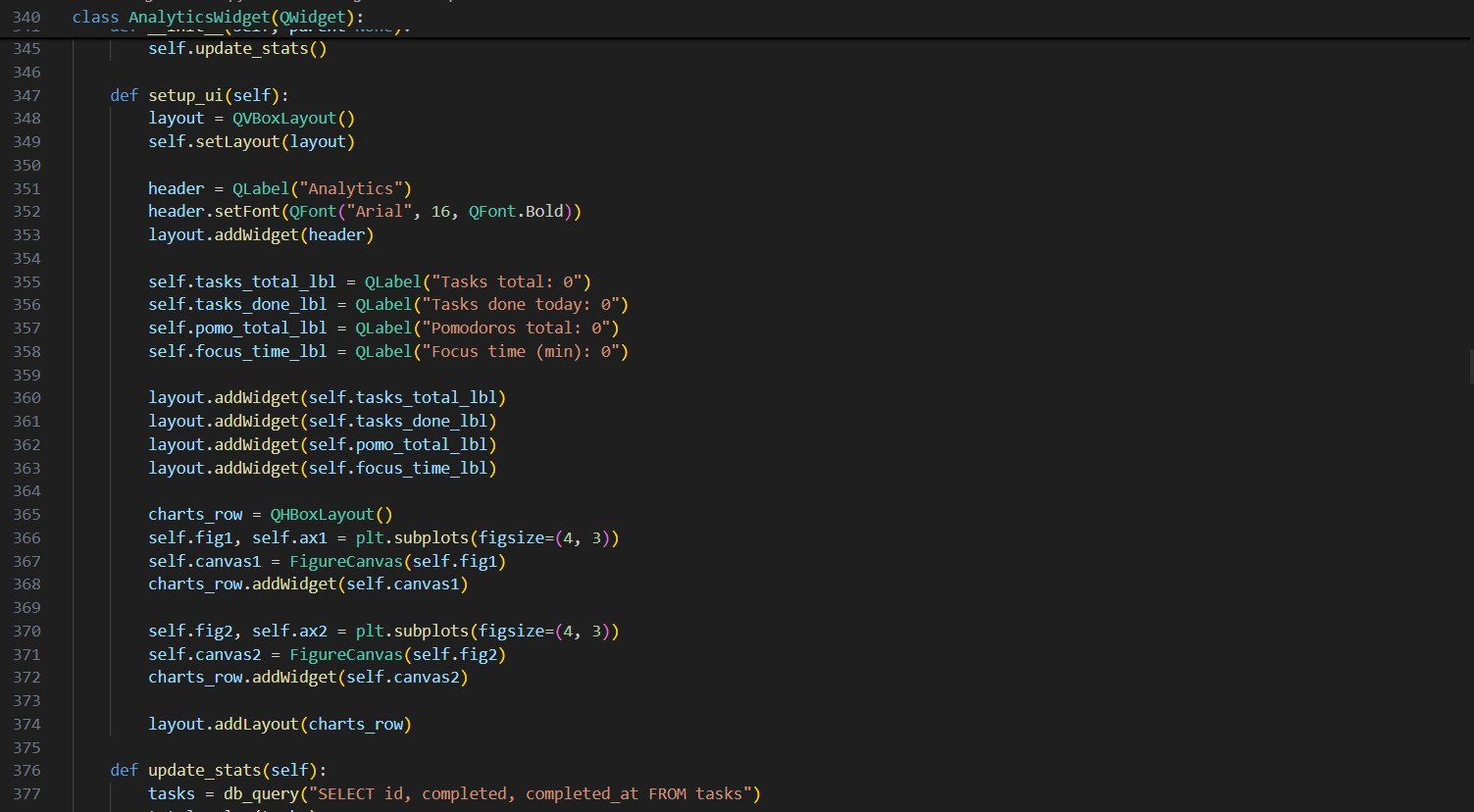

Figure 4.8 – Code for generating productivity charts
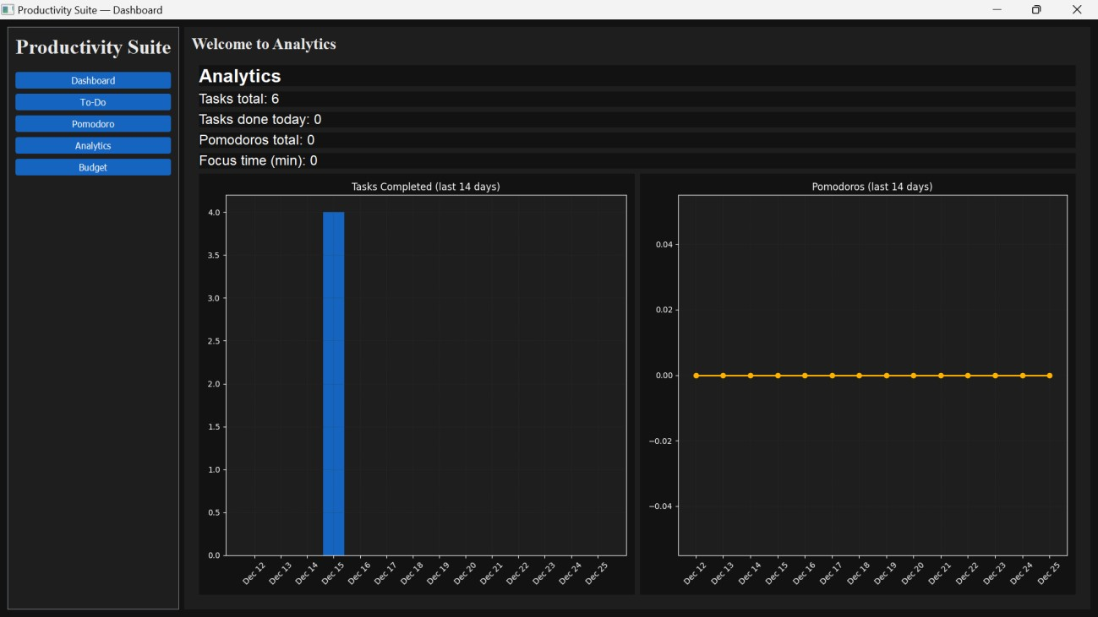

Figure 4.9 – Productivity Analytics visualizing user performance
4.6.4 Budget Planner Module
This module manages user expenses with categories, totals, charts, and PDF generation.
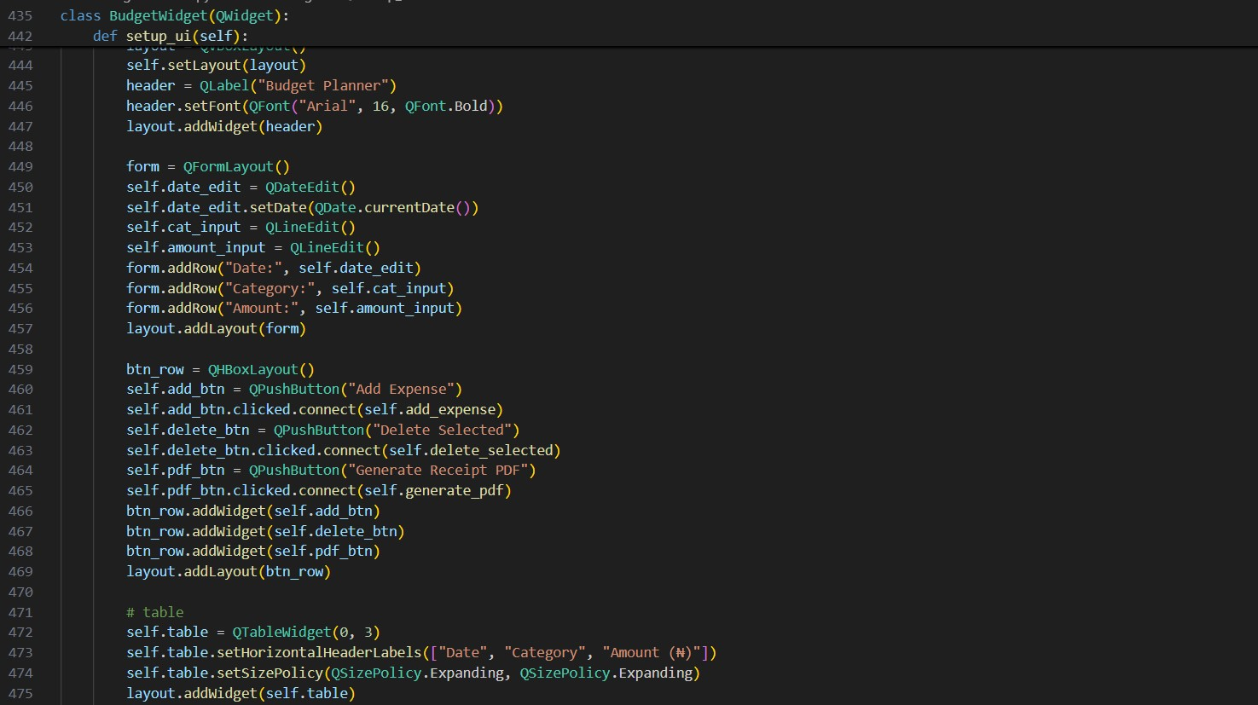

Figure 4.10 – Python code for implementing Budget Planner module
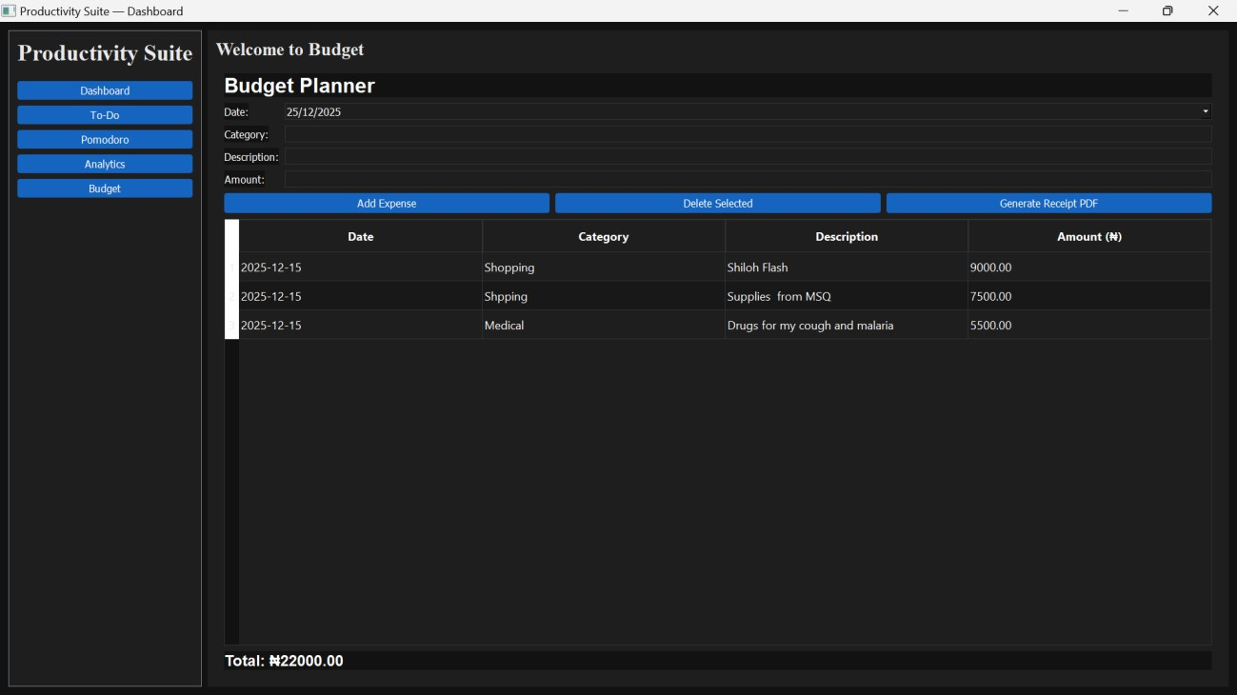

Figure 4.11 – Budget Planner interface with expense table and charts

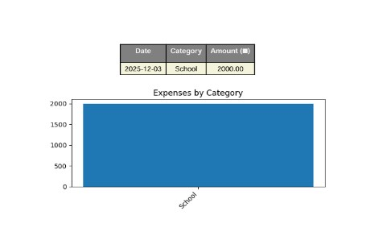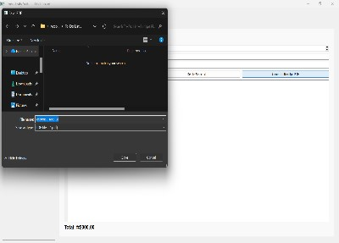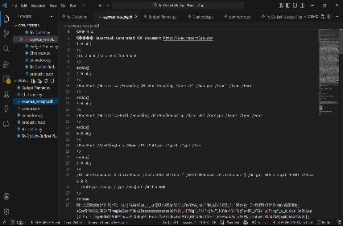

Figure 4.12 – Automatically generated PDF expense receipt
4.7 Testing
Testing included:
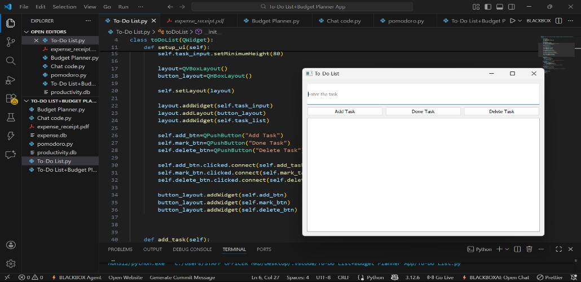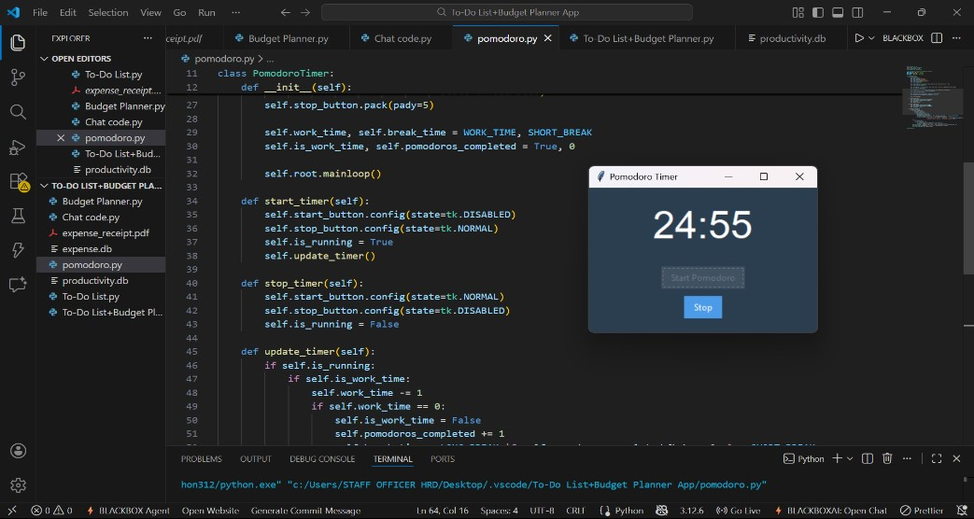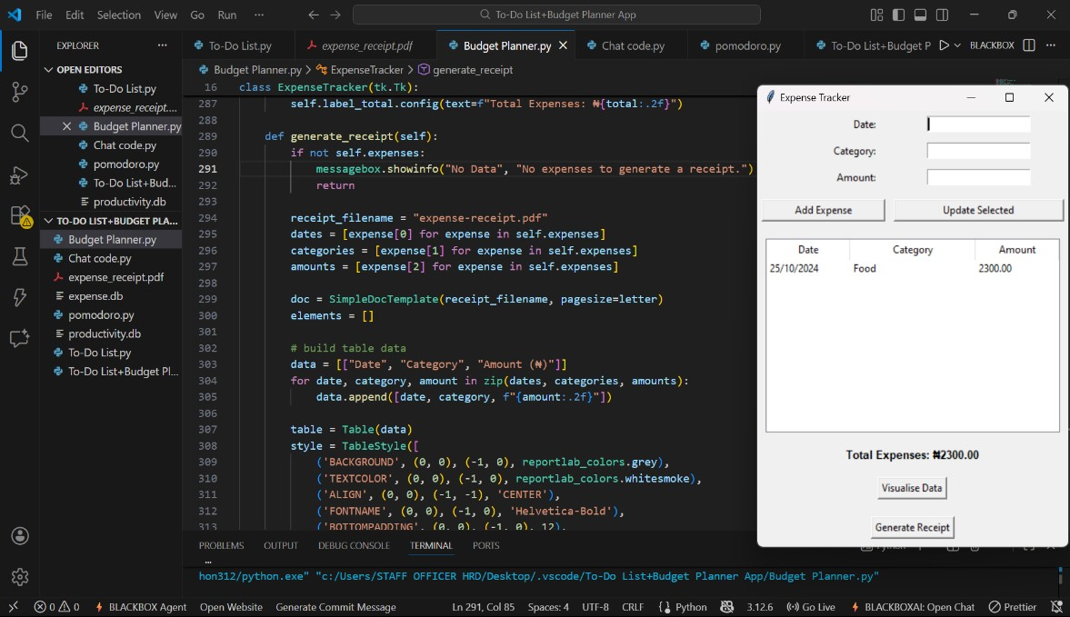

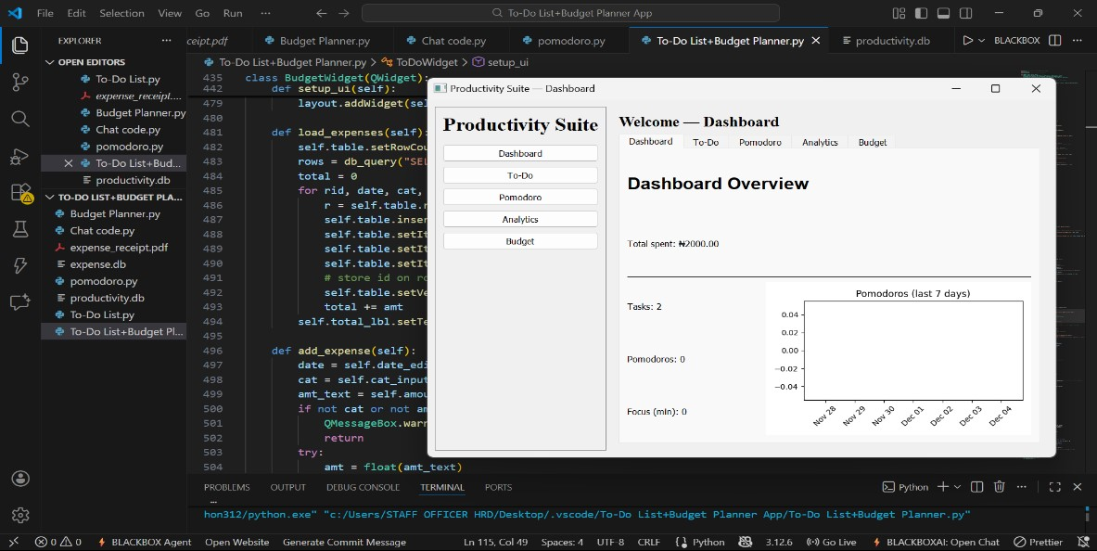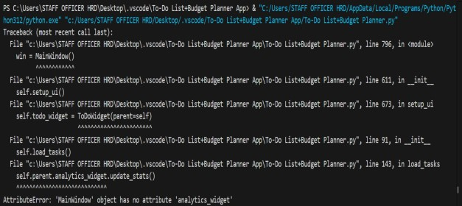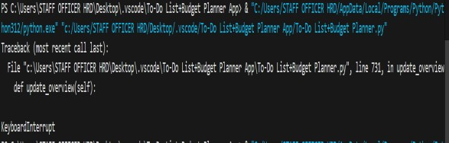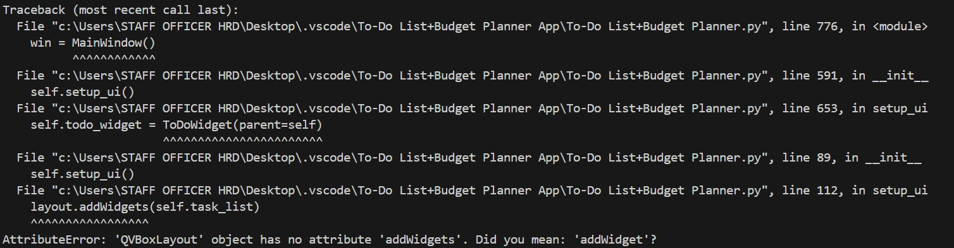

Figure 4.13 – Individual project uilt, Integrated/Combined project and Testing and debugging output during development
4.8 Challenges Encountered
- PyQt5 and Tkinter incompatibility (solved by conversion)
- Timer freezing the GUI (solved with signals/slots)
- SQLite database locking
- Matplotlib chart refreshing issues
- UI styling to maintain consistency
4.9 Summary
This chapter explained the entire development process along with specific areas where images of your code and program output should be inserted. These screenshots strengthen the project documentation and demonstrate practical evidence of implementation.

CHAPTER 5: CONCLUSION AND RECOMMENDATIONS

5.1 Summary of Achievements
The project successfully culminated in the development of a unified Productivity Suite and Budget Tracking Application. Key milestones achieved include:
- Successful Integration: Merging disparate modules (To-Do, Timer, Analytics, Budgeting) into a single PyQt5 interface.
- Data Persistence: Implementation of a robust SQLite3 database that maintains user data integrity across sessions.
- Automated Reporting: Enabling students to export financial data into professional PDF formats via ReportLabs.
- Effective Visualization: Providing real-time feedback on study habits and spending patterns through Matplotlib.

5.2 Conclusion
The development of this application demonstrates that a centralized digital tool can significantly mitigate the organizational challenges faced by modern students. By providing a "one-stop-shop" for academic planning and financial tracking, the system reduces context switching and fosters a more disciplined approach to student life. The project successfully met all the functional and non-functional requirements set forth in the initial proposal.

5.3 Challenges Faced and Lessons Learned
- Technical Challenges: Overcoming the "Main Thread" limitation in PyQt5 was a significant learning point; implementing QThreads for the Pomodoro timer was essential to keep the GUI responsive during countdowns.
- Database Management: Handling concurrent read/write operations in SQLite required careful connection management to avoid database locking.
- Project Management: Utilizing Git for version control taught the team the importance of branching and merging to avoid code conflicts during the integration of different modules.

5.4 Future Improvements
While the current version is a robust desktop tool, future iterations could include:
- Cloud Synchronization: Moving from a local SQLite database to a cloud-hosted solution (e.g., Firebase) for multi-device access.
- Mobile Portability: Developing a companion mobile app using frameworks like Kivy or PyQt6 for "on-the-go" expense logging.
- Predictive Analytics: Integrating basic Machine Learning to suggest optimal study times based on past Pomodoro data.

5.5 Contribution and Usefulness
This application contributes to the Bells University of Technology digital ecosystem by providing a practical utility for student self-management. It serves as a proof-of-concept for how academic institutions can leverage student-led software development to solve real-world student problems, promoting both digital literacy and financial responsibility.

REFERENCES
GreatStack. (2024). Python To-Do List App Tutorial | PyQt5 GUI Development [Video]. YouTube. https://youtu.be/mGJlpQCw8lw
BroCode. (2024). Python Pomodoro Timer Tutorial | Build a Focus Timer with Tkinter [Video]. YouTube. https://youtu.be/R8lE7dlg2f4
Code With Domi. (2024). Python Budget Tracking App Tutorial | Tkinter + Database + Charts
[Video]. YouTube. https://youtu.be/uUWG5cm2Los

APPENDICES
Appendix A: Requirements.txt

Plaintext
PyQt5==5.15.10 matplotlib==3.8.2 reportlab==4.0.8 sqlite3

Appendix B: User Manual Summary
- Installation: Ensure Python 3.12 is installed. Run _{pip install -r} requirements.txt.
- Launching: Double-click _{main.py} to open the dashboard.
- Task Management: Use the 'Tasks' tab to add assignments; check the box to complete.
- Budgeting: Enter amount and category in the 'Budget' tab to update the live pie chart.

Appendix C: GitHub Repository
Link: https://github.com/LR-Hyzik07/Productivity-suite

