Useful Moment of Inertia Formulas

Note: In the table below, the overbar indicates the moment of inertia is taken about an axis that passes through the centroid, denoted as ‘C’. Parallel axis theorems are: CHANGES!!!

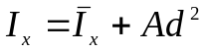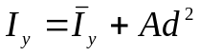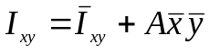
Here, A is the area of the shape, d is the distance from the centroidal axis to the desired parallel axis, and 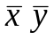 are the x and y distances of the centroid from the origin of the desired coordinate frame.

Rectangle: | y  x  y`  x`  b  h  C  b/2  h/2
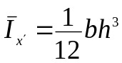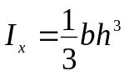  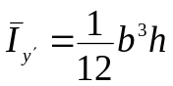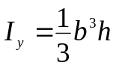  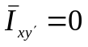 Area = bh | y  x  y`  x`  b  h  C  b/2  h/2
Triangle: | b  h  x  x`  C  h/3  s
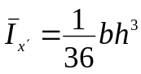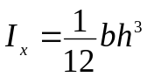  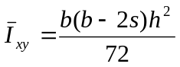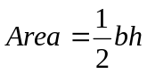 | b  h  x  x`  C  h/3  s
Circle: | C  r  y  x
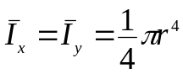  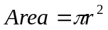 | C  r  y  x
Semi-circle: | C  r  y  x  4r/3π  x`
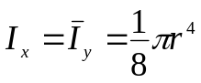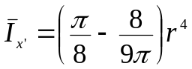  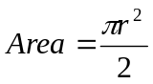 | C  r  y  x  4r/3π  x`
Ellipse: | C  r  y  x  a  b
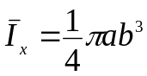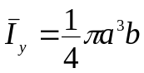  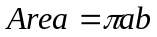 | C  r  y  x  a  b

