**PUSL2010 Analysis**

**RANUL**

* The supermarket being a large network and operating daily requires a lot of capacity within the system handle numerous transactions without failure.
* As the business grows more and more data would be transferred and stored to keep the business in firmly stable with the competition, this requires new equipment to handle network traffic, faster storage drives, accurate GPS modules and more robust IPDS so as the requirements grow more space is required for them. Virtualization could help to overcome this problem in a more economical way sustaining the traditional servers within the chain.

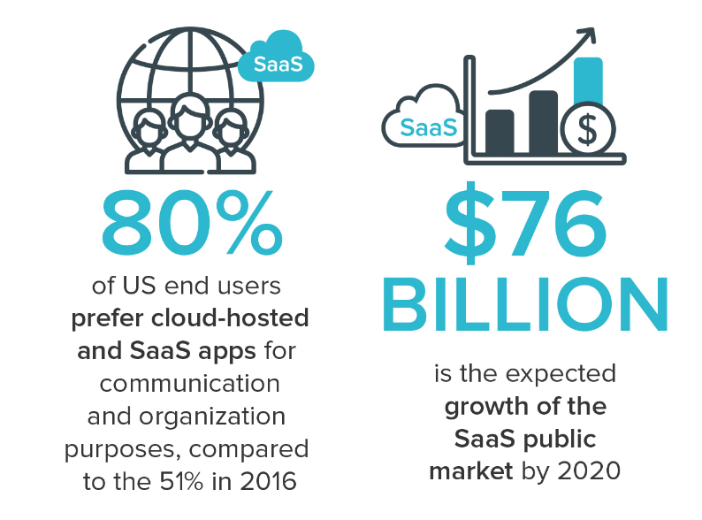

Figure 1: Illustration of trends for SaaS (AALPHA, 2020)

* Most business platforms today run on the Cloud, this helps to work on the go for staff and reduces extra store space required to store serves, and maintenance costs. Due to fact that most business move the SaaS model (Software as a Service), it will be profitable for the Supermarket chain to move the IT Infrastructure to the Cloud. (FinancesOnline, 2020)
* Upgrade will make expansions and future upgrades to the IT Infrastructure more flexible and safer from damages as personalized services as offered by partners businesses. If the Company requires to store company’s sensitive material, the old servers can be utilized for this, making the upgrade more economical and approachable to the company.
* Statistics show increasing trends for people requiring to work from home and for administrators requirements to maintain systems from one service point where actions can be assigned, monitored and controlled. This shows clear evidence for the requirement of the supermarket chain to move to cloud-based infrastructure as studies done by FlexJobs and Global Workplace Analytics shows “that there has been a major upward trend in the amount of people working remotely in the U.S. In the span of one year, from 2016 to 2017, remote work grew 7.9%. Over the last five years it grew 44% and over the previous 10 years it grew 91%. Between 2005 to 2017, there was a 159% increase in remote work. In 2015, 3.9 million U.S. workers were working remotely. Today that number is at 4.7 million, or 3.4% of the population.” (flexjobs, 2020)

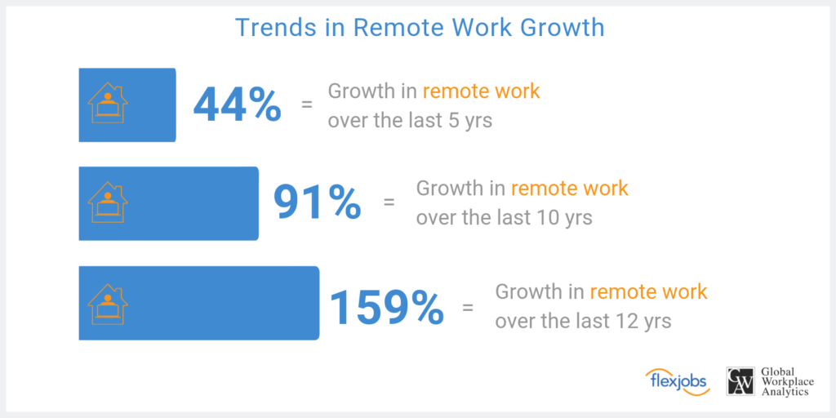

Figure 2: Illustration of Growth in Remote Work (flexjobs, 2020)

**LAHIRU**

**NIDULA**

In the project analysis we determine all the features and functionalities the project must accomplish along with all the risk that we may have to face during the duration of the project so in the analysis we must find these risk and come up with a solution if these risks occur in the future. Having the proper infrastructure is crucial as it provide services to end user so having a good infrastructure can help the organization and as the head of IT operations, we need to ensure that the customer services are satisfied.

**Objective of the project**

Our objective is to select a proper infrastructure which will provide more functionality than the current infrastructure that is being used. And from we must select a specific infrastructure and determine why it is better than the rest of the infrastructures, the options are traditional server deployment, virtualized deployment and in housed (on site) or off-site (ISP) based deployment.

**Details about the Infrastructure**

Each of these infrastructures has their own pros and cons and as the heads of IT operations it is our task to determine an infrastructure that is suitable for the organization. here is some information about each of these infrastructures which may be helpful when deciding an infrastructure for the business.

Traditional server deployment

The traditional server deployment has its pros and cons which may affect the decision of the infrastructure. Some of the pros are High performance and specialized hardware and another advantage is that. The disadvantages are inability to virtualize and expensive disaster recovery and these are only some of the drawbacks to this infrastructure and should be considered when choosing.

Virtualized deployment

Server virtualization is a software architecture that allows more than one server operating system to run as a guest on a given physical server host. Some of the virtualization platforms are VMware, Xen and KVM. The virtualized deployment has its pros and cons some of its pros are less maintenance cost, less physical server and less energy cost. But this infrastructure also has some cons sing point of failure and high stress on single machine. So, deciding whether this infrastructural is perfect for the business depend on the type of business and functionalities the business needs to provide to the customers.

In housed or off-site based deployment

This infrastructure also has its pros and cons when it is chosen Just like the other infrastructures. Some of its pros are that Gives you physical control over your backup, keeps critical data in-house so No third party has access to your information and No need to rely on an Internet connection for access to data. Then there are some disadvantages for this infrastructure, and they are Needs space in your workspace for a rack or server, dedicated IT support and No uptime or recovery time guarantees. So, it depends on the business whether this infrastructure in suitable to the business.

**Project success**

The project will be a success when the correct infrastructure is chosen and has a clear understanding why this specific infrastructure is better than the current and from the other options that were available and what are the new functionalities it will provide. In addition, the infrastructure should be implemented and completed within the given time period and the budget for the project to be successful.

**RYAN**

**ISHAN**

**References**

flexjobs (2020) *Remote Work Statistics: Shifting Norms and Expectations*. Available at: <https://www.flexjobs.com/blog/post/remote-work-statistics/> (Accessed: 03 April 2020).

FinancesOnline (2020) *62 SaaS Statistics You Must Learn: 2020 Market Share & Data Analysis*. Available at: <https://financesonline.com/saas-statistics/> (Accessed: 02 April 2020).

AALPHA (2020) *saas users preference*. Available at: <https://www.aalpha.net/blog/how-to-develop-a-cloud-based-saas-application-software-product/attachment/saas-users-preference/> (Accessed: 02 April 2020).