

School of Computing and Mathematics

PRCO303SL

Final Stage Computing Project

BSc (Hons) Software Engineering (4872)

Ranul Pasan Ladduwahetty

10673986

Government Portal - eGovernment System

2020/2021

Supervisor: Professor Chaminda Rathnayake

Contents

1. Introduction 4

1.1 Project Brief 4

1.2 Background 4

2. Business Case 4

2.1 Business Need 4

2.1.1 Underlaying Problem 4

2.2 Business Objectives 5

3. Project Objectives 5

4. Initial Scope 5

4.1 The System Design 6

4.2 The System Architecture 7

5. Method of Approach 7

5.1 The Agile approach 7

6. Project Plan 8

6.1 Control Plan 8

6.2 Communication plan 8

6.2.1 Routine Communication Plan 8

6.2.2 Risks and Issues Communication 8

7. Initial Risk List 9

8. Initial Quality Plan 10

References 10

Appendices 11

List of Figures

Figure 1: System Design of eGovernment System (Government Portal) in a body 6

Figure 2: System Architecture of eGovernment System (Government Portal) 7

Figure 3: Illustration of PRINCE2 Process Model (PRINCE2, 2020) 8

List of Tables

Table 1: Project Plan 9

Table 2: Risk List 9

Table 3: Quality Plan 10

# Introduction

## Project Brief

The purpose of this research project is for building up the social wellbeing of the citizens of the Democratic Socialist of Republic of Sri Lanka.

A Digitalised government system as a replacement for the paper-based systems currently in use, so all government application processing services such renewals of passports, driving licences and other services such as payments of income tax would be done electronically.

The system would supply a biometric card[1] that allows citizens in any status to be benefited from the system by allowing them to use the system without extra knowledge or training only by handing over their card as identification at government district secretary centres and authorised centres such as hospitals and schools once registered.

Government along would be benefitted by gaining prominent level access to monitoring and managing of services and data, the system will store all activities of a user such as health, educational, police records etcetera but only relevant parties will gain access to user data for updating personal records, this will replace the current paper submission system.

## Background

The “introduction of electronic government (e-government) is a move undertaken by governments to become more service oriented and focused toward the implementation of the widespread digital services through one stop points of access for citizens” (Anthopoulos, Siozos & Tsoukalas, 2007). By understanding implications found on case studies shows, “reflections on the findings indicate that much more care should be given to forecasting potential negative impacts of any e-government initiative” (Letch & Carroll, 2008) and another study suggests that a “citizen’s attitude towards using an e-government citizen report system is mainly influenced by his/her perceptions on whether the system is easy to use (Perceived Ease of Use) and whether the system will give benefits or not (Perceived Usefulness)” (Susanto, Diani & Hafidz, 2017).

# Business Case

## Business Need

Paper submission systems in government and non-government organisations causes delays in processing times, these delays in the processes lead to a competitive disadvantage when interacting with international organisations and creates barriers for international organisations to do business with local organisations, similarly the inconvenience to local customers cause huge costs for organisations in the long run. Citizens look for reliable systems so a digital implementation helps to reduce time and quicken the batch processing periods of requests, e-government would allow open governance of services more collaboration among services, citizens and organisations. (Susanto, Diani & Hafidz, 2017)

### Underlaying Problem

Government need to motivate citizens and organisations to improve the local trade by stimulating the economic progress, this could be by digitalisation of government and NGO[2] processes so organisations using the system are getting a competitive advantage over the others, when services are easier to access, users access them frequently so organisations can increase the cash flow within their business and bringing OGS[3] for their business would further increase collaboration as found on a study done by European Commission[4] (Galasso *et al.*, 2016).

## Business Objectives

Digitalize government services and replace paper-based submission.

* Improves business processing times.
* Reliable information systems to business (tailored services by data analysis).
* Increases saves on business process due to digitalization.
* Increases cash flow to all organizations in the system.
* Effective management of frauds and theft by user monitoring
* Robust platform international and local businesses.
* Trusted system managed by government for authorizing and managing services.

# Project Objectives

This project would focus on the foundation of an e-Government system to the republic of Sri Lanka, this massive system would be broken down into subsystems and implemented on phase basis, this project would aim only on the development of the main platform and one subsystem for the system.

* Identify the requirements of Department of Registration of Persons (DRP) management and customers, and what their recommendations for improvement.
* Design suitable architecture, database diagrams for the system to fulfil requirements.
* Analyze requirements and identify potential technologies for development.
* Develop Government portal web platform as the base structure of the e-Government system and incorporate the DRP services to the system as a subsystem.
* Test driven development by agile incremental development and following PRINCE2 methodologies.
* Provide a single interface for consumers to manage services easily and effectively.

# Initial Scope

At a minimum, this project will cover the following and other implementation of the project may be identified during detailed planning and will be brought into the project scope.

The proposed system will allow:

* Citizens to apply for first time national identification card using e-applications.
* Citizens to apply for renewals of national identification card using e-applications.
* Citizens to apply for corrections of national identification card using e-applications.
* Citizens to apply for lost national identification card using e-applications.
* Citizens can use their Government Portal card to access services related to Department for Registrations of Persons (*current scope of project)*.
* Citizens would be allowed to use eCitizen account to apply and monitor the whole application process using the portal.

The software at initial phase would not allow as these *would not be covered in this project*:

* Government authorities to monitor user interests and activity on education, health, and criminal.
* NGOs can pay business taxes and employees can pay PAYE[5] tax and use the ID as portfolio when applying for work, renewals of driving license, education data management by schools, universities and institutions and other managed services by departments of the Government of Sri Lanka*.*

Use of surveys and further research to identify large scale user requirements to fulfil customer needs in the project.

Provide a website for customers and desktop applications for management team, use of cloud storages for easier scalability and cost management.

## The System Design

The eGovernment system will be managed by the government of Sri Lanka, The Ministry of Home Affairs would manage the system on behalf of the government having direct access to the data warehouse containing all citizen information, this would be highly secured warehouse.

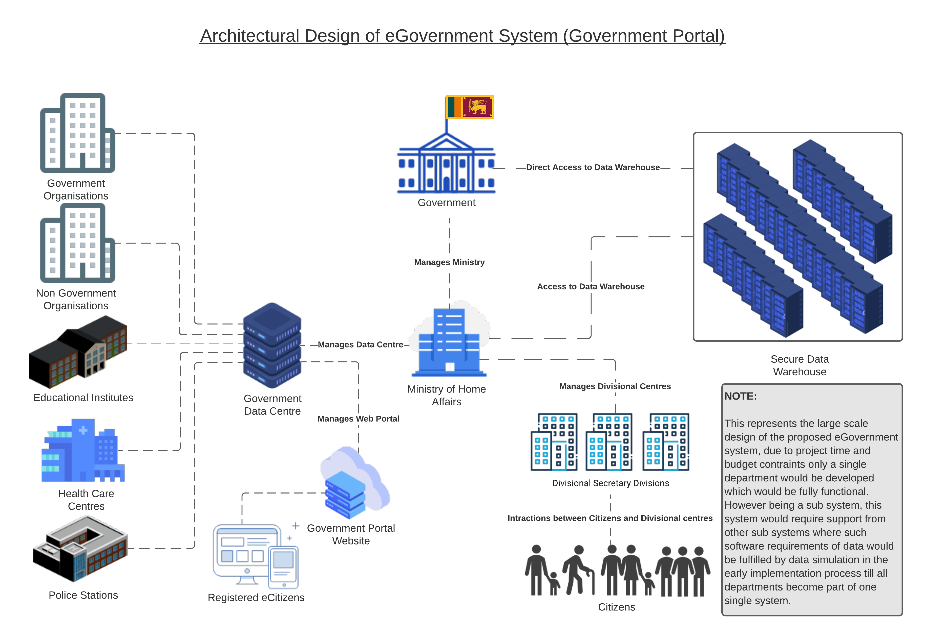

Figure 1: System Design of eGovernment System (Government Portal) in a body

Any currently mentioned entity on the architecture or future entities can access to data *only through the authority of the Ministry* *this prevents data misuse,* citizens are provided the ease of getting registered at the closest divisional centers in the country by providing biometric and personal data and once verified e-Citizens can carry out service using the web portal or by visiting the closest divisional center, still processes would be faster due to biometric card verification and instantaneous data availability for processing.

Other entities such as NGO’s would update their employee details with system, similar hospitals would manage patient information, by design only privileged parties would gain access to resources such as hospital staff cannot access educational data (not covered during this research phase) managed by schools, institutes and universities but NGO’s can access candidates during recruitment with the presence of the biometric card holder or while an employee is working with them. Depending on varying government polices by amends to polices of data and information these access rights could be managed appropriately with this architecture.

Phase implementation is suitable for the system as there is a massive number of departments to be digitalized which is not feasible with the project’s time and budget.

## The System Architecture

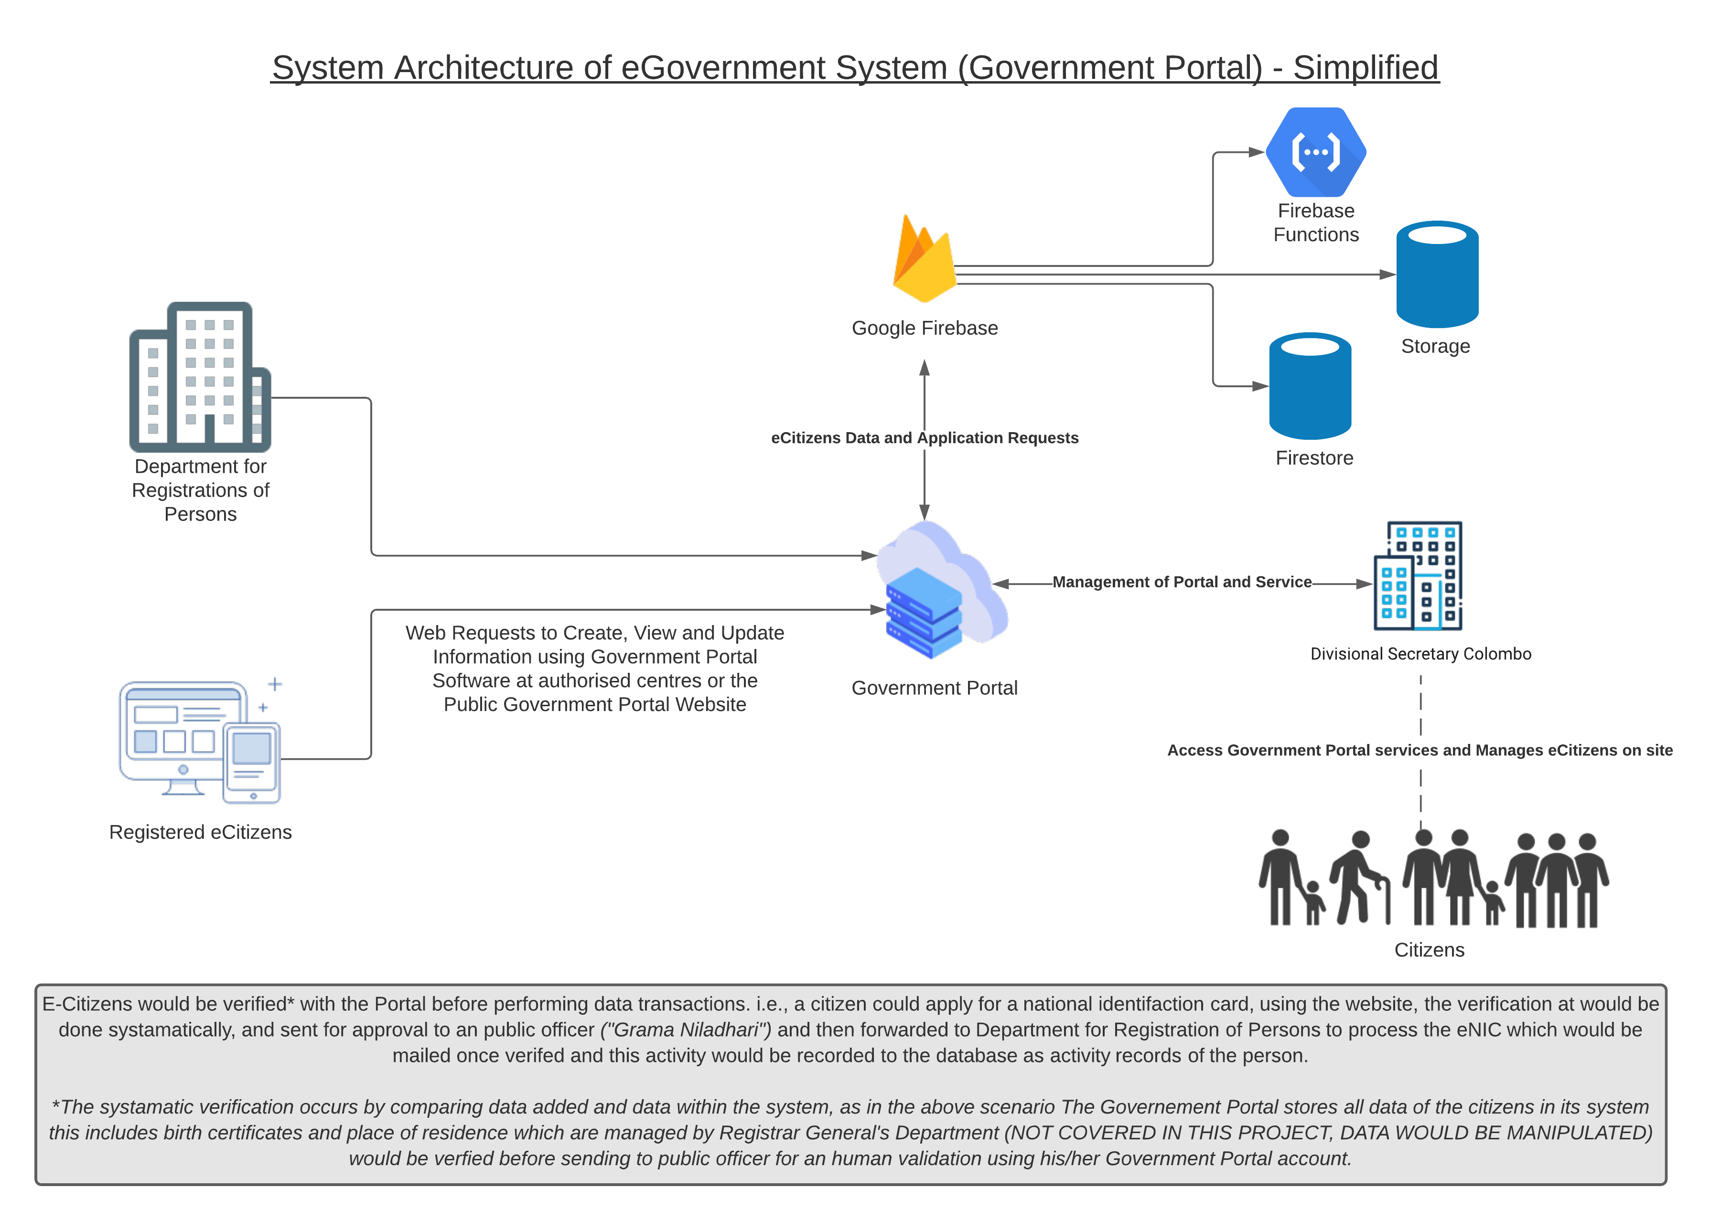

Figure 2: System Architecture of eGovernment System (Government Portal)

Software development of the system would be using Ionic framework as frontend and Google Firebase for backend service. System Architecture above is a portion of the core design of the eGovernment system, only few departments are represented on the illustration to meet business requirements of the project, as there is an excessive requirement to change from human-human communication over to digital-human communication by government as advised health officials during a period of worldwide pandemic. Even after the situation stabilizes the system would help to recover the economy faster due to efficiency and flexible adaptation with digital technologies.

# Method of Approach

## The Agile approach

Consideration of factors such a cost, team size and time an PRINCE2 Agile®[6] approach is most suitable for this enterprise system (Bass, 2019). Due to largescale requirement and changing nature of businesses and government policies.

Following PRINCE2[7] methods with this approach provides flexible and process-based method allows to build a product with maintained quality and business value, using this methodology allows an organisation to get a clear understanding of ROI[8] and use of time and resources. (Waheed, 2014)

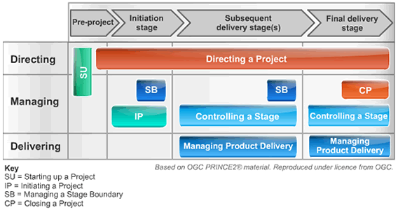

Figure 3: Illustration of PRINCE2 Process Model (PRINCE2, 2020)

# Project Plan

## Control Plan

PRINCE2 Agile® techniques will be employed for project management and delivery and the following control techniques will be active.

* Submission of highlight reports as required by PRCO303SL module handbook.
* Biweekly project progress updates to supervisor including weekly review meetings as required by PRCO303SL module
* Risk management (see Section 7), communication plan (see Section 6.2), and quality plan (see Section 8) and other possibility plans where required.
* Source control system would be used to control development and keep copies on program versions safely from hardware failure, GitHub would be used.

## Communication plan

### Routine Communication Plan

Review meetings to held via Zoom video conferencing for each progression stages and feedback meeting for final report would be held after the two interim reports and project poster have been reviewed and submitted as defined on PRCO303SL module handbook.

### Risks and Issues Communication

Ad-hoc meetings would be held with supervisor via phone for clarifications and approvals for managing quality in research project when required, project drafts to be emailed for reviewing before submission and share product development progress with my supervisor (Professor Chaminda Rathnayake) for tracking and reviewing project progress through Azure DevOps, project management tool.

**Project Plan**

Table 1: Project Plan

|  |  |  |  |
| --- | --- | --- | --- |
| Stage | Expected Start Date | Expected Finish Date | Products/Deliverables/Outcomes |
| 1. Initiation |  | 03/11/2020 | PID draft |
| 1. Requirements analysis | 06/11/2020 | 08/11/2020 | Eliciting requirements via surveys, analysing requirements, build use cases, user stories and review. |
| 1. High-level design | 09/11/2020 | 15/11/2020 | Design database diagrams, architecture diagrams and low-fidelity prototypes |
| 1. Phase 1 | 16/11/2020 | 26/11/2020 | Development and Testing of authentication and registration components |
| 1. Phase 2 | 26/11/2020 | 12/12/2020 | Development of Forms, and intermediated front end of Government portal |
| 1. Phase 3 | 13/12/2020 | 23/12/2020 | Integrate backend connection and CRUD functions |
| 1. Christmas and New Year Holidays | 24/12/2020 | 31/12/2020 |  |
| 1. Phase 4 | 01/01/2020 | 31/01/2020 | Development of Client desktop application, reuse of component where possible |
| 1. Phase 5 | 01/02/2021 | 15/02/2021 | Production of Progress video and incremental component development for each application in system |
| 1. User Testing | 16/02/2021 | 28/02/2021 | Assess all components, audit website performance, optimisation of software |
| 1. Assembly code | 01/03/2020 | 15/03/2021 | Prepare software for distribution, host website and run on another operating system for compatibility, rework bugs |
| 1. Complete Project | 16/03/2021 | 05/04/2021 | Revise report documentation and refractor and optimise code, prepare the final report, and source code for submission |

# Initial Risk List

Table 2: Risk List

|  |  |
| --- | --- |
| Risk | Management strategy |
| Data collection | Use of electronic surveys and virtual meetings to collect data, overcome issues with collecting data in person during a pandemic situation at the time of the project |
| Data analysis | Collect large sets of data and use of analytics software such as IBM SPSS[9] for analysis, overcome data ambiguity |
| Gold plating | Monitor project progress, follow the plan with clear requirements |
| Hardware Failure | Use source control such as Bitbucket or GitHub, keep online backups of all source codes and documentation. |
| Schedule overruns | Use of project management tool such a Jira or Azure DevOps for tracking, hold meetings with supervisor for clarifications |
| Technology Failure | In an event the selected frameworks and APIs becomes abandonware, have a another similar as backups to recover work quickly. Avoid building vulnerable software and unsupported software |
| Difficulty Learning or Management | Use of provided documentation as supportive material to overcome implementation issues and use of project management tool for tracking |
| Natural disaster / illness / family emergency | In an event where any of these is met, project supervisor will be contacted at the earliest possible. An application for extenuating circumstances would be submitted, along with an alternative project plan to supervisor with updated changes. |

# Initial Quality Plan

Table 3: Quality Plan

|  |  |
| --- | --- |
| Quality Check | Strategy |
| Design Validation | Design validation against specifications, and evaluation of interface for effective human computer interaction, and database modelling for scalability and effective management. Any identified issues would be mitigated within the same working phase. |
| Requirement | Requirements checked for feasibility, demonstrability, business value and completeness. Assessment of fidelity diagrams and prototypes with supervisor and colleagues were possible. |
| Process quality | Final quality check on design, documentation, release version and testing |
| Product quality | Final quality check and optimisation of code style, organisation and conventions used in programming. |
| End phase verification | To be conducted at end of every planned development phase to maintain quality |
| System validation and user acceptance | To be conducted in Testing phase |

# References

Anthopoulos, L. G., Siozos, P. & Tsoukalas, I. A. (2007) 'Applying participatory design and collaboration in digital public services for discovering and re-designing e-Government services'. *Government Information Quarterly*, 24 (2),pp. 353-376.

Bass, J. M. (2019) 'Agile on a Large Scale'. *ITNOW*, 61 (1),pp. 56-57.

Dictionary, C. E. (2020a) 'PAYE definition and meaning | Collins English Dictionary'. Collins English Dictionary. [Online]. Available at: <https://www.collinsdictionary.com/dictionary/english/paye>.

Dictionary, C. E. (2020b) 'Return on investment definition and meaning | Collins English Dictionary'. [Online]. Available at: <https://www.collinsdictionary.com/dictionary/english/return-on-investment>.

Galasso, G., Garbasso, G., Farina, G., Osimo, D., Mureddu, F., Kalvet, T. & Waller, P. (2016) 'Analysis of the value of new generation of eGovernment services and how can the public sector become an agent of innovation through ICT'. *European Commission*,

Letch, N. & Carroll, J. (2008) 'Excluded again: implications of integrated e‐government systems for those at the margins'. *Information Technology & People*, 21 (3),pp. 283-299.

PRINCE2 (2020) 'PRINCE2 Information & PRINCE2 Courses for Project Managers provided by ILX Group | EUR'. PRINCE2.

'PRINCE2 Information & PRINCE2 Courses for Project Managers provided by ILX Group | UK'. (2020). [Online]. Available at: <https://www.prince2.com/uk/prince2-methodology>.

Susanto, T. D., Diani, M. M. & Hafidz, I. (2017) 'User Acceptance of e-Government Citizen Report System (a Case Study of City113 App)'. *Procedia Computer Science*, 124 pp. 560-568.

Waheed, N. (2014) 'CMMI, PRINCE2 AND PMBOK-THE BIG THREE'. *International Journal of Advances in Computer Science and Its Applications-IJCSIA*, 4 (2),

'What is PRINCE2 Agile Project Management? | AXELOS'. (2020). [Online]. Available at: <https://www.axelos.com/best-practice-solutions/prince2-agile/what-is-prince2-agile>.

# Appendices

**Record of amendments to PID**

|  |  |
| --- | --- |
| Version No | Remarks |
| 1.0 | Scenario changes to PID draft |
| 1.1 | PID scope discussed and recommended changes by supervisor has been included |
| 1.2 | Revisions to project objects and scope, PID revised |

**Task Diary**

|  |  |  |  |
| --- | --- | --- | --- |
| Type | Subject | Remarks | Date |
| Email Request | Supervision Request | Accepted Supervision | 13/10/2020 |
| Email Request | Proposal Draft | Initial discussion on proposal | 16/10/2020 |
| Coursework Submission | Proposal Submission | Submission of initial proposal | 18/10/2020 |
| Coursework Submission | Revised Proposal Submission | Submission of revised proposal | 28/10/2020 |
| Email Request | Proposal Approved | Proposal approved, recommend scope in | 30/10/2020 |
| Phone Meeting | PID Improvement | Scope in the project | 31/10/2020 |
| Zoom Meeting | Project discussion | Expectation of coursework and revisions to PID | 02/11/2020 |
| Coursework Submission | Revised PID Submission | Submission of revised PID | 04/11/2020 |

1. A card that stores biological information about a person and their personal characteristics
2. Non-Government Organisation
3. Open Government Services
4. Executive body of the European Union, which initiates action in the EU and mediates between member governments
5. “A system of paying income tax in which your employer pays your tax directly to the government” (Dictionary, 2020a)
6. “A complete agile project management solution, combining the flexibility and responsiveness of agile with the governance of PRINCE2®”('What is PRINCE2 Agile Project Management? | AXELOS,' 2020)
7. “A process-based method for effective project management”('PRINCE2 Information & PRINCE2 Courses for Project Managers provided by ILX Group | UK,' 2020)
8. Return on Investment, “A return on investment is a measure of profitability that is calculated by dividing net profit by total assets” (Dictionary, 2020b)
9. Statistical Package for the Social Sciences