**Fig. 8: Summary of LRGASP Data**

Supplementary Fig. . Summary of LRGASP Data.

a)

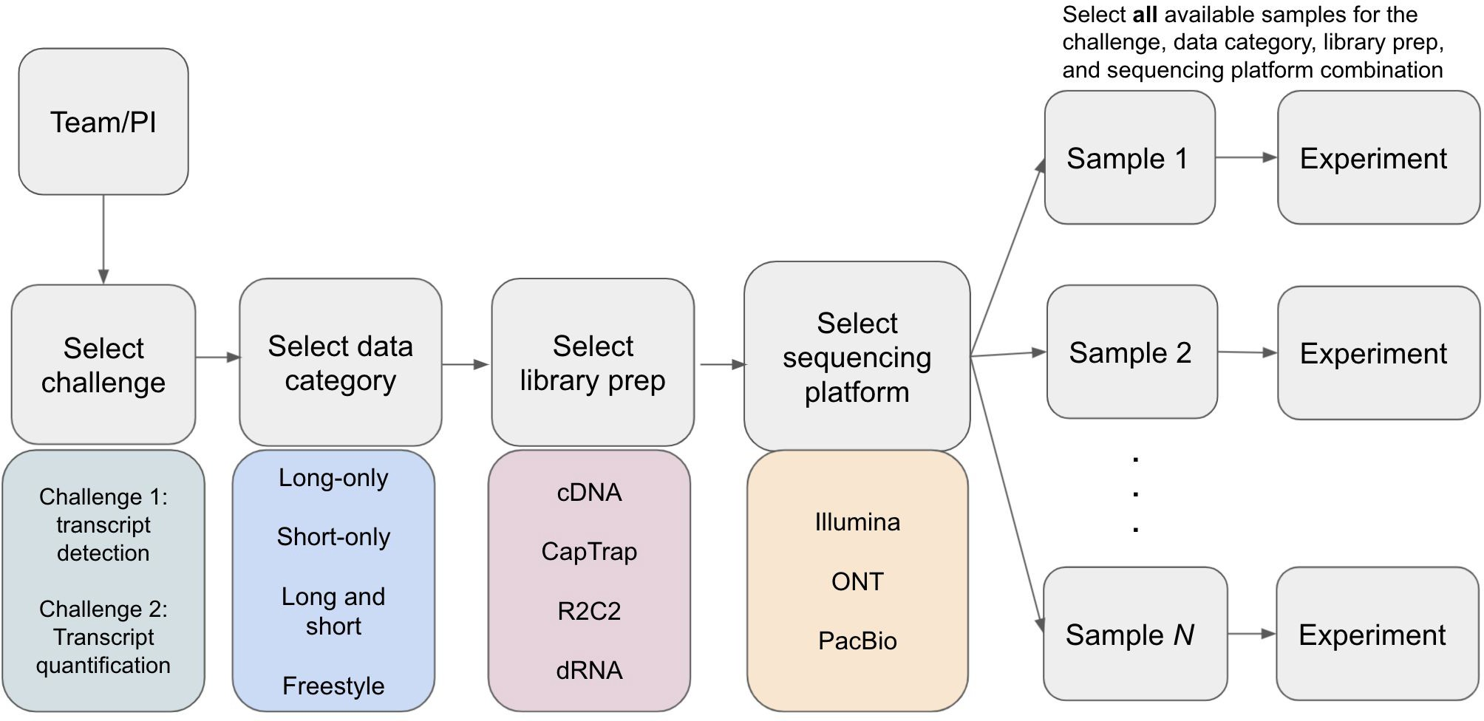

b

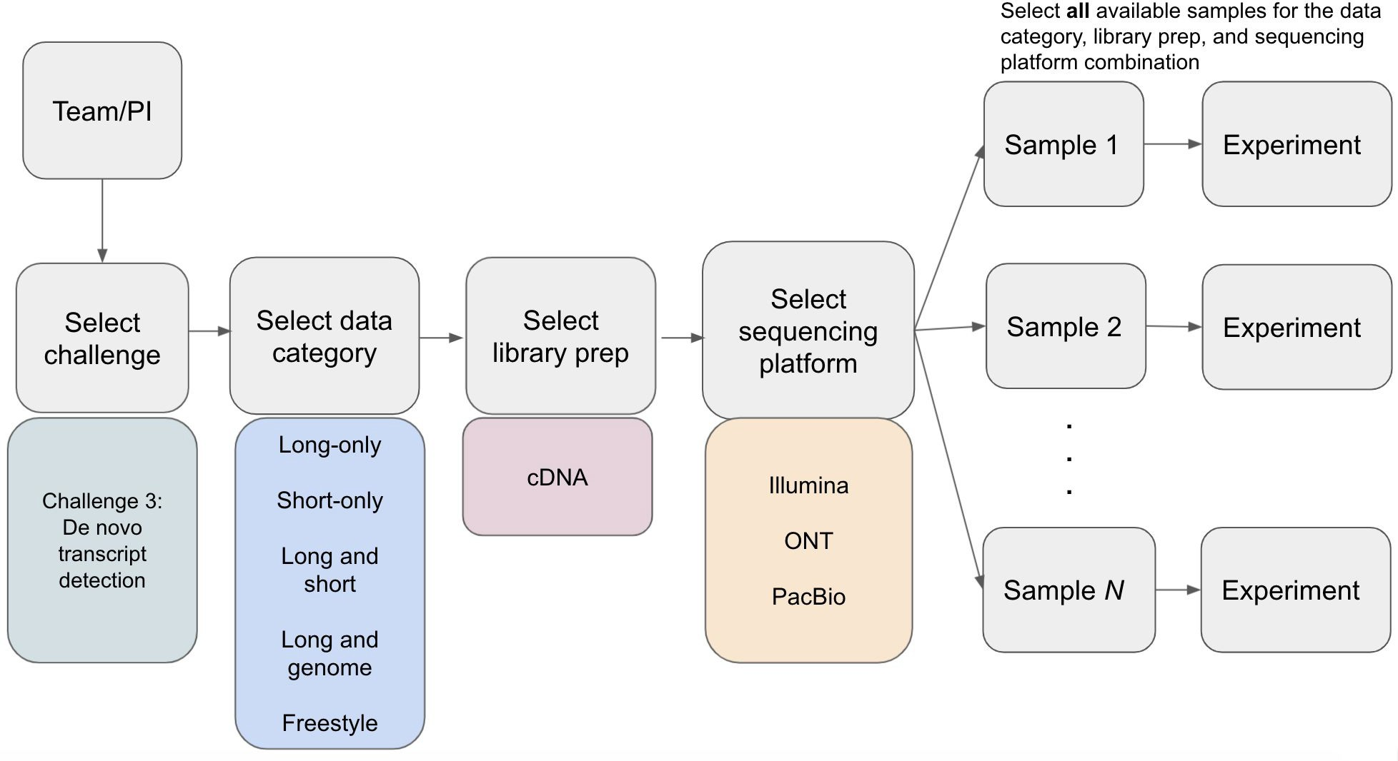

Supplementary Fig. : Challenge submission. a) Overview of submissions to Challenges 1 and 2. Each entry was derived from a specific data category, library prep, and sequencing platform combination. All available samples for the selected combination must be included in an entry. b) Overview of submissions for Challenge 3.

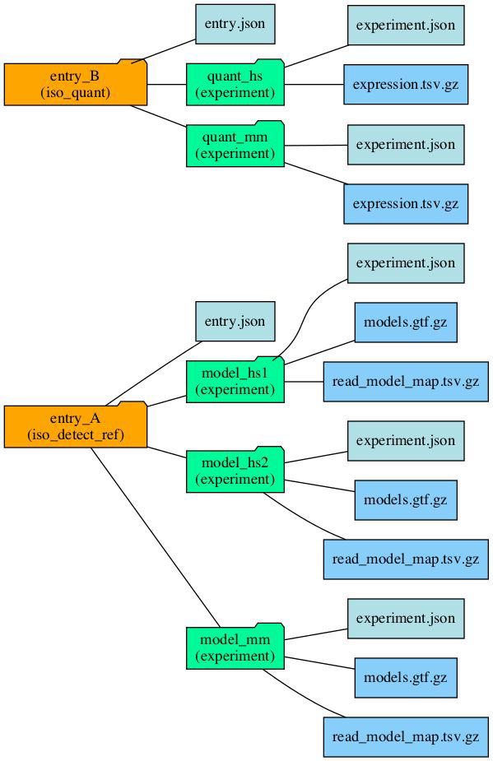

Supplementary Fig. . Schematic of directory structure and files that would be included in each entry.

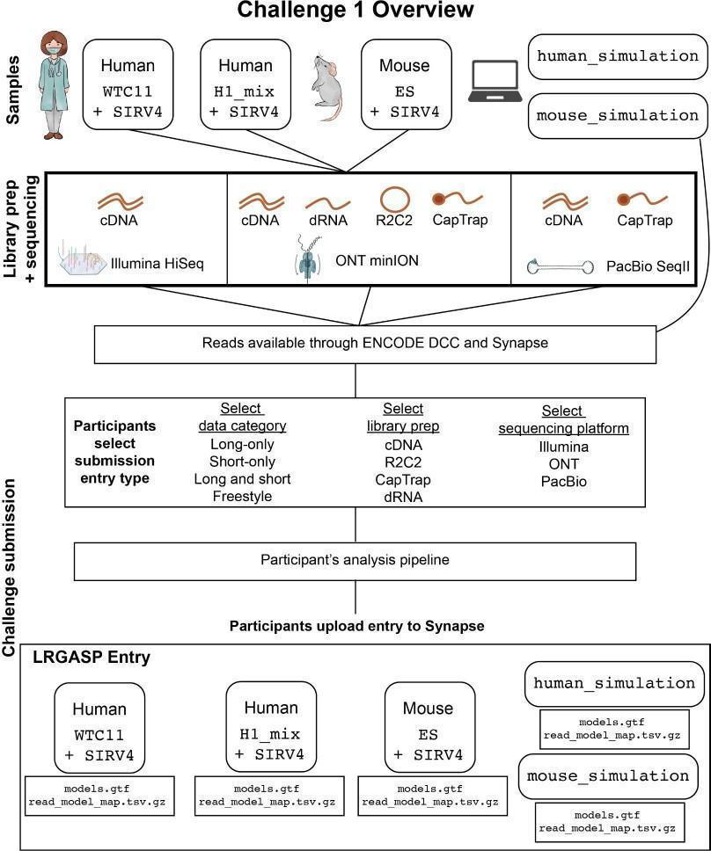

Supplementary Fig. . Flow diagram of Challenge 1: Transcript isoform detection with a high-quality genome. Samples, library prep methods, and sequencing platforms used in the challenge are indicated at the top. Participants select which data category, library prep, and sequencing platform to analyze, run their pipelines to generate transcript predictions, and submit an entry which includes predictions for all samples. The entries include a GTF file of the transcript models and a TSV file that assigns reads that supported each transcript model.

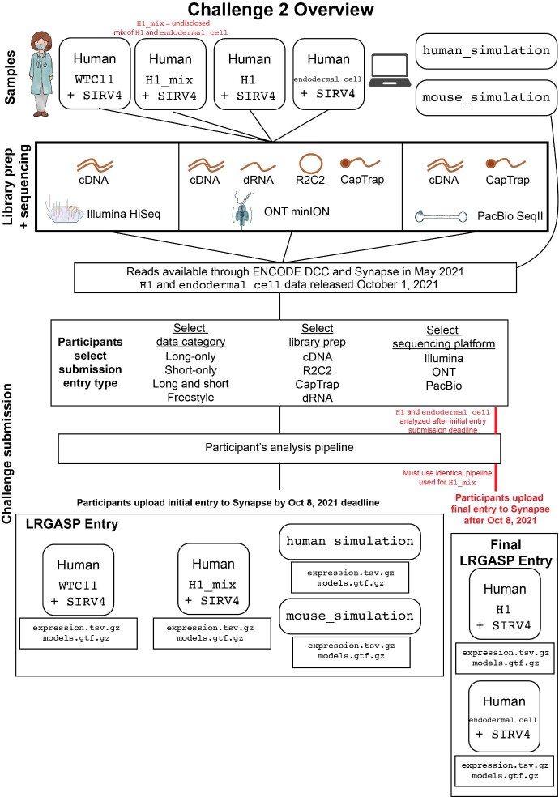

Supplementary Fig. . Flow diagram of Challenge 2: Transcript isoform quantification. Samples, library prep methods, and sequencing platforms used in the challenge are indicated at the top. Participants select which data category, library prep, and sequencing platform to analyze, run their pipelines to generate transcript predictions, and submit an entry which includes predictions for all samples. The entries include a GTF file of the transcript models that are quantified and a TSV file of the expression quantification. The H1 and endodermal cell samples were released after the initial submission deadline and participants were required to submit the quantification after the deadline Supplementary Fig. 9. Flow diagram of Challenge 2: Transcript isoform quantification. Samples, library prep methods, and sequencing platforms used in the challenge are indicated at the top. Participants select which data category, library prep, and sequencing platform to analyze, run their pipelines to generate transcript predictions, and submit an entry which includes predictions for all samples. The entries include a GTF file of the transcript models that are quantified and a TSV file of the expression quantification. The H1 and endodermal cell samples were released after the initial submission deadline and participants were required to submit the quantification after the deadline.

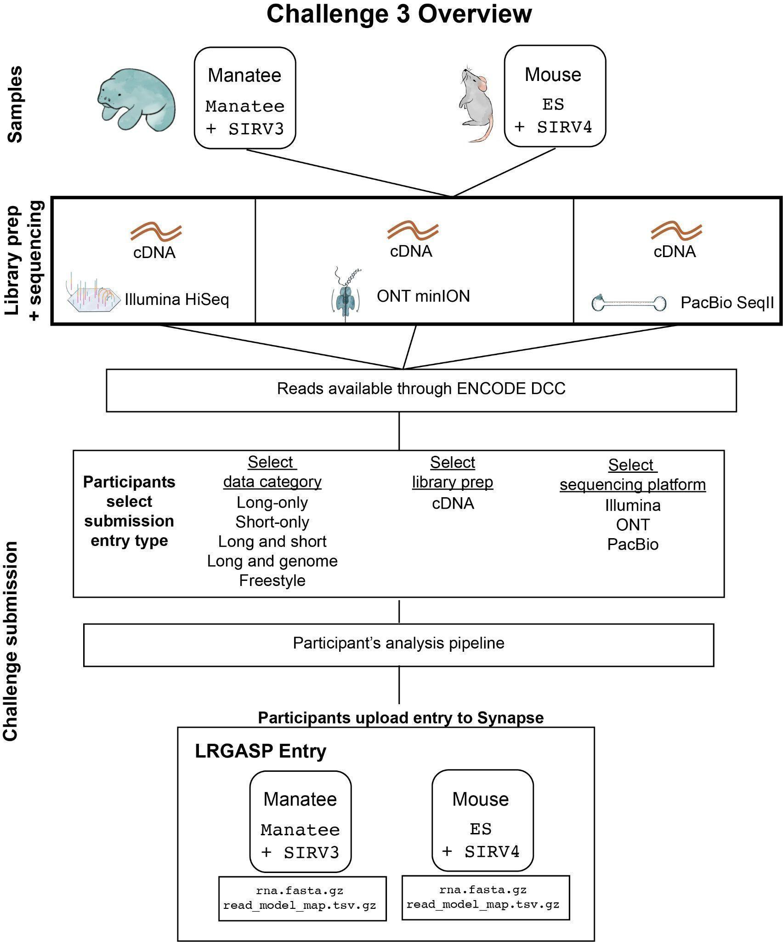

Supplementary Fig. . Flow diagram of Challenge 3. Samples, library prep methods, and sequencing platforms used in the challenge are indicated at the top. Participants select which data category and sequencing platform to analyze, run their pipelines to generate transcript predictions, and submit an entry which includes predictions for all samples. The entries include a FASTA file of the transcript models and a TSV file that assigns reads that supported each transcript model.

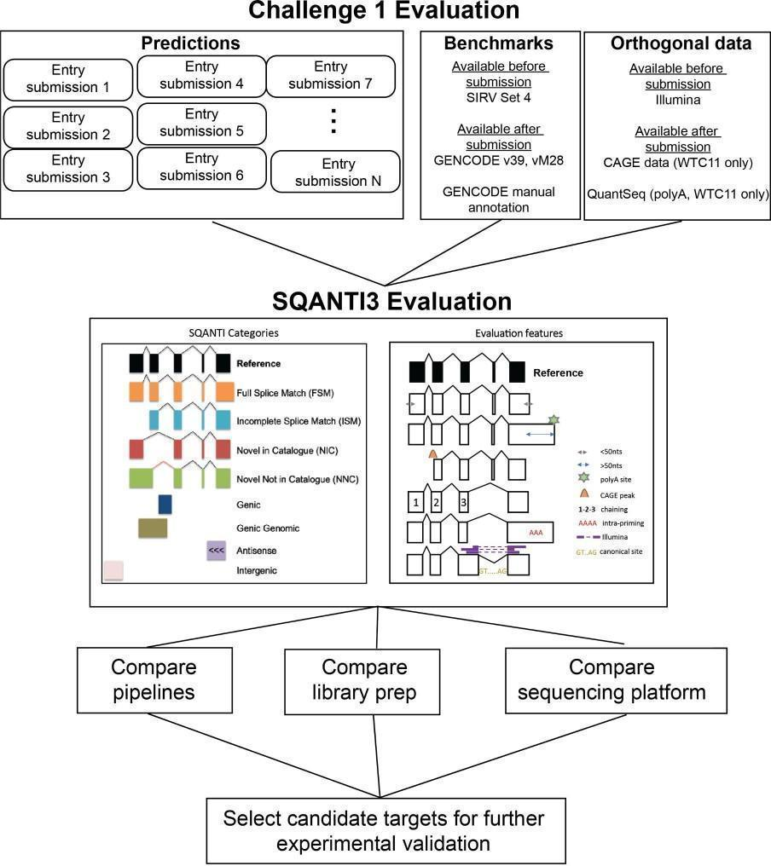

Supplementary Fig. . Flow diagram of the evaluation for Challenge 1. Benchmarks and additional orthogonal data that was used for the evaluation are indicated. For example, CAGE and QuantSeq data from WTC11 cells were generated and made available only after participant submissions; therefore, they represent “hidden” data. These was used to define 5’ transcript starts and 3’ ends.

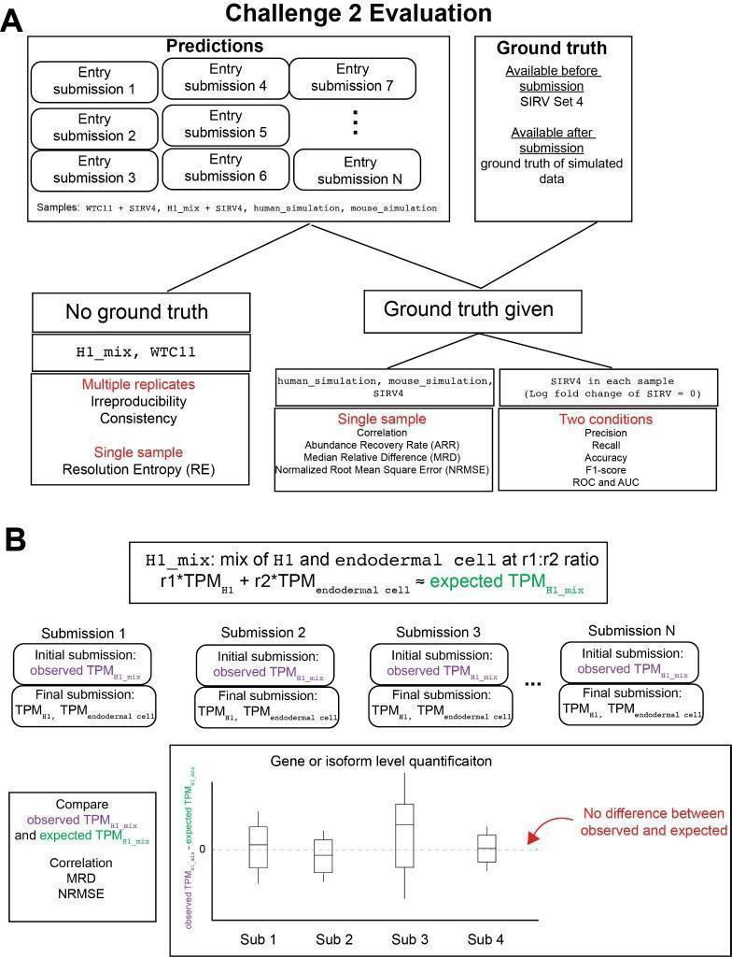

Supplementary Fig. . Flow diagram of the evaluation for Challenge 2. (A) Evaluation of Challenge 2 can be separated into metrics when a ground truth is known or a ground truth is unknown. (B) Example analyses to evaluate transcript expression using the cell mixing experiment. A sample, H1_mix, was initially provided for quantification which was a mix of H1 cells and endodermal cells at an undisclosed ratio. After the initial submission, the individual H1 and endodermal cell samples were released and participants submitted quantifications for each.

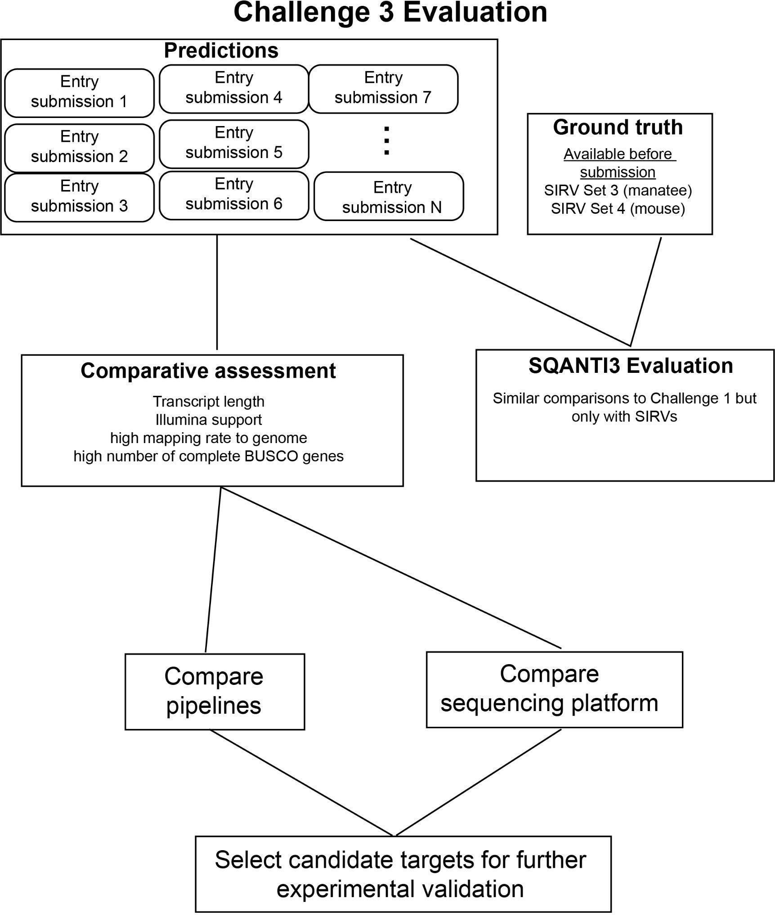

Supplementary Fig. . Flow diagram of the evaluation for Challenge 3. Only SIRVs are available for ground truth information. The evaluation was based on a comparative assessment of the predictions followed by targeting specific candidates for further validation.

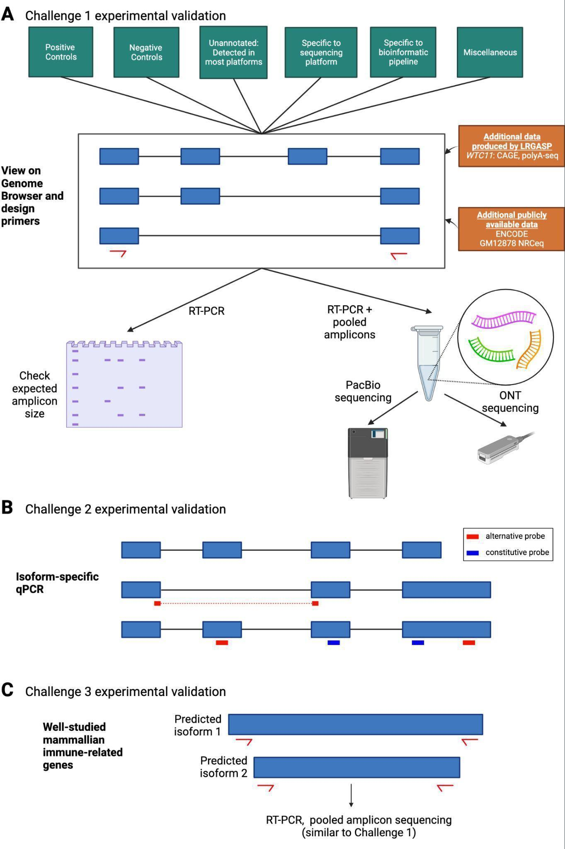

Supplementary Fig. . Experimental validation approaches for the LRGASP challenges. (A) Multiple categories of types of transcript were selected for validation (shown in green boxes). These loci will be viewed in the UCSC Genome Browser along with additional datasets to aid in the manual design of primers. Amplicons will be analyzed by fragment size and pooled to perform long-read sequencing with PacBio and ONT (B) A select number of genes were selected for transcript isoform-specific qPCR. A combination of probes detecting constitutive and alternative regions will be used. (C) RT-PCR validation will be performed similar to Challenge 1, except transcript were selected from well-studied mammalian immune-related genes.

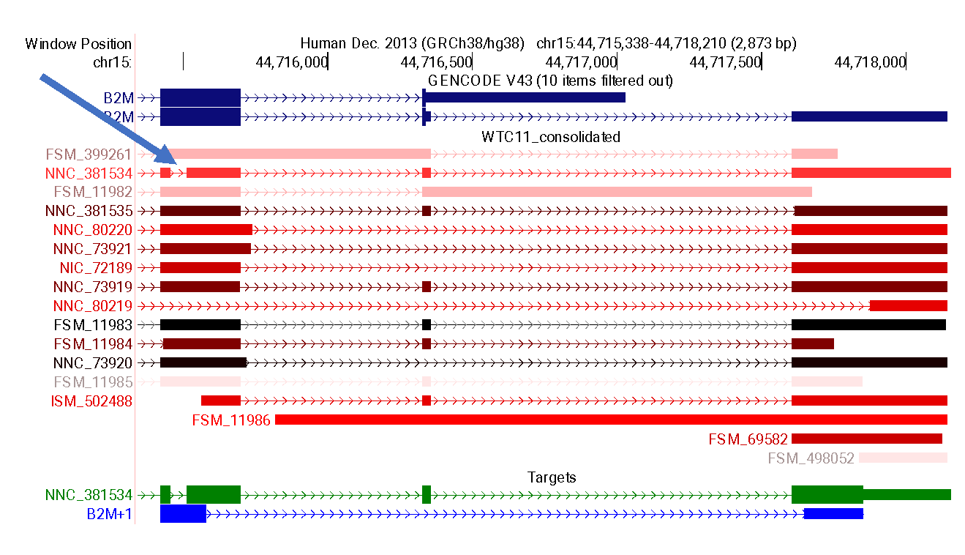

Supplementary Fig. . An example of a unique intron in transcript NNC_381534 to validation. The green and blue region vertical highlights indicate the manually selected primer pair regions. The 'Targets' track, produced by Primers-Juju, recapitulates the region as blue item B2M+1, and transcript with the maximal possible amplicon drawn in thick boxes.

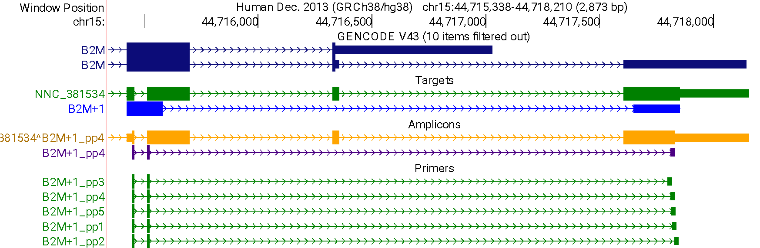

Supplementary Fig. 16. The Primers-Juju track hub with the addition of the primer pairs design. This adds Primer3 results (Primers track) and the most stable primer along with the amplicon sequence for the target transcript (Amplicons track).