**Research Review**

Historical Development #1 – Introduction of problem description languages

The introduction of the problem description language PDDL is covered extensively in the Russell and Norvig text. The significance of the introduction of a ‘planning language’ is that it allowed computer scientists to focus on abstract concepts around defining problems for computers to solve, as opposed to creating tightly coupled optimizers for each domain of problems.

Historical Development #2 – Introduction of SATPLAN algorithm

The introduction of SATPLAN in 1992 helped tie the problem of planning back to the known NP-hard problem of Boolean Satisfiability. This is indeed the ‘canonical’ NP-hard problem so by reducing planning to this problem, the authors were able to estimate a good upper bound on the running time for complex planning problems. Boolean satisfiability (the problem of finding an assigning of N different Boolean variables to satisfy a complex instruction) is a problem for which many optimized solvers exist, so by linking planning to Boolean Satisfiability the authors helped advance the state of the art for planning optimizer software.

Historical Development #3 – Introduction of Greedy and Lazy Greedy Planning Heristics

The article “Strategic Planning for Setting up Base Stations in Emergency Medial Systems” (Ghosh and Varakantham 2016) describes an algorithm to find the ‘right’ locations to place emergency medical base stations and was presented in 2016. This is a problem of significant human importance as the rapidity with which emergency medical responders to reach an injured person can be critical to that person’s survival. The placement of both base stations and ambulances at those base stations is evaluated in this paper. The authors find “…an incremental greedy approach to discover the placement of bases that maximises the service level of EMS.”

We can define a greedy algorithm as one that makes the “locally optimal choice at each stage” (<https://en.wikipedia.org/wiki/Greedy_algorithm)>. In this case, the authors gave a

Specifically the authors “employ an incremental greedy approach that identifies the base with maximum marginal gain in each iteration and add it to the resulting base set.” The present the following graph as an overview of their approach:

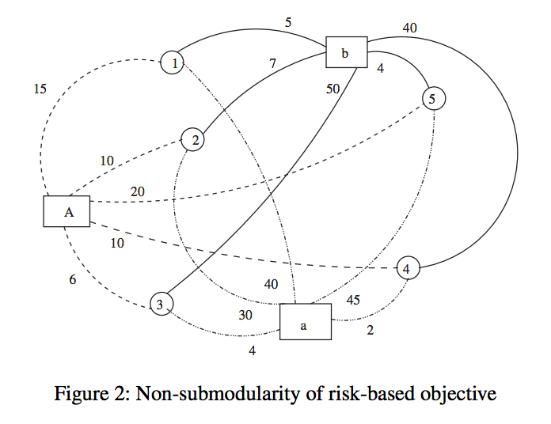

In this case, the square with an upper-case letter A represents the existing emergency response station, and location b represents a station we are considering adding; the numbers in circles represent requests and the numbers along the paths represent costs to reach them. By potentially adding new base station *b*, requests 1, 2, and 5 can be served more optimally than from A; because this is the most optimal station to add, it is added before potential EMS station *a*.

As simple as this approach is, the authors note a serious flaw with its runtime performance. Specifically, when evaluating a real-world-derived dataset of 3,000 EMS requests form a large Asian city, they find, “Greedy approach is unable to finish more than 20 iterations within the cut-off time of 2 hours”. In contrast, “lazy greedy approach provides a significant gain over greedy and completes the process within 10 minutes.”

The main difference with “lazy greedy” is that instead of calculating the gain for each base, it finds a base with a “highest upper bound” and only once calculates the marginal gain across the entire graph, once it has found a base with the estimated “higest upper bound”. This approach has strong similarities to the planning graph approach, where some potential optimality is sacrificed in the interest of finding a solution in a time-bounded manner. This paper and approach is significant because it shows again how imperfect heuristics in advanced planning problems may lead to discoverable (if not guaranteed optimal) solutions, and that it is often better to work with them than to wait for a ‘perfectly optimal’ solution to be guaranteed.

Citations:

GHOSH, S.; VARAKANTHAM, P.. Strategic Planning for Setting Up Base Stations in Emergency Medical Systems.**International Conference on Automated Planning and Scheduling**, North America, mar. 2016. Available at: <<https://www.aaai.org/ocs/index.php/ICAPS/ICAPS16/paper/view/13031/12701>>. Date accessed: 02 Jul. 2017.

H. A. Kautz and B. Selman (1992). Planning as satisfiability. In *Proceedings of the Tenth European Conference on Artificial Intelligence (ECAI'92)*, pages 359-363.