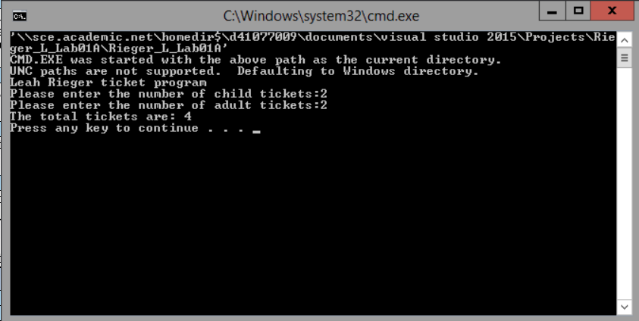

// ---------------------------------------------------------------

// Programming Assignment: LAB1A

// Developer: Leah Rieger

// Date Written: 07/10/2019

// Purpose: Ticket Calculation Program

// ---------------------------------------------------------------

#include <iostream>

using namespace std;

void main()

{

cout << "Leah Rieger ticket program\n";

int childTkts, adultTkts, totalTkts;

cout << "Please enter the number of child tickets:";

cin >> childTkts;

cout << "Please enter the number of adult tickets:";

cin >> adultTkts;

totalTkts = childTkts + adultTkts;

cout << "The total tickets are: " << totalTkts << endl;

}