**LAB A:**

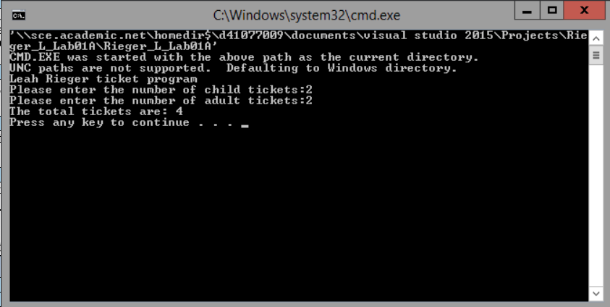

// ---------------------------------------------------------------

// Programming Assignment: LAB1A

// Developer: Leah Rieger

// Date Written: 07/10/2019

// Purpose: Ticket Calculation Program

// ---------------------------------------------------------------

#include <iostream>

using namespace std;

void main()

{

cout << "Leah Rieger ticket program\n";

int childTkts, adultTkts, totalTkts;

cout << "Please enter the number of child tickets:";

cin >> childTkts;

cout << "Please enter the number of adult tickets:";

cin >> adultTkts;

totalTkts = childTkts + adultTkts;

cout << "The total tickets are: " << totalTkts << endl;

}

**LAB B:**

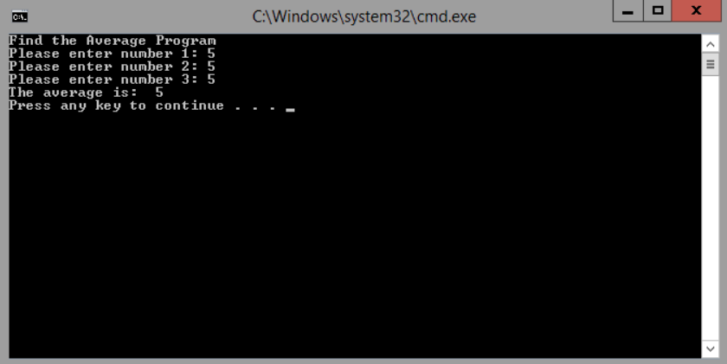

// ---------------------------------------------------------------

// Programming Assignment: LAB1B

// Developer: Leah Rieger

// Date Written: 07/11/2019

// Purpose: Average Program

// ---------------------------------------------------------------

#include <iostream>

using namespace std;

void main()

{

cout << "Find the Average Program\n";

double num1, num2, num3, average;

cout << "Please enter number 1: ";

cin >> num1;

cout << "Please enter number 2: ";

cin >> num2;

cout << "Please enter number 3: ";

cin >> num3;

average = (num1 + num2 + num3) / 3;

cout << "The average is: " << average << endl;

system("pause");

}

**LAB B ERRORS:**

**1)** Syntax Error: cin << num2; wrong sign, needed to be >>

**2)** Syntax Error: cout << “Please enter number 2: “ MISSING A **‘;’**

**3)** Logic Error: average = num1 + num2 + num3 / 3;

Needed to be: average = (num1 + num2 + num3) / 3

**LAB C:**

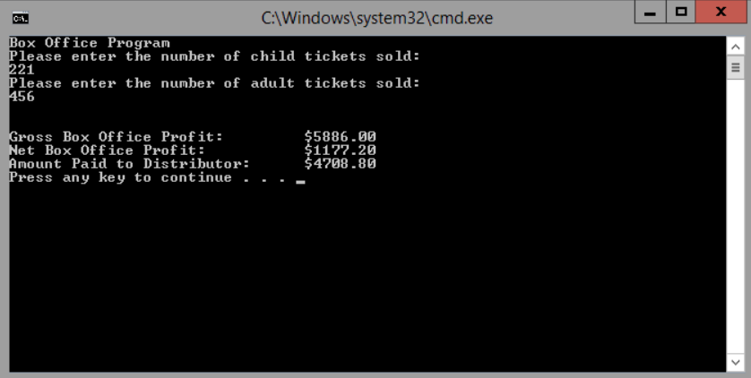

// Programming Assignment: LAB1C

// Developer: Leah Rieger

// Date Written: 07/11/2019

// Purpose: Payroll Program

// ---------------------------------------------------------------

#include <iomanip>

#include <iostream>

using namespace std;

void main()

{

cout << "Box Office Program\n";

int child, adult; //declare variables, price const

float netProfit, distributeTotal, grossProfit;

const float theater = 0.20, kidPrice = 6.00, adultPrice = 10.00; //declare float var

//inputs

cout << "Please enter the number of child tickets sold: \n";

cin >> child;

cout << "Please enter the number of adult tickets sold: \n";

cin >> adult;

cout << " \n";

cout << " \n";

//processing

grossProfit = (child * kidPrice) + (adult * adultPrice); //calculating how much made total

netProfit = theater * grossProfit; //calculating the total multiplied by theater %

distributeTotal = grossProfit - netProfit; //calculating how much goes to distributor

//outputs

cout << fixed << setprecision(2);

cout << "Gross Box Office Profit:\t $" << setw(8) << grossProfit << endl;

cout << "Net Box Office Profit:\t\t $" << setw(8) << netProfit << endl;

cout << "Amount Paid to Distributor:\t $" << setw(8) << distributeTotal << endl;

system("pause");

}