BUCKSTAR Coffee Shop

Game Design Document

Contents

1. Game Abstract 2

1.1 Gameplay Features 2

1.2 Market Features 2

1.3 Fiscal Goals 2

1.4 Business Goals 2

2. Game Details 3

2.1 General Feature List 3

2.2 Menu Screens 3

2.3 Game Screens 4

2.4 Gameplay 5

2.5 Gameplay Features 7

2.6 Input Systems 8

3. Graphics & Art Style 9

4. Sound 11

4.1 Songs 11

4.2 Sound Effects 11

5. Development Load & Resources 12

5.1 Team Members & Responsibilities 12

# Game Abstract

## Gameplay Features

The game gives the player full control of a Coffee Shop, with the goal of creating a financially successful business. The player has control over many things: finances, ingredients, recipes, menu, prices, staff, equipment and facility/location. The player starts with a loan and must invest in a number of initial items to get their coffee stand up and running, pay back the loan, and go on to build a successful coffee shop. The goal of the game is for the coffee stand’s cash assets to reach a high level, which is achieved by controlling operating costs (affected by daily inventory and equipment purchases, staff salaries and rent) and making money (done by selling coffee).

The game cycle consists of an “End-Of-Day” and a “Business Hours” period. During the “End-Of-Day”, the player is able to perform several key activities to improve the coffee stand and buy ingredients required to prepare the coffee items to be sold, setup the menu for the next day, hire new staff, buy new equipment, and research new recipes. In order to improve the coffee stand, the player must try to upgrade (through research of new recipes) and maintain their menu to include items that are popular based on their location’s customer-base, and to try to sell items that have the best profit margins.

## Market Features

Game will be easily accessible to a wide audience on the Android platform, targeting casual and serious gamers, and a wide range of ages. The game will implement various ladders as a multi-player component.

## Fiscal Goals

This is a hobby project so any profit made from it would be a bonus and split evenly among the development team.

## Business Goals

Release initial version with a modest feature-set for free, followed by a more feature-filled version for a small price and finally a sequel with additional features and an AI “Rival” component.

# Game Details

## General Feature List

* Easily accessible, intuitive controls
* Simple, yet detailed 2D art-style and animations
* Online Ladders For: Total Wealth, Highest Selling Day, Fastest Time To $X
* Progressively more challenging gameplay

## Menu Screens

* SPLASH SCREEN

Title/Logo, Company Name

Buttons (New Game, Load Game, Options)

* NEW GAME SCREEN

Difficulty (Easy, Medium, Hard)

Sex of the Player (Male/Female)

Pop-up Screen explaining the granted loan amount and the interest rate

Advice to pay back the loan as fast as possible

* FACILITY SCREEN

Location Map (only is affordable at first)

Facility/Coffee Stand and or store options

Shows daily rent, and upfront cost, and some customer information

Player may see all other options but can’t afford them, but they are shown as a teaser

* EQUIPMENT SCREEN

Coffee Machine (player can only afford one at first)

Show equipment features, the recipes it unlocks, and other attributes

* RECIPE PURCHASE SCREEN

Show the (3) recipes that the equipment unlocked, allow the player to buy one (at first)

Show pop up, or bubble with the weather forecast, maybe just time of the year and a range in temperature

* INGREDIENTS SCREEN

Show the three qualities and the types of coffee drinks they each offer

For Example: Standard = brewed coffee, mocha, mocha frap

High = brewed coffee, caramel, caramel frap

Gourmet = brewed coffee, French vanilla, French vanilla frap

List all the ingredients needed to make any of the recipes

Coffee Beans (standard, high, gourmet)

Sugar

Ice

Syrups (chocolate, caramel, French vanilla)

Total of 8 ingredients

Show the dollar amount on all the ingredients and the option to save money if they buy in bulk

* MENU SCREEN

Pick the limit of 3 recipes the player will sell during business day and the price for each recipe

Show “?” on all screens for an advice on what to do, or an explanation of what they are doing

* REPORT SCREEN

Summary of the day activities

Income: profit

Appreciation jar amount

Costs: cost of goods sold

Sunk cost (lost ingredients, like ice)

Daily rent

Daily loan interest cost

Profit margin = profit + appreciation jar / sunk cost + cost of goods sold

Customer Satisfaction

Average Transaction time

Total customers (potential, actual, lost)

Breakdown of recipes sold (quantities)

* END OF DAY SCREEN

Report + Links to the various menu screen to prepare for next business day

Facility

Equipment

Recipe

Ingredients

Menu

Hire/Fire Staff

Loans

Button: Advance to Next Business day

## Game Screens

**Game Play Screen (HUD**)

The HUD should display the following:

* Dollar amount of sales for the day
* Time and date
* Current weather conditions
* 2D detailed game view, ~~overview of the outside of the structure(Roofless), and immediately adjacent area ( See Art style)~~
  + Show passerby customers (potential customers)
  + Show actual customers ~~inside~~
  + Potential Customers will approach the stand (or go inside the shop) and look over the menu. They will analyze the menu in comparison to their likes, and if they find something they like enough, they will make a purchase.
* “Appreciation Jar” Amount
  + As a way to display overall happiness with service (eg: quick service, good prices, item purchased is item that the customer likes a lot)
* Counter for lost customers

**End-Of-Day Screen**

* Reports ( See Gameplay -> Gameplay Overview -> End-Of-Day)
* Button pointer to view the update menu screen
* Button pointers to Buy equipment, recipes, and ingredients screens
* Button Pointer to facility upgrade screen

## Gameplay

**Gameplay Overview**

* Business Hours
  + Player observes as the day plays out and customers walk up to stand and buy coffee
  + Customers who are very happy or very unhappy with their experience will express their feelings via icons in a comic-style message bubble
  + Various counter values will be seen on the screen, including:
    - Money made
    - Quantities of all ingredients remaining
    - Quantities of items sold, broken down by item categories and individual item types
    - Clock showing the time of day
    - Temperature and Weather Status
    - Customers served, broken down by customer types
* End-Of-Day
  + Statistics of days sales, including:
    - Items sold, broken down by categories and item types
    - Ingredients used
    - Customer satisfaction/dissatisfaction, broken down by categories and customer types
    - Money made
    - Cost analysis (Money Made Vs Cost of Goods Sold + Operating Costs)
  + ~~Market Research~~
    - ~~Ability to research what certain customer types like (for a fee)~~
    - ~~Ability to research what items are trending/popular~~
  + Coffee Menu Features
    - Ability to buy new recipes for to sell new items
    - Ability to decide which items will be sold tomorrow (only a certain # of items allowed on the menu on any given day)
    - Ability to buy additional menu slots to sell additional items on the same day
  + Inventory Features
    - Ability to buy new ingredients or replenish quantities
  + Hire/Fire Staff
    - Hiring additional staff is costly but adds selling capacity
    - Firing ineffective employees is required as there is a limit to the amount of Point-of-Sales staff working at the stand
    - Employees have key categories which they may be good/bad at:
      * Friendliness/Service: good values helps keep demanding customers happy
      * Transaction Speed: controls the amount of time it takes to perform a single transaction with a customer
  + Advance to next day

## Gameplay Features

* Loan
  + Loan system as a method of obtaining early capitol and emergency funds
  + Interest must be paid back
* Purchases
  + Player is able to purchase things in game
  + Game progression can be determined by your assets
  + Ability to purchase
    - Facilities
    - Ingredients
    - Recipes
    - Equipment
* Equipment
  + Purchasable items needed for day-to-day business operations fulfills requirements for recipes
  + Affects
    - Throughput
  + Unlocks recipes
* Ingredients
  + Normal Coffee, Flavored Coffee ,Sugar ect.
  + 3 Quality levels for most if not all ingredients
  + The higher the quality, the more expensive it is for the owner.
* Recipes
  + Menu expansion
  + Use different types and quality of ingredients
  + 3 Quality levels
  + Each recipe calls for amounts and quality of ingredients
  + Different recipes have different attributes (Hot or Cold, flavor, Caffeine levels?)
* Weather
  + Has an effect on customer wants ( hot or cold drinks)
* Menu
  + Built with recipes
  + Controls what recipes you are selling
  + Lets player modify price of items
  + Limit of three items per menu (no restriction on recipe types)
* Customers
  + Different customer types ( Business men, Teens etc.)
  + Every customer has attributes
  + Each customer type defines a range in the attributes (wealth, weather inclination, flavors)
  + Each customer has a satisfaction level after purchase, influenced by speed of service, quality of purchased item and how much they liked the item purchased (item-compatibility).

## Input Systems

The input systems will consist of the standard touch-screen and basic android menu button functionality (like the “Back” key).

# Graphics & Art Style

The overall art style of the game will be 2D and very detailed. Shadows and some elements maybe drawn in perspective views will add depth and more realistic spatial qualities to the game experience.

* **Coffee Counter (Stand)**

To be drawn at a perspective (or angle) to allow the user to have more of a wide view of entire coffee shop. Maybe a location map can be shown to the user before, or we could implement various coffee stand models and such.

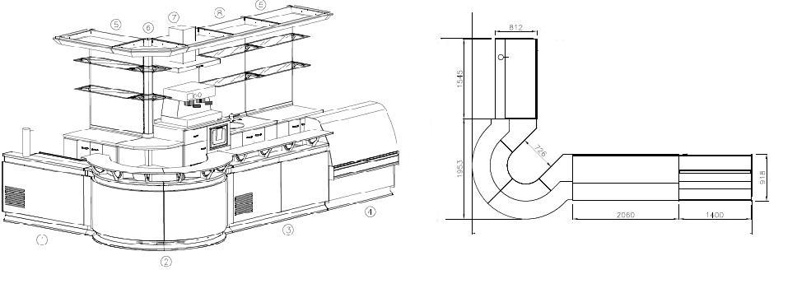For Example:

Another idea is to provide a plan view (or top view) of the actual coffee counter (stand) for the user to choose, allowing the player to understand the layout of the space better. We could diagram a very simple circulation path around the plan of the shop, mostly to show the point of entry and exit.

For Example:

* **Color Palette**

Friendly, warm; cozy, fall or autumn like colors

For Example:

* **Game Characters**

The main idea here is to have one very generic form, simple yet memorable. One main form or volume with very similar characteristics i.e. big round head, big oval eyes, small body, the characters then become very customizable. This allows for the characters to have very unique and colorful features without being too overwhelming because they are still so similar in shape and scale.

For Example: (just an idea to get a visual I will be designing ours)

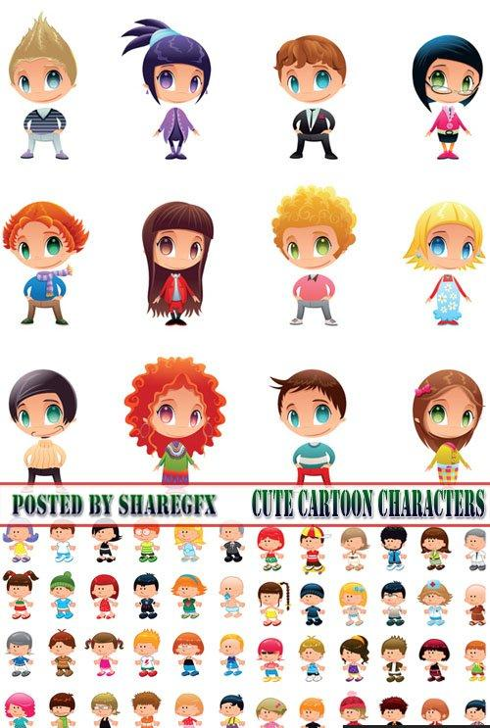

# Sound

## Songs

The soundtrack will consist of lively, upbeat, simple songs (like Hot Shots Golf).

**Soundtrack Items**

* Start Game Screen Theme: heard when the game starts, before the player has loaded an old or started a new game.
* End-of-Day Theme: head throughout the End-of-Day screens.
* Facility/Location Theme Song: different theme song for each location.

## Sound Effects

Sound effects will be present, but will not be overwhelming. Key events will trigger sound effects, such as buying new equipment, a very satisfied/dissatisfied customer (whenever a thought-bubble-icon is displayed), buying a new recipe, placing/removing an item on the menu, etc.

# Development Load & Resources

## Team Members & Responsibilities

There will be no minimum or maximum amount of hours to be worked on a daily or weekly basis, however, when a Ticket is assigned to you, you are expected to complete the ticket by the set Due Date. This is very important for project planning and to keep things moving. Make an effort to finish your tickets by their Due Date, and if you cannot please let the Project Manager know

* Luis Rizo – Project Manager, Game Designer, Developer
  + Responsibilities:
    - Creating, updating and closing Project Tickets
    - Game design
    - Development
* Brian Rizo – Game Designer, Developer
  + Responsibilities:
    - Closing assigned project tickets
    - Game design
    - Development
* Susana Neira – Game Designer, Art Director
  + Responsibilities:
    - Closing assigned project tickets
    - Game design
    - Art & Graphics – Icons, Menu, Layouts, Characters