Source Data Mapping Approach to CDMV5.3.1

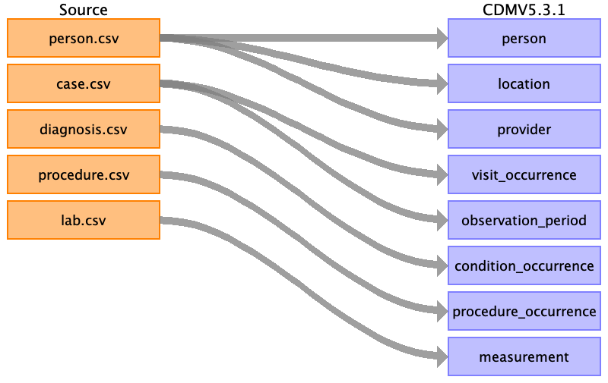

Table name: person

Reading from person.csv

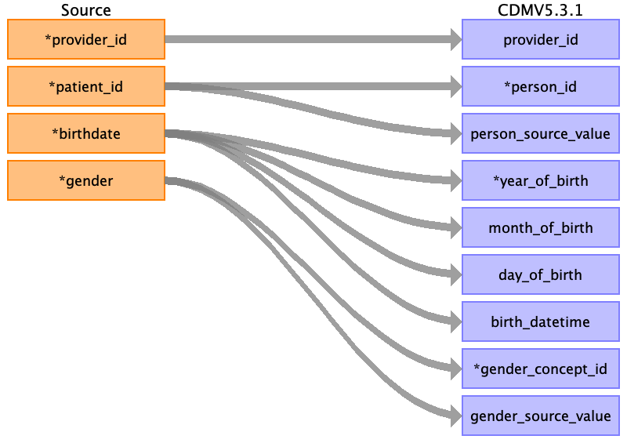

|  |  |  |  |
| --- | --- | --- | --- |
| Destination Field | Source Field | Logic | Comment |
| provider_id | provider_id |  |  |
| person_id | patient_id |  |  |
| person_source_value | patient_id |  |  |
| year_of_birth | birthdate |  | year |
| month_of_birth | birthdate |  | month |
| day_of_birth | birthdate |  | day |
| birth_datetime | birthdate |  | Tag |
| gender_concept_id | gender |  | w -> 8532 FEMALE  m -> 8507 MALE  8532 FEMALE  8507 MALE |
| gender_source_value | gender |  |  |
| race_concept_id |  |  | set 4218674 Unknown racial group |
| ethnicity_concept_id |  |  | 0? 38003563 (Hispanic?), 38003564 (Not hispanic?) |
| location_id |  |  | Zurückspiegeln aus location table |
| care_site_id |  |  |  |
| race_source_value |  |  |  |
| race_source_concept_id |  |  |  |
| ethnicity_source_value |  |  |  |
| gender_source_concept_id |  |  |  |
| ethnicity_source_concept_id |  |  |  |

Table name: location

Reading from person.csv

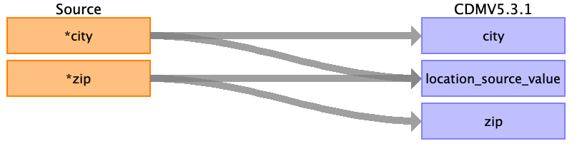

|  |  |  |  |
| --- | --- | --- | --- |
| Destination Field | Source Field | Logic | Comment |
| city | city |  |  |
| location_source_value | city  zip |  |  |
| zip | zip |  |  |
| location_id |  |  | Autogenerate, zurückspiegeln in person |
| address_1 |  |  |  |
| address_2 |  |  |  |
| county |  |  |  |
| state |  |  |  |

Table name: provider

Reading from person.csv

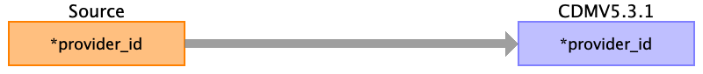

|  |  |  |  |
| --- | --- | --- | --- |
| Destination Field | Source Field | Logic | Comment |
| provider_id | provider_id |  |  |
| provider_source_value |  |  |  |
| provider_name |  |  |  |
| npi |  |  |  |
| dea |  |  |  |
| specialty_concept_id |  |  |  |
| care_site_id |  |  |  |
| year_of_birth |  |  |  |
| gender_concept_id |  |  |  |
| specialty_source_value |  |  |  |
| specialty_source_concept_id |  |  |  |
| gender_source_value |  |  |  |
| gender_source_concept_id |  |  |  |

Table name: visit_occurrence

Reading from case.csv

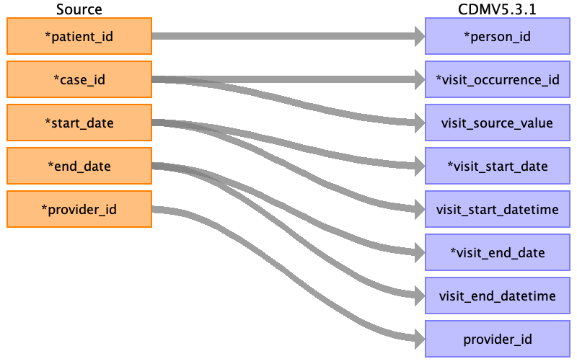

|  |  |  |  |
| --- | --- | --- | --- |
| Destination Field | Source Field | Logic | Comment |
| person_id | patient_id |  |  |
| visit_occurrence_id | case_id |  |  |
| visit_source_value | case_id |  |  |
| visit_start_date | start_date |  |  |
| visit_start_datetime | start_date |  |  |
| visit_end_date | end_date |  |  |
| visit_end_datetime | end_date |  |  |
| provider_id | provider_id |  |  |
| visit_type_concept_id |  |  | 44818518 Visit dervied from EHR record |
| visit_concept_id |  |  | 38004515 Hospital |
| care_site_id |  |  |  |
| visit_source_concept_id |  |  |  |
| admitting_source_concept_id |  |  |  |
| admitting_source_value |  |  |  |
| discharge_to_concept_id |  |  |  |
| discharge_to_source_value |  |  |  |
| preceding_visit_occurrence_id |  |  |  |

Table name: observation_period

Reading from case.csv

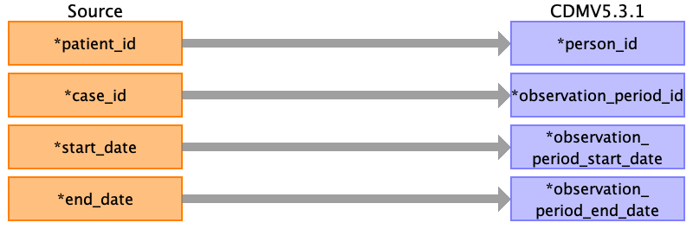

|  |  |  |  |
| --- | --- | --- | --- |
| Destination Field | Source Field | Logic | Comment |
| person_id | patient_id |  |  |
| observation_period_id | case_id |  |  |
| observation_period_start_date | start_date |  | Format |
| observation_period_end_date | end_date |  |  |
| period_type_concept_id |  |  | 32817 EHR |

Table name: condition_occurrence

Reading from diagnosis.csv

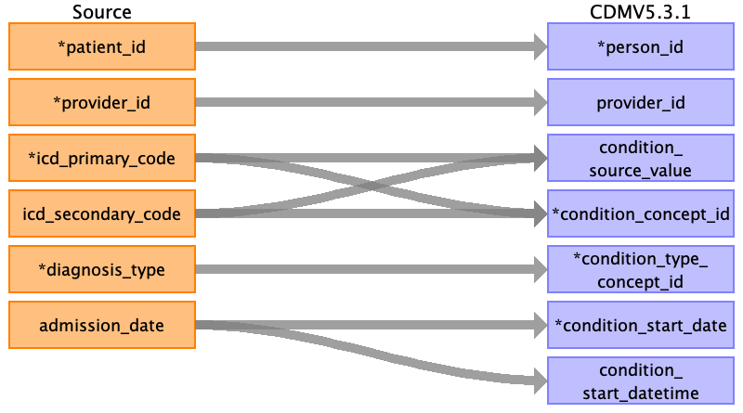

|  |  |  |  |
| --- | --- | --- | --- |
| Destination Field | Source Field | Logic | Comment |
| person_id | patient_id |  |  |
| provider_id | provider_id |  |  |
| condition_source_value | icd_primary_code  icd_secondary_code |  |  |
| condition_concept_id | icd_primary_code  icd_secondary_code |  | Get from condition concept_id as concept_id_1  WHERE concept_code = icd-primary_code  AND  WHERE VocabularyId = "ICD10GM"  concept_relationship = „Maps to“  condition_concept_id (SNOMED) = concept_id2 |
| condition_type_concept_id | diagnosis_type |  | HD -> 44786627 Primary condition  ND -> 44786629 Secondary condition |
| condition_start_date | admission_date |  |  |
| condition_start_datetime | admission_date |  |  |
| condition_occurrence_id |  |  | Auto generate UNIQUE |
| condition_status_concept_id |  |  |  |
| condition_source_concept_id |  |  |  |
| condition_end_date |  |  |  |
| condition_end_datetime |  |  |  |
| stop_reason |  |  |  |
| visit_occurrence_id |  |  |  |
| visit_detail_id |  |  |  |
| condition_status_source_value |  |  |  |

Table name: procedure_occurrence

Reading from procedure.csv

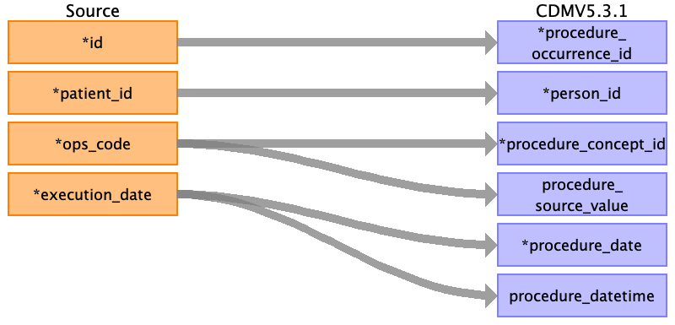

|  |  |  |  |
| --- | --- | --- | --- |
| Destination Field | Source Field | Logic | Comment |
| procedure_occurrence_id | id |  |  |
| person_id | patient_id |  |  |
| procedure_concept_id | ops_code |  | SNOMED-ID des korrespondierenden Codes |
| procedure_source_value | ops_code |  |  |
| procedure_date | execution_date |  |  |
| procedure_datetime | execution_date |  |  |
| procedure_type_concept_id |  |  | 32817 EHR |
| procedure_source_concept_id |  |  |  |
| modifier_concept_id |  |  |  |
| quantity |  |  |  |
| provider_id |  |  |  |
| visit_occurrence_id |  |  |  |
| visit_detail_id |  |  |  |
| modifier_source_value |  |  |  |

Table name: measurement

Reading from lab.csv

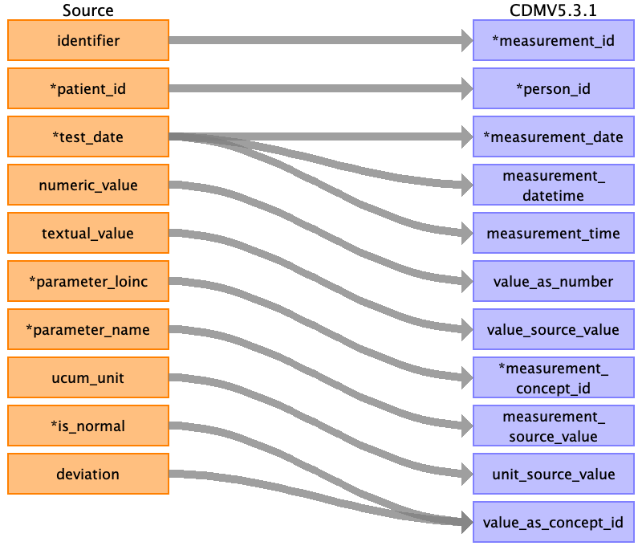

|  |  |  |  |
| --- | --- | --- | --- |
| Destination Field | Source Field | Logic | Comment |
| measurement_id | identifier |  |  |
| person_id | patient_id |  |  |
| measurement_date | test_date |  |  |
| measurement_datetime | test_date |  |  |
| measurement_time | test_date |  |  |
| value_as_number | numeric_value |  |  |
| value_source_value | textual_value |  |  |
| measurement_concept_id | parameter_loinc |  |  |
| measurement_source_value | parameter_name |  |  |
| unit_source_value | ucum_unit |  |  |
| value_as_concept_id | is_normal  deviation |  | 1 -> 4124457 (normal, bzw. negatives Testergebnis)  0 -> 4328749, wenn Deviation "+" (Hoch)  -> 4267416, wenn Deviation "-" (Niedrig) |
| measurement_type_concept_id |  |  | 32856 Lab |
| range_high |  |  |  |
| range_low |  |  |  |
| unit_concept_id |  |  |  |
| operator_concept_id |  |  |  |
| measurement_source_concept_id |  |  |  |
| provider_id |  |  |  |
| visit_occurrence_id |  |  |  |
| visit_detail_id |  |  |  |

Table name: note

Table name: attribute_definition

Table name: death

Table name: observation

Table name: device_exposure

Table name: drug_exposure

Table name: fact_relationship

Table name: note_nlp

Table name: specimen

Table name: visit_detail

Table name: cohort

Table name: cohort_attribute

Table name: condition_era

Table name: dose_era

Table name: drug_era

Table name: cost

Table name: payer_plan_period

Table name: care_site

Table name: cdm_source

Table name: metadata

Table name: cohort_definition

Appendix: source tables

Table: person.csv

|  |  |  |  |
| --- | --- | --- | --- |
| Field | Type | Most freq. value | Comment |
| provider_id | INT | 260123451 |  |
| patient_id | INT |  |  |
| birthdate | DATE | 1950-01-16 |  |
| gender | VARCHAR | w |  |
| city | VARCHAR | Ort_637 |  |
| zip | INT | 63766 |  |
| death_date | VARCHAR | NA |  |
| death | VARCHAR | nein | Nur mappen wenn hier "JA", dann concept EHR |
| date_of_life | VARCHAR | 2020-11-26 17:00:00 |  |
| forname | VARCHAR | Grete |  |
| name | VARCHAR | Schulzen |  |
| insurance | VARCHAR | BKK_800 |  |
| insurance_id | VARCHAR |  |  |

Table: case.csv

|  |  |  |  |
| --- | --- | --- | --- |
| Field | Type | Most freq. value | Comment |
| patient_id | INT | 0001189 |  |
| case_id | INT |  |  |
| start_date | VARCHAR | 2020-03-11 15:00:00 |  |
| end_date | VARCHAR | 2020-03-11 15:59:59 |  |
| provider_id | INT | 260123451 |  |

Table: diagnosis.csv

|  |  |  |  |
| --- | --- | --- | --- |
| Field | Type | Most freq. value | Comment |
| patient_id | INT | 246 |  |
| provider_id | INT | 260123452 |  |
| icd_primary_code | VARCHAR | I10.00 |  |
| icd_secondary_code | VARCHAR |  |  |
| diagnosis_type | VARCHAR | HD |  |
| admission_date | VARCHAR | 22.01.2020 |  |
| clinical_status | VARCHAR | Aktuell |  |
| icd_version | INT | 2020 |  |
| admission_number | INT | 440 |  |
| orpha_code | VARCHAR |  |  |
| orpha_text | VARCHAR |  |  |
| alphaid_code | VARCHAR | I26740 |  |
| alphaid_text | VARCHAR | Benigne Hypertonie |  |
| icd_text | VARCHAR | Benigne essentielle Hypertonie: Ohne Angabe einer hypertensiven Krise |  |
| diagnostic_explanation | VARCHAR |  |  |
| icd_manifestation | VARCHAR |  |  |

Table: procedure.csv

|  |  |  |  |
| --- | --- | --- | --- |
| Field | Type | Most freq. value | Comment |
| id | VARCHAR | NA |  |
| patient_id | INT | 0000410 |  |
| ops_code | VARCHAR | 3-990 | FROM Procedure  WHERE Concept code = ops_code  --> maps_to SNOMED.ConceptId |
| execution_date | VARCHAR |  |  |
| ops_version | VARCHAR | ops2020 |  |

Table: lab.csv

|  |  |  |  |
| --- | --- | --- | --- |
| Field | Type | Most freq. value | Comment |
| identifier | INT |  |  |
| patient_id | INT | 0000074 |  |
| test_date | VARCHAR |  |  |
| numeric_value | REAL |  |  |
| textual_value | VARCHAR |  |  |
| parameter_loinc | VARCHAR | 2484-4 |  |
| parameter_name | VARCHAR | IGF-I [Somatomedin C] i.S. |  |
| ucum_unit | VARCHAR | 10*3/uL |  |
| is_normal | INT | 0 |  |
| deviation | VARCHAR |  |  |
| unit | VARCHAR | mmol/L |  |
| normal_values | VARCHAR | (null) |  |
| category | VARCHAR | Carnitinstatus |  |
| status | VARCHAR | Korrektur bereits gemeldeter Ergebnisse |  |
| comment | INT | 0 |  |