Title: *Chasing Shadows: Finding Class 1 Sites for Weather Sensors Using Hillshade*

Notice: Dr. Bryan Runck

Author: Lucas Rosen

Date: 5/7/2021

**Project Repository:*****https://github.com/LRosen656/GIS5572.git***

**Abstract**

Weather sensors provide a variety of applications in agriculture including determining evapotranspiration as well as growing degree days. Accurate weather sensors rely on multiple factors including shading. The goal of this project is to find Class 1 suitability shading in Minnesota using hillshade. A digital surface model (DSM) was downloaded from the Digital Repository of University of Minnesota (DRUM). Analyses were done in both Arc Pro and Earthpy. The tiles were merged and a hillshade was performed based on zenith and azimuths. Azimuths were determined by location and date. The rasters were then reclassed and multiplied to get the final suitability analysis. Arc Pro and Earthpy produce similar results. However, moving from the centroid location makes the results less accurate.

# Problem Statement

Weather sensors provide a variety of applications in agriculture including determining evapotranspiration as well as growing degree days. Evapotranspiration shows water escaping from plants and the ground, which is useful for scheduling irrigation (Porter et al., 2012). Growing degree days use temperature to find the growing season of a crop. Both rely on accurate temperature and humidity sensors. Many factors contribute to the accuracy of weather sensors such as distance from buildings and shading. The World Meteorological Organization (2014) defines Class 1 (best) placement for air temperature and humidity sensors as “away from all projected shade when the sun is higher than 5° [elevation]” (**Figure 1**). While many urban and photovoltaic studies use hours of sun to get total radiation (Fleming, Grimes, Lebreton, Maré, & Nunns, 2018; Oh & Park, 2018), there is little research that shows radiation at specific elevations.

The goal of this study is to find areas in Minnesota that meet Class 1 shading suitability for temperature and humidity weather sensors.

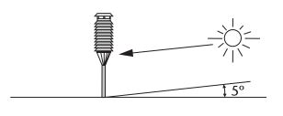

Figure Class 1 Suitability for Shading (source WMO)

## Parameters for Analysis

There are several parameters needed to do a hillshade analysis. The first is an elevation model to find slope and aspect. Both can be derived from a digital surface model. The second is the zenith or the altitude the sun is above the horizon. This was set at 5o to fit the Class 1 site suitability and it occurs twice a day: once in the morning and once in the evening. Finally, there is the azimuth or direction the sun is in the sky. This varies based on location, date, and time. **Figure 2** shows an example of azimuth an zenith (Joint, 2018).

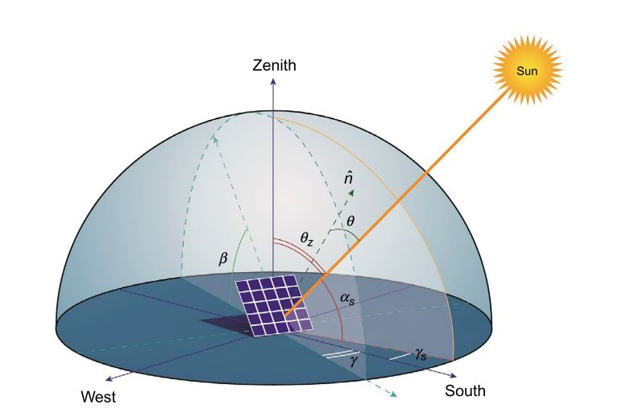

Figure Solar Zenith and Azimuth Example (Joint, 2018)

*Table 1. The measurements required for this project are slope, aspect, and shade.*

|  |  |  |  |  |  |  |
| --- | --- | --- | --- | --- | --- | --- |
| **#** | **Requirement** | **Defined As** | **Spatial Data** | **Attribute Data** | **Dataset** | **Preparation** |
| 1 | Slope | Change in Height over Distance | DSM | N/A | DRUM | None (part of Hillshade) |
| 2 | Aspect | Direction of Slope | DSM | N/A | DRUM | None (part of Hillshade) |
| 3 | Shade | Values of 0 at a given Sun Azimuth and Elevation | DSM | N/A | DRUM | Hillshade |

## Input Data

The input data for the project was a digital surface model (DSM) raster downloaded from Digital Repository of the University of Minnesota (DRUM). The data was collected from LiDAR data between 2006 and 2012. The Datum is North American 1983 (meter), and the pixel resolution is 1 meter. The elevation measure is also 1 meter. Each raster tile is 10,000 by 10,000 pixels.

*Table 2. The required data for this project is a DSM downloaded from DRUM.*

|  |  |  |  |
| --- | --- | --- | --- |
| **#** | **Title** | **Purpose in Analysis** | **Link to Source** |
| 1 | DSM | Raw input dataset for Hillshade analysis from DRUM | [DRUM](https://conservancy.umn.edu/handle/11299/172696) |

# Methods

**Figure 3** shows a flowchart of the methods. The analysis was performed both in Arc Pro and Earthpy. The reason why Earthpy was used was because it is an open-source program that could be installed in a supercomputer to expand the area. 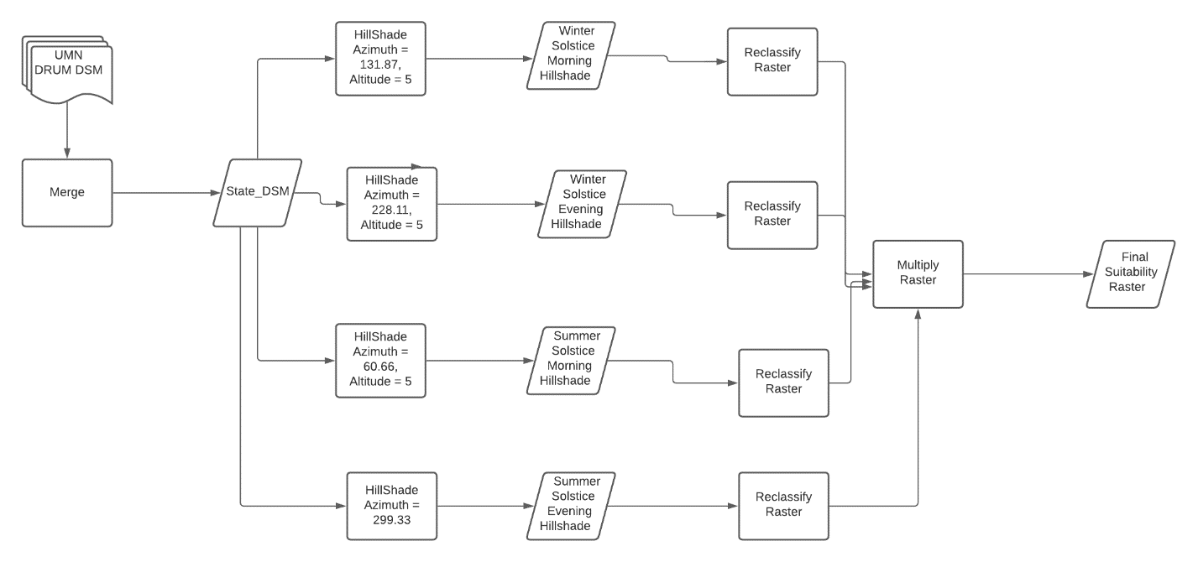

Figure Flowchart

#### Finding Azimuth

Rather than finding the azimuth for every single day of the year, I just focused on two dates: The winter solstice and the summer solstice. If they are both in sun or both in shadow, then other dates would not change the result. These azimuths can be derived from a sun calculator found on NOAA. I first used the centroid of Minnesota to find the location. I then used the date and times to calculate 4 azimuths: winter solstice morning, winter solstice evening, summer solstice morning, and summer solstice evening. Each date showed a zenith of 5°.

## Arc Pro

### Merging Tiles

The DSM I downloaded from DRUM was from Ashland quartile that consisted of 4 (useful) tiles. Once downloaded, I merged them to form a single tile [1], I could then do a hillshade analysis.

### Hillshade Analysis

Arc Pro has a hillshade analysis function that uses azimuth and altitude (zenith) parameters. There is also a “model shadows” parameter that includes the angle of shadows and would increase the amount of pixels with shadow values in the output. This process was ignored because Earthpy does not have that same function. The DSM was put in as the input, 5o was put in for the elevation, and four different azimuths were put in: 131.87°(Winter Solstice Morning), 228.11°(Winter Solstice Evening), 60.66°(Summer Solstice Morning), and 299.33°(Summer Solstice Evening). The results show four rasters with values ranging from 0 to 255 with 0 being shadow.

### Reclassification and Multiplication

Once all the hillshade rasters were complete, the next step was to reclassify all values greater than 0 to 1. This used the reclassify function with the list from 1 to 255 and an output of 1. This changed all the values except 0 to 1. Finally, the last step was to multiply all the rasters. The reason why I did this was because values of 1 in all of them are suitable (no shadow) and values of 0 in any of them are not suitable (shadow at some point). I opened raster calculator and selected all the normalized hillshade raster to multiply (In arcpy, this is done simply by multiply the rasters and saving the output, which is even easier than arc pro). The result shows a single raster suitability with 1 suitable and 0 not suitable.

### Earthpy

Earthpy is an open-source python program that can perform a hillshade analysis on elevation rasters. I used rasterio opened to turn the raster to an array and merged the tiles. Then I used the hillshade function with the same parameters as Arc Pro. I then reclassified the outputs by overwriting the values with 0 or 1. However, the hillshade function is a bit different than in Arc Pro. Looking in the documentation, it turns out that values less than or equal to 127.5 are classified as shade. So, values 127.5 or less were classified as 0 and the rest classified as 1. Finally, I multiplied the arrays to get the suitability output.

#### Array to Raster

Not related to the final output but needed for the verification was to convert the Earthpy array back to a raster to find the differences from the Arc Raster. To convert an array to a raster, I needed extent, cell size, and a coordinate system. Unfortunately, the function to declare a coordinate system (gdal) was not working. To get around this, I used the Pickle package to save the array so that I could open it in arcpy. Finally, I could use NumpytoRaster function to convert the array to a raster. Once I subtracted the Earthpy raster from the Arcpro raster, I could compare the results with a histogram.

## Results

**Figure 3** shows a suitability analysis from Earthpy and **Figure 4** shows the suitability analysis from Arc Pro. White areas indicate a value of 1 which are suitable and black areas indicate a value of 0 which are not suitable.

Figure Arc Pro Result

### Results Verification

Figure Earthpy Result

To compare the results, I subtracted the raster from Earthpy from the raster from the Arc Pro raster. The output can be seen in a histogram (**Figure 5**) with value between -1, 0, and 1. Values of -1 showed that the location was suitable in Earthpy and unsuitable in Arc Pro. Values of 1 showed that the location was suitable in Arc Pro and unsuitable in Earthpy. Values of 0 showed no conflict. Of the 100,000,000 pixels, about 96,000,000 showed a value of 0, about 3,000,000 showed a value of -1, and about 1,000,000 showed a value of 1. This means that both rasters are close and that the hillshade function is similar in both.

## Discussion and Conclusion

Results showed that both Arc Pro and Earthpy can use the hillshade function to produce similar suitability analyses. This is important because the Earthpy hillshade could expand the extent to the entire state using super computers. However, before moving up to that scale, there are certain factors to consider. First, the suitability analyses are meant to be done in real time and the DSMs used were from a decade ago. Surfaces can change drastically in ten years so it may not be accurate. Furthermore, I used the centroid in Minnesota to apply to the DSM for the entire state. However, The azimuth changes by latitude throughout the state by as much as 1 degree in the summer and 3 degrees in the winter. Comparing the same area using the centroid and bottom extent of the state azimuth, about 70% of the output was the same. Perhaps a lower pixel resolution would show less of a difference.

In conclusion, it may be possible to use hillshade to create a suitability analysis. However, if you want to expand it and use it in real time, you must consider quality of the data and assumptions made to calculate azimuth in the program.

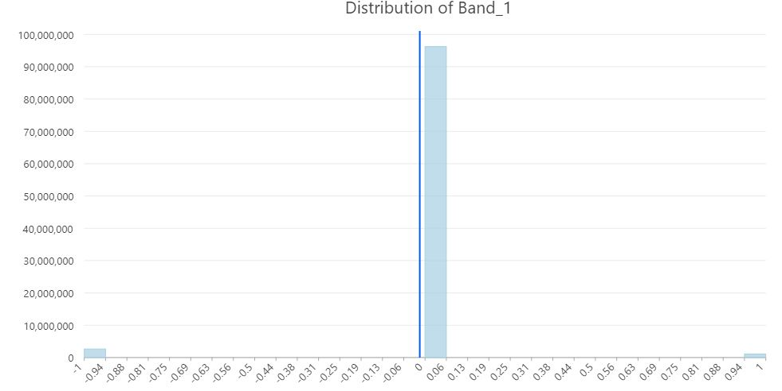

Figure Histogram of difference.

### References

Fleming, D., Grimes, A., Lebreton, L., Maré, D., & Nunns, P. (2018). Valuing sunshine. *Regional Science and Urban Economics*, *68*(November 2017), 268–276. https://doi.org/10.1016/j.regsciurbeco.2017.11.008

Joint, J. R. C. (2018). Photovoltaic Electricity. In *Submerged and Floating Photovoltaic Systems* (pp. 13–32). https://doi.org/10.1016/B978-0-12-812149-8.00002-8

Oh, M., & Park, H. D. (2018). A new algorithm using a pyramid dataset for calculating shadowing in solar potential mapping. *Renewable Energy*, *126*, 465–474. https://doi.org/10.1016/j.renene.2018.03.068

Porter, D., Gowda, P., Marek, T., Howell, T., Moorhead, J., & Irmak, S. (2012). SENSITIVITY OF GRASS- AND ALFALFA-REFERENCE EVAPOTRANSPIRATION TO WEATHER STATION SENSOR ACCURACY. *Applied Engineering in Agriculture*, *28*(4), 543–549.

World Meteorological Organization. (2014). *Siting classifications for surface observing stations on land*. *2014*(ANNEX 1 . B .), 13. Retrieved from https://www.wmo.int/pages/prog/www/IMOP/SitingClassif/CIMO_Guide_2014_en_I_1-2_Annex_1B.pdf

**Self-score**

|  |  |  |  |
| --- | --- | --- | --- |
| **Category** | **Description** | **Points Possible** | **Score** |
| **Structural Elements** | All elements of a lab report are included **(2 points each)**:  Title, Notice: Dr. Bryan Runck, Author, Project Repository, Date, Abstract, Problem Statement, Input Data w/ tables, Methods w/ Data, Flow Diagrams, Results, Results Verification, Discussion and Conclusion, References in common format, Self-score | 28 | **28** |
| **Clarity of Content** | Each element above is executed at a professional level so that someone can understand the goal, data, methods, results, and their validity and implications in a 5 minute reading at a cursory-level, and in a 30 minute meeting at a deep level **(12 points)**. There is a clear connection from data to results to discussion and conclusion **(12 points)**. | 24 | **22** |
| **Reproducibility** | Results are completely reproducible by someone with basic GIS training. There is no ambiguity in data flow or rationale for data operations. Every step is documented and justified. | 28 | **26** |
| **Verification** | Results are correct in that they have been verified in comparison to some standard. The standard is clearly stated **(10 points)**, the method of comparison is clearly stated **(5 points)**, and the result of verification is clearly stated **(5 points)**. | 20 | **20** |
|  |  | 100 | **96** |

1. While the analyses were done both on a single tile and merged tiles, the verification was just done on a single tile due to faster processing. All images shown are of a single tile.

  