**Prospectus**

Title: *Using LiDAR and Viewshed Analysis to Detect Shadows in Minnesota*

Notice: Dr. Bryan Runck

Author: Lucas Rosen

Date: 2/17/2021

**Project Repository:*****https://github.com/LRosen656/GIS5572.git***

**Abstract**

A viewshed analysis will be used to determine shadows when the sun is 5% above the horizon. LiDAR data will be downloaded from the DNR and converted to a DSM for the state of Minnesota. A viewshed analysis will be done using a “pseudo-sun” to detect visibility. The result will show a raster with 1 representing light and 0 representing shadows.

## Problem Statement

Viewsheds identify raster cells that can be visible from a certain point. The purpose of this project is to use Light Detection and Ranging (LiDAR) data and a Viewshed analysis to detect shadows when the sun is at 5% above the horizon for the state of Minnesota.

*Table 1.The required data will be LAS data from the state of Minnesota.*

|  |  |  |  |  |  |  |
| --- | --- | --- | --- | --- | --- | --- |
| **#** | **Requirement** | **Defined As** | **Spatial Data** | **Attribute Data** | **Dataset** | **Preparation** |
| 1 | Minnesota State LiDAR | Raw input dataset from MNDNR | LAS (LiDAR Data Format) | N/A | MNDNR | Unzip LAZ file if Applicable. Possibly remove noise and pits. |
| 2 | Minnesota State Boundary | Boundary of Minnesota | SHP Vector | Geometry | MNGEO |  |
| 3 |  |  |  |  |  |  |
| 4 |  |  |  |  |  |  |

## Input Data

All the outputs will be derived from the LAS dataset. After the LAS data is cleaned, a digital surface model DSM will be derived from the return points. From there a Viewshed model will create the final output.

*Table 2. Input data needed for the Analysis*

|  |  |  |  |
| --- | --- | --- | --- |
| **#** | **Title** | **Purpose in Analysis** | **Link to Source** |
| 1 | Minnesota LiDAR | LiDAR data to derive a DSM for analysis. | DNR FTP <https://resources.gisdata.mn.gov/pub/data/elevation/lidar/> |
| 2 | DSM | Surface Model for the viewshed analysis | Derived from LAS data |
| 3 | Minnesota Boundary | Creates a boundary that the data can be clipped to | MN GEO. |
|  |  |  |  |

## Methods

The ETL will download around 1 Terabyte of Minnesota LAZ (zipped LAS). Once converted to a LAS, it will be over 7 Terabytes of data (I might have to downsize). After the tiles are converted to a DSM, merged, and clipped to Minnesota state. the Viewshed analysis can begin.

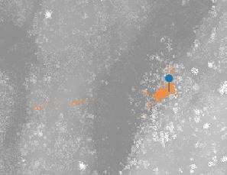Similar studies (Sobala et al., 2020 and Cahalane, 2015) used Arc Pro’s Viewshed analysis to detect visibility ranges from certain objects. **Figure 1** shows an example of a viewshed. Notably, the viewing object must be in the same coordinate system as the raster data and the Sun is not within any coordinate system. To work around this, a “pseudo-sun” can be made as the viewing object **so long as the azimuth and elevation angle are the same as the actual sun**. Cahalane did a similar viewshed using satellites and can be seen in **Figure 2. Figure 3** shows the workflow chart.

Figure Viewshed example. The blue pin is the observer and the orange cells are the visibility.

## 

Figure Example of using a pseudo object in a Viewshed analysis (Source Cahalane 2015)

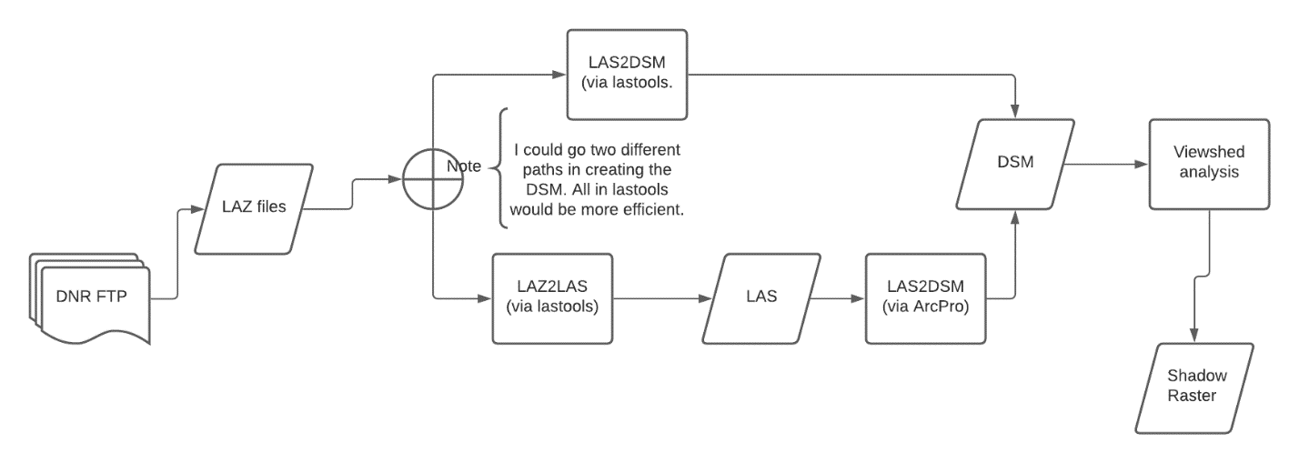

Figure Flowchart

## Results

The result will be a binary raster map of the state with 1 representing visibility and 0 representing shadows.

### Results Verification

A root mean square error will be used to compare the predicted shadow to the actual shadow.

## Discussion and Conclusion

Perhaps the hardest part of the project will be the scale. 7 Terabytes of data is time (and money) consuming. To prevent errors at the large scale, I will first start with a single tile to make sure the equation works. Then, I will scale it up to a county to make sure it merges correctly and there is not any noise. Once confident with the output, I will finally scale it up to the state.

### References

Cahalane, C. (2015). Combining 2D mapping and low density elevation data in a GIS for GNSS shadow prediction. *ISPRS International Journal of Geo-Information*, *4*(4), 2769–2791. <https://doi.org/10.3390/ijgi4042769>

Sobala, M., Myga-Piątek, U., & Szypuła, B. (2020). Assessment of changes in a viewshed in the Western carpathians landscape as a result of reforestation. *Land*, *9*(11), 1–17. https://doi.org/10.3390/land9110430

**Self-score**

|  |  |  |  |
| --- | --- | --- | --- |
| **Category** | **Description** | **Points Possible** | **Score** |
| **Structural Elements** | All elements of a lab report are included **(2 points each)**:  Title, Notice: Dr. Bryan Runck, Author, Project Repository, Date, Abstract, Problem Statement, Input Data w/ tables, Methods w/ Data, Flow Diagrams, Results, Results Verification, Discussion and Conclusion, References in common format, Self-score | 28 |  |
| **Clarity of Content** | Each element above is executed at a professional level so that someone can understand the goal, data, methods, results, and their validity and implications in a 5 minute reading at a cursory-level, and in a 30 minute meeting at a deep level **(12 points)**. There is a clear connection from data to results to discussion and conclusion **(12 points)**. | 24 |  |
| **Reproducibility** | Results are completely reproducible by someone with basic GIS training. There is no ambiguity in data flow or rationale for data operations. Every step is documented and justified. | 28 |  |
| **Verification** | Results are correct in that they have been verified in comparison to some standard. The standard is clearly stated **(10 points)**, the method of comparison is clearly stated **(5 points)**, and the result of verification is clearly stated **(5 points)**. | 20 |  |
|  |  | 100 |  |