**Lab Report**

Title: *A Comparison of Interpolation Methods for Average Monthly Air Temperature in Minnesota*

Notice: Dr. Bryan Runck

Author: Lucas Rosen

Date: 4/22/2021

**Project Repository: *https://github.com/LRosen656/GIS5572.git***

**Abstract**

Interpolation models can create predictive maps using limited input. The goal of this assignment is to compare interpolation methods for monthly average temperatures. Data was downloaded from NDAWN and reshaped to turn into a feature class. The methods used were inverse distance weighting, ordinary kriging, universal kriging, and Empirical Bayesian Kriging. Geostatical analysis was run all methods to compare the cross validation. Overall, Empirical Bayesian Kriging had the lowest root mean square error and universal kriging produced the best-looking output. All methods produce similar maps.

# Problem Statement

The purpose of this project is to create monthly average temperature maps for Minnesota and compare the interpolation methods. The interpolation methods are: Inverse Distance Weighting (IDW), Ordinary Kriging, Universal Kriging, and Empirical Bayesian Kriging (EBK).

*Table 1. Required Data*

|  |  |  |  |  |  |  |
| --- | --- | --- | --- | --- | --- | --- |
| **#** | **Requirement** | **Defined As** | **Spatial Data** | **Attribute Data** | **Dataset** | **Preparation** |
| 1 | Monthly Average Temperatures in Minnesota | Average air temperature at Minnesota weather stations over 30 days | Station (Point) | Average Air Temperature | NDAWN | Extract, get average temp over 30 days per station, create points from latitude and longitude. |

# Input Data

The input data for the project was obtained from Minnesota Weather Station sites found on NDAWN. Data was extracted to tables and reshaped to contain the station name, latitude, longitude, and average monthly air temperature (3/18/2021-4/16/2021). The table was then coverted to XY points using the latitude and longitude to WGS_84 Datum in Arc Pro. I was unable to find the datum by looking though NDAWN documentation but WGS_84 appears to be reasonable.

*Table 2. The input data for the project was weather stations from NDAWN*

|  |  |  |  |
| --- | --- | --- | --- |
| **#** | **Title** | **Purpose in Analysis** | **Link to Source** |
| 1 | Weather Stations | Interpolation of Average Air Temperature | [NDAWN](https://ndawn.ndsu.nodak.edu/table.csv?&station=%27Ada%27,%27Becker%27,%27Campbell%27,%27Clarissa%27,%27Eldred%27,%27Fox%27,%27Greenbush%27,%27Hubbard%27,%27Humboldt%27,%27Kennedy%27,%27Little%20Falls%27,%27Mavie%27,%27Ottertail%27,%27Parkers%20Prairie%27,%27Perham%27,%27Perley%27,%27Pine%20Point%27,%27Rice%27,%20%27Roseau%27,%27Sabin%27,%27Staples%27,%20%27Stephen%27,%27Ulen%27,%27Wadena%27,%27Warren%27,%27Waukon%27,%27Westport%27,%27Williams%27&%27variable=hdt,%20%25variable=hdt9&ttype=hourly&quick_pick=&begin_date='2021-03-18'&end_date='2021-04-16') |

# Methods

**Figure 1** shows a flowchart of the methods.

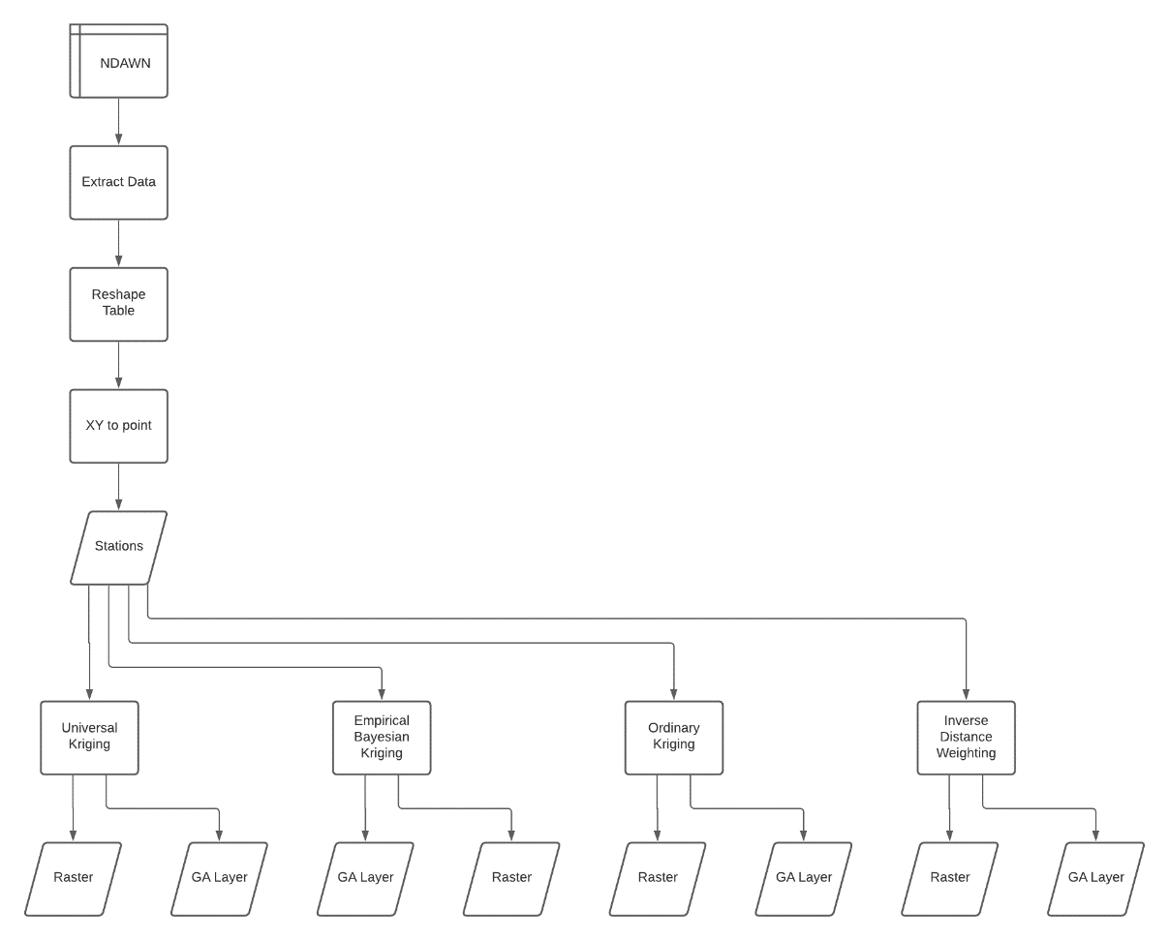

Figure FlowChart

### Extracting Data to Points

To extract the data from NDAWN, code created by Jeffery Bishop was used. The parameters are station name (number), variables, start date and end date. The station name was all the Minnesota weather stations and had to be entered manually. The variable was ‘Average Air Temp’ in degrees Fahrenheit. The Datetime package was used to create the start and end date. The end date was today, and the start date was today minus 30. The output was a table containing the hourly temperatures at the weather stations over the past 30 days.

To shape the table so that it shows average 30-day temperature, I used the ‘group by’ function to group station name and the average latitude, longitude (those do not change per station), and air temperature. Now that the table was ready, I used the “XY to Point” to put the stations on the map in Arc Pro. I was unable to find the Datum the latitude and longitude were in, so I just used WGS 84 (the default on the map). The data is now ready for interpolation.

### Interpolation

Four interpolation methods were used: inverse distance weighting, ordinary kriging, universal kriging (literature recommended), and Empirical Bayesian Kriging (esri recommended).

#### Inverse Distance Weighting

One of the fastest methods of interpolation is inverse distance weighting. The code just requires an input (stations), a field (average air temperature) and an output (raster layer). The output shows a raster of temperature values with the station boundary limits.

#### Ordinary Kriging

Ordinary kriging was the second interpolation on the data. To do this, I selected “Kriging”, input the data, used ordinary for the method and spherical for the semivariogram. I left everything else to the defaults. The output shows an ordinary kriging raster.

#### Universal Kriging

Universal Kriging was the third method I used and the one recommended by literature (Wu & Li, 2013). Once again, I used the kriging function with the input data and then selected universal for the method and linear drift for the semivariogram. The output shows a universal kriging raster. This looked weird so I used Geostatisical Wizard to create a Universal Kriging layer with a Spherical semivariogram. That looked better and is the one shown in the results.

#### Empirical Bayesian Kriging

The last interpolation method used was Empirical Bayesian Kriging. This method is a function apart from ordinary and universal kriging. I selected Empirical Bayesian Kriging and set the surface type to “Prediction” and the semivariogram to “Power”. The output shows the kriging raster.

#### Statistical Analysis

Geostatistical Wizard was used to create a geostatical analysis that includes a cross validation. I was able to create a geostatical analysis layer in code, I was unable to save the output.

# Results

**Figure 2** shows the output for the inverse distance weighting method. **Figure 3** shows the output for the ordinary kriging method. **Figure 4** shows the output for the universal kriging method. Finally, **Figure 5** shows the output for the Empirical Bayesian Kriging method. All methods look reasonable and are scaled from blue to red with blue being the lowest temperature and red being the highest temperature. Overall universal kriging looks the most realistic because it is the smoothest.

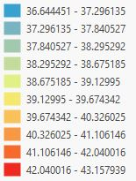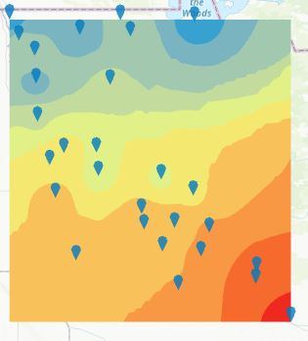

Figure Inverse Distant Weighting



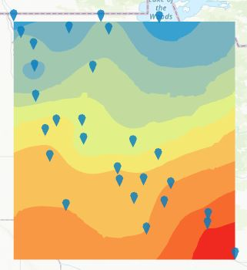Figure Ordinary Kriging

**

Figure Universal Kriging

## 

Figure Empirical Bayesian Kriging

## Results Verification

Results were verified using the root mean square error (RMSE) in the cross-validation analysis (leave one out). Inverse distance weighting had the highest RMSE at 0.66. Universal kriging had the second highest at 0.58. Ordinary kriging had the third highest at 0.57. Finally, Empirical Bayesian Kriging had the lowest RMSE at 0.55. All RMSEs looked similar.

# Discussion and Conclusion

Looking through the literature, there are plenty of articles that discuss temperature interpolation. However, the methods that they used were all over the place. The most prominent and recent methods used involved machine learning. I do not have time or data to train a machine without risk of overfitting (though cross validation also has its overfitting issue). A review of interpolation methods in environmental sciences suggests that kriging is the most common method (Li & Heap, 2011). However, kriging alone is vague and could mean many different methods. The reason I choose universal kriging was because the closest study to the project (Wu & Li, 2013) used residual kriging and from what I saw was the same (or at least close) to universal kriging.

All interpolation methods seem to produce a reasonable result with higher temperatures down south and lower temperatures up north. The statistical methods (kriging) had a better RMSE than non-statistical methods (inverse distance weighting). While Empirical Bayesian Kriging had the best statistics overall, universal kriging had the best-looking output.

### References

Li, J., & Heap, A. D. (2011). A review of comparative studies of spatial interpolation methods in environmental sciences: Performance and impact factors. *Ecological Informatics*, *6*(3–4), 228–241. https://doi.org/10.1016/j.ecoinf.2010.12.003

Wu, T., & Li, Y. (2013). Spatial interpolation of temperature in the United States using residual kriging. *Applied Geography*, *44*, 112–120. https://doi.org/10.1016/j.apgeog.2013.07.012

**Self-score**

*Fill out this rubric for yourself and include it in your lab report. The same rubric will be used to generate a grade in proportion to the points assigned in the syllabus to the assignment.*

|  |  |  |  |
| --- | --- | --- | --- |
| **Category** | **Description** | **Points Possible** | **Score** |
| **Structural Elements** | All elements of a lab report are included **(2 points each)**:  Title, Notice: Dr. Bryan Runck, Author, Project Repository, Date, Abstract, Problem Statement, Input Data w/ tables, Methods w/ Data, Flow Diagrams, Results, Results Verification, Discussion and Conclusion, References in common format, Self-score | 28 | **28** |
| **Clarity of Content** | Each element above is executed at a professional level so that someone can understand the goal, data, methods, results, and their validity and implications in a 5 minute reading at a cursory-level, and in a 30 minute meeting at a deep level **(12 points)**. There is a clear connection from data to results to discussion and conclusion **(12 points)**. | 24 | **23** |
| **Reproducibility** | Results are completely reproducible by someone with basic GIS training. There is no ambiguity in data flow or rationale for data operations. Every step is documented and justified. | 28 | **27** |
| **Verification** | Results are correct in that they have been verified in comparison to some standard. The standard is clearly stated **(10 points)**, the method of comparison is clearly stated **(5 points)**, and the result of verification is clearly stated **(5 points)**. | 20 | **19** |
|  |  | 100 | **97** |