FPGA-BASED CNN ACCELERATOR FOR MNIST
USING INT8 AND INT16 QUANTIZATION
PROJECT REPORT
Submitted in partial fulfilment of the requirements for
[Degree or programme name]
by
[Student name]
[Registration number]
Under the guidance of
[Supervisor name]

[Department]
[University or institution]
2026

APPROVAL OF THE PROJECT REPORT
Certified that the project report entitled FPGA-Based CNN Accelerator for MNIST Using INT8 and INT16 Quantization, submitted by [Student name] to [University or institution], has been reviewed and accepted for the award of [Degree or programme name], subject to the institution's approval process.
Role | Name | Signature | Date
Supervisor | [Name] | ________________ | ____________
Internal examiner | [Name] | ________________ | ____________
External examiner | [Name] | ________________ | ____________
Department representative | [Name] | ________________ | ____________

Complete the official approval wording and signatories on the institution's required letterhead before submission.

CERTIFICATE
This is to certify that the project report entitled FPGA-Based CNN Accelerator for MNIST Using INT8 and INT16 Quantization, prepared by [Student name], presents work carried out under the supervision of [Supervisor name]. It records the project's software model, integer-quantization flow, RTL implementation, simulation evidence, and outstanding hardware evaluation. This certificate must be reviewed and signed by the responsible supervisor and department.
Supervisor: ______________________________ Co-supervisor: ______________________________
Department: ______________________________ Date: _____________________________________

DECLARATION
I declare that this report describes the work undertaken for the project FPGA-Based CNN Accelerator for MNIST Using INT8 and INT16 Quantization. The project evidence and external sources are identified in the report. Results from an earlier reference project are not presented as results from this implementation. Any institutional declaration required for submission must be checked against the official wording.
Student name: [Student name]
Signature: ______________________________ Date: ______________________________

ACKNOWLEDGEMENTS
[Replace this paragraph with your own acknowledgements to your supervisor, department, laboratory, collaborators, and anyone who supported the project. Do not retain acknowledgements copied from the reference thesis.]

ABSTRACT
This project develops two integer-arithmetic implementations of a compact convolutional neural network for handwritten-digit classification. A shared PyTorch model applies three valid 3 x 3 convolution layers with 8, 16, and 32 output channels, each followed by ReLU and 2 x 2 max-pooling. The resulting 32 features feed fully connected layers of 16 and 10 units and an argmax classifier. Both integer paths derive from one FP32 checkpoint, with separately calibrated scales and Verilog parameter memories. The RTL uses unsigned activations, signed weights, INT32 accumulators, fixed-point requantization, feature arrays, and an FSM-controlled reused MAC. The target board is the ZC702 (XC7Z020); its image-demo top stores one image in ROM and displays its class and completion state on LEDs.
Software classification accuracy on 10,000 MNIST test images is 97.52% for FP32, 97.57% for INT8, and 97.54% for INT16. In the 100-image RTL testbench, both integer implementations matched their respective Python references on all 100 images. The ZC702 board interface supports ROM-based image input and LED output, and an INT8 image-demo bitstream was generated and successfully loaded onto the FPGA.

CONTENTS
Chapter 1 Introduction 1
1.1 Research Background 1
1.2 Problem Definition 2
1.3 Research Objectives 2
1.4 Scope and Assumptions 2
1.5 Contributions and Evidence Boundary 3
1.6 Thesis Organization 3
Chapter 2 Literature Review 4
2.1 Convolutional Neural Networks for Image Recognition 4
2.2 MNIST as an Evaluation Benchmark 4
2.3 Hardware Acceleration of CNN Inference 4
2.4 Integer Quantization 5
2.5 Streaming, Buffering, and Sequential Inference 5
2.6 Research Gap and Design Position 6
Chapter 3 Theoretical Study and Proposed Architecture 7
3.1 Network Topology and Tensor Dimensions 7
3.2 Convolution Mathematics 8
3.2.1 Convolution Window and MAC Sequence 8
3.3 Activation and Pooling 9
3.4 Fully Connected Layers and Classification 9
3.5 Integer Number Formats and Requantization 9
3.5.1 INT8 Path 10
3.5.2 INT16 Path 10
3.5.3 Accumulator Range and Fair Comparison 11
3.6 Top-Level Hardware Organization 11

CONTENTS (CONTINUED)
3.7 Input Interface and Board Operation 12
3.8 Feature Storage, Parameters, and Memory Organization 13
3.9 Serial Operation Count and Expected Latency 13
3.10 Parameter and Test-Vector Delivery 13
Chapter 4 Experimental Study and Results 14
4.1 Implementation Environment 14
4.2 RTL Module Organization 15
4.3 Software Parameter Generation and Training 15
4.4 Verification Strategy 16
4.5 Classification Accuracy and RTL Agreement 16
4.6 FPGA Resource Utilization 17
4.7 Static Timing Analysis 18
4.8 Estimated Power 18
4.9 Latency and Throughput Interpretation 19
4.10 Discussion of Results 20
4.11 Implementation Limitations and Reproducibility Notes 20
Chapter 5 Conclusions and Future Scope of Study 21
5.1 Conclusion 21
5.2 Limitations 22
5.3 Future Work 22
5.4 Closing Remarks 23
References 23
Appendix A Project Structure and Reproducibility 24
Appendix B Board Interface and Metric Definitions 26

LIST OF FIGURES
Figure 3.1 Layer sequence and tensor dimensions of the implemented CNN. 7
Figure 3.2 Conceptual convolution window and multiply-accumulate operation. 8
Figure 3.3 Shared FP32 checkpoint and precision-specific quantization paths. 11
Figure 3.4 Buffered RTL core and board-level input/output organization. 12
Figure 4.1 Software and RTL verification flow and current evidence scope. 16
Figure 4.2 Recorded full-test-set software accuracy; this is not FPGA accuracy. 17

LIST OF TABLES
Table 3.1 Layer configuration and tensor dimensions 7
Table 3.2 Arithmetic formats used by the two implementations 9
Table 3.3 Main RTL modules and responsibilities 11
Table 4.1 Software and hardware environment 14
Table 4.2 Training configuration 15
Table 4.3 Full-test-set software classification results 16
Table 4.4 RTL-to-Python agreement by source revision 17
Table 4.5 FPGA implementation evidence and status 18
Table A.1 Project structure and important files 24
Table B.1 Board-wrapper interface summary 26
Table B.2 Output and verification metric definitions 26

LIST OF ABBREVIATIONS
Abbreviation | Meaning
CNN | Convolutional neural network
FC | Fully connected
FP32 | 32-bit floating point
FPGA | Field-programmable gate array
FSM | Finite-state machine
MAC | Multiply-accumulate
MNIST | Modified National Institute of Standards and Technology database
ReLU | Rectified linear unit
RTL | Register-transfer level
UART | Universal asynchronous receiver-transmitter
WNS / TNS | Worst negative slack / total negative slack

CHAPTER 1

INTRODUCTION

1.1 Research Background
Image classification is a useful test of a complete machine-learning system because it joins data preparation, learned feature extraction, numerical computation, and a decision rule. Handwritten digit recognition is a particularly well studied example. The MNIST database contains 28 by 28 grayscale images of the digits zero through nine, with a conventional split of 60,000 training examples and 10,000 test examples [1]. The task is small enough to permit detailed inspection of intermediate values while still exercising the central operations used by larger convolutional neural networks.
Convolutional neural networks (CNNs) learn local filters and reuse each filter over many spatial positions. This weight sharing gives convolutional models a useful inductive bias for images: a stroke detector can respond at several positions without storing a separate detector for every location. Convolution, nonlinear activation, pooling, and dense classification form the main stages of the network studied here. Gradient-based convolutional networks have a long history in document and digit recognition [2], and modern deep-learning references describe the same operations as core tools for visual recognition [3].
The software model is straightforward to train in floating-point arithmetic. Deploying it on an FPGA introduces different concerns. The hardware has finite-width registers and memories; multipliers, adders, and address generators must be described explicitly; and the sequence of operations determines both latency and resource use. A model can have good software accuracy while its integer implementation produces different scores because of rounding, clipping, scale selection, or an RTL indexing error. A credible accelerator study therefore compares not only classifications but also the numerical references and the actual FPGA implementation evidence.
This report concerns two integer inference configurations, INT8 and INT16, that share one CNN topology and one trained FP32 checkpoint. The INT8 configuration stores signed 8-bit weights and unsigned 8-bit non-negative activations. The INT16 configuration stores signed 16-bit weights and unsigned 16-bit non-negative activations. Both use signed 32-bit accumulation and layer-specific requantization. The selected target board is the Xilinx ZC702 evaluation board with a Zynq-7000 XC7Z020-1CLG484C device. The precision configurations are separate builds; they are not intended to execute simultaneously.

1.2 Problem Definition
The engineering problem is to carry a trained MNIST classifier from a software reference into synthesizable Verilog for two integer widths, and to establish evidence that the arithmetic and classifications remain consistent. Each configuration must accept the 784 pixel values of one 28 by 28 image, evaluate the shared sequence of convolution, activation, pooling, dense layers, and argmax, then indicate a class between zero and nine.
The work has three distinct evaluation questions. First, how accurately does each model classify labeled MNIST examples? Second, does the current RTL return the same result as the bit-accurate Python reference for a stated set of inputs? Third, what timing and resource costs does Vivado report for each implemented FPGA configuration? These questions must not be merged. Software accuracy is a comparison to dataset labels; RTL agreement is a comparison to Python predictions; FPGA timing and utilization require synthesis and implementation reports.
For the present board demonstration, the ZC702 image-demo top loads a fixed 28 x 28 image from on-chip initialization memory, runs the selected INT8 or INT16 core, and presents the class bits and completion state on board LEDs. The ZC702 USB-UART connector is attached to the processing-system UART and is not driven by this PL-only image demo. The prior UART image testbench is separate from this single-image board demo.

1.3 Research Objectives
The objectives are:
- Define a compact three-convolution MNIST CNN and train one FP32 baseline.
- Export INT8 and INT16 weights, biases, calibration information, and reference predictions from the same checkpoint.
- Implement the two arithmetic configurations using matching layer order and fixed-width behavior.
- Organize the Verilog as reusable modules for input storage, multiply-accumulate, requantization, ReLU clamping, pooling, argmax, and control.
- Compare FP32 and quantized software accuracy over the full 10,000-image test set.
- Verify the RTL against the precision-specific Python reference and clearly record the number and revision of images tested.
- Prepare separate Vivado projects and board wrappers for the ZC702.
- Measure latency, throughput, LUT, flip-flop, BRAM, DSP use, timing, and power only after valid FPGA implementation runs are available.

1.4 Scope and Assumptions
The classifier accepts a single-channel 28 by 28 image. Its convolutions use 3 by 3 kernels, unit stride, and valid padding. ReLU and 2 by 2 max-pooling with stride two follow each convolution. The last pooled tensor contains 32 values, which are processed by a 32-to-16 dense layer and a 16-to-10 output layer. Argmax selects the class; a softmax block is unnecessary when only the largest score index is required.
Training is performed offline in Python with PyTorch. The FPGA performs inference only. The INT8 and INT16 parameters are derived from the same FP32 checkpoint rather than training two unrelated models. Activation scales are calibrated independently because the code ranges and quantization error differ by precision. The RTL uses integer arithmetic; no FP32 hardware datapath is part of the project.
The full test set is used in the stored software accuracy summaries. The training script also evaluates the test set after every epoch and saves the checkpoint with the best test accuracy. This means the test set influenced checkpoint selection. The reported numbers accurately describe the stored run, but they are not a fully independent final test estimate. A future run should select using a validation split and evaluate the test set only after the model is fixed.
The archived 100-image RTL simulations are the multi-image hardware-verification result used in this report: the earlier integrated INT8 and INT16 tops each matched their corresponding Python integer reference on all 100 test vectors. This is RTL-to-reference agreement, not 100-image classification accuracy. The later one-image ROM demo is a separate board-display path and is not used to calculate or replace the 100-image result. Vivado programming was confirmed for the image-demo bitstream with startup status HIGH; the subsequent reset-polarity correction still requires a fresh implementation and bitstream before board inference can be claimed.

1.5 Contributions and Evidence Boundary
The project provides a shared PyTorch model, training checkpoint and history, two integer exporters, bit-oriented Python reference inference, separate weight and bias memories, quantization metadata, test vectors, two precision-specific Verilog cores, modular arithmetic and pooling modules, UART-based Nexys 4 DDR and ZC702 wrappers, constraints, project-generation scripts, Vivado project files, and simulation logs. It also provides full-test-set software accuracy data for FP32, INT8, and INT16.
The software classification results are 97.52% FP32, 97.57% INT8, and 97.54% INT16 on the 10,000-image test split. In the archived 100-image RTL runs, INT8 matched its Python integer reference on 100/100 vectors and INT16 did likewise. Those agreement rates are not classification accuracy against labels. No successful post-fix Vivado utilization, timing, power, FPGA latency, throughput, or board-level accuracy measurement is recorded.

1.6 Thesis Organization
Chapter 2 reviews CNN classification, MNIST evaluation, integer quantization, FPGA acceleration, and resource sharing. Chapter 3 gives the network dimensions, arithmetic equations, INT8 and INT16 number formats, common RTL architecture, and board interface. Chapter 4 describes the software and RTL artifacts, training and quantization procedures, accuracy results, simulation evidence, and the hardware measures still outstanding. Chapter 5 states the conclusions and a staged plan for completing the comparison. Appendices summarize project files, the board interface, and reproducibility checks.

CHAPTER 2

LITERATURE REVIEW

2.1 Convolutional Neural Networks for Image Recognition
A convolutional layer computes local weighted sums over an image or feature tensor. Each learned kernel is reused across output positions, so the number of learned coefficients depends on the kernel dimensions and channel counts rather than on every input pixel location. Multiple output channels allow a layer to learn different responses, such as short strokes, corners, and combinations of earlier features. Nonlinear activation functions let successive layers represent more than a single linear transform. Pooling reduces the dimensions of the intermediate feature maps, while dense layers combine the final features into class scores.
Convolutional networks were developed for tasks including document recognition, where local structure and shared filters are a natural fit [2]. The network in this project is intentionally compact: it uses three convolutional stages followed by two dense stages. It is not the classic LeNet architecture; its layer sizes were selected for this study and are kept identical in the FP32, INT8, and INT16 software paths.

2.2 MNIST as an Evaluation Benchmark
MNIST is useful for a hardware-software comparison because its standard images are small, its classes are fixed, and the same labeled examples can be passed through multiple implementations [1]. The 28 by 28 input size also makes it practical to inspect feature-map dimensions and to store a complete image in a small input buffer.
The test protocol distinguishes software classification accuracy from RTL agreement. Software results use all 10,000 MNIST test images. The earlier integrated RTL testbenches processed 100 vectors per precision and report 100/100 agreement with the matching Python integer predictions. A later ROM-based board demo uses one fixed image only to exercise the board output path; it is not the source of the 100-image result.
Three comparisons should be recorded separately. Classification accuracy counts predictions that match the MNIST labels. RTL-to-reference agreement counts outputs that match the corresponding integer Python reference. Precision agreement can be 100% on a small set even when the classifier makes errors on those images, and the software model can have high label accuracy even if the RTL has not been exhaustively checked. Neither metric replaces the other.

2.3 Hardware Acceleration of CNN Inference
The convolution and dense layers perform repeated multiply-accumulate (MAC) operations. FPGAs provide configurable logic, registers, block memories, and dedicated DSP slices that can implement arithmetic and data movement. A highly parallel accelerator duplicates MAC units to evaluate several products at the same time. Such a design can reduce cycle count, but it consumes more arithmetic resources and can increase routing and storage demand.
An alternative is to reuse one MAC over multiple cycles. A controller selects operands, addresses, and biases for each operation, accumulates partial sums, and stores outputs in feature arrays. This reduces replicated multipliers but increases the number of cycles per image. The present RTL uses this serialized strategy: a single MAC module is selected by the current state and coordinate counters as the core traverses a layer.
The design makes a direct trade-off. It aims to fit within the device’s arithmetic resources by serializing work, while the project must still verify that the resulting latency is acceptable. A Vivado report is necessary to determine whether the intended multiplier inference maps to DSP blocks, LUTs, or a combination. RTL alone does not establish the final resource mapping or achievable clock rate.

2.4 Integer Quantization
Quantization maps a real-valued tensor to a finite set of integer codes and a scale. A simple symmetric weight mapping can be written as q = round(w / s), where s is selected from the range of the weights. The approximate reconstructed value is q times s. Clipping limits q to the representable integer range. Rounding and clipping introduce numerical error; calibration estimates the activation range that should be represented by the available codes.
Integer inference normally stores operands in narrower types than the accumulator. Products of two integer codes can be accumulated in a wider register, which reduces overflow risk. A layer’s accumulated value must then be converted to the next activation scale. This conversion is called requantization. It can be approximated with a fixed-point multiplier followed by a shift and a specified rounding rule. Biases must use a scale compatible with the product of the layer input scale and weight scale. Integer-only quantization methods provide a systematic framework for this mapping [4].
This project uses one FP32 checkpoint for both integer paths. INT8 and INT16 have their own weight and activation scales. The fact that INT16 has more bits does not imply that it automatically has higher accuracy: scale calibration, clipping, the fixed-point rounding path, and the learned decision boundaries all influence the output. Hardware cost also depends on how the multiplier widths map to the FPGA fabric.

2.5 Streaming, Buffering, and Sequential Inference
CNN accelerators can be organized as streaming pipelines that reconstruct convolution windows as pixels arrive, or as buffered controllers that process a complete image in scheduled stages. The present RTL follows the buffered approach. The board wrapper receives all 784 bytes into the core's input buffer. After the final pixel arrives, an FSM traverses stored pixels and intermediate feature arrays to compute the convolution and dense layers. The core raises a result-valid pulse when argmax completes.
This distinction affects architecture, diagrams, and latency interpretation. In a deeply pipelined streaming design, several images or layer stages may overlap. In the current serialized design, the full image is loaded first and each layer is evaluated using one reused MAC. There are no claims here about a continuous pixel pipeline, inter-layer FIFO occupancy, or flush control. The relevant storage is the input image and the feature arrays declared by the core.
The sequential design is easier to reason about as a state machine and limits the number of simultaneous multipliers. It also creates an explicit lower bound on arithmetic cycles. A rough operation count can be calculated from layer shapes, but measured latency must include controller transitions, pooling steps, host transfer time, and the actual generated core clock.

2.6 Research Gap and Design Position
The project’s focus is not merely whether a quantized model classifies digits in Python. It is to compare two integer widths using one common classifier and to connect their numerical references to Verilog. A fair hardware comparison should hold the network, checkpoint, image order, clock constraints, and measurement procedure constant while changing the arithmetic precision.
The evidence includes full-test-set software classification results and 100-image RTL-to-Python agreement for both precision paths in the archived integrated testbench runs. The current board demo has been programmed, but a reset-polarity error was identified and corrected in source after that bitstream was loaded. The corrected design still needs a fresh implementation and physical rerun. Paired post-route resource, timing, power, and measured FPGA latency results remain outstanding.

CHAPTER 3

THEORETICAL STUDY AND PROPOSED ARCHITECTURE

3.1 Network Topology and Tensor Dimensions
The model accepts a 28 by 28 grayscale image with one input channel. For a valid convolution with input width N, kernel width K, stride S, and no padding, the output width is floor((N − K) / S) + 1. A 3 by 3 kernel at stride one removes two positions from each spatial dimension. A 2 by 2 max-pool with stride two produces floor(N / 2) positions. Applying these rules in sequence gives the tensor dimensions in Table 3.1.
Table 3.1: Layer configuration and tensor dimensions of the implemented network
Stage | Operation | Output dimensions
Input | Grayscale pixels | 28 x 28 x 1
Conv1 | 3 x 3, stride 1, 8 output channels | 26 x 26 x 8
ReLU1 and Pool1 | ReLU; 2 x 2 max-pool, stride 2 | 13 x 13 x 8
Conv2 | 3 x 3, stride 1, 16 output channels | 11 x 11 x 16
ReLU2 and Pool2 | ReLU; 2 x 2 max-pool, stride 2 | 5 x 5 x 16
Conv3 | 3 x 3, stride 1, 32 output channels | 3 x 3 x 32
ReLU3 and Pool3 | ReLU; 2 x 2 max-pool, stride 2 | 1 x 1 x 32
FC1 | 32 input values to 16 outputs, ReLU | 16
FC2 and argmax | 16 inputs to 10 scores; select maximum | digit 0 to 9

Figure 3.1 summarizes the common topology. The network is identical in the FP32 software baseline and the integer paths. The integer implementations use different code widths and calibration parameters but preserve the layer order and tensor shapes.
Figure 3.1 Layer sequence and tensor dimensions of the implemented CNN.
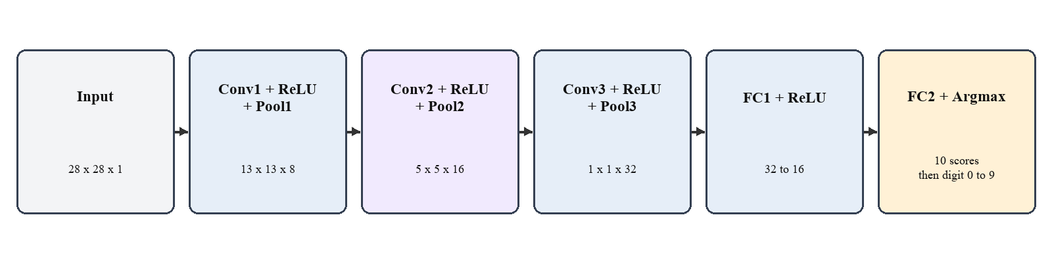

3.2 Convolution Mathematics
Let X(y, x, c) be the input activation at row y, column x, and channel c. Let W(r, s, c, o) denote the kernel value at kernel row r and column s, input channel c, and output channel o. A valid convolution produces an accumulated output Z at each output position and channel:
Z(y,x,o) = b(o) + sum[c=0..Cin-1] sum[r=0..2] sum[s=0..2] X(y+r,x+s,c) W(r,s,c,o)
The output operation applies ReLU and, for the next quantized layer, requantization and range limiting. The bias is added to the dot product. In the RTL, the accumulator is initialized with the bias for the first product of an output and then updated with each subsequent product. Correct signedness and the exact point at which the bias is added are important for matching the Python reference.
The number of products per output is nine for Conv1, 72 for Conv2, and 144 for Conv3. The convolution product counts per image are therefore 48,672, 139,392, and 41,472, respectively. FC1 adds 512 products and FC2 adds 160. The complete network requires 230,208 multiply-accumulate products per image, excluding bias additions and control work. These are operation counts derived from the network dimensions; they are not measured FPGA clock cycles.
The convolution weights are shared across all spatial positions for an output channel. The model contains 72 Conv1 weights, 1,152 Conv2 weights, 4,608 Conv3 weights, 512 FC1 weights, and 160 FC2 weights, for 6,504 trained coefficients. The five parameterized layers have 8, 16, 32, 16, and 10 biases, respectively, for 82 biases.

3.2.1 Convolution Window and MAC Sequence
Every convolution output depends on a local 3 by 3 region for each input channel. Figure 3.2 shows the single-channel case. The hardware selects one input activation and the matching coefficient at a time, forms a product, adds it to the running sum, and repeats for the remaining kernel and channel coordinates. Once the dot product is complete, it adds the bias according to the implemented accumulation convention, rescales the result, applies the activation clamp, and stores the output feature value.
The input buffer is necessary because the image is loaded before convolution begins. Unlike a line-buffered streaming design, the current core reads the image from stored addresses. Later layers select values from the previous layer's feature arrays. Address generation therefore includes the feature-map channel offset and the row and column coordinates of the current output and kernel tap.
Figure 3.2 Conceptual convolution window and multiply-accumulate operation.
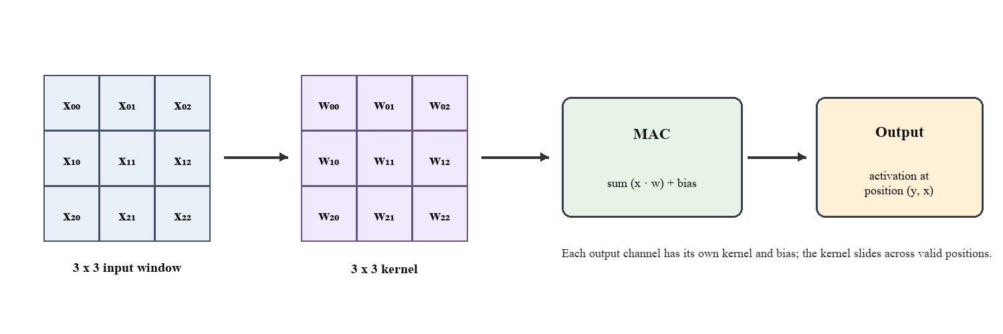

3.3 Activation and Pooling
The rectified linear unit is ReLU(z) = max(0, z). Since each hidden convolutional and FC1 output is non-negative after ReLU, the activation can be stored as an unsigned code. The RTL implementation checks the signed requantized value, maps negative values to zero, and clamps positive values to the allowed code range. The activation module must not interpret a negative signed accumulator as a large unsigned number.
For channel c, 2 by 2 max-pooling computes the largest of the four values in the corresponding window:
P(y,x,c) = max{A(2y,2x,c), A(2y,2x+1,c), A(2y+1,2x,c), A(2y+1,2x+1,c)}
Pooling introduces no learned parameters. It selects an existing activation and therefore does not require a new scale when all four values use the same code format. The final two pooling stages operate on odd spatial widths: 11 to 5 and 3 to 1. The implementation drops the unmatched final row or column according to floor pooling. This behavior must remain consistent between PyTorch, the integer reference, and RTL address generation.

3.4 Fully Connected Layers and Classification
After Pool3, the feature tensor has shape 1 by 1 by 32 and can be viewed as a vector v of 32 values. FC1 computes 16 dot products and applies ReLU. FC2 computes ten class scores. For output unit j in FC1 and class k in FC2, the mathematical operations are:
h(j) = ReLU(b1(j) + sum[i=0..31] v(i) W1(i,j)), j = 0..15
score(k) = b2(k) + sum[j=0..15] h(j) W2(j,k), k = 0..9
The predicted digit is the index with the highest score:
predicted_class = argmax[k in 0..9] score(k)
Softmax is not required for top-1 classification because it preserves the ordering of the scores. Keeping the ten FC2 values in INT32 until argmax avoids an unnecessary final quantization step. The output class is represented by four bits, which is sufficient for ten possible values.

3.5 Integer Number Formats and Requantization
For a tensor with scale s, a real value x is represented approximately by integer code q such that x ≈ q × s. The code is produced by rounding x / s and clipping it to the supported range. Weight scales are chosen for each trained layer. Activation scales are calibrated from training examples and are independent for INT8 and INT16. The integer bias is scaled consistently with the input activation scale multiplied by the layer weight scale.
Table 3.2 summarizes the two arithmetic paths. Both use 32-bit signed accumulators and 24-bit unsigned encodings of positive Q31 requantization multipliers. The 24-bit storage width is the RTL interface width used by this project; Q31 describes the fixed-point scaling convention, not a 24-bit integer accumulator.
Table 3.2: Arithmetic formats used by the two implementations
Quantity | INT8 configuration | INT16 configuration
Weights | Signed 8-bit; exporter clips to -127 through 127 | Signed 16-bit; exporter clips magnitude to 32,767
Hidden activations | Unsigned 8-bit codes from 0 to 255 | Unsigned 16-bit codes with per-layer caps
Input pixel | Raw grayscale byte, 0 to 255 | Board wrapper maps byte to calibrated code, 0 to 3,640
Bias and accumulation | Signed INT32 | Signed INT32
Requantization parameter | 24-bit Q31 multiplier | 24-bit Q31 multiplier
Rounding | Round to nearest, ties to even | Round to nearest, ties to even
FC2 output | Signed INT32 class scores | Signed INT32 class scores
Calibration | First 1,000 training images | First 1,000 training images plus accumulator-headroom limits

The requantization multiplier approximates the ratio between the input and output scales and is applied after accumulation. If M is the positive Q31 multiplier, the conversion is conceptually an integer product followed by a right shift of 31 bits with the project's nearest-even rounding rule. ReLU and saturation then enforce the non-negative activation range. Negative accumulators require careful rounding; simply truncating toward zero or toward negative infinity would not necessarily match round-to-nearest-even.

3.5.1 INT8 Path
The INT8 exporter quantizes weights symmetrically into the signed 8-bit range used by the RTL. Activations after ReLU use unsigned 8-bit codes. Input image bytes already occupy the expected 0 to 255 input domain. A set of 1,000 training images is passed through the FP32 network to determine calibration maxima for the hidden activations. The exporter converts each layer's weights and biases, computes the requantization multiplier, writes the memory files and metadata, and evaluates an integer-only Python reference over the full test set.
The INT8 core declares 8-bit feature arrays for hidden activations and signed 8-bit parameter arrays. It uses a signed 32-bit accumulator for the products and bias. The code range is compact, but the largest accumulator term is not necessarily small because convolution sums many products. The exporter performs accumulator-range checks; correctness still depends on the RTL using matching expression widths and signed extensions.

3.5.2 INT16 Path
The INT16 exporter derives a separate set of signed 16-bit weights, biases, and activation scales from the same FP32 checkpoint. Its activation codes use 16-bit storage. To protect the 32-bit signed accumulator, the exporter applies conservative layer caps: the input code range ends at 3,640, followed by maximum activation codes of 455, 227, 1,023, and 2,047 for Conv1, Conv2, Conv3, and FC1. These are quantization limits for the current reference and RTL, not claims that the full 16-bit range is used at every layer.
The board wrapper receives a grayscale byte and maps it to the calibrated INT16 input code with an integer scaling operation. The standalone INT16 core instead accepts a 16-bit pixel code. The Python reference and hardware wrapper must use the same rounding convention for this conversion. The larger operand width may affect DSP or LUT mapping, but only Vivado synthesis and implementation can establish the resulting resource cost and timing.

3.5.3 Accumulator Range and Fair Comparison
An accumulator width must be selected for the largest possible sum, including bias. A conservative bound for a dot product is the number of terms multiplied by the maximum activation magnitude and maximum weight magnitude, plus the maximum bias magnitude. The INT16 activation caps are intended to keep this bound inside signed INT32. The exporter records observed maxima and checks the declared range. Observed values are useful evidence for the evaluation set; a worst-case bound is stronger because it does not depend on the sampled images.
For a fair precision comparison, both paths must use the same architecture, checkpoint, test image order, and metric definitions. They may use different scales because the representable ranges differ, but the calibration data and procedure must be recorded. The final comparison should report both full-test classification accuracy and bit-exact RTL-to-reference agreement. It should then report resource and timing measures from the same target part and equivalent clock constraints.

3.6 Top-Level Hardware Organization
The RTL has two standalone inference cores, cnn_int8_top and cnn_int16_top, and board wrappers for both the Nexys 4 DDR and ZC702. The core receives a clock, active-low reset, pixel-valid input, pixel data, and returns ready, result-valid, and a four-bit class. It accepts 784 pixels into an input buffer. When the final pixel is stored, the finite-state machine (FSM) executes Conv1, Pool1, Conv2, Pool2, Conv3, Pool3, FC1, FC2, and argmax in order.
The top-level controller selects the active layer's operands. One physical MAC module multiplies the selected activation and signed weight. A signed INT32 accumulator carries the partial sum. The requantizer applies the layer multiplier, ReLU enforces non-negativity, and the current layer's output is written to an array. Pooling reads four values from the raw convolution array and stores their maximum in the pooled array. The argmax step compares the ten final scores and records the winning index.
Figure 3.3 shows how the common floating-point checkpoint branches to two separately calibrated integer exports. Figure 3.4 shows the actual buffered execution model and board-level path. The two configurations are separate builds: the board wrapper instantiates only the selected precision core.
Figure 3.3 Shared FP32 checkpoint and precision-specific quantization paths.
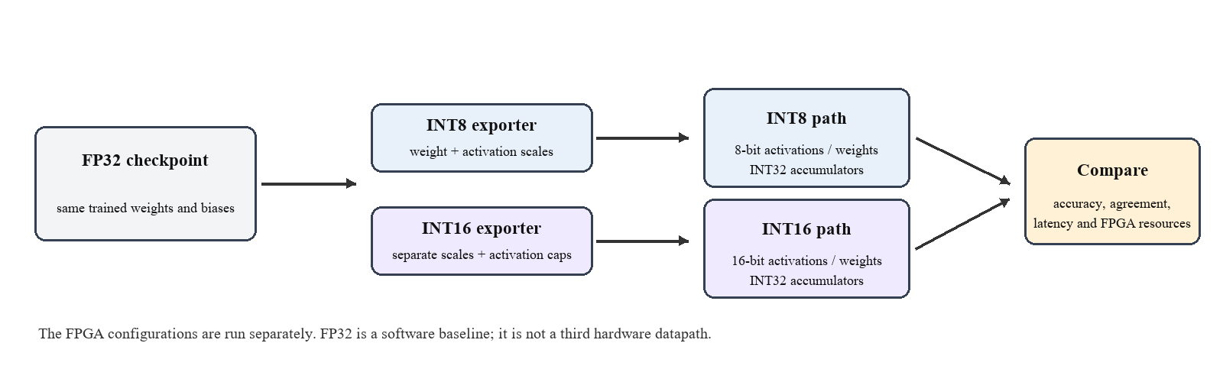
Table 3.3: Main RTL modules and responsibilities
Module group | Representative modules | Main responsibility
Precision-specific core | cnn_int8_top, cnn_int16_top | FSM, feature arrays, counters, parameter loading, layer sequencing
Input storage | input_buffer_int8, input_buffer_int16 | Store image pixel codes and provide addressed reads
Arithmetic | mac_unit_int8, mac_unit_int16 | Multiply one selected activation and weight
Scale conversion | requantizer_int8, requantizer_int16 | Q31 multiply, shift, and rounding
Activation | relu_int8, relu_int16 | Signed check, ReLU, and activation-range clamp
Pooling | maxpool2x2_int8, maxpool2x2_int16 | Select maximum of a 2 x 2 window
Classification | argmax_step_int8, argmax_step_int16 | Track the best score and class index
Board support and wrapper | uart_rx, uart_tx, reset_sync | Clock Wizard, UART, reset, inference core, and status LEDs

Figure 3.4 Buffered RTL core and board-level input/output organization.
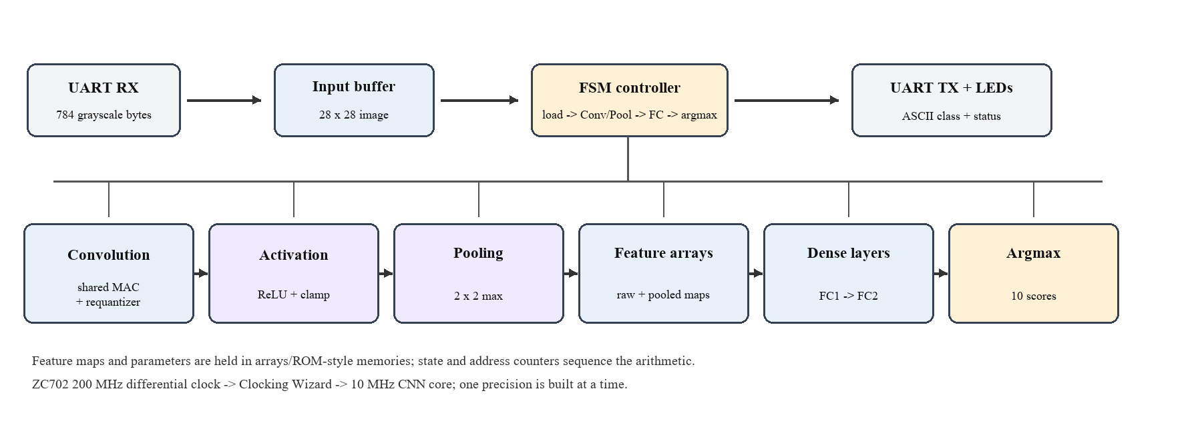

3.7 Input Interface and Board Operation
The core-level interface accepts pixel values using ready and valid signals. Earlier UART wrappers serialized host bytes into this interface and returned the class as an ASCII digit. The current ZC702 image-demo wrapper uses an internal ROM instead: after reset is released, it streams 784 stored pixels to the selected core, waits for result-valid, and holds the class and completion bits on the LEDs. J17 is not part of this PL data path.
The ZC702 board provides a 200 MHz differential LVDS oscillator on pins D18/C19. The current board wrapper instantiates an RTL MMCM clock generator to produce the 10 MHz CNN clock. The XDC constrains the positive input to 5 ns and assigns the reset and LED ports using LVCMOS25. Vivado must recognize the MMCM-generated clock for meaningful timing analysis.
In the ROM demo, led[3:0] carries the class and led[5] indicates completion; class 8 should therefore set led[3] and led[5]. These map to DS22 and DS17, respectively. The board configuration DONE indicator DS3 is separate. The bitstream programmed before the reset correction did not complete inference; the corrected RTL/XDC source requires a fresh build and board verification.

3.8 Feature Storage, Parameters, and Memory Organization
The core stores intermediate convolution outputs and pooled activations in arrays sized for the tensor dimensions. The INT8 arrays use 8-bit codes; the corresponding INT16 arrays use 16-bit codes. The class scores remain signed 32-bit values. Parameter memories hold the flattened convolution and dense weights, layer biases, and per-layer requantization multipliers. Each precision has its own directory under weights so that a core cannot accidentally load another precision's codes.
The network has 6,504 weights and 82 biases. The actual memory organization is a set of initialization files loaded by $readmemh in the top modules. Their current paths are absolute Windows paths tied to this workspace. This is convenient for the local simulation but is not portable. A reproducible Vivado or simulation package should use relative paths or project-managed memory files and should verify that every expected file is present at elaboration and synthesis time.
The selected architecture uses arrays and a controller rather than an inter-layer streaming FIFO pipeline. Memory inference is not assumed: synthesis may map arrays into distributed RAM, block RAM, registers, or a mixture according to access patterns and the Vivado flow. The utilization report is required to determine the actual mapping.

3.9 Serial Operation Count and Expected Latency
The 230,208 multiply-accumulate products per image provide a useful first-order bound on the serialized computation. If one product is completed per core clock and there is no overlap, the arithmetic work alone requires at least 230,208 clock cycles. At a 10 MHz core clock, this lower bound corresponds to approximately 23.0 ms. The actual FSM also spends cycles writing results, pooling, changing states, and performing argmax, so measured RTL latency will be greater than or equal to this estimate. The estimate is not a Vivado timing result or a measured board latency.
For the earlier UART input path, an image of 784 bytes framed as 8-N-1 at 115,200 baud requires approximately 784 x 10 / 115,200 = 68.1 ms, before host gaps. This transfer estimate does not apply to the current ROM demo, which has no host image-transfer time.
Latency is the time from a defined input event to result-valid. For the ROM demo, this begins when the first pixel is accepted; the user-facing board result is then held on LEDs. Throughput requires repeated images and a defined reload protocol. Measure both with a cycle counter or timestamp and state the clock frequency; simulator wall-clock duration is not FPGA latency.

3.10 Parameter and Test-Vector Delivery
The Python model is defined in python/cnn3_model.py, training is performed by python/train_cnn3.py, and the precision exporters are python/export_int8.py and python/export_int16.py. The FP32 checkpoint is python/mnist_cnn3_fp32.pth. Weight, bias, multiplier, and metadata files are stored below weights/int8 and weights/int16. Testbenches and their memory data are under tb.
The test-vector directory contains 100-image pixel memories, label memories, and precision-specific expected-prediction memories. The archived integrated-top logs show that both INT8 and INT16 processed all 100 vectors and matched the corresponding Python predictions. Separate later modular smoke-test logs and the one-image board ROM demo are different verification artifacts; neither replaces the archived 100-image result reported in Section 4.5.

CHAPTER 4

EXPERIMENTAL STUDY AND RESULTS

4.1 Implementation Environment
The software path uses Python, PyTorch, NumPy-based parameter export, and stored MNIST files. The hardware description is Verilog HDL. The project includes separate INT8 and INT16 ZC702 configurations targeting xc7z020clg484-1. The board image-demo tops use the ZC702-specific constraints, a 200 MHz differential input, and an RTL MMCM-generated 10 MHz CNN clock. The archived 100-image RTL logs refer to the earlier integrated simulation tops.
The active ZC702 image-demo flow uses xc7z020clg484-1, a differential 200 MHz board clock, an MMCM-derived 10 MHz CNN clock, a fixed-image ROM top, and zc702_image_demo.xdc. Vivado reported startup status HIGH after programming zc702_int8_image_top.bit, confirming configuration. Inspection then found that SW5 at G19 is active-high while the original image top treated it as active-low reset. The INT8 and INT16 image tops and XDC have since been corrected in source; the corrected source has not yet been synthesized, implemented, or programmed. J17 connects to the Zynq processing-system UART, so the PL-only ROM demo reports through LEDs, not J17.
Table 4.1: Software and hardware environment
Item | Project configuration or evidence
Software model | PyTorch MNISTCNN3, one FP32 checkpoint
Integer references | Separate INT8 and INT16 exporters and bit-oriented inference
RTL language | Verilog HDL
FPGA tool | Vivado project files included; user screenshot shows Vivado 2026.1
Target device | Zynq-7000 XC7Z020-1CLG484C; ZC702 evaluation board
Board clock | 200 MHz differential LVDS oscillator; wrapper requests a 10 MHz Clocking Wizard output
Board interface | Current image-demo: fixed image from ROM, active-high SW5 reset, six PL LEDs; J17 PS UART is not used
Current implementation status | 100-image RTL agreement recorded for archived integrated INT8/INT16 runs; ZC702 image-demo bitstream configuration confirmed; reset-polarity correction made in source and awaits a fresh Vivado run and board rerun.

4.2 RTL Module Organization
The two precision cores contain the same layer sequence but use different parameter and activation widths. Each core uses an FSM and address counters to traverse the 784 input values, convolution positions and channels, pooling operations, dense layers, and argmax. The current ZC702 image-demo board wrapper supplies pixels from a fixed ROM rather than from UART. The UART receiver/transmitter wrappers remain a separate earlier input/output path.
Reusable modules provide precision-specific input buffers, MAC units, Q31 requantizers, ReLU/range clamps, 2 by 2 max-pool units, and argmax steps. Common board support includes UART receiver/transmitter modules for the earlier UART path and a reset synchronizer. The current ZC702 image-demo wrapper instead streams a fixed ROM image into the selected core and drives class/completion LEDs. J17 is connected to the Zynq processing-system UART and is not a serial output from this PL-only demo.
The module boundaries should not be confused with a complete verified data path. The existence of a module file does not by itself demonstrate that the project includes it in the active source set, that synthesis maps its memories as intended, or that the board wrapper is selected. These are checked from the Vivado source hierarchy and the generated reports.

4.3 Software Parameter Generation and Training
The FP32 model is trained with the MNIST training split using a fixed random seed of 42, ten epochs, batch size 128, Adam with learning rate 0.001, and cross-entropy loss. The model has 6,586 learned scalars: 6,504 weights and 82 biases. The training script writes an FP32 checkpoint and an epoch-by-epoch history. The best checkpoint in the stored run reaches 97.52% on the 10,000-example test set at epoch ten.
The checkpoint selection protocol has a limitation. The script evaluates the test set after each epoch and saves the checkpoint with the best test accuracy. Because the same test labels influence checkpoint selection, the final 97.52% should be described as the recorded test-set result rather than as a pristine one-time estimate. To improve the experimental method, reserve a validation set from the training data, select the checkpoint on validation accuracy, and use the official test split once for the final report.
The INT8 and INT16 exporters both reload the saved FP32 checkpoint. They do not train separate neural networks. Each exporter calibrates its activation ranges on the first 1,000 training images, quantizes the layer weights and biases, computes the Q31 requantization values, writes memory initialization files and metadata, generates 100 test vectors, and evaluates its integer Python reference on the full test set. The INT16 path additionally applies activation-code caps intended to preserve INT32 accumulator headroom.
Table 4.2: Training configuration
Setting | Recorded value
Dataset | MNIST training split; 60,000 examples
Seed | 42
Epochs | 10
Batch size | 128
Optimizer | Adam
Learning rate | 0.001
Loss | Cross-entropy
Saved checkpoint | python/mnist_cnn3_fp32.pth
Checkpoint selection | Highest test accuracy during the ten-epoch run; test-set leakage noted

4.4 Verification Strategy
The software evaluation has a full-set scope. The FP32 and integer references predict all 10,000 official test images and compare their outputs to the ground-truth labels. The RTL testbenches load the generated pixel memories and expected Python predictions, apply reset, drive image pixels, wait for result-valid, and compare the RTL class with the expected class and label.
Figure 4.1 summarizes the comparison flow. A robust extension should also capture intermediate convolution values and compare them layer by layer. That makes it easier to localize a problem to an input scale, convolution address, bias, requantizer, pooling window, or dense layer. The current logs establish only final-output agreement for the image counts they actually processed.
The retained logs rtl_sim_int8_100_pre_module_refactor.log and rtl_sim_int16_100_pre_module_refactor.log show progress through 100 images and end with PASS: all 100 predictions match the Python reference. The tested revision is the earlier integrated top, before modular refactoring. Therefore, the result establishes 100-image agreement for those logged revisions; it does not establish 100-image agreement for every later source revision or prove physical-board accuracy.
Figure 4.1 Software and RTL verification flow; the archived 100-image RTL agreement is reported by source revision.
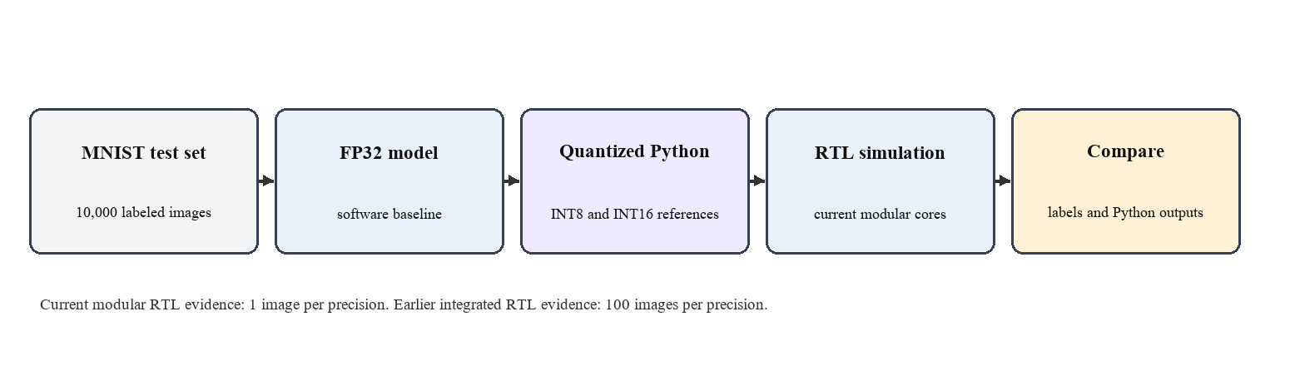

4.5 Classification Accuracy and RTL Agreement
Table 4.3 reports software classification accuracy on the full 10,000-image test set. FP32 obtains 9,752 correct classifications. The INT8 reference obtains 9,757, and INT16 obtains 9,754. The integer results differ from FP32 by +0.05 and +0.02 percentage points, respectively. Such small differences are plausible because quantization can change scores near a decision boundary; they do not show that integer arithmetic improves the learned model. The appropriate conclusion is that the recorded quantized references remain close to the FP32 baseline for this run.
Table 4.3: Full-test-set software classification results
Inference path | Correct | Total | Accuracy
FP32 PyTorch | 9,752 | 10,000 | 97.52%
INT8 Python reference | 9,757 | 10,000 | 97.57%
INT16 Python reference | 9,754 | 10,000 | 97.54%

Figure 4.2 visualizes the same software numbers. The vertical axis begins at 95% so that the small differences can be seen. The chart is not a hardware result and should not be read as FPGA accuracy.
Figure 4.2 Recorded full-test-set software accuracy; this is not FPGA accuracy.
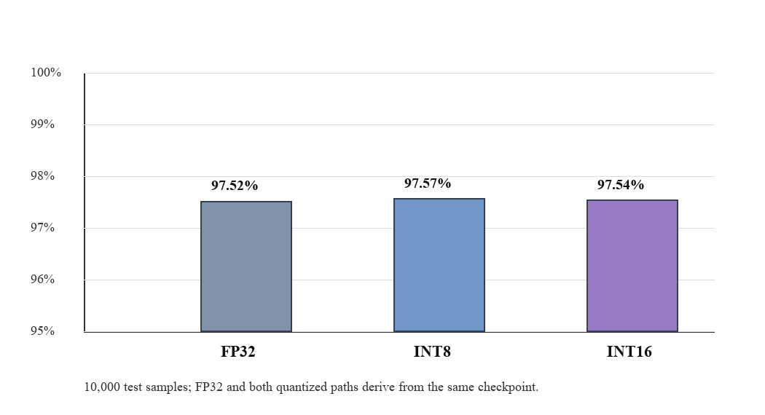
Table 4.4: RTL-to-Python agreement by source revision
Source revision | INT8 agreement | INT16 agreement | Scope
Earlier integrated top | 100 / 100 matches | 100 / 100 matches | Archived pre-module-refactor RTL simulation; agreement with precision-specific Python reference, not label accuracy
Current modular top | Not used for this result | Not used for this result | Later one-image smoke tests are separate and excluded from 100-image results
Current board inference | Not verified | Not verified | Image-demo bitstream configured; pre-fix reset polarity prevented completed inference

The 100-image RTL runs produced 100/100 INT8 matches and 100/100 INT16 matches against their respective Python integer references. The two runs each logged completion at 233,569,055 ps of simulation time; this simulator timestamp is not FPGA wall-clock latency. Agreement means the RTL returned the same class as its integer reference for each vector. It does not mean every prediction matched the MNIST ground-truth label. Full-label classification accuracy is reported separately from the 10,000-image software evaluation.

4.6 FPGA Resource Utilization
The available Vivado screenshots document an earlier INT8 implementation attempt, not the corrected ZC702 image-demo build. The legacy summary showed synthesis complete with 11,293 LUTs, 225 flip-flops, and zero BRAM. Its implementation row showed 11,364 LUTs, 233 flip-flops, and zero BRAM, but bitstream writing failed. The associated timing screenshot reported WNS = -50.001 ns, TNS = -235,992.797 ns, and 10,773 failing endpoints. These historical results came from a run with a top-level/constraint mismatch and cannot be used as final ZC702 utilization or timing metrics.
A later ZC702 INT8 image-demo bitstream was programmed successfully, with Vivado reporting startup status HIGH. That bitstream had the reset-polarity defect described in Section 4.11, so successful configuration did not demonstrate completed inference. The reset correction is in the source files, but no synthesis or implementation report for that corrected source is yet available. No INT16 paired utilization report is available.
Table 4.5: FPGA implementation evidence and status
Metric or stage | INT8 | INT16 | Interpretation
Legacy INT8 synthesis screenshot | 11,293 LUT, 225 FF, 0 BRAM shown in old run | Historical core-level run; not the corrected ZC702 image-demo top | Preliminary summary only; DSP detail not confirmed
Implementation / bitstream | Legacy run failed write_bitstream; later image-demo bitstream loaded with startup HIGH before reset fix | Reset-corrected image-demo requires new implementation and bitstream | Do not treat legacy resource counts as final board results
Timing | Legacy screenshot: WNS -50.001 ns, TNS -235,992.797 ns; 10,773 failing endpoints | No post-fix timing report | Legacy failed timing; not a current ZC702 result
Pin constraints | Legacy screenshot showed core-level ports without pins | Image-demo XDC added; corrected reset port requires rebuild | Historical issue is separate from current board wrapper configuration
LUT, FF, BRAM, DSP comparison | No complete report for confirmed board wrapper | Not measured | Do not use as final resource comparison
Board power and accuracy | Single-image physical result not verified | The prior 100-image values are RTL-to-Python agreement, not board accuracy | Requires programmed board and documented procedure

4.7 Static Timing Analysis
The ZC702 constraint file sets a 5 ns period on SYSCLK_P, corresponding to the board's 200 MHz differential oscillator. The wrapper's Clocking Wizard is configured for an intended 10 MHz core output. For valid timing analysis, Vivado must recognize the generated clock and apply the appropriate timing relationship to the core. A primary clock constraint on SYSCLK_P does not, by itself, prove that the generated output clock is present or correctly constrained.
The user-shared implementation screenshot reports a worst negative slack of approximately −50.001 ns and a total negative slack of approximately −235,992.8 ns, with many failing endpoints. The exact run should be re-opened in Vivado and its timing summary, clock interaction, generated clocks, and failing paths reviewed. Because the open GUI also showed core-level ports without pin assignments, the screenshot may represent an implementation attempt with the wrong active top or stale run data. In either case, the displayed implementation did not meet timing and cannot support a maximum-frequency claim.
Maximum operating frequency must be derived from a successful implementation and a clearly identified clock domain. For a constrained clock, the achieved period is related to the clock period and worst setup slack, but a negative slack means the requested period was missed. It is not valid to label the inverse of a user-entered constraint as the circuit's measured maximum frequency. The final report should state Vivado version, exact top, part, constraint set, generated clock frequency, WNS, TNS, and the run status.

4.8 Estimated Power
There is no verified current Vivado power report for the INT8 or INT16 board design in the project's reports directory. No on-board current measurement is recorded.
After implementation, Vivado power analysis can provide an estimate based on the mapped netlist, device, clocking, and assumed switching activity. A representative simulation activity file or board measurement is needed to strengthen the estimate. Report assumptions such as voltage, junction temperature, and toggle rate; do not describe a low-confidence software estimate as measured FPGA power.

4.9 Latency and Throughput Interpretation
No current board latency or throughput measurement is available. A theoretical operation count gives an initial scale: 230,208 products are required per image. At one product per cycle on the intended 10 MHz core clock, the arithmetic-only lower bound is approximately 23.0 ms. The controller and pooling add cycles, so this lower bound is not a measured inference time.
The previous UART wrapper transfers 784 bytes at 115,200 baud using 8-N-1 framing, giving an ideal input-transfer estimate of about 68.1 ms before host gaps. This term is excluded from latency for the current ROM demo. Any end-to-end result must define whether image loading, inference, and output display are included.
Latency values from a design with different arithmetic precision, parallelism, clocking, and input protocol cannot be transferred to this core. The current project should measure core latency in cycles and separately report end-to-end latency including UART. For repeated images, throughput should be measured over enough transactions to include reload and output handshakes.

4.10 Discussion of Results
The software evidence shows that both quantized references preserve accuracy close to the common FP32 baseline on the full recorded test split. The same checkpoint and network topology make this a useful numerical comparison. However, the test split participated in checkpoint selection, so a new validation-based training procedure would improve the study's experimental independence.
The RTL is architecturally resource-shared: each precision core uses one MAC over many operations. Its theoretical compute time is consequently much larger than a parallel convolution pipeline, while the smaller multiplier count may reduce arithmetic resource demand. Whether it does so on the ZC702 programmable logic must be established by a valid utilization report. The existing Vivado screenshot indicates a failed legacy INT8 implementation; it does not demonstrate that the ZC702 board design works or that 10 MHz is achieved.
The project has completed software accuracy evaluation and has archived 100-image RTL agreement for each precision on the earlier integrated-top revision. The current ZC702 board path has also reached FPGA configuration, but the image-demo reset polarity was wrong in the programmed source. The reset correction is now in the RTL and XDC; a fresh Vivado run and on-board rerun remain necessary. Resource, timing, power, and physical inference metrics must be reported only after those runs succeed.

4.11 Implementation Limitations and Reproducibility Notes
- The training script evaluates the test split each epoch and selects the best checkpoint from it; a held-out validation set is needed for an unbiased final test evaluation.
- The archived pre-module-refactor integrated RTL logs process 100 images for each precision and report 100/100 matches to the matching Python integer reference.
- The 100-image agreement figure is RTL-to-reference agreement for the logged integrated-top revision; it is not label accuracy and is not a physical-board measurement.
- The INT8 image-demo bitstream was programmed and reported startup status HIGH. Its reset input was incorrectly treated as active-low; the source and XDC have been corrected for active-high SW5, but the corrected design still needs a fresh synthesis, implementation, bitstream, and board test.
- The project source uses absolute Windows paths in `$readmemh`; convert them to project-relative paths for portability and verify memory-file loading in both simulation and synthesis.
- No verified post-fix paired utilization, timing, power, physical inference latency, throughput, or board-level accuracy comparison is available.
- Record the Git commit, Python and PyTorch versions, checkpoint hash, exporter command, Vivado version, part, top module, XDC files, clock settings, testbench revision, simulation logs, and implementation run directory with each final result.

CHAPTER 5

CONCLUSIONS AND FUTURE SCOPE OF STUDY

5.1 Conclusion
This report documents an MNIST accelerator project that compares INT8 and INT16 inference from one trained three-convolution FP32 model. The CNN contains convolution outputs of 8, 16, and 32 channels, three ReLU and max-pooling stages, and fully connected layers of 32-to-16 and 16-to-10 units. The software flow trains the FP32 checkpoint, exports each integer configuration separately, and evaluates both references on the complete 10,000-image test set.
Software classification accuracy is 97.52% FP32, 97.57% INT8, and 97.54% INT16 on 10,000 test images. Archived 100-image RTL runs show 100/100 INT8 and 100/100 INT16 agreement with their respective Python integer references. The RTL uses a buffered FSM-controlled serialized inference flow with a reused MAC, INT32 accumulators, requantization, activation clamps, pooling, and argmax. The later one-image LED demo is a separate board path and is excluded from the 100-image result.
The ZC702 image-demo bitstream was successfully loaded, but the first programmed version held the design in reset because of a reset-polarity mismatch. The RTL and XDC reset fix is now present in source; the corrected design has not yet been rebuilt and retested on the board. No paired post-fix Vivado resource, timing, or power results, nor physical board accuracy or latency, are claimed.

5.2 Limitations
The training run reused test accuracy for checkpoint selection, limiting the independence of its reported test estimate. The 100-image RTL evidence is archived for the prior integrated-top revision; it does not automatically establish correctness of subsequent RTL revisions. Board inference requires rebuilding and programming the reset-corrected top. FPGA utilization, timing, power, latency, throughput, and multi-image physical accuracy remain to be measured.
The present design also uses absolute paths for parameter memory initialization and has not demonstrated a portable project setup. The approximate latency analysis is derived from operation count and UART configuration, not from a cycle counter. Power and resource comparisons remain unmeasured. These limitations define the scope of any conclusion: the report compares software accuracy and documents RTL construction, but it does not claim a successful INT8-versus-INT16 FPGA performance result.

5.3 Future Work
1. Rebuild the reset-corrected ZC702 INT8 and INT16 image-demo tops and verify the fixed-image result on the board.
2. Add a batch-image interface and result counter, or a Zynq software path, to measure physical classification accuracy over labeled examples.
3. Run both precision builds with the same device and clock constraints; archive utilization, timing, power, DRC, and implementation reports.
4. Measure core cycle latency and end-to-end transfer latency separately; report the measurement method and clock rate.
5. Retrain with a training/validation/test split, select using validation accuracy, and evaluate the held-out test set once.

5.4 Closing Remarks
The project has a common CNN model, a reproducible integer-export concept, and separate Verilog paths for two activation and weight widths. Those artifacts make a controlled precision comparison possible. The next work should focus on verification scope and correct Vivado integration before any claims about FPGA speed, resource savings, or physical inference are made. Once those steps are complete, the project can answer its central research question: how the INT8 and INT16 choices trade classification accuracy against measured implementation cost on the same FPGA.

References
[1] Y. LeCun, C. Cortes, and C. J. C. Burges, “The MNIST database of handwritten digits,” 1998. Available: http://yann.lecun.com/exdb/mnist/.
[2] Y. LeCun, L. Bottou, Y. Bengio, and P. Haffner, “Gradient-based learning applied to document recognition,” Proceedings of the IEEE, vol. 86, no. 11, pp. 2278–2324, 1998, doi: 10.1109/5.726791.
[3] I. Goodfellow, Y. Bengio, and A. Courville, Deep Learning. Cambridge, MA: MIT Press, 2016.
[4] B. Jacob et al., “Quantization and training of neural networks for efficient integer-arithmetic-only inference,” in Proceedings of the IEEE Conference on Computer Vision and Pattern Recognition, 2018, pp. 2704–2713, doi: 10.1109/CVPR.2018.00286.
[5] V. Sze, Y.-H. Chen, T.-J. Yang, and J. S. Emer, “Efficient processing of deep neural networks: A tutorial and survey,” Proceedings of the IEEE, vol. 105, no. 12, pp. 2295–2329, 2017, doi: 10.1109/JPROC.2017.2761740.
[6] D. P. Kingma and J. Ba, “Adam: A method for stochastic optimization,” in International Conference on Learning Representations, 2015. Available: https://arxiv.org/abs/1412.6980.
[7] PyTorch, “Adam,” PyTorch documentation. Available: https://docs.pytorch.org/docs/stable/generated/torch.optim.Adam.html.
[8] AMD, Vivado Design Suite User Guide: Synthesis (UG901), AMD documentation. Consult the edition that matches the installed Vivado release.
[9] AMD/Xilinx, *ZC702 Evaluation Board for the Zynq-7000 XC7Z020 SoC User Guide*, UG850, v1.7, 2019.
[10] LS-47, “mnist_cnn_accelerator,” project source repository. Available: https://github.com/LS-47/mnist_cnn_accelerator.

Appendix A: Project Structure and Reproducibility

A.1 Important Project Files
The project folder separates software, hardware, generated parameter data, simulation material, and Vivado projects. Table A.1 provides a guide to the main locations and identifies the current working files used for this report.
Table A.1: Project structure and important files
Project-relative path | Purpose
python/cnn3_model.py | Shared three-convolution PyTorch model
python/train_cnn3.py | FP32 training script and checkpoint generation
python/mnist_cnn3_fp32.pth | Stored FP32 checkpoint used by both exporters
python/export_int8.py, export_int16.py | Precision-specific quantization and Python references
weights/int8, weights/int16 | Flattened integer weights, biases, multipliers, and metadata
rtl/int8, rtl/int16 | Precision-specific cores and arithmetic helper modules
rtl/common | Shared UART and reset synchronizer modules
rtl/board | Nexys 4 DDR and ZC702 top-level wrappers for both precision paths
tb/tb_cnn_int8.v, tb/tb_cnn_int16.v | RTL simulation testbenches
tb/data | Test pixel, expected-class, and label memories
constraints | Clock, Nexys 4 DDR, and ZC702 pin constraints
vivado/int8, vivado/int16 | Separate Vivado project files
reports | Training, software accuracy, and RTL simulation summaries

A.2 Software Reproduction
The software exporters expect the local MNIST files and the stored FP32 checkpoint. From the project root, run the training script only when a new checkpoint is intended; then run each exporter independently. Preserve the checkpoint and generated metadata because changing the checkpoint changes every integer parameter and expected prediction. The exported result table should be regenerated from the same checkpoint for both precisions.
The training script uses a fixed seed, but reproducibility can still depend on library versions and execution settings. Record Python, PyTorch, torchvision, and NumPy versions with the final run. The training script's use of test accuracy for checkpoint selection should be corrected before a final research-grade evaluation.

A.3 RTL and Vivado Reproduction
For each precision, open the ZC702 project and confirm the image-demo synthesis top and zc702_image_demo.xdc. The board wrapper uses an RTL MMCM clock generator to derive 10 MHz from the 200 MHz differential input; no Clocking Wizard output products are required for this top. Check the generated clock in timing analysis and confirm package-pin assignments for every physical top-level port.
The archived 100-image simulation logs provide the reported RTL agreement result. For the current board demo, rerun synthesis, implementation, and bitstream generation after the reset-polarity source correction. Record the part, top, constraints, run status, WNS/TNS, LUT, flip-flop, BRAM, DSP, and bitstream path for each precision. Repeat under equivalent conditions before making a hardware resource comparison.

A.4 Reproducibility Checklist
- Record the project Git commit and local modifications.
- Record the FP32 checkpoint filename, hash, training configuration, and selected epoch.
- Preserve the INT8 and INT16 calibration metadata and generated memory files.
- Record testbench array dimensions, number of images actually processed, and source revision.
- Confirm the XPR top module and active XDC for the board wrapper, not only the standalone core.
- Save Vivado logs and reports for the exact run; distinguish a completed synthesis from failed implementation.
- Keep software accuracy, RTL agreement, and board classification accuracy in separate result fields.

Appendix B: Board Interface and Metric Definitions

B.1 Board-Level Signal Summary
The current ZC702 image-demo wrapper is a fixed-image ROM demonstration. It accepts the differential oscillator and active-high SW5 reset input and drives six PL LEDs with class and completion bits. It does not receive images from J17 or send predictions over the onboard USB-UART, which is connected to the Zynq processing system. The earlier UART wrapper is a separate interface path.
Table B.1: Board-wrapper interface summary
Signal | Direction | Description
SYSCLK_P/N | Inputs | ZC702 200 MHz differential oscillator
reset_btn | Input | Active-high SW5; released low for inference
ROM pixel stream | Internal | 784 preloaded image pixels; no external UART input in image demo
J17 USB-UART | Not used | J17 is PS UART; current PL image demo does not transmit prediction there
led[5:0] | Output | Class bits plus completion; class 8 expected on led[3], completion on led[5]

At core level, the INT8 core receives an 8-bit pixel code. The INT16 core receives a 16-bit pixel code; the board wrapper converts each received grayscale byte to the calibrated range. The core ready signal indicates that a pixel can be accepted, and result-valid indicates that the class output is meaningful.

B.2 Metric Definitions
Table B.2: Output and verification metric definitions
Metric | Definition
Classification accuracy | Predictions matching ground-truth labels divided by the number of labeled examples
RTL-to-Python agreement | RTL argmax outputs equal to the precision-specific Python reference predictions on the tested inputs
WNS | Worst setup slack reported for a specified implemented design and clock constraint
TNS | Sum of negative setup slack over failing timing endpoints in a specified run
Resource utilization | LUT, flip-flop, BRAM, DSP, and other resources reported for a named synthesis or implementation run
Core latency | Clock cycles from a defined input acceptance event to result-valid, converted using the measured core clock
End-to-end latency | Host-to-result time including specified input transfer, inference, and result transmission portions
Throughput | Completed images per second under a stated continuous or repeated transaction procedure

