How does partisan type influence affective polarization?
  - Conceptualization, measurement, and scope conditions in 25 European democracies
Tristan Muno
Thomas König
January 30, 2026
Abstract
DRAFT: Work in progress. Please do not cite or circulate without the author’s permission. Current status: framing and roadmap notes.
We distinguish between explicit identifiers, implicit partisans (vote-based), and non-partisans.
The core claim of the paper is that observed levels and cross-national patterns of affective polarization (AP) depend systematically on how partisanship and polarization are conceptualized and measured in multi-party systems.

1 Data and empirical domain
We use data from Hahm, Hilpert, and König (2024), collected in 2019 in 25 European democracies (all EU member states at the time except Luxembourg and Malta, plus the UK).
The dataset has been used to study partyism and coalition partnership dynamics (e.g., APSR article based on the same project), but our contribution differs in focus:
we center on conceptualization, measurement, and comparative scope conditions of affective polarization rather than coalition alignment or generalized partyism.
Temporal limitation:
- Data stem from a two cross-sectional waves (2019).
- Findings do not capture post-2019 developments (e.g., pandemic politics, recent electoral realignments).

2 Framing: Conceptual proliferation in comparative AP research
Affective polarization has become central in political science and is increasingly studied in comparative multi-party systems. This expansion raises conceptual and methodological questions.
Recent work distinguishes between:
- Ideological vs. ideational polarization
- Identity-based vs. attitude-based affective polarization
- Targets of affect (Areal and Harteveld 2024; Röllicke 2023; Reiljan et al. 2024):
  - Vertical/political (toward political elites (LAP) / parties (PAP))
  - Horizontal/social (toward fellow citizens / partisans)
In multi-party systems, additional choices matter:
- Ingroup identification: explicit identification vs. vote intention/choice
- Outgroup construction: all parties vs. most distant party
- Weighting by party size
- Inclusion (or exclusion) of non-partisans
Comparative research has rarely examined how these design choices affect:
- the magnitude of AP,
- cross-country rankings,
- and substantive inferences about democratic implications.
This is our entry point.

3 Analytical separation of components
We proceed in three conceptually distinct steps:
- Thermometer-based AP (attitudinal; vertical; party-targeted)
→ Used to illustrate how operationalization choices affect comparative inference in multi-party systems.
- Behavioral AP (conjoint; horizontal; citizen-targeted)
→ Estimated via solidarity and trust games.
→ Presented as behavioral consequences of partisan boundaries.
- Comparative scope and composition
→ How the distribution of partisan types across 25 democracies conditions aggregate AP.
We explicitly separate thermometer and game results to avoid conflating:
- concept,
- measurement,
- and behavioral manifestation.

4 Part I – Thermometer-based affective polarization
This section uses only party-targeted thermometer items.
Key limitation:
- No direct measure of affect toward fellow citizens.
- Thus: vertical (party) rather than horizontal (citizen) AP.

4.1 Roadmap for this section
We demonstrate how AP estimates change depending on:
- Explicit vs. implicit ingroup definition
- Inclusion vs. exclusion of non-partisans
- Alternative aggregation and weighting strategies
Main goal: Show that in multi-party systems, the choice of operationalization meaningfully affects:
- effect sizes,
- country rankings,
- dispersion across countries.
This directly addresses open questions about the transferability of U.S.-centric AP concepts to fragmented party systems.

4.2 Comparative composition of partisan types (idea notes)
The share of:
- explicit identifiers,
- implicit (vote-based) partisans,
- non-partisans,
varies substantially across countries.
Loose idea for theoretical anchoring:
- Link variation to classic work on partisan dealignment in Europe
- Consider long-term differences in party system institutionalization and partisan attachment
- Connect to literature on party identification decline and electoral volatility in Europe.
Potential implication: Countries with weak partisan identities may mechanically display lower identity-based AP but not necessarily lower behavioral discrimination.
This section remains exploratory and descriptive but could situate our compositional findings in broader comparative political culture debates.
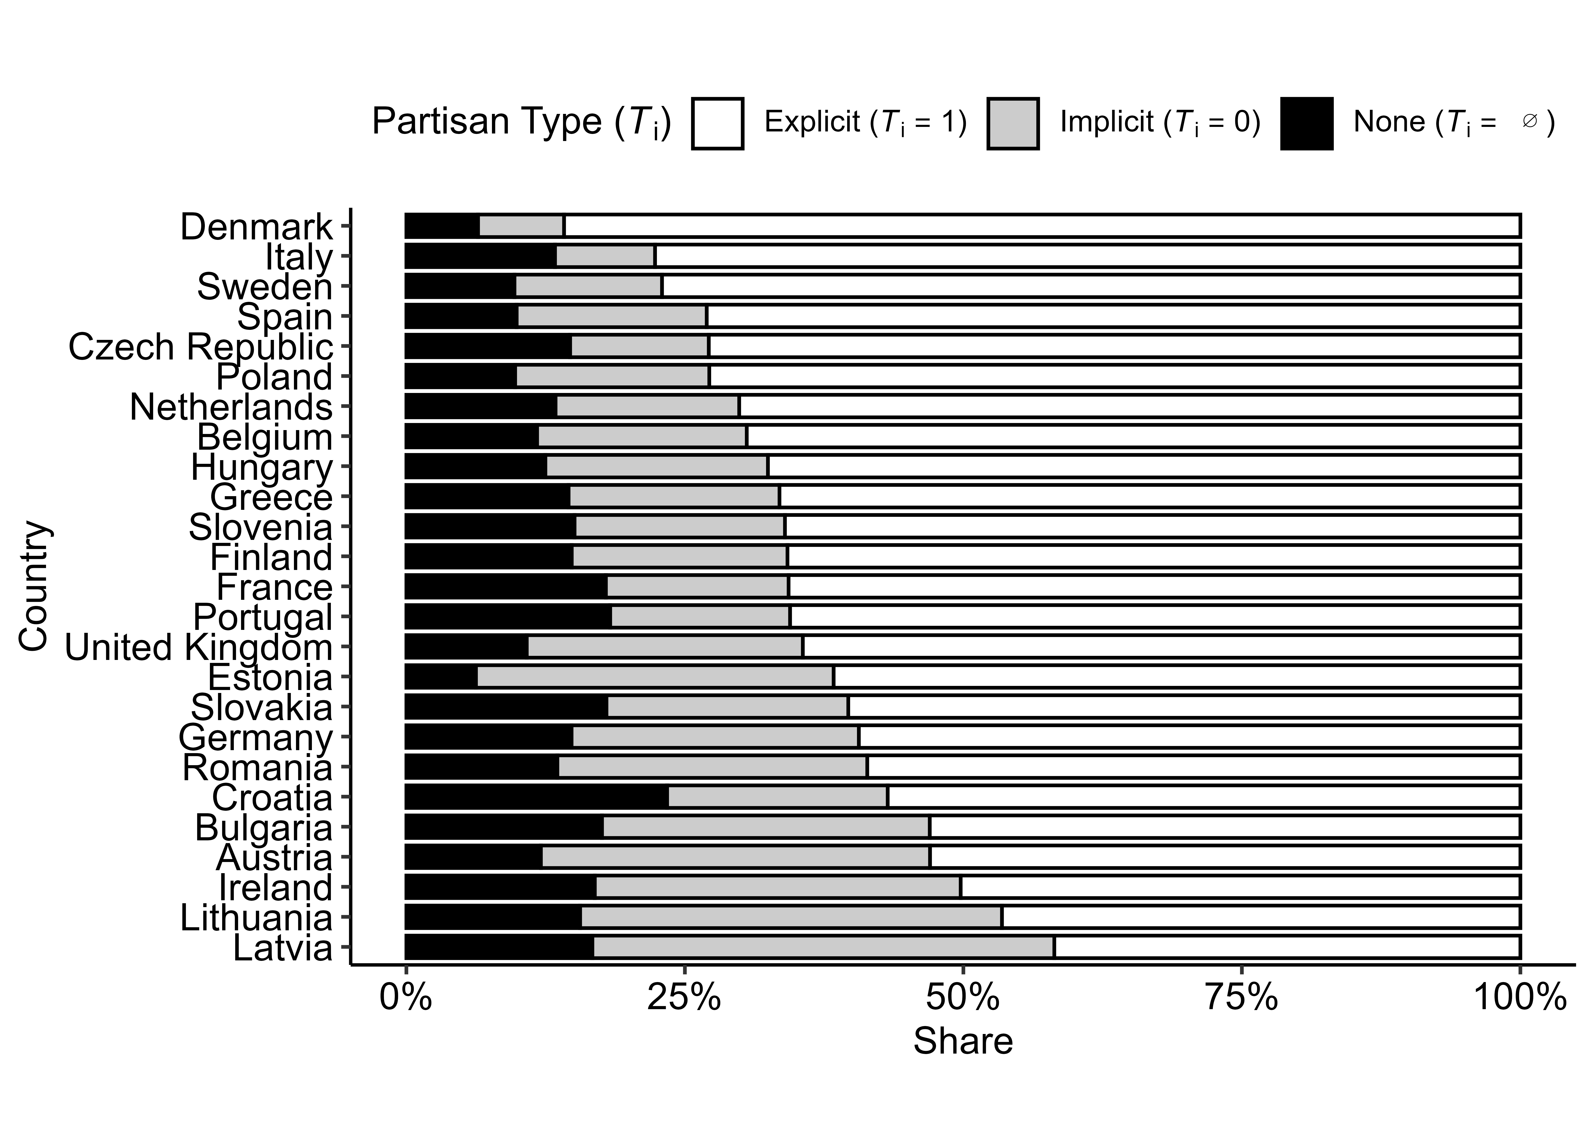
Figure 1: Distribution of partisan types, by country. Stacked horizontal bars show the within-country share (%) of three partisan types: explicit partisans (respondents who reported a subjective attachement to a party, $T_{i}=1$), implicit partisans (respondents who reported no attachement but did report a vote preference or intention, $T_{i}=0$), and respondents who reported neither (none, $T_{i}=∅$). Percentages sum to 100% within each country, with country samples containing about $1,100$ respondents each (detailed numbers are reported in appendix section X).
_{Source: Code Notebook 3.1}

5 Part II – Behavioral polarization as consequences
We present the conjoint results separately from thermometer analyses.
Conceptual shift:
- From attitudinal differentiation toward parties (vertical)
to
- Behavioral discrimination toward fellow citizens (horizontal).
Outcomes:
- Solidarity allocations (dictator game logic)
- Trust allocations (trust game logic)
Here, affective polarization manifests as:
- Differential allocation toward co-partisans vs. out-partisans.
We treat these as behavioral consequences of partisan boundaries, rather than as alternative scaling of thermometer AP.
Open conceptual question: To what extent do attitudinal (vertical) and behavioral (horizontal) AP align within and across countries?
Possible empirical extension:
- Estimate correlation between country-level attitudinal AP and behavioral AP (posterior correlation).

6 Muslimhood, partisan interaction, and sorting (targeted extension)
The religion attribute in the conjoint is uniformly randomized across:
- Muslim
- Christian
- Non-religious
Thus, estimates assume no religious sorting in exposure.
Exploratory results (note to be formalized):
- Muslim co-partisans receive fewer tokens than Christian or non-religious co-partisans.
- Muslim out-partisans receive fewer tokens than Christian or non-religious out-partisans.
- The penalty is larger within the co-partisan condition than within the out-partisan condition.
- Interaction effects are therefore asymmetric, not uniform across partisan categories.
Two implications:
- Theoretical:
One should not assume symmetric sorting or interaction effects between partisan and religious identities.
Minority attributes may condition in-group favoritism differently than out-group derogation.
- External validity:
Because religion is uniformly distributed by design, real-world exposure patterns (where Muslim citizens are not evenly distributed across partisan categories) are not reflected.
Possible extension:
- Incorporate prior information about realistic joint distributions of religion × partisanship to simulate more externally valid scenarios.
- Use the uniform design as a benchmark (“no-sorting counterfactual”) against which realistic sorting patterns could be contrasted.
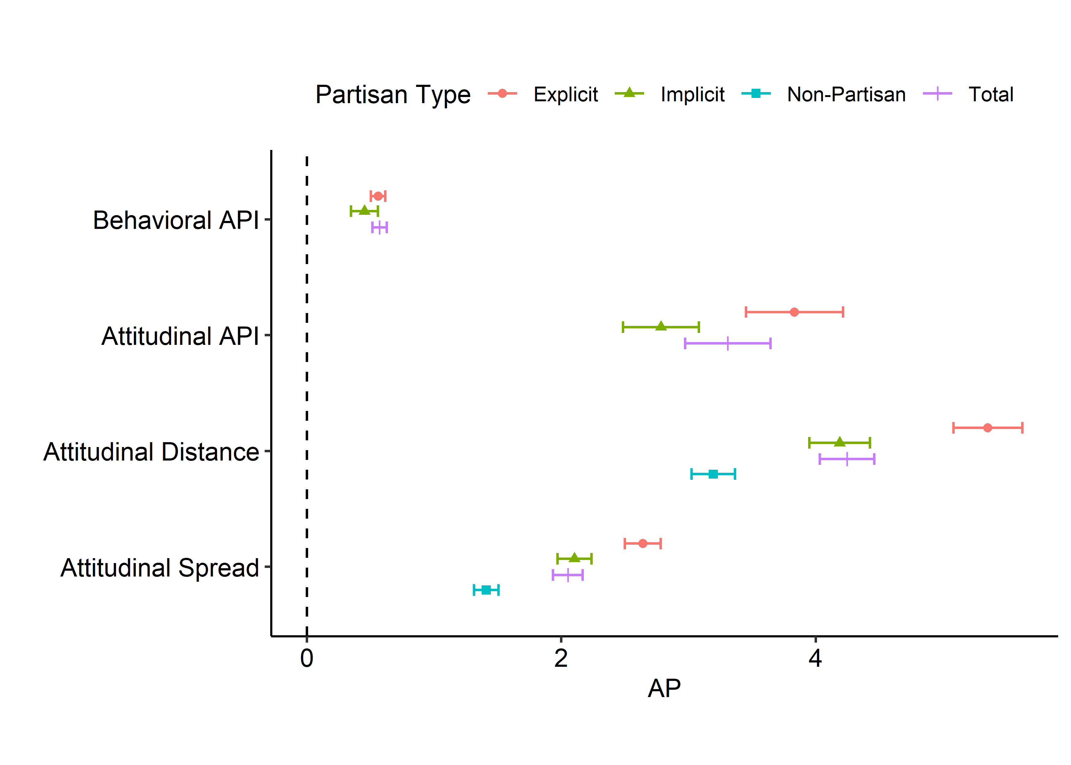
Figure 2: Comparison of Behavioral and Attitudinal Affective Polarization in the EU25. This figure displays aggregated affective polarization (AP) scores across four different operationalizations, categorized by partisan attachment type. Behavioral API (Token) measures the difference in expected token allocations between co-partisans and out-partisans in a conjoint game. Attitudinal API represents Reiljan (2020)’s index, calculated as the distance between in-group and average out-group thermometer scores. Attitudinal Distance and Spread follow Wagner (2021) metrics, capturing the root mean square distance from the most-liked party and the overall standard deviation of party evaluations, respectively. All estimates are weighted by party vote shares within each country to reflect national party system compositions and then averaged across 25 European countries. To ensure comparability, attitudinal thermometer scores (originally 0–100) have been rescaled to a 0–10 range to match the behavioral token scale. Explicit partisans are those reporting a psychological attachment to a party; Implicit partisans are those denying attachment but reporting a vote choice; Total represents all individuals with a partisan anchor; and Non-Partisans represent respondents without a reported party anchor. Error bars indicate 95% confidence intervals based on cross-national variance.
_{Source: Code Notebook 3.2}

7 Modeling strategy (note)
Planned approach:
- Hierarchical (partial pooling) estimation for country-level quantities.
- EU-level benchmarks derived via marginalization over country-level posteriors.
- Report standardized or scale-relative effects (thermometer vs. token scales not directly comparable).
Potential extension:
- Estimate posterior correlation between country-level attitudinal AP and behavioral AP.

8 Limitations (draft notes)
- Party-targeted thermometers only
→ No direct citizen-targeted affect measure in the attitudinal section.
- Weighting by party size
Assumes encounter probability proportional to electoral share.
Social visibility may violate this (e.g., radical challenger parties).
- Uniform conjoint distribution
No endogenous religious sorting; real-world joint distributions may differ.
- Cross-sectional design (2019)
Results capture a specific pre-pandemic political context.
No dynamic inference about temporal change.

9 Contribution (working formulation)
In comparative multi-party systems:
- Affective polarization is not a single quantity.
- Its magnitude and cross-national configuration depend on:
  - ingroup definition,
  - inclusion of non-partisans,
  - aggregation rules,
  - and whether polarization is conceptualized vertically or horizontally.
Rather than asking only “How polarized are European democracies?”,
we ask:
How does conceptualization reshape what, and even who, we observe as polarized in multi-party contexts?

10 References
Areal, J., and E. Harteveld. 2024. “Vertical Vs Horizontal Affective Polarization: Disentangling Feelings Towards Elites and Voters.” Electoral Studies 90. https://doi.org/10.1016/j.electstud.2024.102814.
Hahm, Hyeonho, David Hilpert, and Thomas König. 2024. “Divided We Unite: The Nature of Partyism and the Role of Coalition Partnership in Europe.” American Political Science Review 118 (1): 69–87. https://doi.org/10.1017/S0003055423000266.
Reiljan, Andres. 2020. “‘Fear and Loathing Across Party Lines’(also) in Europe: Affective Polarisation in European Party Systems.” European Journal of Political Research 59 (2): 376–96. https://doi.org/10.1111/1475-6765.12351.
Reiljan, Andres, Diego Garzia, Frederico Ferreira Da Silva, and Alexander H Trechsel. 2024. “Patterns of Affective Polarization Toward Parties and Leaders Across the Democratic World.” American Political Science Review 118 (2): 654–70. https://doi.org/10.1017/S0003055423000485.
Röllicke, L. 2023. “Polarisation, Identity and Affect - Conceptualising Affective Polarisation in Multi-Party Systems.” Electoral Studies 85. https://doi.org/10.1016/j.electstud.2023.102655.
Wagner, Markus. 2021. “Affective Polarization in Multiparty Systems.” Electoral Studies 69: 102199. https://doi.org/10.1016/j.electstud.2020.102199.

11 Appendix

11.1 Sample descriptives
Table 1: Sample composition by country. Numbers denote respondents.
Country | N | Percent
Austria | 1277 | 0.04
Belgium | 1305 | 0.04
Bulgaria | 982 | 0.03
Croatia | 1240 | 0.04
Czech Republic | 1135 | 0.04
Denmark | 1200 | 0.04
Estonia | 944 | 0.03
Finland | 1160 | 0.04
France | 1156 | 0.04
Germany | 1188 | 0.04
Greece | 1161 | 0.04
Hungary | 986 | 0.03
Ireland | 1061 | 0.04
Italy | 1172 | 0.04
Latvia | 1148 | 0.04
Lithuania | 1265 | 0.04
Netherlands | 1221 | 0.04
Poland | 1198 | 0.04
Portugal | 1187 | 0.04
Romania | 1480 | 0.05
Slovakia | 1297 | 0.04
Slovenia | 1135 | 0.04
Spain | 1396 | 0.05
Sweden | 1254 | 0.04
United Kingdom | 1279 | 0.04
Total | 29827 | 0.99

_{Source: Code Notebook 3.1}
Table 2: Sample composition by country and gender. Numbers denote respondents.
Country | Male | Female | Other
Austria | 645 | 630 | 2
Belgium | 729 | 574 | 2
Bulgaria | 463 | 518 | 1
Croatia | 545 | 694 | 1
Czech Republic | 515 | 618 | 2
Denmark | 690 | 508 | 2
Estonia | 331 | 611 | 2
Finland | 586 | 567 | 7
France | 562 | 594 | 0
Germany | 587 | 597 | 4
Greece | 588 | 572 | 1
Hungary | 493 | 492 | 1
Ireland | 481 | 577 | 3
Italy | 603 | 569 | 0
Latvia | 415 | 733 | 0
Lithuania | 462 | 803 | 0
Netherlands | 642 | 577 | 2
Poland | 540 | 658 | 0
Portugal | 593 | 593 | 1
Romania | 837 | 641 | 2
Slovakia | 550 | 746 | 1
Slovenia | 569 | 566 | 0
Spain | 677 | 718 | 1
Sweden | 648 | 602 | 4
United Kingdom | 635 | 641 | 3
Total | 14386 | 15399 | 42

_{Source: Code Notebook 3.1}
Table 3: Sample composition by country and age group. Numbers denote respondents.
Country | 18 to 25 | 26 to 35 | 36 to 45 | 46 to 55 | 56 to 65 | 66 to 75 | > 75
Austria | 144 | 177 | 249 | 263 | 286 | 142 | 0
Belgium | 197 | 132 | 160 | 235 | 333 | 239 | 3
Bulgaria | 57 | 195 | 231 | 250 | 212 | 33 | 0
Croatia | 119 | 251 | 272 | 331 | 205 | 47 | 0
Czech Republic | 88 | 187 | 227 | 219 | 281 | 126 | 0
Denmark | 132 | 134 | 139 | 208 | 321 | 249 | 4
Estonia | 56 | 168 | 164 | 283 | 265 | 7 | 0
Finland | 125 | 178 | 210 | 242 | 259 | 137 | 1
France | 123 | 176 | 242 | 267 | 279 | 51 | 0
Germany | 125 | 184 | 200 | 240 | 313 | 117 | 0
Greece | 77 | 202 | 376 | 318 | 136 | 34 | 0
Hungary | 51 | 175 | 196 | 166 | 273 | 117 | 1
Ireland | 128 | 216 | 223 | 187 | 169 | 120 | 0
Italy | 104 | 196 | 264 | 195 | 294 | 98 | 2
Latvia | 78 | 251 | 231 | 338 | 239 | 6 | 0
Lithuania | 223 | 311 | 257 | 250 | 212 | 2 | 0
Netherlands | 149 | 126 | 161 | 234 | 340 | 194 | 3
Poland | 200 | 342 | 222 | 187 | 196 | 42 | 0
Portugal | 112 | 260 | 289 | 231 | 218 | 67 | 1
Romania | 128 | 339 | 373 | 347 | 202 | 65 | 0
Slovakia | 139 | 223 | 282 | 290 | 250 | 108 | 1
Slovenia | 97 | 186 | 246 | 284 | 234 | 72 | 0
Spain | 125 | 293 | 355 | 305 | 228 | 66 | 1
Sweden | 124 | 165 | 156 | 234 | 297 | 261 | 3
United Kingdom | 121 | 184 | 196 | 234 | 268 | 250 | 1
Total | 3022 | 5251 | 5921 | 6338 | 6310 | 2650 | 21

_{Source: Code Notebook 3.1}

11.2 Experimental setup
Before the behavioral games, Hahm, Hilpert, and König (2024) presented respondents a short background information overview and instructions. For the dictator game, these were: This game is played by pairs of individuals. Each pair is made up of a Player 1 and a Player 2. Each player will have some information about the other player, but you will not be told who the other players are during or after the experiment. The game is conducted as follows: A sum of 10 tokens will be provisionally allocated to Player 1 at the start of each round. Player 1 will then decide how much of the 10 tokens to offer to Player 2. Player 1 could give some, all, or none of the 10 tokens. Player 1 keeps all tokens not given to Player 2. Player 2 gets to keep all the tokens Player 1 offers. You will play this game three times with three different people. In the trust game, the provided information and instruction were: This game is played by pairs of individuals. Each pair is made up of a Player 1 and a Player 2. Each player will have some information about the other player, but you will not be told who the other players are during or after the experiment. Each player will receive 10 tokens. Player 1 then has the opportunity to give a portion of his or her 10 tokens to Player 2. Player 1 could give some, all, or none of the 10 tokens. Whatever amount Player 1 decides to give to Player 2 will be tripled before it is passed on to Player 2. Player 2 then has the option of returning any portion of this tripled amount to Player 1. Then, the game is over. Player 1 receives whatever he or she keeps from the original 10 tokens, plus anything returned to him or her by Player 2. Player 2 receives their original 10 tokens, plus whatever he or she keeps after returning any portion of the tripled amount to Player 1. You will play this game three times, with three different people. The more tokens you obtain, the more successful you will be.
In both games respondents were shown a tabular overview of Player 2 after the instructions. Figure 3 shows an example of such a profile along with the interface respondents were provided to assign the 10 tokens. Each round, a new profile was displayed to respondents.
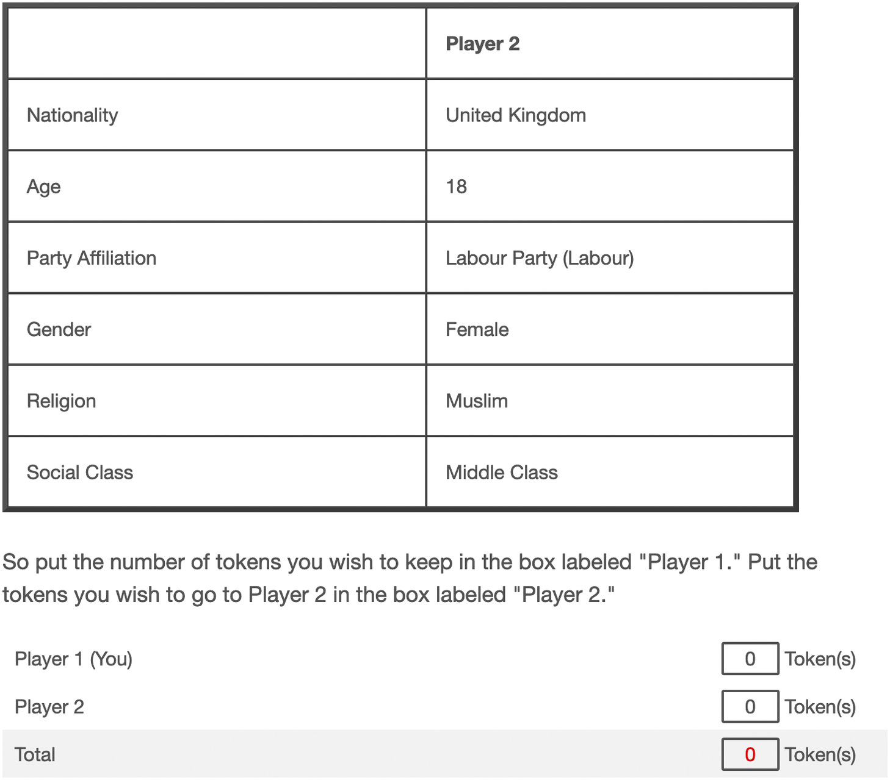
Figure 3: Example of potential co-player profile.

11.3 Distribution of Y
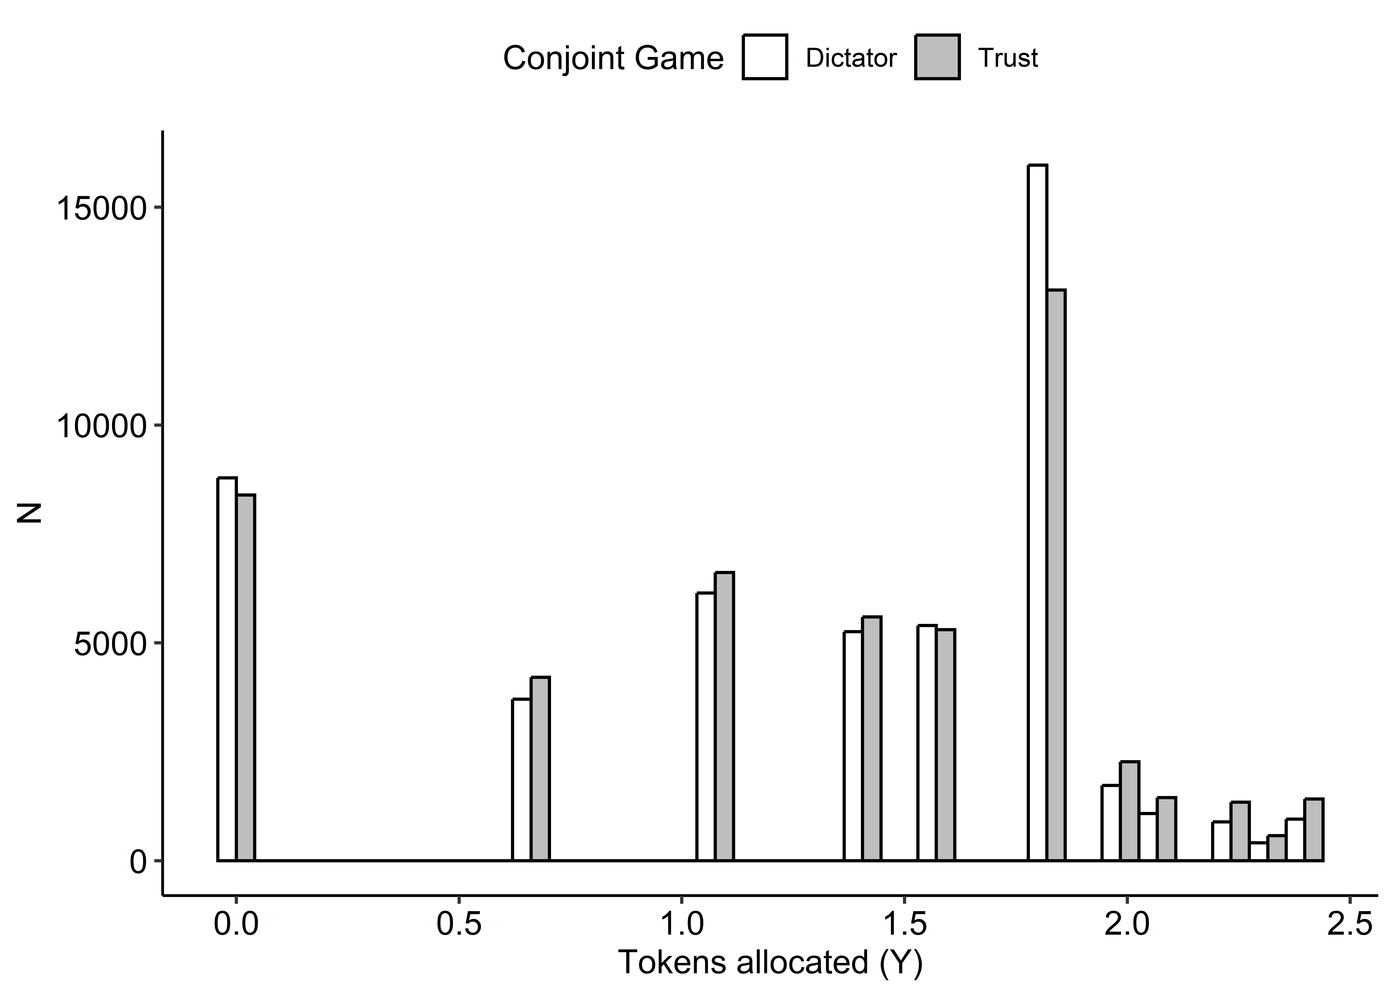
Figure 4: Distribution of token allocation (Y) by game. Dictator game: $Mean=3.41$, $median=4$, $SD=2.35$. Trust game: $Mean=3.48$, $median=4$, $SD=2.49$
_{Source: Code Notebook 3.1}

11.4 Distribution of T and R
Table 4
der_partisan_type | None | Co | Out
0 | 5123 | 1948 | 18465
1 | 14898 | 30820 | 29366

_{Source: Code Notebook 3.1}

11.5 Distribution of Covariates by T
Table 5
Variable | 0  N = 25,536¹ | 1  N = 75,084¹
q_lrpos2_z | -0.08 (-0.45, 0.29) | -0.08 (-0.82, 0.66)
q_eupos2_z | 0.08 (-0.68, 0.46) | 0.08 (-0.68, 0.84)
q_econ_nativism_z | 0.15 (-1.03, 0.74) | 0.15 (-1.03, 0.74)
q_cult_nativism_z | 0.07 (-1.03, 0.62) | 0.07 (-1.03, 0.62)
q_satis_demo_country_z | 0.30 (-0.81, 1.40) | 0.30 (-0.81, 0.30)
q_understand_nat_pol_z | 0.12 (-0.65, 0.12) | 0.12 (-0.65, 0.90)
q_understand_eu_pol_z | 0.22 (-0.50, 0.22) | 0.22 (-0.50, 0.94)
q_parties_harm_z | 0.25 (-0.38, 0.88) | 0.25 (-0.38, 0.88)
q_officials_talk_action_z | 0.41 (-0.33, 1.15) | 0.41 (-0.33, 1.15)
q_politics_good_evil_z | -0.14 (-0.76, 0.48) | -0.14 (-0.76, 0.48)
q_people_unaware_z | 0.40 (-0.81, 1.00) | -0.20 (-0.81, 1.00)
q_leaders_educated_z | 0.39 (-0.32, 1.10) | 0.39 (-1.03, 1.10)
q_expert_decisions_z | 0.16 (-0.49, 0.80) | 0.16 (-0.49, 0.80)
q_listen_other_groups_z | 0.18 (-0.74, 1.10) | 0.18 (-0.74, 1.10)
q_democracy_compromise_z | -0.29 (-0.29, 0.57) | -0.29 (-0.29, 0.57)
q_interest_pol_country_z | 0.06 (-0.60, 0.72) | 0.06 (-0.60, 0.72)
q_interest_pol_eu_z | -0.28 (-0.96, 0.39) | 0.39 (-0.28, 1.06)
q_eval_finance_household_z | 0.01 (-0.99, 1.00) | 0.01 (-0.99, 1.00)
q_eval_job_z | 0.11 (-0.80, 1.03) | 0.11 (-0.80, 0.11)
q_eval_econ_country_z | -0.14 (-1.03, 0.76) | -0.14 (-1.03, 0.76)
q_eval_econ_eur_z | 0.07 (-0.94, 1.09) | 0.07 (-0.94, 1.09)
q_risk_taking_z | 0.11 (-0.56, 0.78) | 0.11 (-0.56, 0.78)
q_future_discount_z | -0.17 (-0.84, 0.50) | -0.17 (-0.84, 0.50)
q_edu_z | -0.08 (-0.73, 0.57) | -0.08 (-0.73, 0.57)
q_age_z | -0.11 (-0.92, 0.64) | 0.09 (-0.79, 0.91)
q_religion_en
catholic | 8,606 (34%) | 27,379 (36%)
no religion | 9,462 (37%) | 25,678 (34%)
protstnt | 1,881 (7.4%) | 7,570 (10%)
other religion | 5,470 (21%) | 13,791 (18%)
muslim | 114 (0.4%) | 664 (0.9%)
q_perc_class
Working class | 5,307 (22%) | 15,198 (21%)
Lower middle class | 4,866 (20%) | 13,924 (19%)
Middle class | 12,060 (49%) | 35,019 (48%)
Upper middle class | 2,055 (8.4%) | 7,622 (10%)
Upper class | 191 (0.8%) | 1,310 (1.8%)
q_rural_urban
Rural area or village | 5,819 (23%) | 17,093 (23%)
Small or middle sized town | 9,069 (36%) | 28,418 (38%)
Large town | 10,573 (42%) | 29,298 (39%)
q_gender
Male | 10,939 (43%) | 39,456 (53%)
Female | 14,565 (57%) | 35,514 (47%)
Other | 32 (0.1%) | 114 (0.2%)
¹ Median (Q1, Q3); n (%)

_{Source: Code Notebook 3.1}

11.6 Robustness

