Le Song

ensf 617
[Garbage Classification Project Proposal]

Introduction
This section of the project aims to define constraints and parameters, detail experimental design and metrics, as well as collect balanced data for the garbage classification problem statement, guided by City of Calgary’s Garbage, Recycling and Compost guidelines.
Design and Data Processing
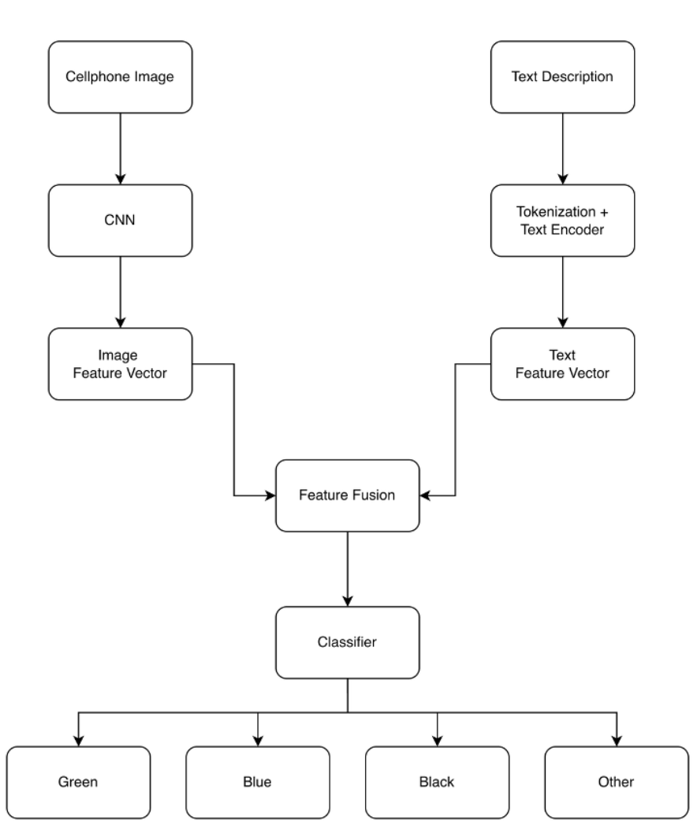
Fig.1 Overview of the proposed multimodal garbage classification system. CNN is used to extract visual features from the cellphone image, while the text description is tokenized and encoded separately.

(Photo goes here for fig.2):

Component | Specification
Image count | 128 images
Image content | One centered object per image
Classes | Green, Blue, Black, Other
Image resolution | TBD
Text description | Short sentence (5–15 words)
Class balance | 30 images per standard class  8 images for “other”
Table 1. Image/Text format and constraints.

