# Task Log

Estimated time to Complete each package

Package_001 : 4Day/s

Package_002 : 3Day/s

Package_003 : 1Day/s

Package_004 : 1Day/s

Estimated Time to Put Game/Demo together

Game/Demo : 10Day/s

Rough Interruption time estimation

Major Breaks : 30Min - 1Hour 30min

Minor Breaks : 15Min

|  |  |  |  |
| --- | --- | --- | --- |
| Date and Time | Update | Interruptions | Task |
| March 3rd, 2019  10:00 – 16:00 | Planning out different ideas in my head for what I would like to produce. | Major breaks have been taken and lunch breaks have been taking during the planning process. | Planning |
| March 4th, 2019  15:00 – 21:00 | Basic movement has been created for the game and core mechanic isn’t working as intended.  Connection between the two objects keeps breaking apart or causes the movement to become rigid when using joints. | Lunch and dinner breaks  And minor work breaks in between. | Script/Package One, includes the docking mechanic. |
| March 8rd, 2019  18:00 – 22:00 | Controls has been improved movement feels a bit more fluid and runs far better than before. | dinner breaks  And minor work breaks in-between. | Package one and two’s Movement |
| March 9rd, 2019  11:00 – 16:00 | Collision issues found when connecting the two objects together making it difficult to dock from the sides of the object. Attempts have been made to try and resolve such issues.  Docking has also been overhauled and now use a parent and child connection instead of a joint. | Lunch, Breakfast and minor work breaks in-between. | Package one |
| March 12rd, 2019  14:00 – 16:00 | Basic movement has been corrected. The player can successfully connect with the object and control it without any major movement issues. | Lunch and minor work break in-between. | Package one and two’s Movement |
| March 13rd, 2019  10:00 – 16:00 | Docking in of itself has become smoother but can still be rather difficult to do so. I have created some methods of smoothing out the process such as the ability to snap Object A into the same rotation as object B. Also, the ability to shine a beam downwards to help with connecting the objects properly. | Lunch and major work break in-between. | Script/Package One, includes the docking mechanic. |
| March 16rd, 2019  10:00 – 20:00 | Both Object A and B have been giving their own design to fit the games inspiration. | Lunch, Breakfast and major work breaks have been taken | ART |
| March 17rd, 2019  10:00 – 16:00 | I have created a projectile in which the player can use to defeat possible enemies. The projectile launches forward and returns to the player once it hits something or when you press a button. | Minor work breaks have been taken | Package Three |
| March 20rd, 2019  10:00 – 13:00 | A secondary projectile has been made which explodes upon contact with anything or after 3 seconds. | No interruptions have been made | Package Four |
| March 22rd, 2019  10:00 – 16:00 | Art has been completed. Packages has been edited slightly to work better with the game.  All packages have also been completed. | Lunch and major work break in-between. |  |
| April 5th, 2019  12:00 – 16:00 | Tutorials were created for each one of the packages with a description of how to set them up. | Minor work breaks. | Tutorials |

# Learning Journal

Overall, I didn’t really learn all that much from making these packages due to still being very familiar with what I already know.

|  |  |  |
| --- | --- | --- |
| Date | What I’ve learnt | Sources |
| March 4th, 2019 | I have learnt about joints and how to use them. This wasn’t something that I knew how to do already and will come in handy during later projects | <https://www.youtube.com/watch?v=MElbAwhMvTc>  <https://docs.unity3d.com/Manual/Joints.html>  <https://www.youtube.com/watch?v=GB8BdFjX8vM> |
| March 17rd, 2019 | I was wondering if it was possible to have it, so an object does the opposite of look at and I found a way. I was having the trouble with figuring out how to make the boomerang return to me once I shot it out but thanks to multiple sources online, I manged to figure it out. | <https://forum.unity.com/threads/getting-an-object-to-look-away-from-another.297022/>  <https://www.youtube.com/watch?v=gWkFwPj421g> |
| March 20rd, 2019 | This may not sound like much, but I actually learnt how to make a object constantly grow in size | <https://docs.unity3d.com/ScriptReference/Transform-localScale.html> |
|  |  |  |

# Tutorials

All assets for said packages have already been built and can work together right out the bag without further adjustment. The following tutorials are here with the intention of editing them outlining how they function and how to put them together.

## Tutorial Package_01

1. Create an Object and apply a Rigidbody as shown in the image below and give it a “Tag” of your choosing, for the sake of this tutorial I’m going to give it the tag “ObjectA”.

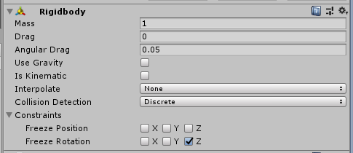

1. Create another object and give it a “Tag” of your choosing and again for the sake of this tutorial I’m going to call it “ObjectB” and give it a Rigidbody.

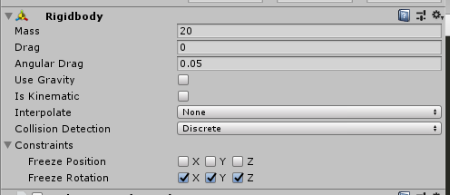

Now you would want to create another object and give it the tag “Dock” and again give this object a Rigidbidy, place it onto object and make it a child of ObjectB.

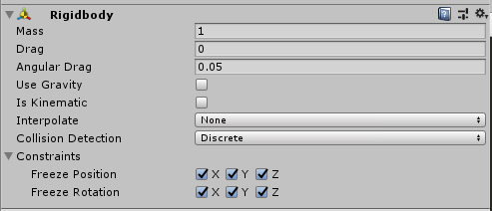

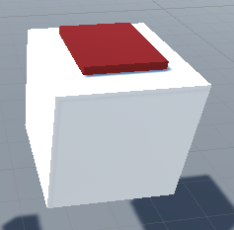

(*I gave the dock a red material so it can be seen visually*)

1. Apply the package One script to Object A. This is also the step where you can also edit the package to better fit your game.

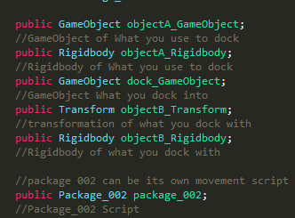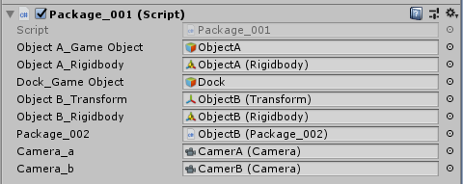

Package_002 doesn’t have to be used, the designer can use any script here to control the movement once you have docked and the camera doesn’t have to be changed. The camera can simply be removed the from this script so that the camera doesn’t change.

1. Now that everything has been setup when Object A moves and touches the “Dock” Object it’ll be connected to Object B and the script on Object B(Package_02) will activate allowing a change in controls and camera. When the player decides to disengage all he/she must do is press SHIFT + G.

## Tutorial Package_02

Package_02 allows the player to move and make a variety of projectile attacks and this is how to use the script

1. Create a cube and remove the texture and the collider, this will be where the projectiles will come from. If the designer wishes you can create a duplicate of this cube and place them both in two different positions on object B and make them children. For this demonstration I will be using three different spawns.

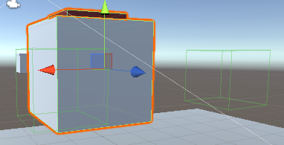

1. Create two or more projectiles make them prefabs and assign them in the inspector and firing by pressing “E” or “R”.

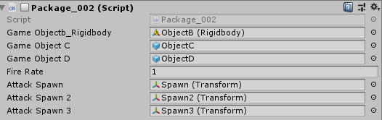

1. Within the script there are three different options for projectiles

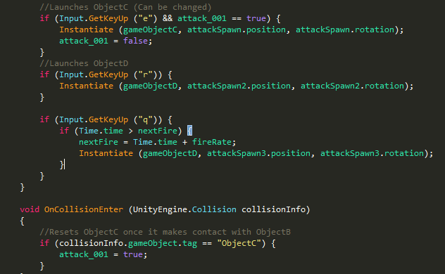

“E” is showing how this package can be used to make a special projectile and in this case a boomerang attack.

“R” is a standard attack which when the button is pressed it’ll fly out.

“Q” launches a projectile when you hold the “Q” button and continuous to fire projectiles till the button is released.

## Tutorial Package_03

Package 3 is the boomerang attack itself. Whilst Package contained information on how to fire them package 3 contains how the missile itself operates and doesn’t require much of a tutorial but maybe a brief explanation of how it works.

The projectile will fly forward slowly reducing in speed till it reaches 0 and once it reaches 0 the object will face away from Object B causing it to fly back. Pressing the “E” button will set its speed back to 0 if its greater than 0 forcing it to return to the player. Once it touches Object B it will “Package_02” script will detect it allowing it to be fire via the script once again.

## Tutorial Package_04

Package_04 is much simpler it’s a second projectile which when it contacts an object will detonate an explosion which slowly grows in intensity before exploding. **WARNING** when using the “R” button to launch the projectile do not spam it, it’ll eventually crash unity!

The projectile known as Object D contains the first half of the script which causes it to not just fly forward but also summon the explosion which comes after contact. For the explosion it is a sphere containing the second half of the script which causes the sphere to grow and disappear.

# Game/Demo Instructions

Game Demo, inspired by the Anime/Manga MazingerZ <https://youtu.be/MR7xA2JbNCQ>

