Click and point movement + camera

For the movement I used a tutorial (<https://www.youtube.com/watch?v=KU2CKBlCAxQ&list=PLYfhoo43XjpRWWb2WgV59bFeS7rnCXb4R&index=2&t=0s>)

It moves on mouse button down and uses navmesh component that needs to be added to the character. Then you have to select the area player can walk on. The tutorial was made in MAC version; therefore it took me some time to find the “navigation” option in PC version – it’s in Component->AI. You select the area make sure it’s set to “navigation static” “walkable” and then you “bake” it. You also have to select any objects that you do not want the player walk on – make them “unwalkable” and “bake” again.

After implementing the code, you have to create a layer “ground” for what can be clicked on and assign it to the floor.

Had a problem with “NullReferenceException: Object reference not set to an instance of an object” but it was easily sorted with tagging the camera as “maincamera”.

Position the camera how you would like to see your level.

I made this mostly for my point and click one screen adventure game, therefore, no need to move the camera.

Inventory and picking up

I am using the scene set up with the player and movement. Created a few texts in the canvas: “inventory” and “matches”, also a text in the middle saying how to pick up an object.

Create an object to be picked up, in this case “matches” and assign a pick up script.

In the pick up script we use create text game objects for a pick up text and when the object is acquired in the inventory space. You also create two bools 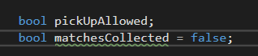

For the start, disable the texts. In the update section create an if statement, when pickup is allowed and space is pressed pickup() is initiated 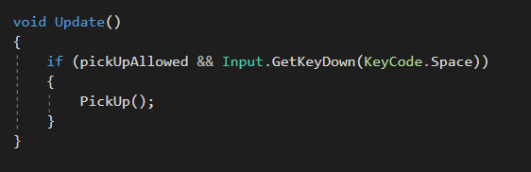

Then you need private voids when the player collides with the object for texts to appear and pick up to be allowed 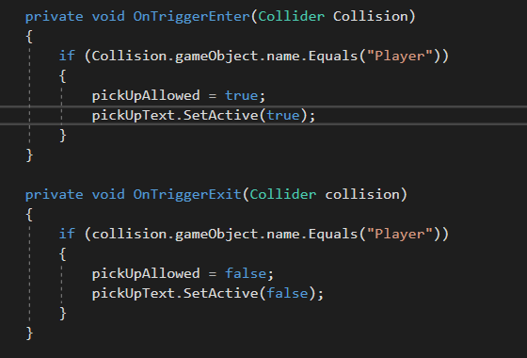

And you need a pickup() which destroys the object and makes object appear in the inventory

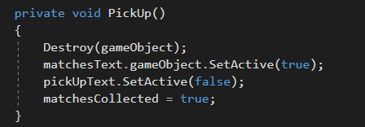

Interacting and count system

I needed a system to count “essence” throughout the game – for that I created a count system. I put it on the player script so it doesn’t get deleted on pickable objects or something. Also created an empty text object for the ui where count will be displayed 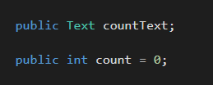

Created a void for setting count an put it in update section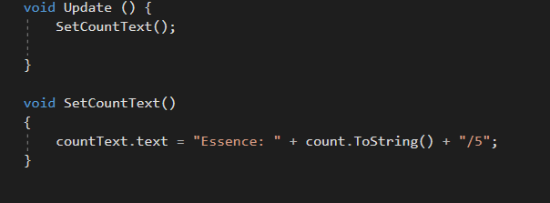

For interacting, I created logs – fire to be made with matches. Created a text saying that something is needed to ignite the logs. Put in the code for it to be activated in the “fire” script

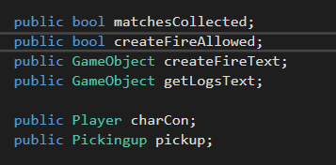

Created bools for fire to be ignited and a bool whether matches are collected, also referenced player script where the count is kept and pick up script. I also adjusted the pickup script, referencing this script.

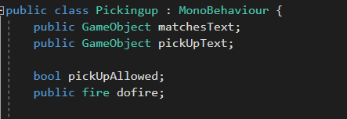

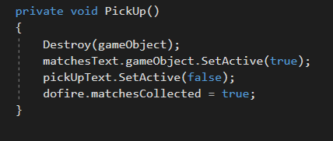

Created an if statement where making fire will be allowed when matches are obtained and player is triggering the collider and then pressing “space” 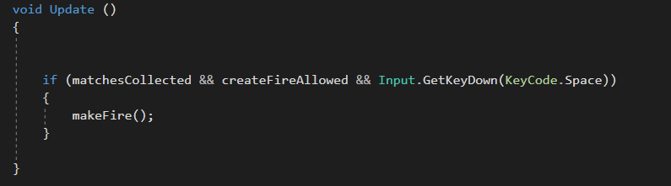

Created private voids for entering and exiting collisions 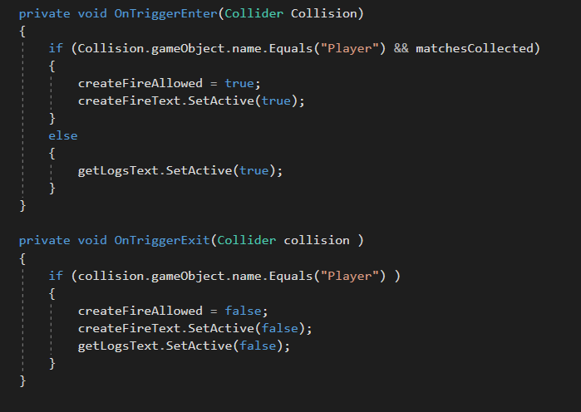

Then cretaed a make fire action that removes matches from the inventory and increases the count.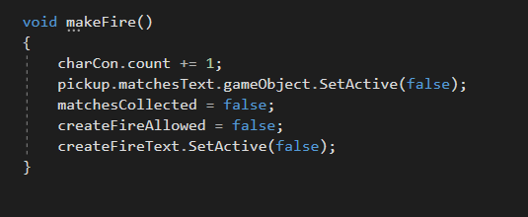

In unity I put the correct object in scripts in order for it to work.