Project day 1:

I had an idea of a video game about a witch with kind of domestic themed gameplay, where she grows a garden, buy/sell products, craft different ingredients and cook magic potions. So, I made my first steps in this with a game component for crafting/combine items. After some research I made a list of things I thought be necessary for the coding part. Bringing up memories from the gameplay of Diablo 2’s crafting system and UI, also Doodle God was a massive reference for this component, my list looked like that.

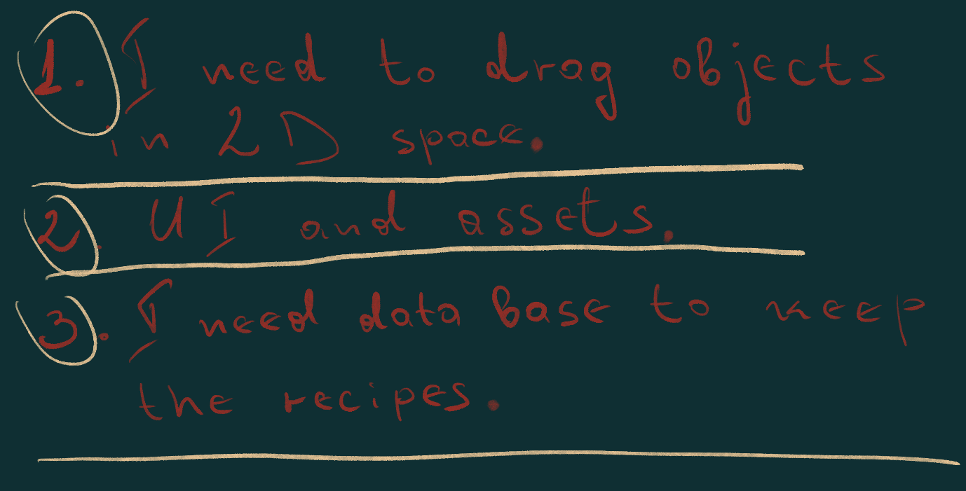

Project day 2:

In order to start preparing the code for the dragging system I needed some assets to start with. I came up with ideas like pigeon legs, dried mushrooms, magic potions etc. I picked up my iPad and made images of the slots to mount on the grid with different items.

 

Along with some UI concepts I started importing the assets to Unity.

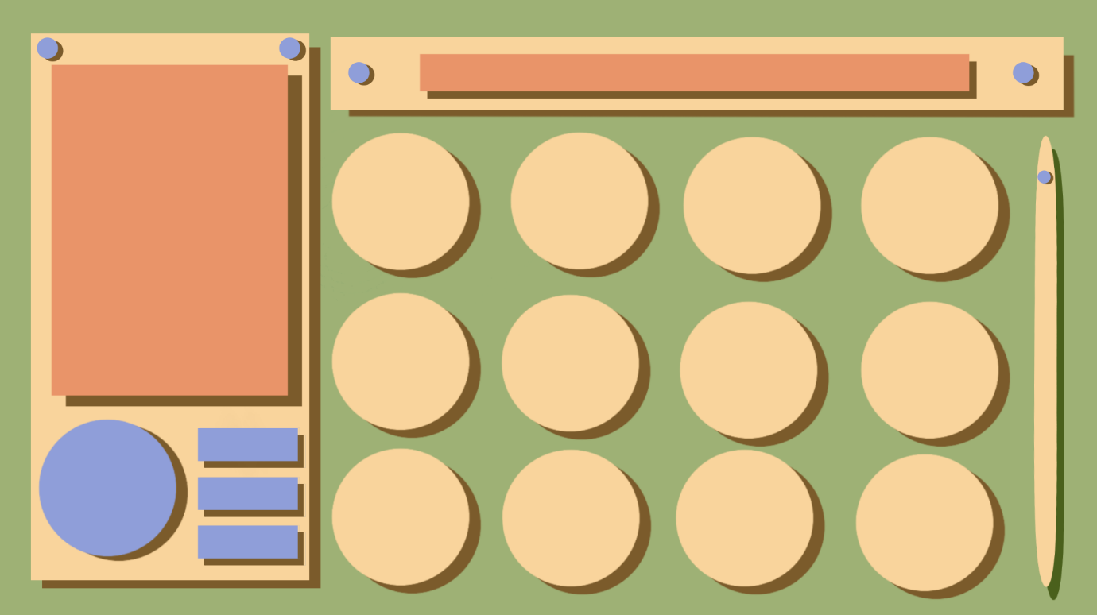

Project day 3:

Once I had the idea in my head and concept assets inside Unity, I had a better idea of what I am looking for and started browsing tutorials that could help me out. Making the objects move around with the position of the cursor wasn’t so difficult, but the second part with the drop and make the object stick to the right position was a lot more difficult. I used Ray casts, but it was a bit unclear how to implement those.

Project day 4:

I had to look for help on the game controller, my teacher David explained to me about the libraries with recipes I can create. I thought of funny combinations and here is the book with recipes:

* Rat + Red Candle = Rat Bones
* Arcane + Pigeon Leg + Red Candle = Red Potion
* Dry Herbs + Red Candle = Ash
* Arcane + Rat Bones + Red Candle = Hex
* Ash + Red Candle + Red Potion = Curse
* Arcane + Dry Herbs + Red Candle = Cup of Tea
* Arcane + Rat = Poison
* Arcane + Fresh Herbs = Blessing
* Black Candle + Blessing + Curse = Dark Magic

Project day 5:

On the final day I had to make sure all the assets are finalised so I can put the parts together.

