Tutorial #1

In these tutorials I will explain how to create a game component for crafting items using libraries in Unity and C#. I am going to build a library from which we will extract the crafting information.

The game controller script holds the core functionality. The script starts with distinguishing the elements we are going to use. I am going to use dictionaries of strings into the game objects. Let’s create a list of game objects as a public so later it can be adjusted into the Unity inspector, and a list of strings for the names of these objects.

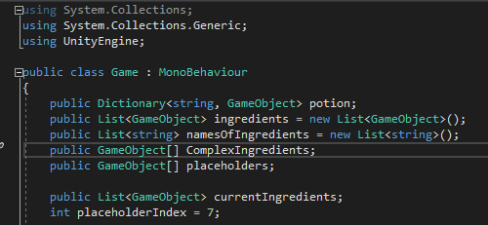

Those first lines will create into the Unity inspector, a list of the items we can use as default, a list of the items that are going to be created by crafting, and a list of the total amount of slots in the UI of this game component.

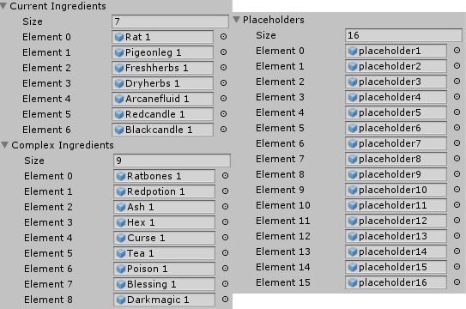

The program starts with building the dictionary, lets call the function created earlier for dictionary and follow with descriptions of the exact strings.

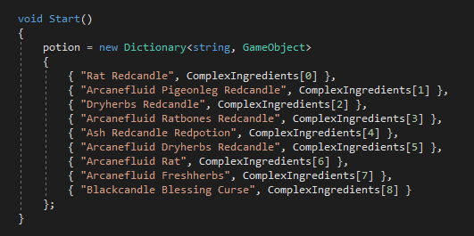

What is very important for the dictionary is that every row needs to arrange the names of these ingredients alphabetically. For the results of each combination I don’t need to call the name of the item, but just the number of the “Placeholder” I created earlier in the inspector. Once I have this library of exact recipes for cooking, I can easily call for the objects that contain those tags.

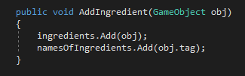

The following line check on the name tags of items and submit.

