Tutorial #2

In this tutorial I will explain how to create draggable objects, to click on and move to a different position. For this class I am going to use Unity UI.

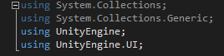

I will attach to those objects also a short description of the ingredient using a public string which I can edit inside the Unity editor.

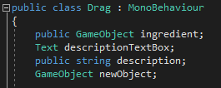

At the start of the program I need to call for the tags of the objects we created in the previous tutorial.

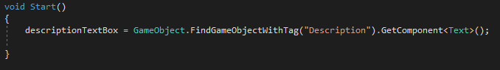

The following lines take the position of the mouse cursor and on click of the mouse button the code will instantiate a copy of the selected ingredient.

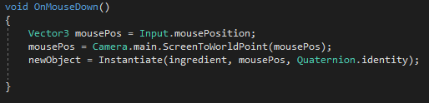

Now I need to be able to transform the position of this object on the “Z” axis as the player will drag it across the scene.

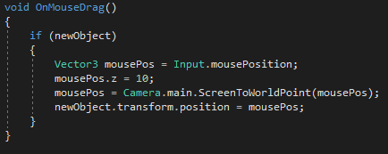

The final touch I want to have attached to this script is to be able to extract the information from the description I have declared in the beginning of the tutorial as I point with the cursor of the mouse. In this I use the function “OnMouseOver”.

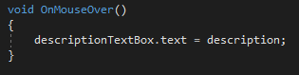

With this my draggable objects are ready to use.