Tutorial #3

In this tutorial I am going to add some more detail to the objects to move around the scene, the drop mechanic. For this I will declare that I am in use of the game controller and the layer I want to drop on top of.

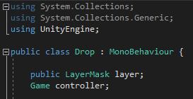

The program will start with finding the game controller.

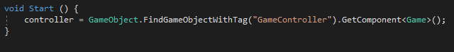

And will update the program with taking input from the mouse button, in this case want to get something on the release of the left mouse button using the function “GetMouseButtonUp”. But to make sure I will be able to drop my item only on the right spot I will use “Raycast”.

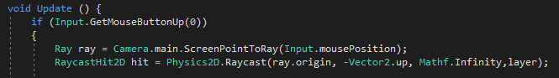

In the next line I am using “If” and “Else” statements which will allow me transform the position of the ingredient, if its placed on a drop zone, and immediately after that will delete this script from the instantiated object so the player won’t be able to move it again once its there.

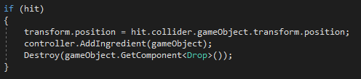

One final touch to this script will destroy the ingredient object if it’s not placed on a drop zone, so it won’t make mess all over the scene with different instances of the objects.

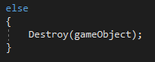

Here is the whole class compiled to use.

