Tutorial #4

The last script I am going to prepare for the component is going to be a button that submit the ingredients. Simply call for the Game controller.

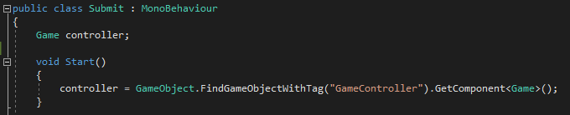

And tell that will submit the ingredients on a click of the left mouse key using the function “On Mouse Down”.

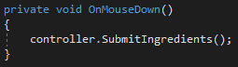

Where “Submit Ingredients” is a function I created earlier in the first tutorial. Inside the Game Controller I will insert an if statement that will say: if the ingredients are correct to the library, instantiate the result into the next empty slot.

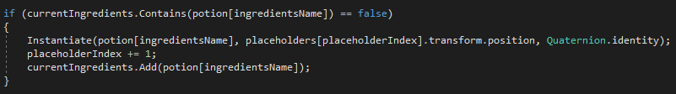

I also want my code to destroy the objects right after the submission and reset the list if there is a new instance.

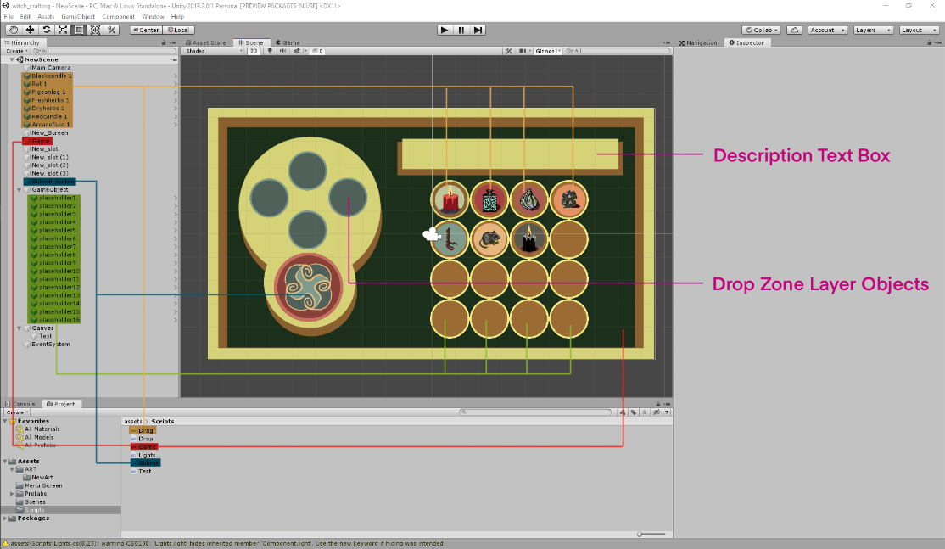

On this picture I am showing where the scripts are attaching. The game controller is an empty object in the corner of the scene, the ingredients use draggable script and a custom sprite, submit button has attached the submission script and a custom sprite. Place holders are part of the UI grid where the new items will be instantiated, drop zone objects have custom sprites and a layer tag referring to the ray cast check I created earlier in tutorial #3. On top of the UI I placed the description text box created in tutorial #2.