Game Programming

Player Movement Tutorial

In this series of tutorials I will demonstrate how to build a simple Pac-man like games, where the player will have to evade an enemy and whilst collecting items to increase their score and power ups which will allow them to temporarily kill the enemy.

In this tutorial I will go through how to make your make your player character move around the game space.

1. Place your character sprite within the game screen, then inside the inspector you want to add a 2D collider (whichever is the most suitable for your sprite). 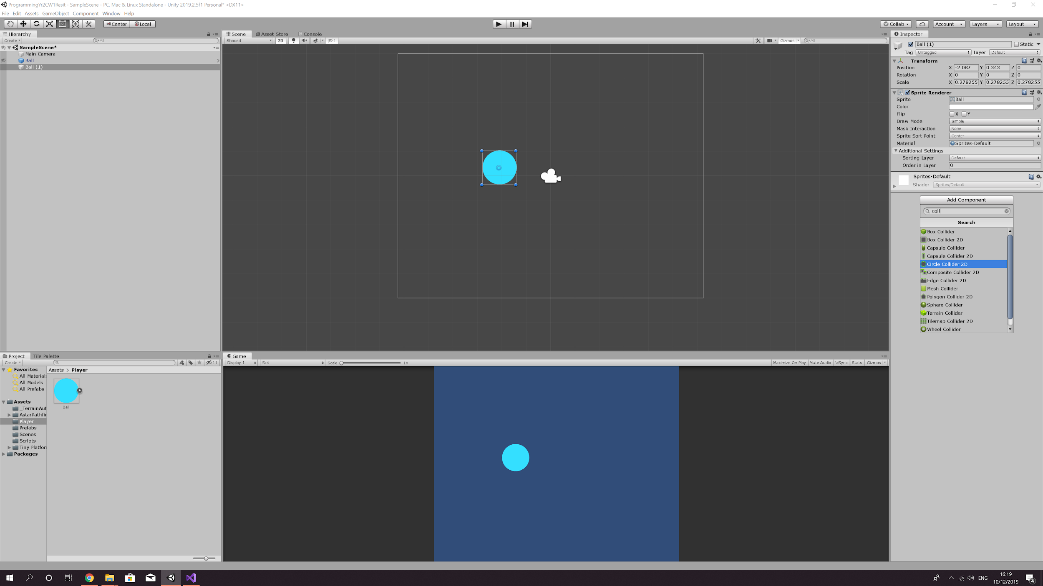
2. You then will need to add a Rigidbody2D. Once added open the constraints tab and freeze rotations around the z axis, this will stop your sprite spinning like a wheel when collides with another object.

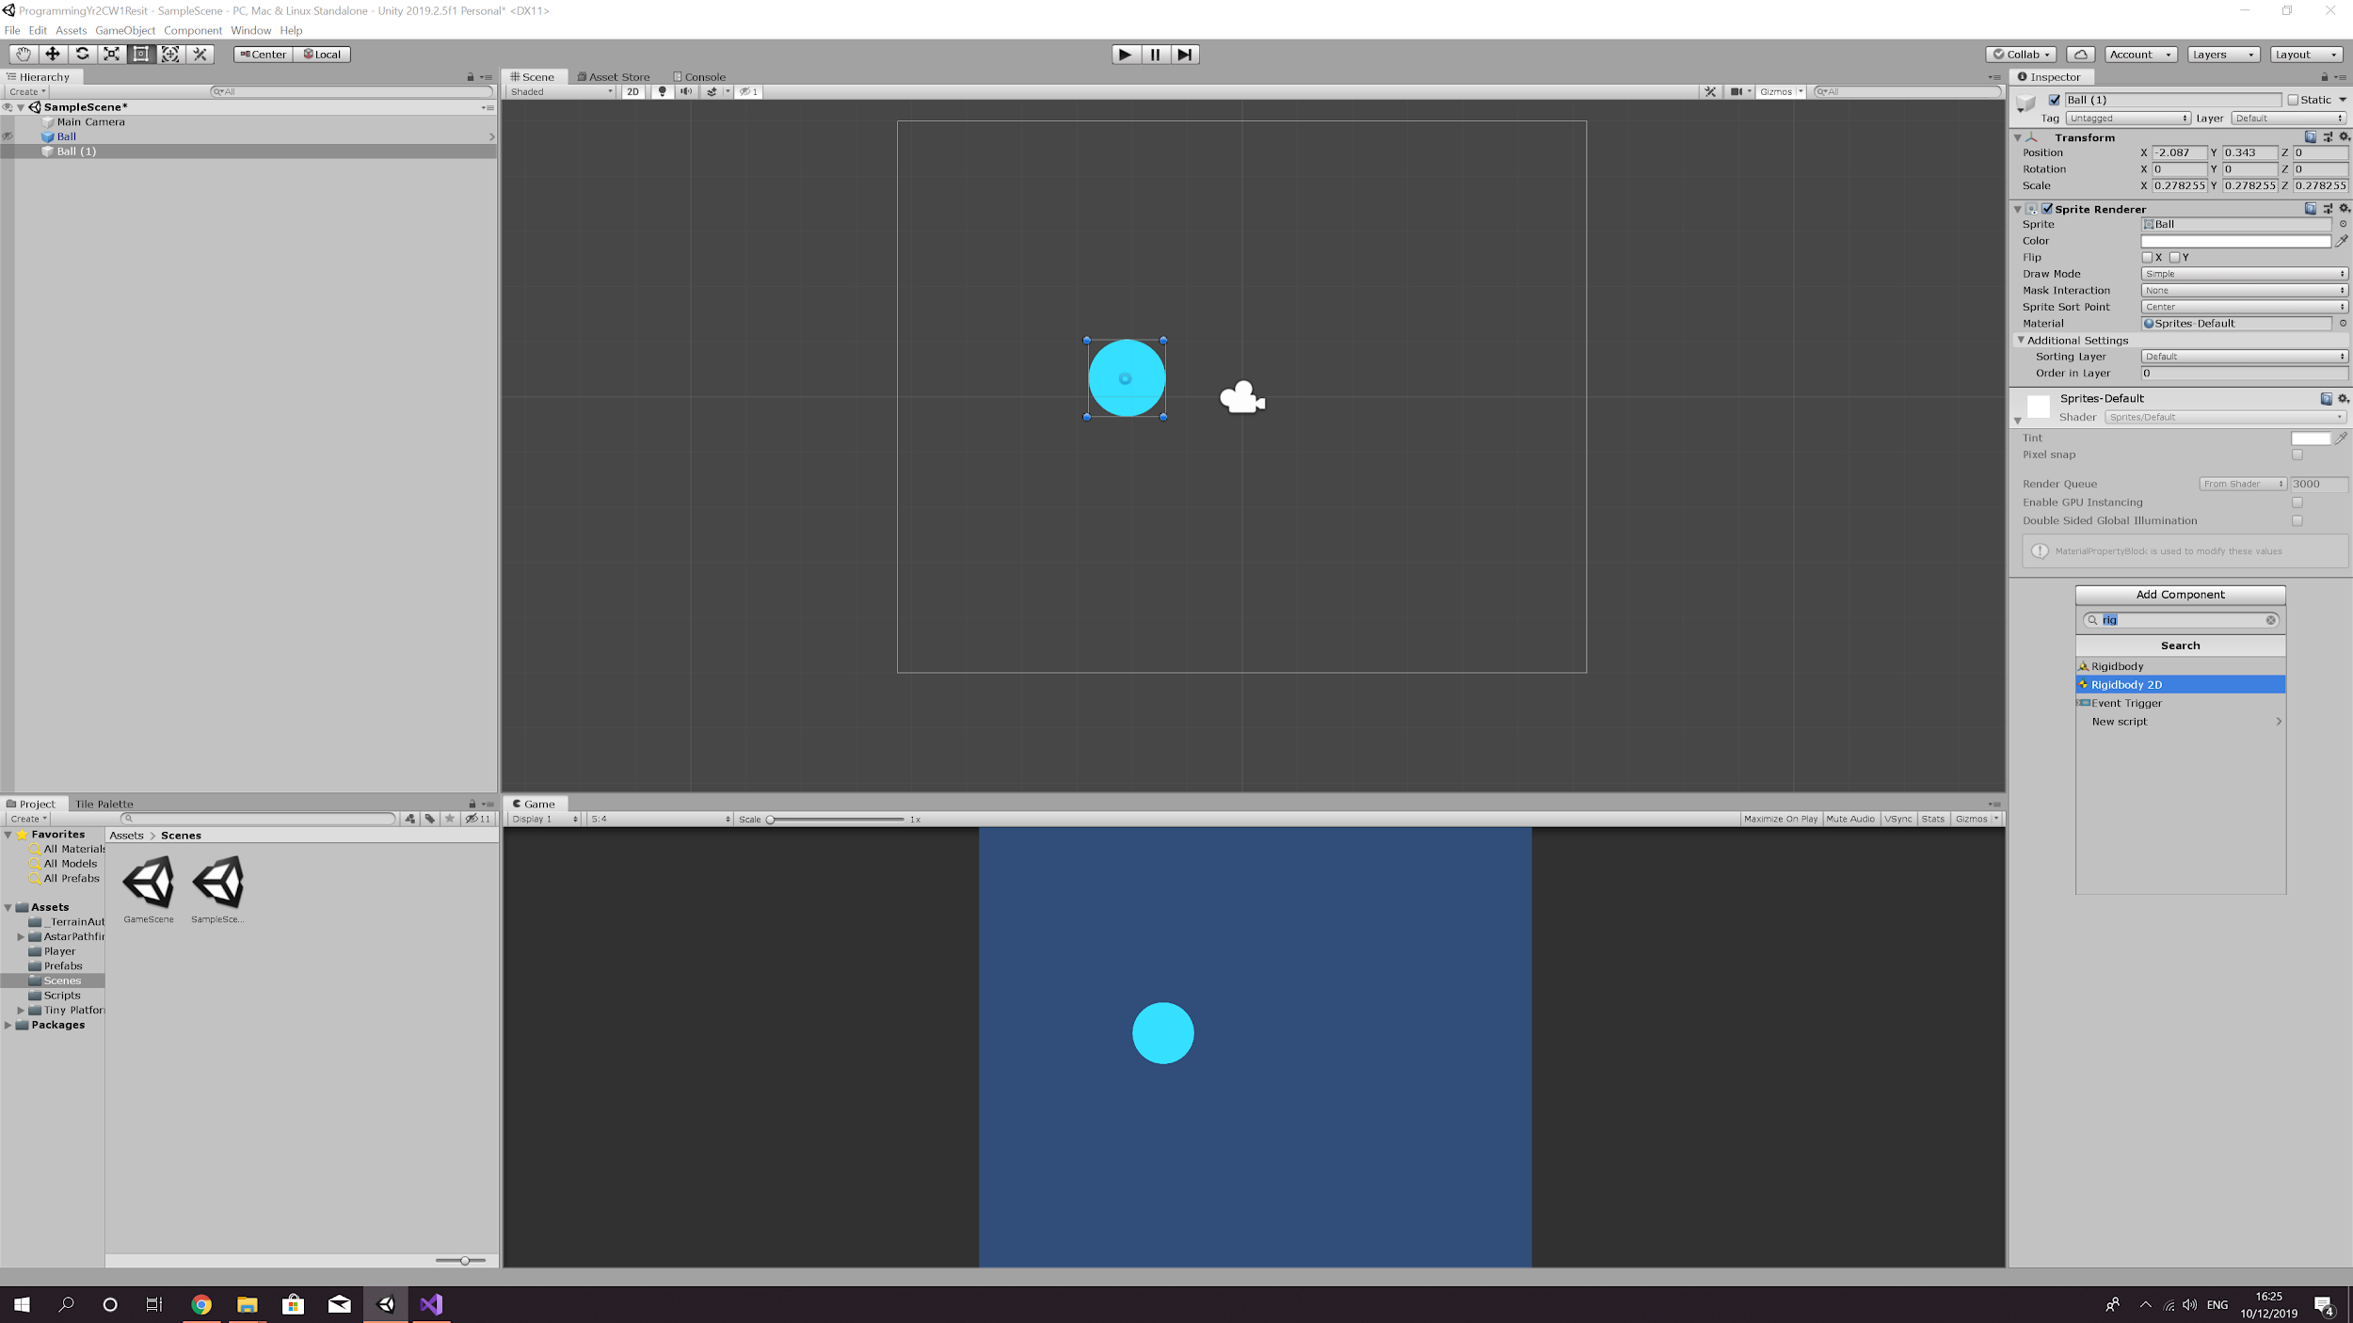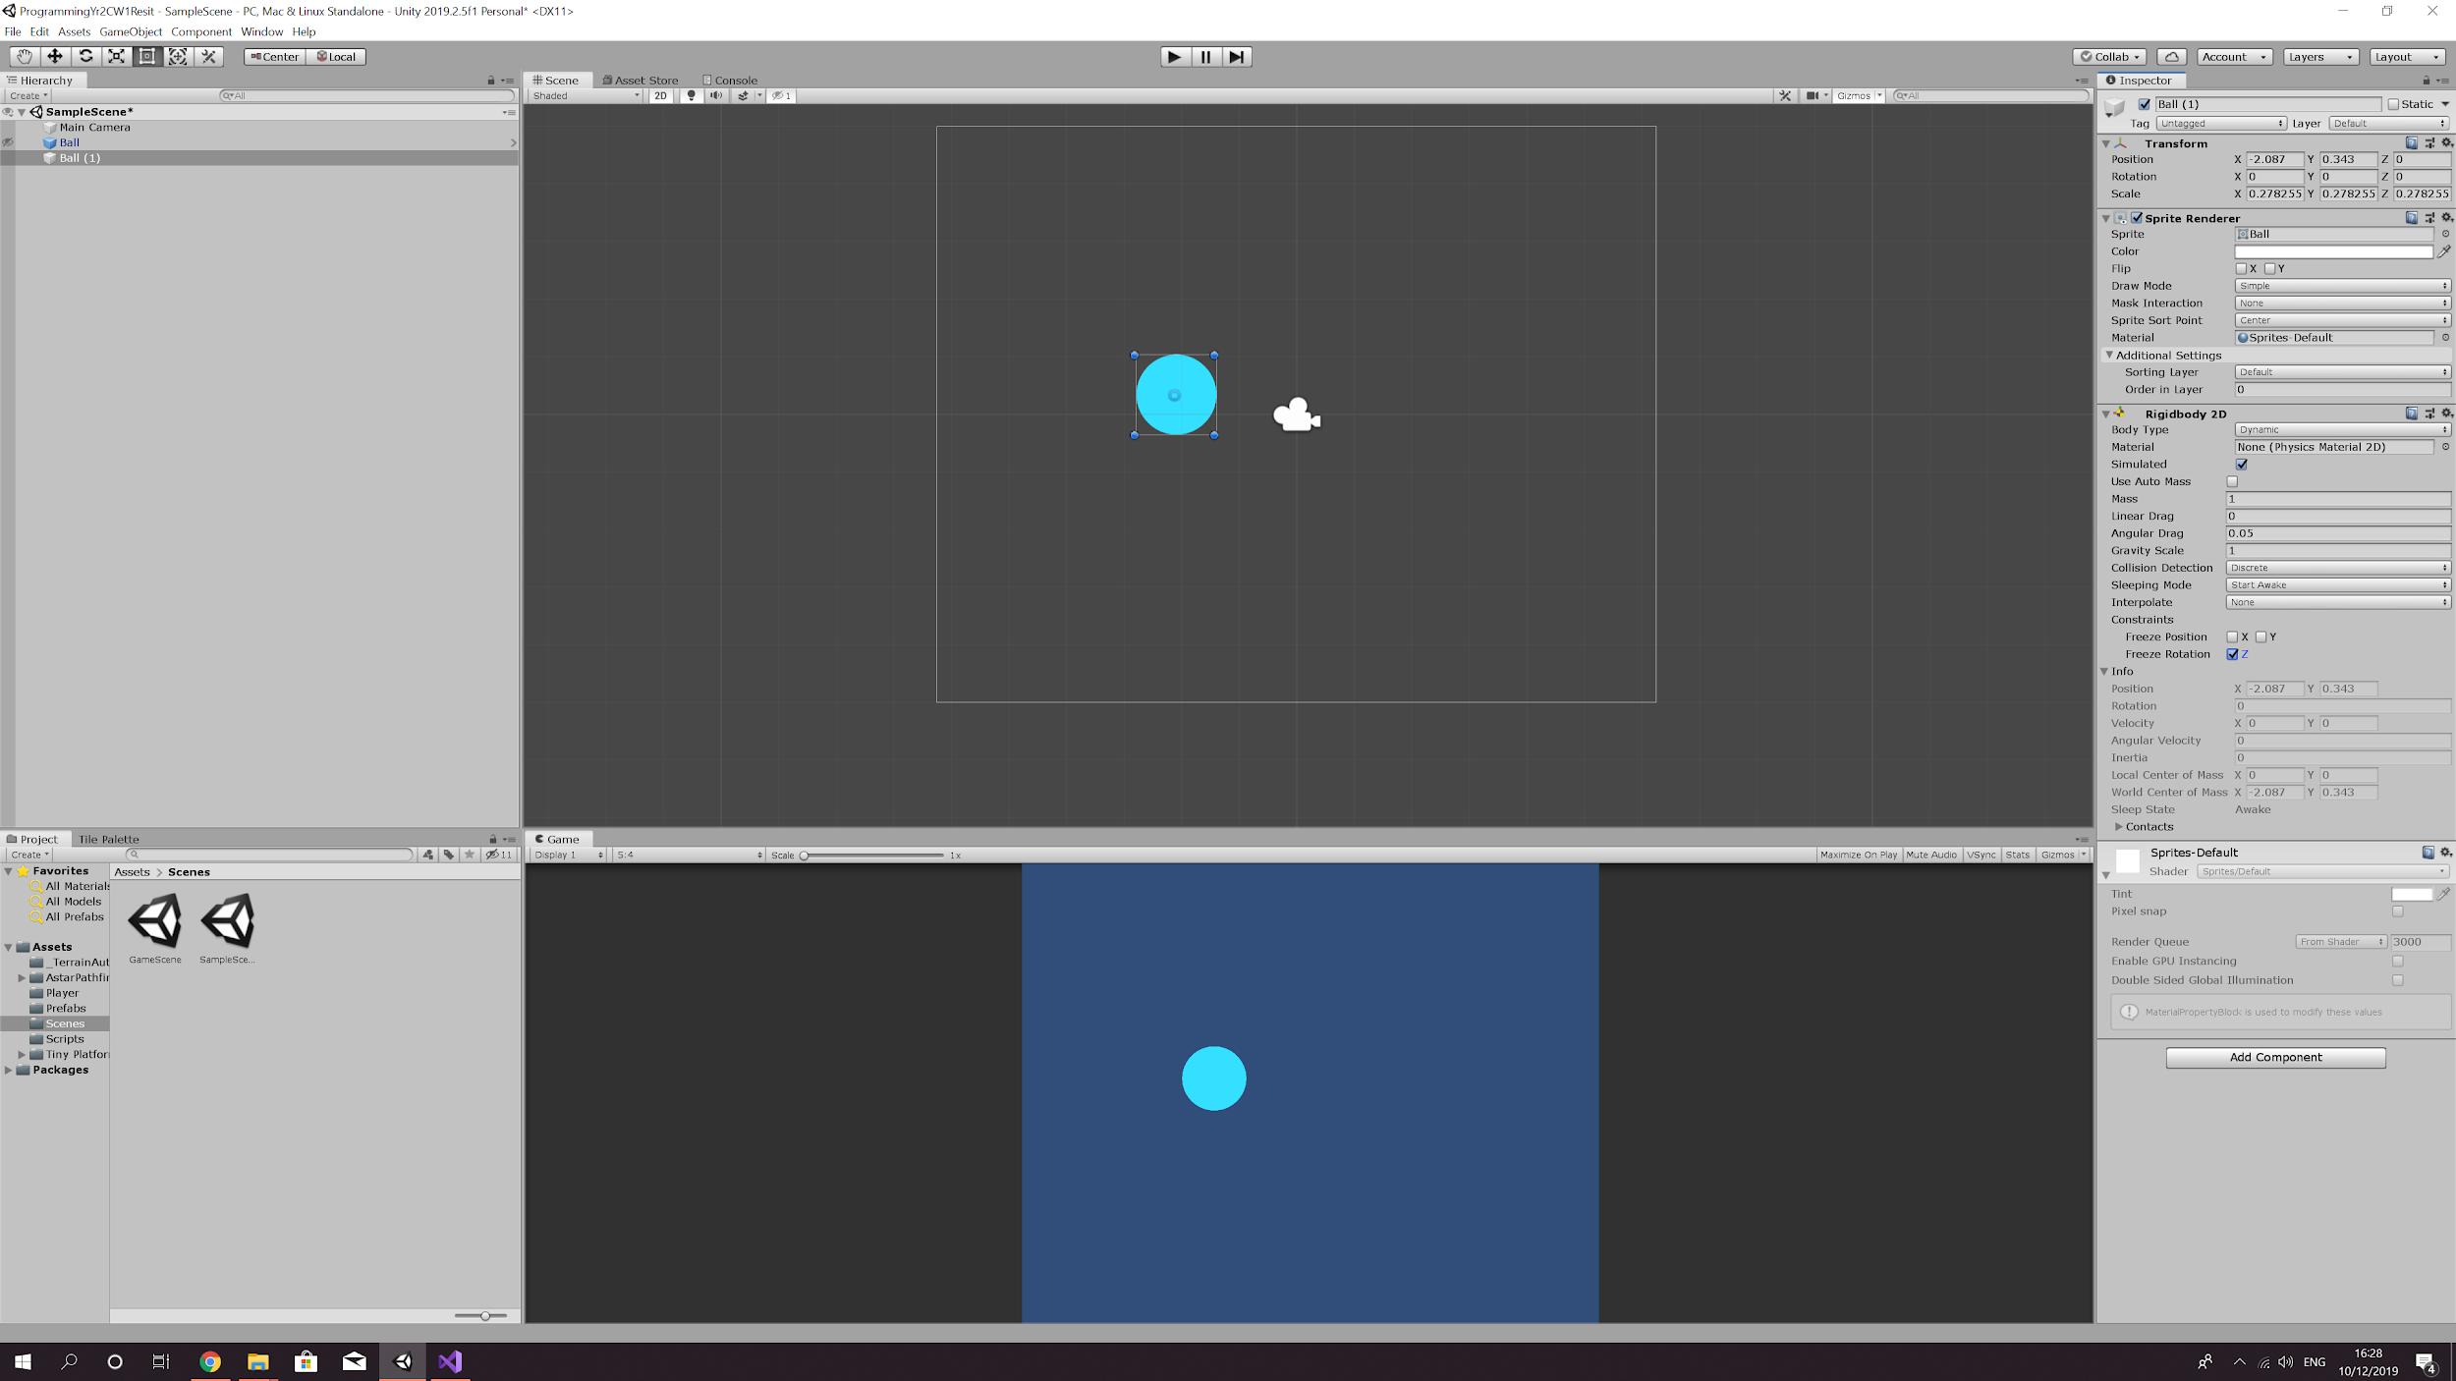

1. Now you need create script so that the sprite can be moved. So, go to the scripts folder in your project and right click > Create > C# Script and name the script ‘PlayerMovement’.

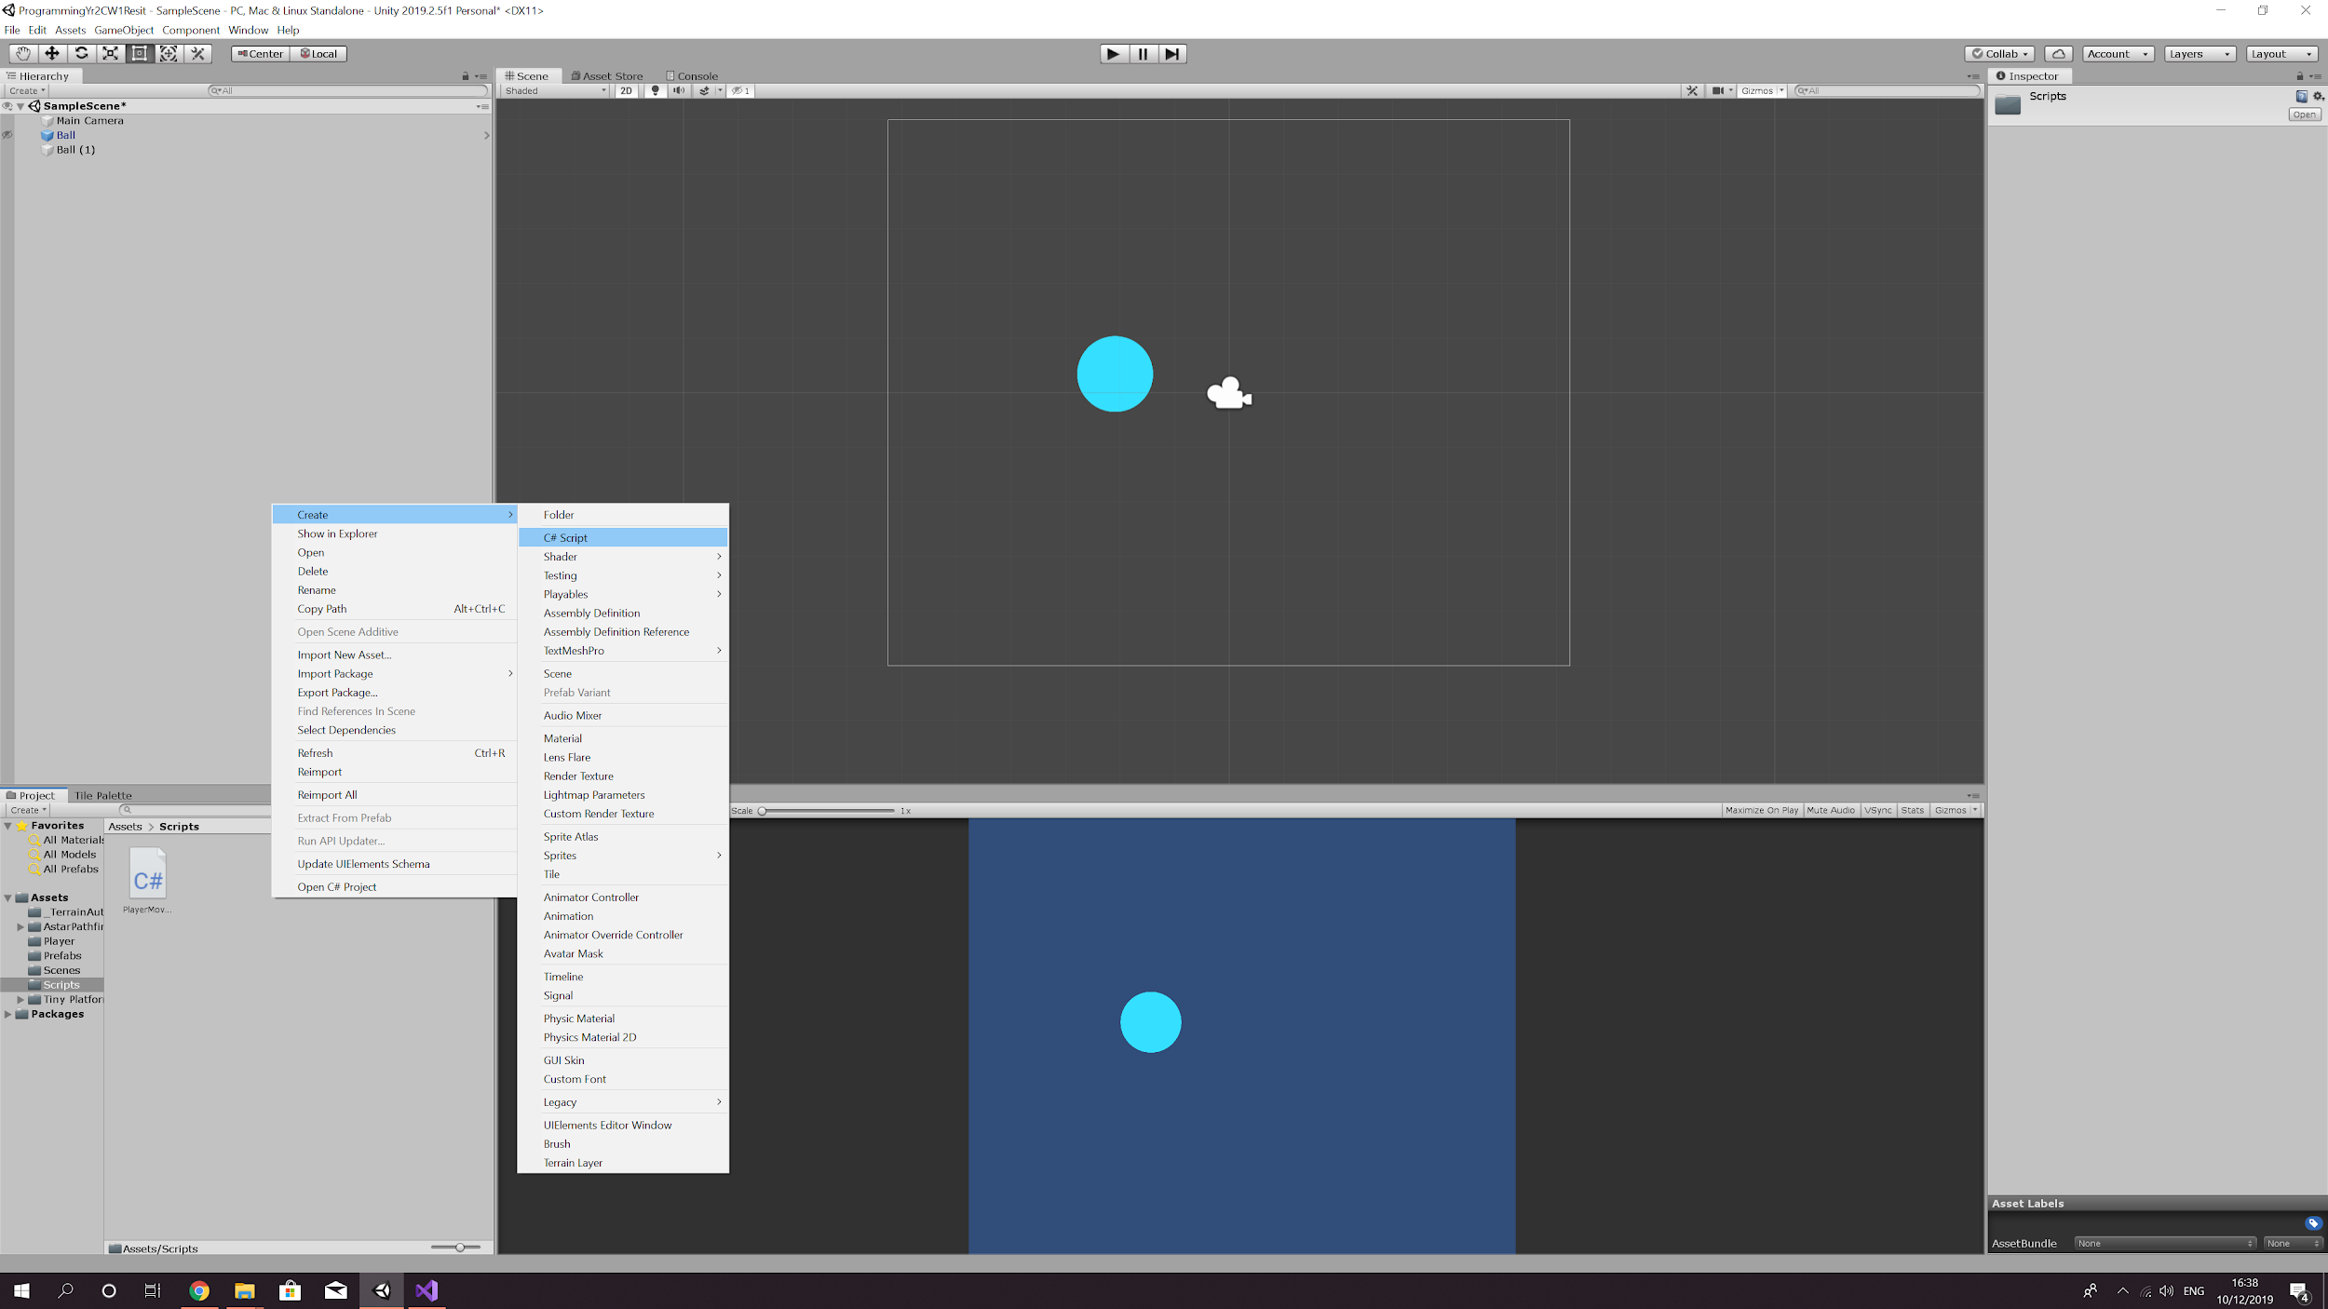

1. Double click the script to open it in your script editor. You will now be looking at a blank script.

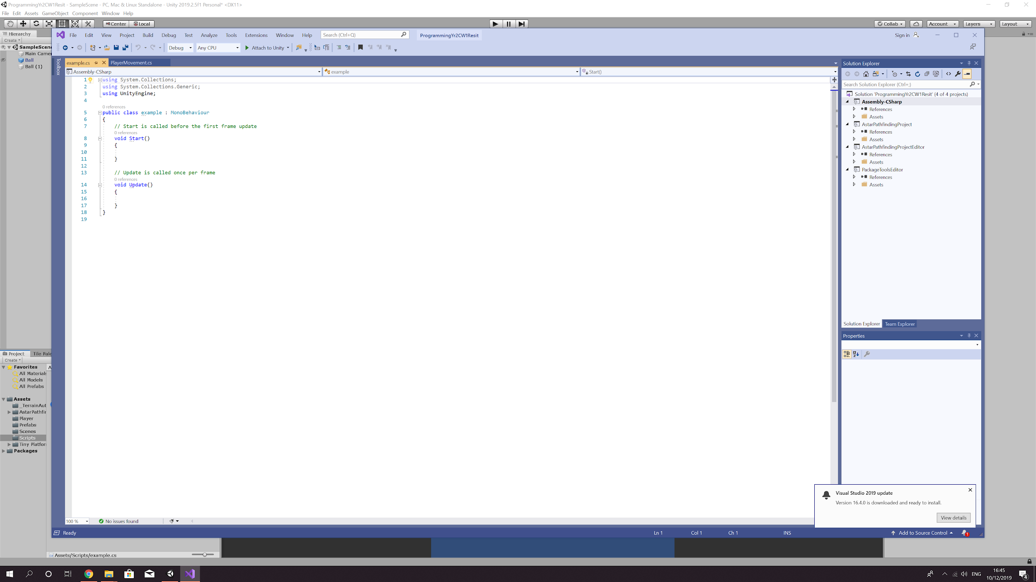

1. The first thing you will need to do is add some variables:

* public float speed; ---> by making this public you will be able to change the speed via the inspector.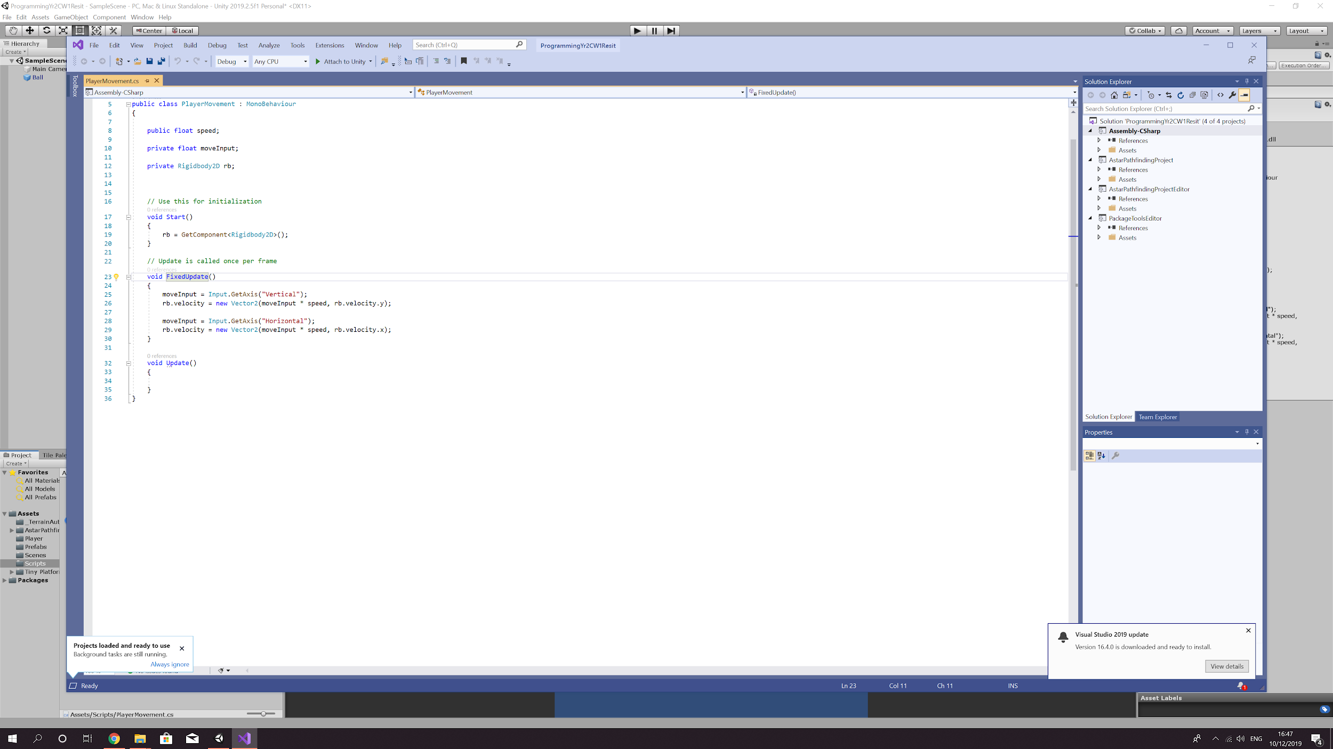
* private float moveInput;
* private Rigidbody2D rb;

1. Inside the Start function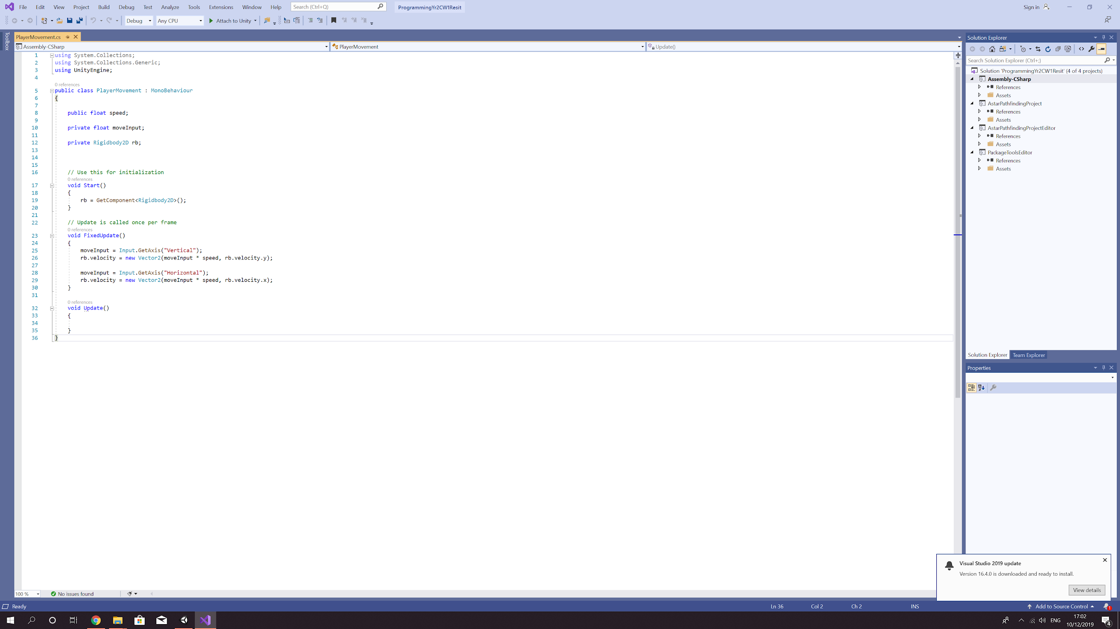
2. Inside the Update function.

* moveInput = Input.GetAxis(“Vertical”/”Horizontal”); ---> taking directional information from the input manager (Edit > Project Settings > Input).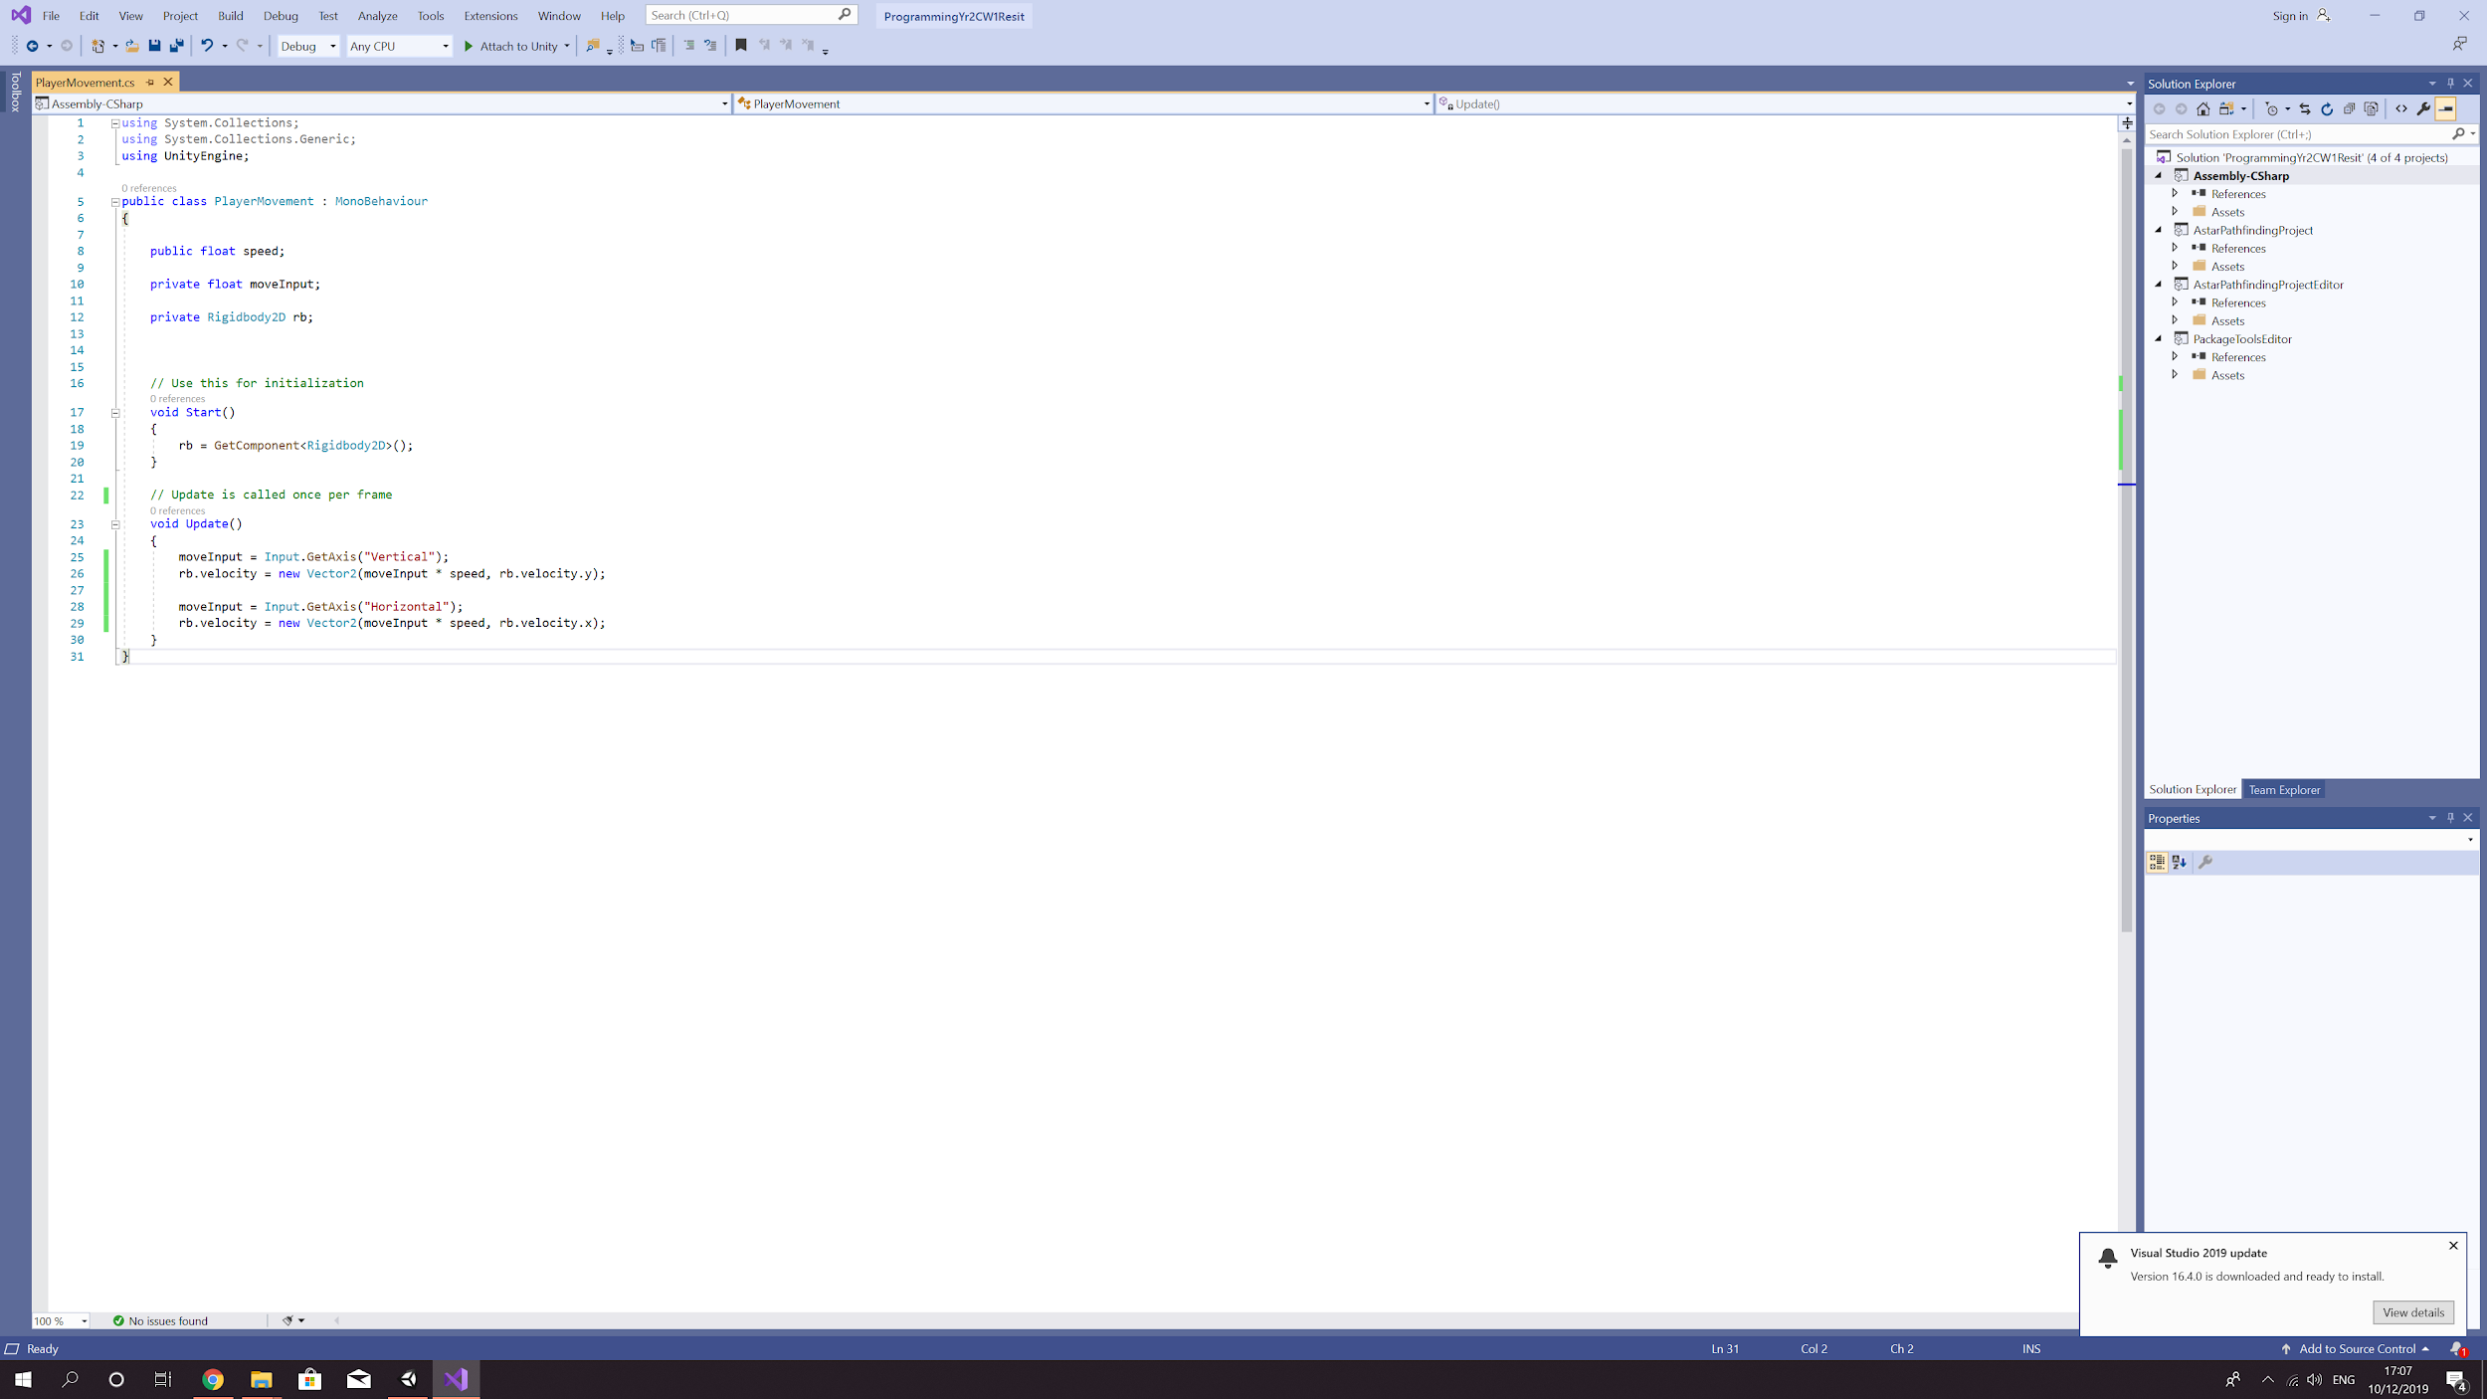

1. Save your script and add it to your sprite and set the speed. Now you should be able to move your sprite left, right, up and down.

using System.Collections;

using System.Collections.Generic;

using UnityEngine;

public class PlayerMovement : MonoBehaviour

{

public float speed;

private float moveInput;

private Rigidbody2D rb;

// Use this for initialization

void Start()

{

rb = GetComponent<Rigidbody2D>();

}

// Update is called once per frame

void Update()

{

moveInput = Input.GetAxis("Vertical");

rb.velocity = new Vector2(moveInput \* speed, rb.velocity.y);

moveInput = Input.GetAxis("Horizontal");

rb.velocity = new Vector2(moveInput \* speed, rb.velocity.x);

}

}

NOTES: