**2D Character Controller**

**Tutorial 1 – Switching between states (characters)**

1. Create a new 2D unity project.

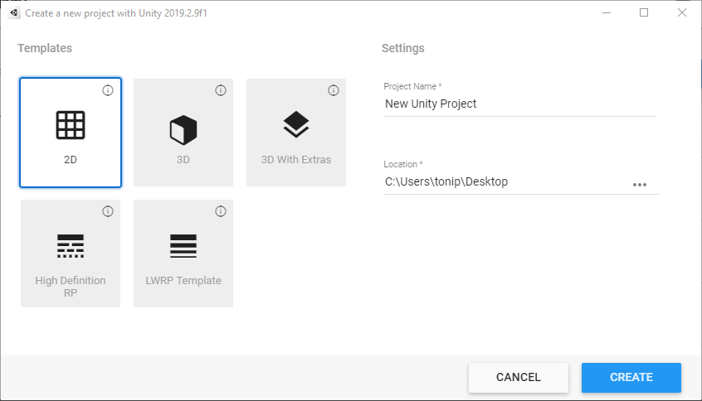

1. 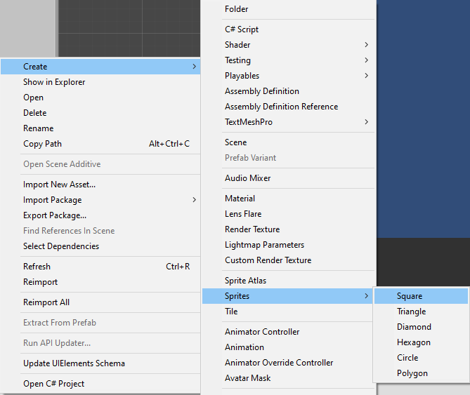Right click in the Assets folder and create 4 Sprite’s - Circle, Hexagon, Square and a Diamond.
2. 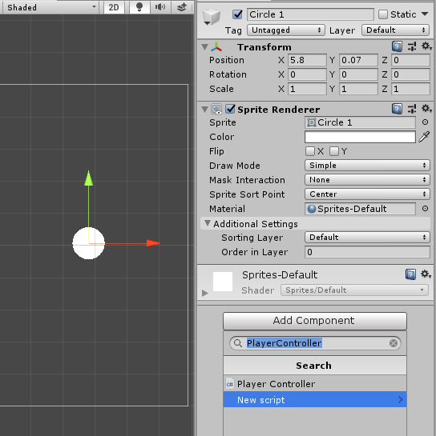Drag one of the sprites in the scene and create a new script on it.
3. Create a public sprite array and a public sprite renderer.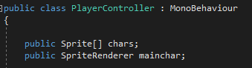
4. In the Update void get the input from four keys and set the main sprite to change to a sprite from the sprite list.

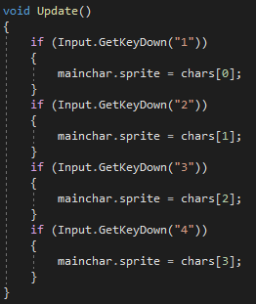

1. Set the Size to 4 and drag the 4 sprites we created earlier into them. Also drag the sprite from the Hierarchy(from the scene) into the Mainchar slot.

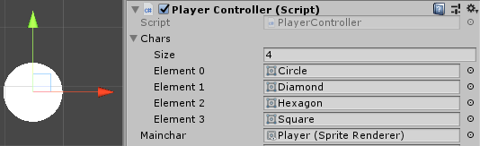

**Tutorial 2 – Character movement.**

1. 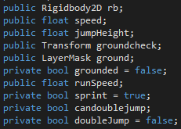On the “PlayerController” script create the following elements –
2. Create a void FixedUpdate.
3. 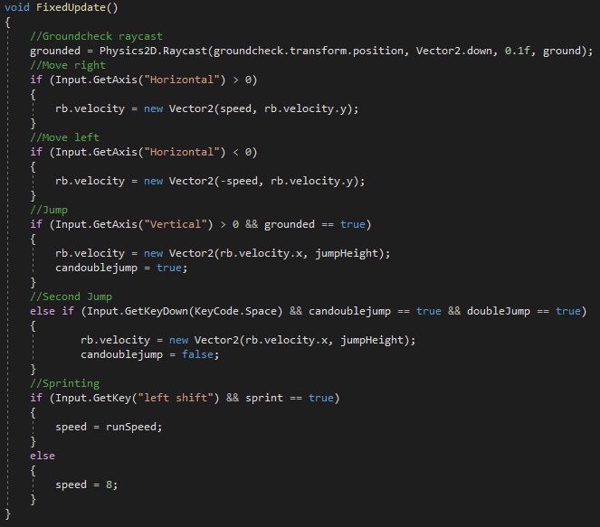Add the following code to the FixedUpdate –
4. 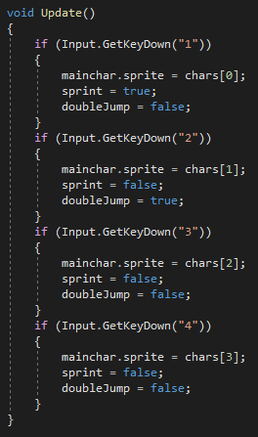Add the sprint and doubleJump bools to their characters.
5. 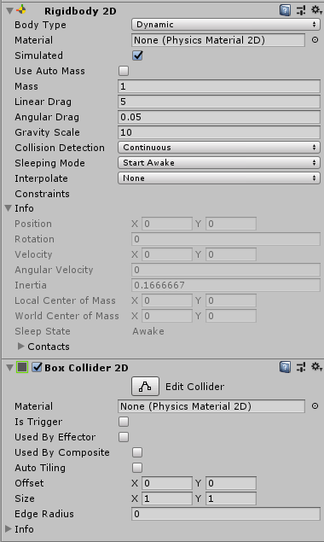Add a BoxCollider2D and a Rigidbody2D to the sprite in the scene and set the values on them as shown in the image.
6. Create and empty GameObject in the scene name it Groundcheck and add an empty script to it.
7. 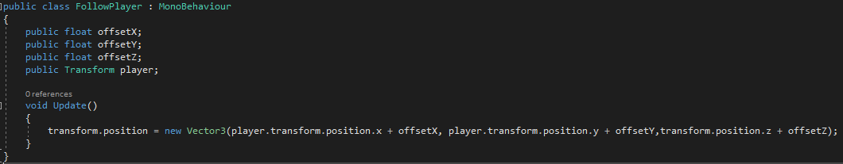Add the code from the image to the empty script.
8. 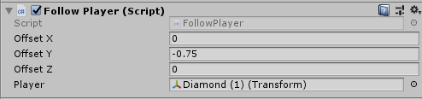Set the Y value on the script to -0.75 and add the Player to it.
9. 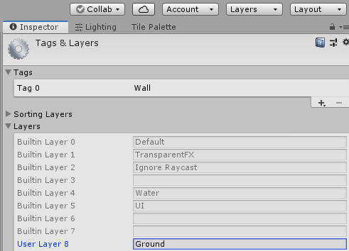Create a new Layer called: “Ground”
10. Set the layer on the floor to “Ground”
11. Add the components to the character controller and set the values as shown in the image –

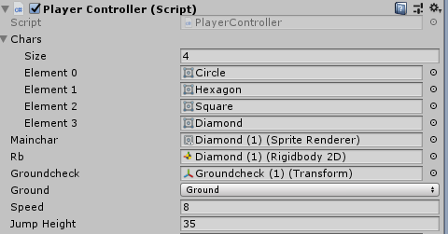

**Tutorial 3 – Sticking to walls.**

1. 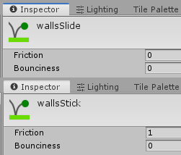Create 2 2D physics materials. One with 0 and one with 1 friction.
2. Create a public reference in the script to the materials.
3. 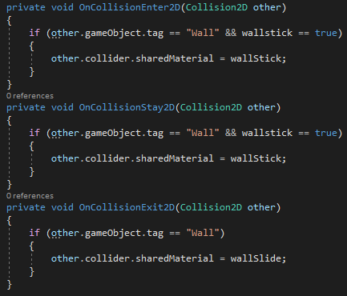Add the following code –
4. 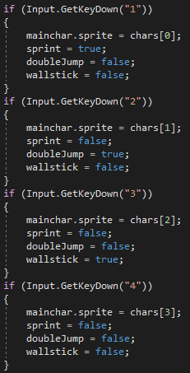Add the bool to the characters –
5. 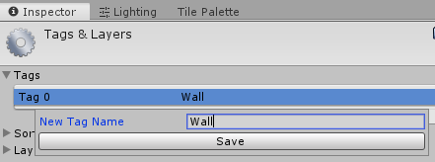Create a new tag with the name “Wall”
6. Add the material with 0 friction to “Wall Slide” and add the material with 1 friction to “Wall Stick”
7. Tag your walls.

**Tutorial 4 – Teleportation.**

1. 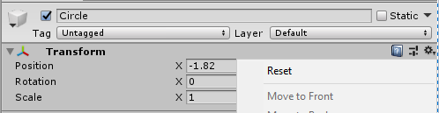Drag another circle sprite onto the scene and in the Hierarchy make it a child of the “Player” and reset its transform.
2. Set the layer to be lower than the layer on the player and make it semi-transparent and add colour to it.

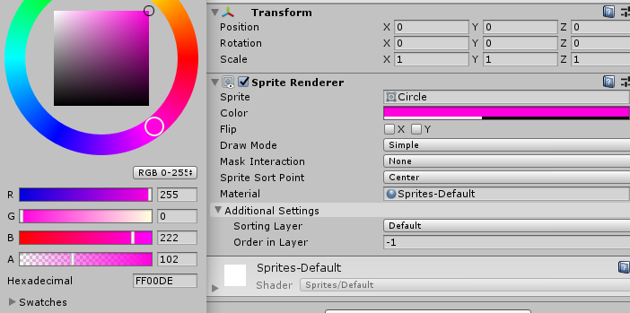

1. 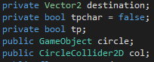In the player controller script add the elements from the image –
2. 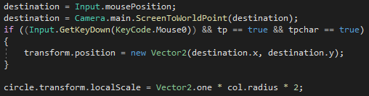In the void Update add this code –
3. 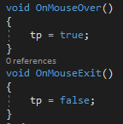Create a OnMouseOver and a OnMouseExit voids and set the tp bool to true and false on them.
4. 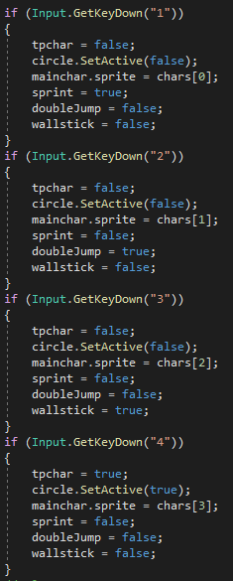Add the bools to the characters.
5. 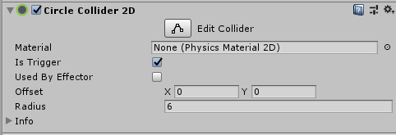On the “Player” GameObject add a circle collider that is a trigger.
6. Add the circle collider and the child GameObject to the script

