**Random Movement of a Player or an Object**

**How to use:**

1. 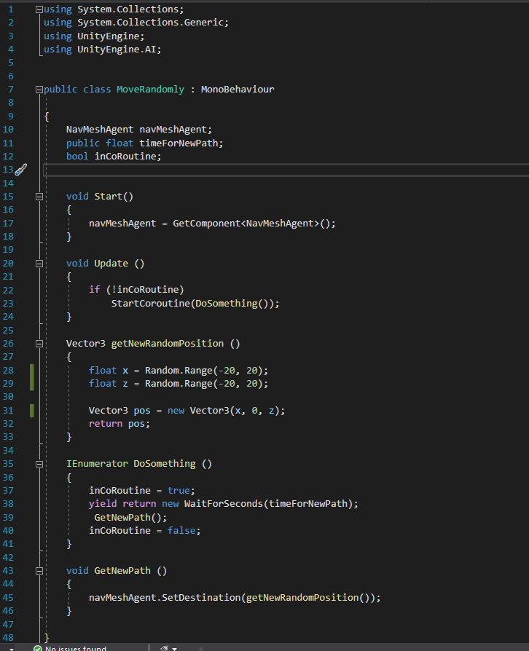**Add Script to you object you want to move randomly.**
2. **Create a nav Mesh Agent from the Add Component box.**

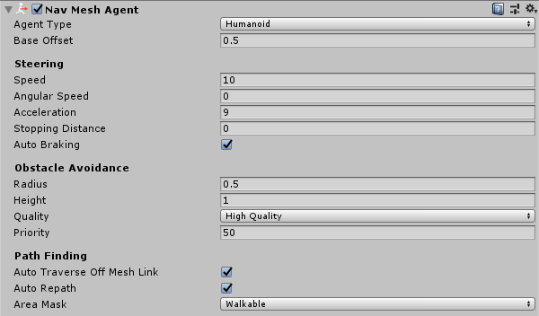

1. **Select the area/Object which you want the random movement to take place and bake it.**

**3.1) Open the Navigation tab which can be found under window >> AI>>Navigation**

**3.2) Make it Static and walkable.**

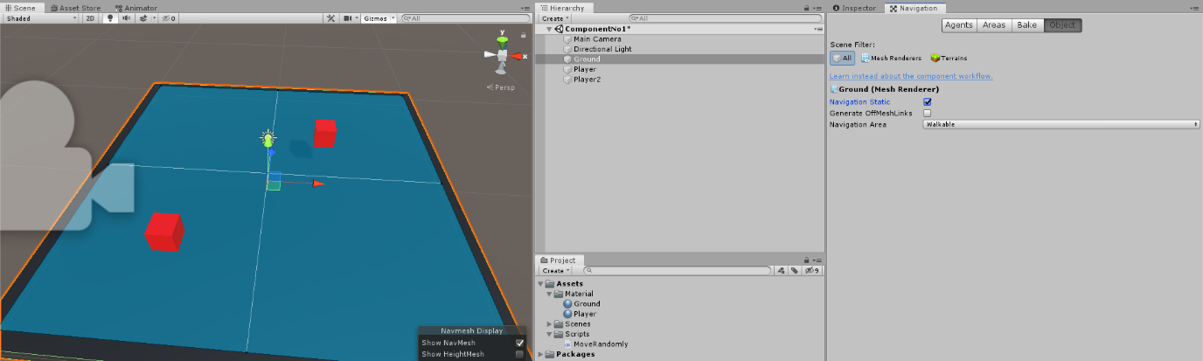

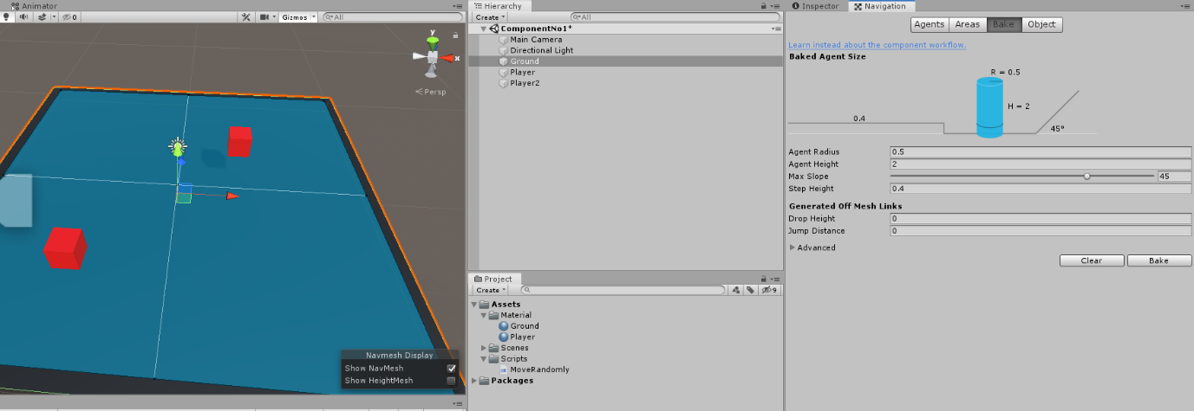**3.3) Head over to the bake tab and bake the scene. (It will turn blue which) The valuables under bake tab determine the area which you want to bake which means the area which your objects will be able to be moving randomly.**

1. **Controlling the valuables of the random movement.**

**4.1) Time for New Path: This Controls the amount of time the object will take to set a new random direction as well as how long will maintain it.**



**4.2) Basically most of the controls come under Nav Mesh Agent.**

**Base Offset: How up or down you want the mesh of the object to be.**

**Speed: The speed of the random movement.**

**Angular Speed: The speed of which the object will turn.**

**Acceleration: Determines the rate of which the object will change its pace.**

**Stopping Distance: Determines the radius which the object should stop.**

**Area Mask: Must be put on walkable in order for the object to move.**

