**Camera control and smooth follow up**

**How to use:**

1. **Add Script into you Camera.**

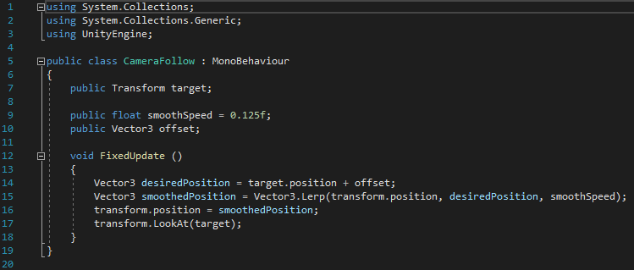

1. 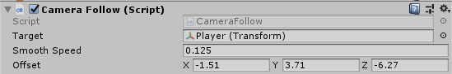**After Adding the script to your camera, you will get the following Target/Smooth Speed/Offset.**

**2.1) Target: That is the object that your camera will focus on following. Make sure you drag the object that your camera wants you to follow and place it in the Target’s box. (In my case the Player)**

**2.2) Smooth Speed: That determines the smoothness of your camera’s follow up.**

**2.3) Offset: That allows you to position the camera to your preference X Axis being Left/Right, Y Axis Being Down/Up and Z Axis Being Back/Frond.**