**Making an object or player multiply or scatter into many other larger/smaller objects**

**How to use.**

1. **Add Script into the player or object you want to manipulate.**
2. 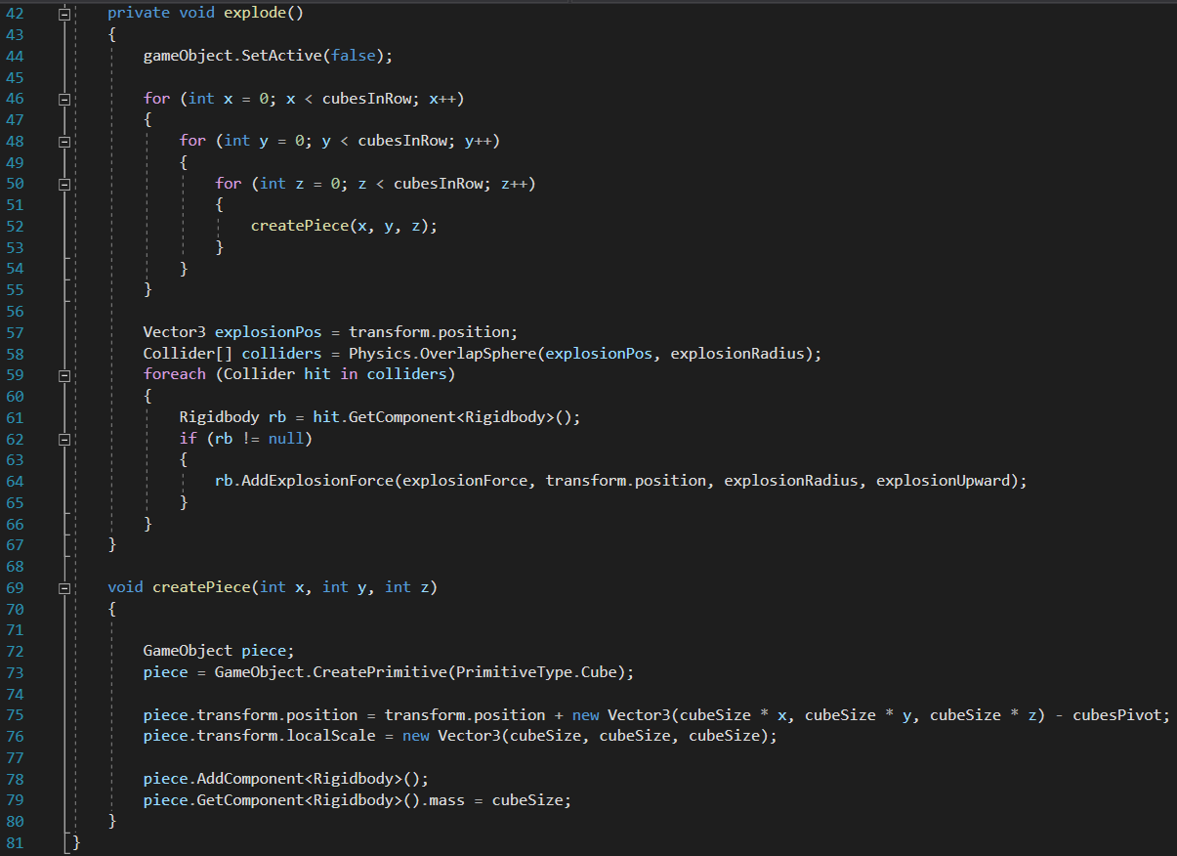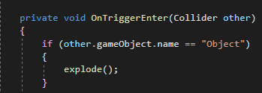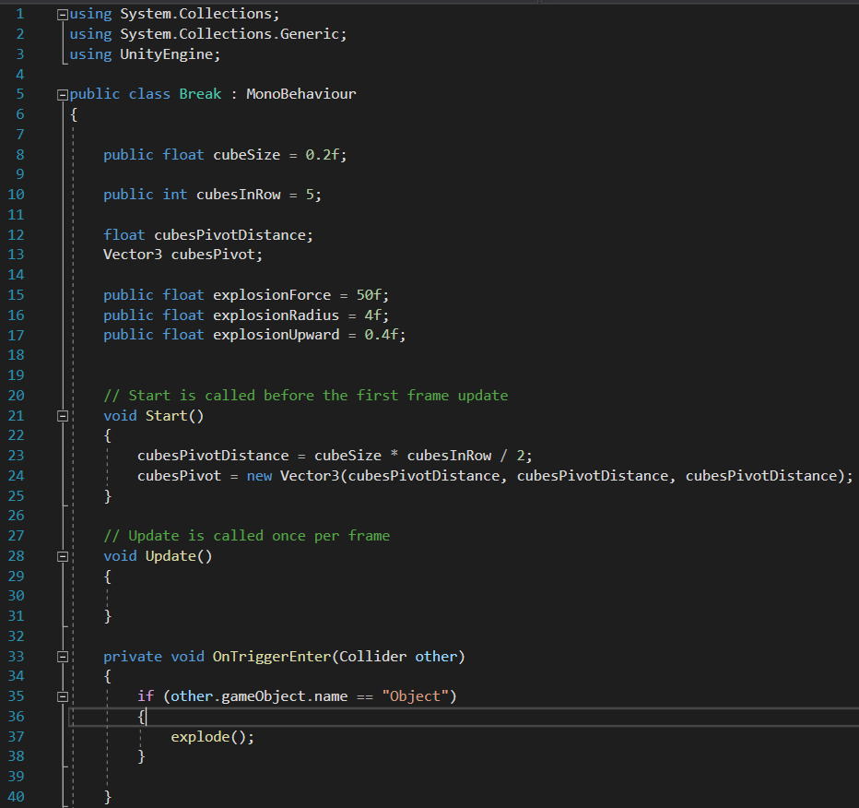**Make sure the object you add the script got colliders as well as the object it will bounce to. Name the object correctly. For Example, in my scene the Object the player bounces to is named Object, so I addressed it as >>Object.**
3. 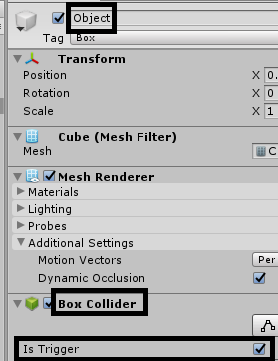**Make sure the your “Object” is triggered**

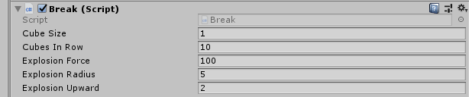**4)Once all in place and you have added the script in to your player or object of manipulation. You will get the valuables of the script which you can play around and attain your own wanted outcome.**

**4.1) Cube Size: That’s the scale of each piece that will be created after the collision.**

**4.2) Cubes In Row: That’s the amount of cubes that will be created after the collision. Example if you set it to 2 that would mean (2x2x2=8) Meaning you will get 8 boxes.**

**4.3) Explosion Force: The amount of force/power that will be given on collision.**

**4.4) Explosion Radius: The amount of area that will be covered by the collision.**

**4.5) Explosion Upward: The amount of y Axis meaning how towards the up they will go.**