**UI Scoring System Based on Time**

**How to Use:**

1. **Write Up Script.**

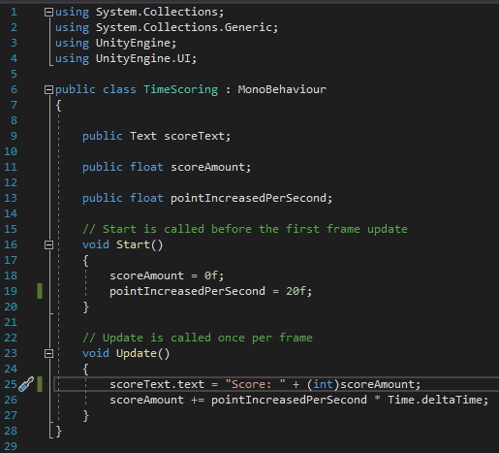

1. **Create a Text (Image for aesthetic)**

**2.1) Rect Transform: Set the position of the image or text in your scene as well as the text within your image.**

**2.2) Text (Script): Manipulate the looks and values of your text such as Style, Size, Alignment, Colour etc.**

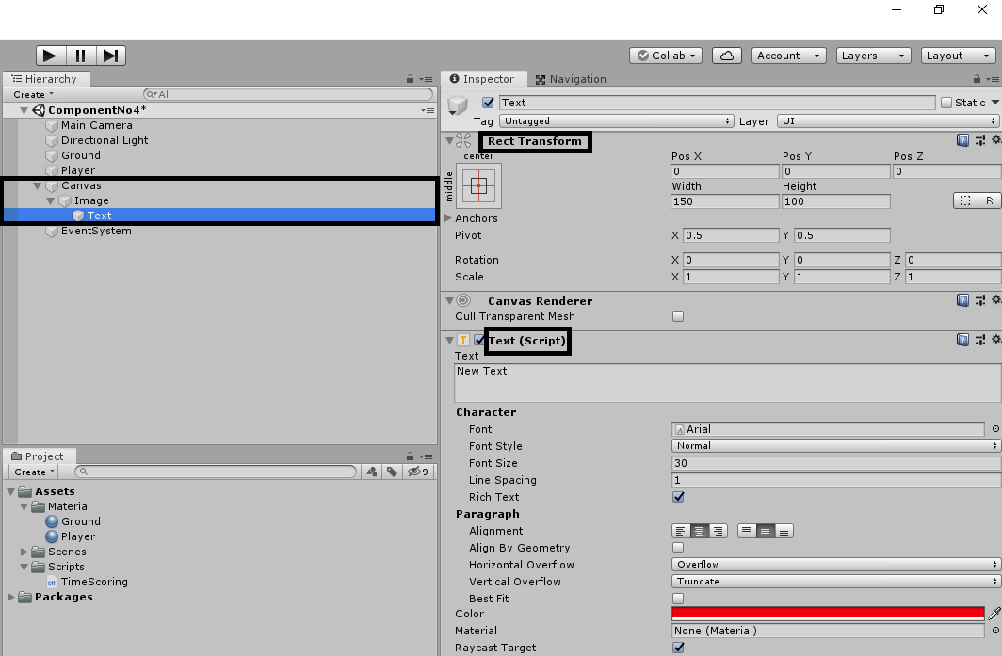

1. **Applying the Script.**

**3.1) Apply the script into your player or the object that you want to be counting until it gets destroyed and drag the text you have created into the Score Text box.**

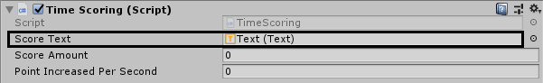

**3.2) Score Amount: The amount of your score.**

**3.3) Point Increased Per Second: The amount of points**

**gained every second.**