When coming up for a game mechanic that I could export into some sort of package I usually try to think of a mechanic that is somewhat essential for most games to have within them. This time I thought of the mechanic where, upon interaction of the player, an amount of text would appear in the game. I thought that this was an almost essential component for a game to have as every game needs to have a tutorial of some sort within it and most games do that with text appearing in front of them saying something like “F to interact”.

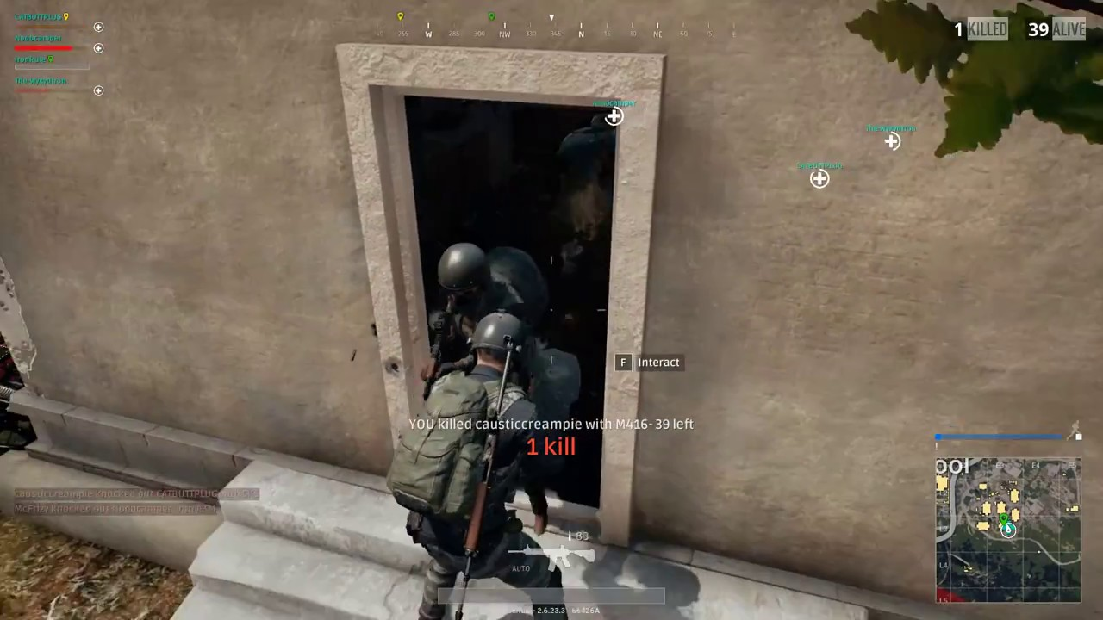

When making the component I found that I will often take, even though a bit shorter then I originally thought I would take, a long time to create a new form of code that I am unfamiliar with. Even though I find this to be somewhat of an annoyance I understand that progress can often be slow until mastered, such as is my skill within Maya, however it is surprising to me that how some form of code when made can be remade in a matter of minutes compared to the hour or so when originally in the making as you know how the code works due to having created it.