This is a documentation for the counting mechanic.

1. 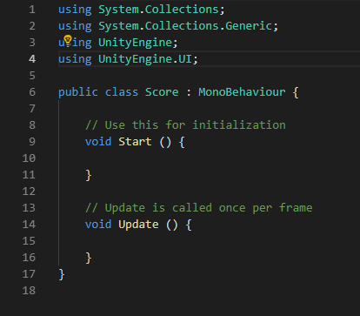I first typed “**Using UnityEngine.UI**”. This was so I could make the script apply to the UI (user-interface).

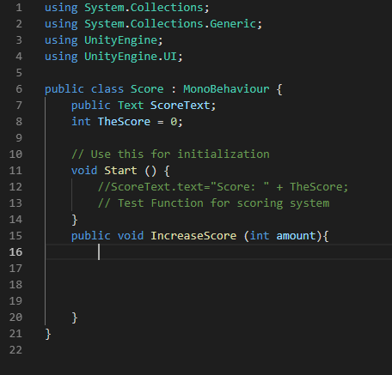

1. I then got rid of the update function as I wouldn’t be needing it.
2. I proceeded to making two variables for the script, this being the “**ScoreText**” & “**TheScore**”.
3. I then added my own void called “**IncreaseScore**” and made it public so I could change and access it from within Unity itself.
4. 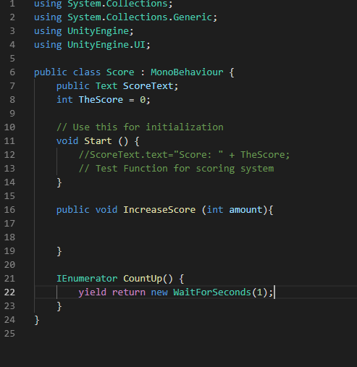I then began to add a counting function which would count up in units of 1. By creating a coroutine function.

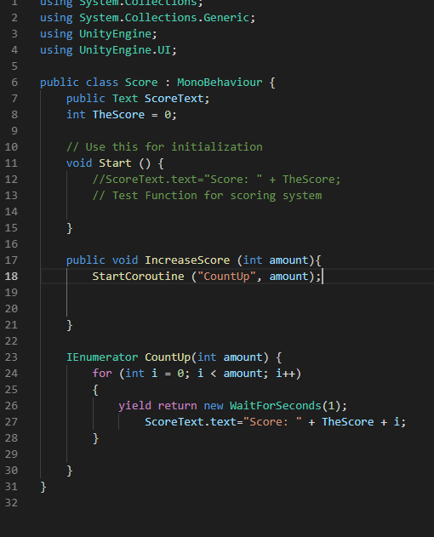

1. I then made the coroutine count up in units of one per second.

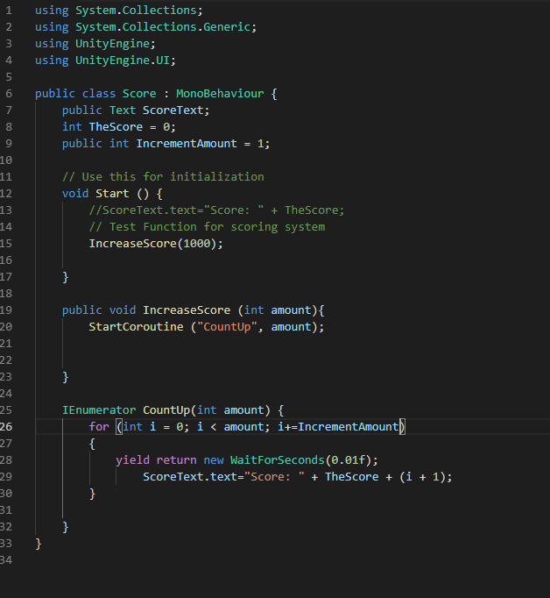

1. I then added in a function that would enable me to edit the amount it would increase by per second within Unity.

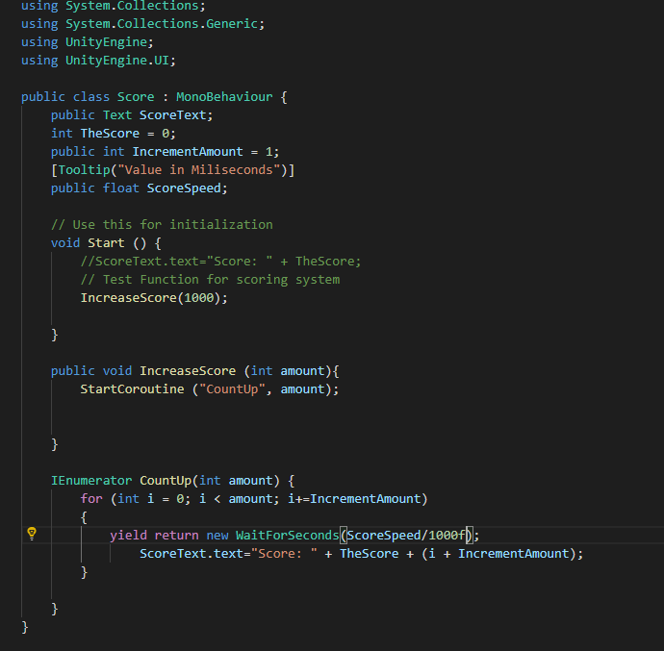

1. I then created a variable for the speed that I could control also within Unity.

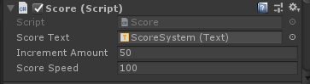

1. This is an image of the function that enables me to edit its speed and the increase amount working in Unity.
2. 