**Programming – assignment 2**

First I make a cube and call it player. I add a rigidbody to it.

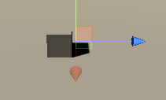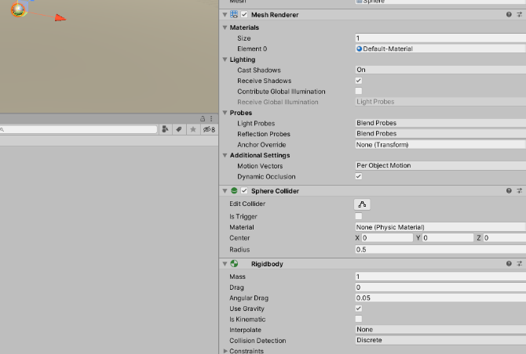

I then make a sphere and call it bullet. This will be the bullet the player shoots.

I then create a empty object and call this emitter. I placed this just infront of the player and then attached it to the player as this is where I want the bullets to be fired from.

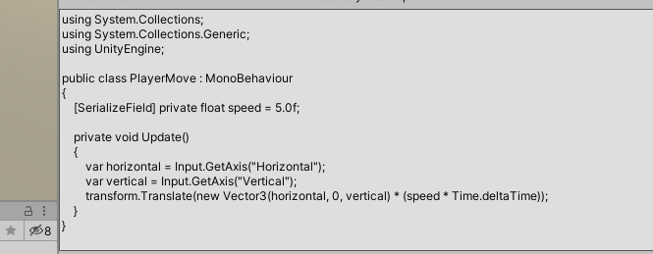**Player move**

Now I have added a player move and camera follow scripts. I got these from a project I am currently doing for a game.

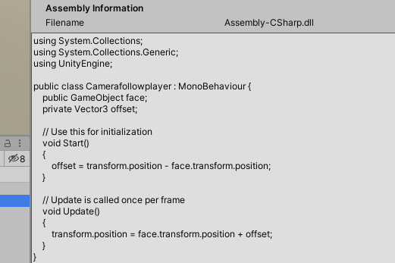**Camera follow**

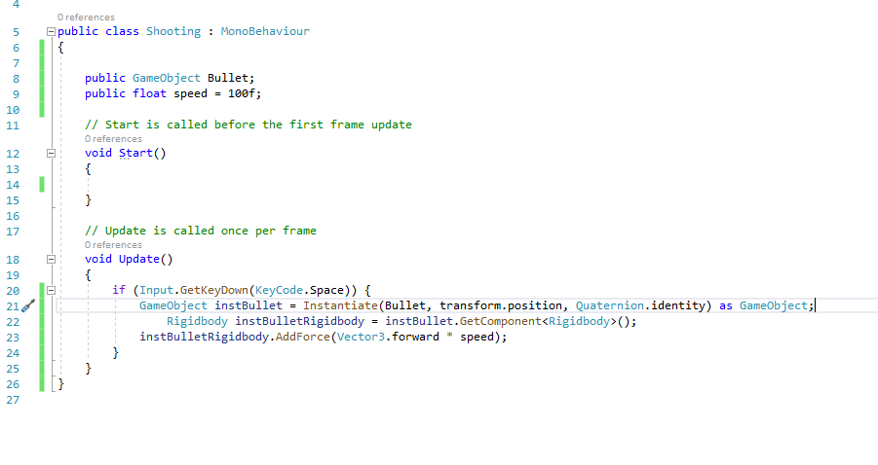**Shooting**

Now I add a shooting script that I got in the link below. I add this script to the emitter.

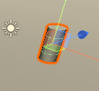

Created an object to be the enemy/target

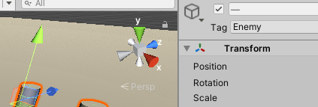

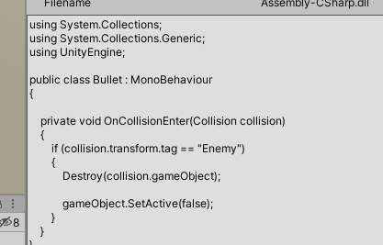

I added this script to the bullet.

This tells the bullet to destroy the enemy once hit.