Tutorials

**Tutorial 1**

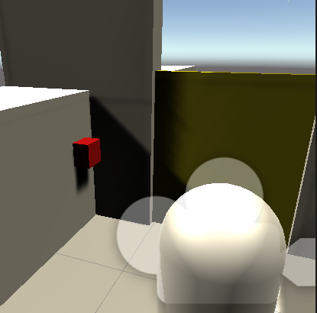My first tutorial was to show a simple button code. This code was going to be used to open and close a door. This is to have a simple door mechanic for the player to interact with.

Red is Button.

Yellow is Door.

When the button is hit it will raise the door up and stay in that position

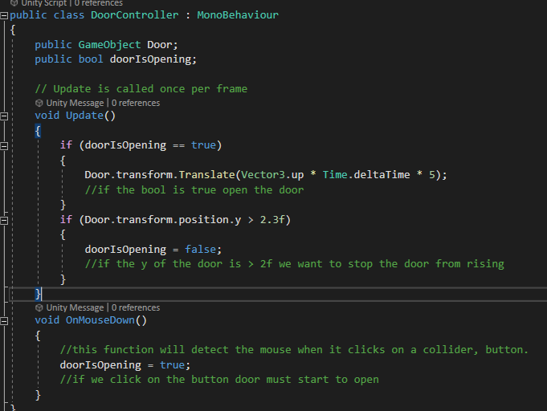

Tutorial 2

The next script I put in in the next scene is the walking, this is because I wanted a simple way to explore the level.

It is a simple scrip using just Void Update.

This is code that im using as a Third Person controller. So where hes looking is where hes going there isn’t a look script implemented.

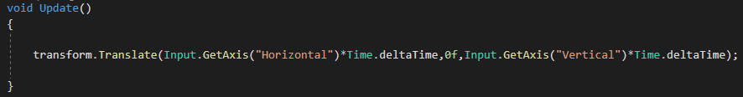“Input.GetAxis(“Horizontal”)” is to move left right on the X and “Input.GetAxis(“Vertical”)” is to move up and down or forward or back on the Y and Z.

Tutorial 3

The next scene is the scene with teleportation code. This is to make it so that you can teleport from Platform “a” to “b”.

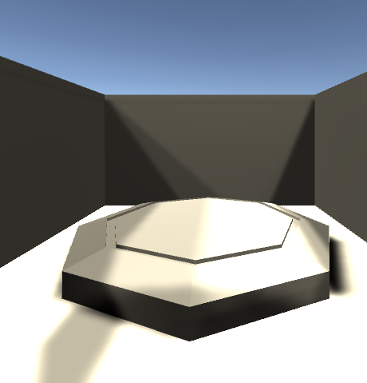

Platforms

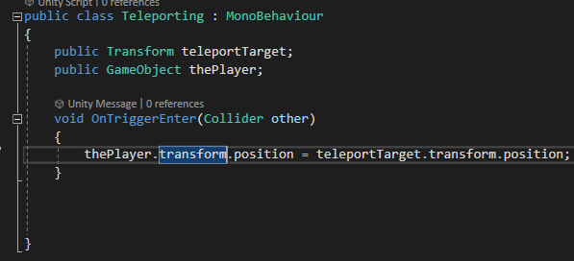

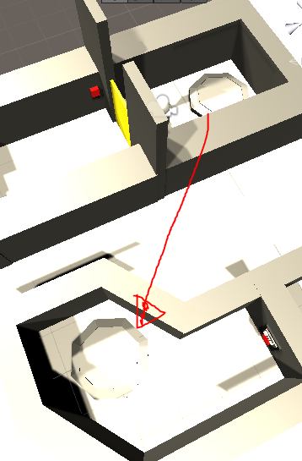Public Transform, is Where you are going to be teleported to, where the other teleport pad is and public GameObject is who is going to be teleported once made contact with the platform. The OnTriggerEnter is to make sure that the player has made contact with the area and will move it to the other platform.

Tutorial 4

I have one last button which is that it will make it so that when the button is hit it will go and change scene to the scene allocated to the button.

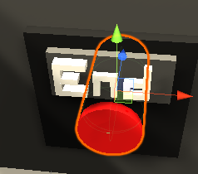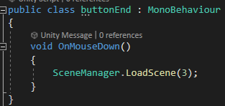

The script is very simple, Void OnMouseDown, is when the mouse is pressed anywhere on the cylinder collider of the button, it will look in Scene manager and Load the scene, in this case it is scene 3.

Tutorial 5

The final tutorial is of a Quit button that is on the The End screen. This is to make sure that when you have finished the game that the level is going to quit. 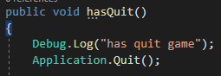

Debug.Log(“has quit game”) this will just be mainly used in unity to show that it is responding and if the button can be pressed. “Has Quit Game” will show in the console of unity. Application.Quit is the command to quit and close the game.

Beginning of my Tutorial scripts, I decided to first create a simple level with a button that is connected to a door. The code told the button when the Red Button is clicked on with the mouse, slide the door up a few units and it will be in a new position.

30/11/2020

I then wanted to add a bit more movement into the tutorials. I then added in a Teleportation script. I created 2 platforms in different positions in Autodesk Maya. One of them had a Script on for teleporting. Which was that When the Player walks over the platform, it will look for its “teleport target” and send the player to that mesh in the level.

2/11/2020

The next code I added in was another button but this time for him to change scene. So once the button was hit the game scene will change to the next available scene in the build and this was the end game screen.

3/11/2020

The final code I added was a quit button in the end screen so that you can quit the game when you finish.