**3D Item Viewer Package.**

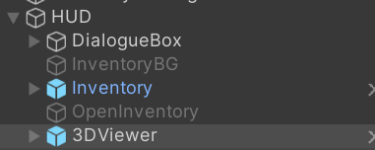Create a canvas object and drag the Inventory and 3DViewer prefabs onto the canvas, un-hide these so we can see what we are doing.

Create a separate gameObject and call this Inventory Manager, drag the 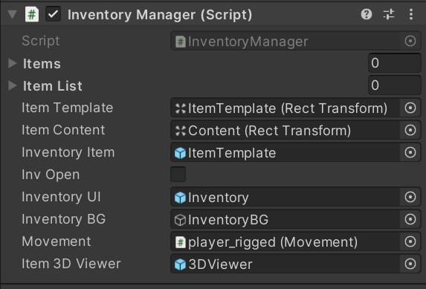Inventory Manager script onto the gameObject and drag in the 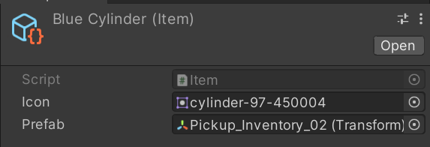corresponding objects into their slots.

Then make some items that you want to be picked up by the player, do this by right clicking in your Assets folder > Create > Item. Add in an icon sprite and the prefab of the item that is to be 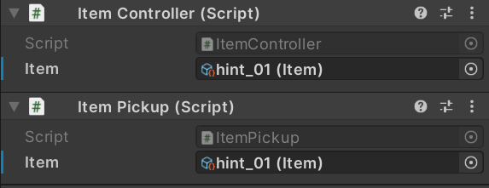picked up.

Then add the Item Controller and Item Pickup scripts to the object that is to be picked up, place the item that you just made into the Item slot.